Full Name: Nguyễn Thị Huyền
ID: 23IT110

Step 1:
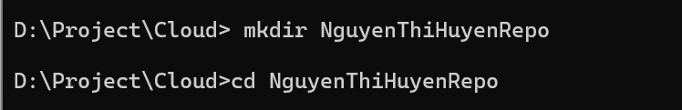
Step 2:
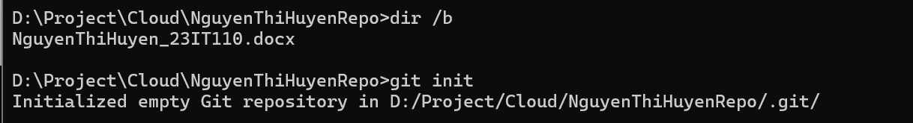
Step 3:

