Lesson 3 Homework 11/24/20 – Nayana Kumari Thakur

1. *The project showing that you can view* ***YOUR*** *data tables in pycharm:*

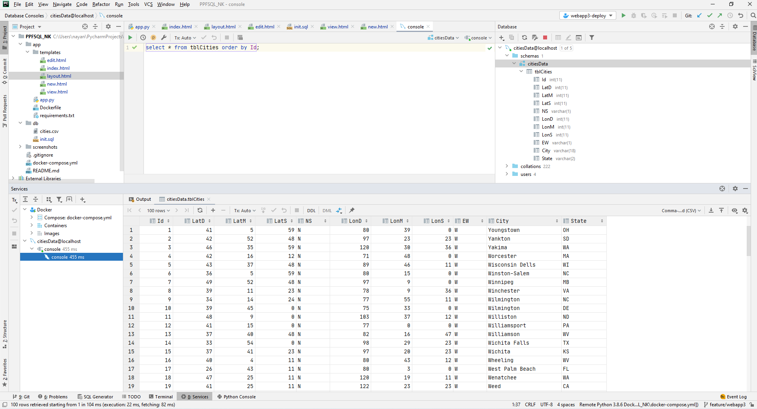

1. ***YOUR*** *project running correctly in the browser displaying your homepage with your data:*

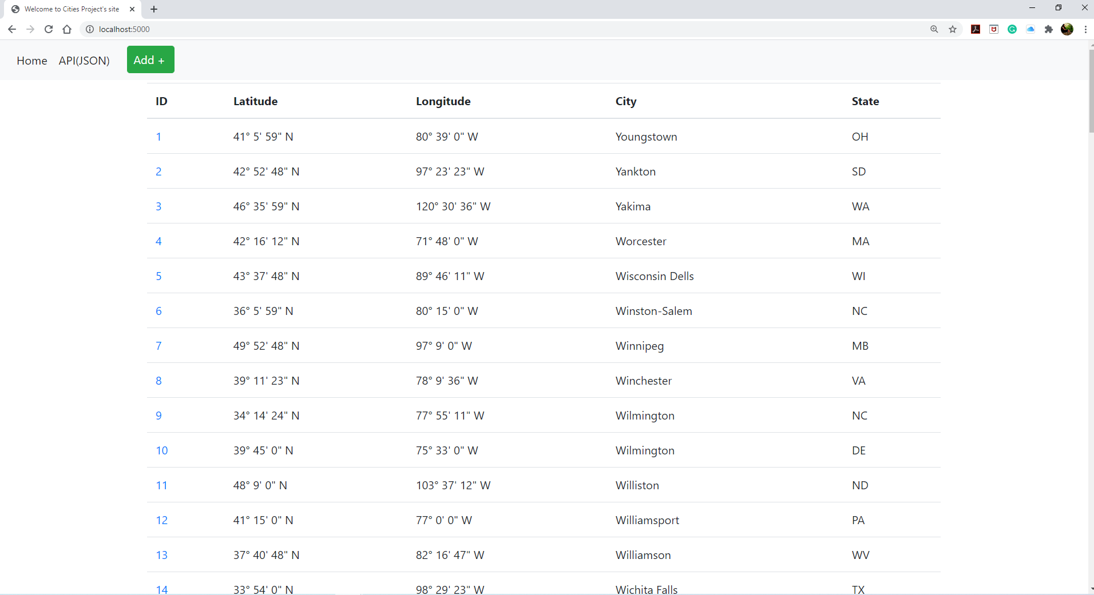

1. ***YOUR*** *project running correctly in the browser displaying your data record as a view of one record*

*Following can be seen upon clicking the number link 7:*

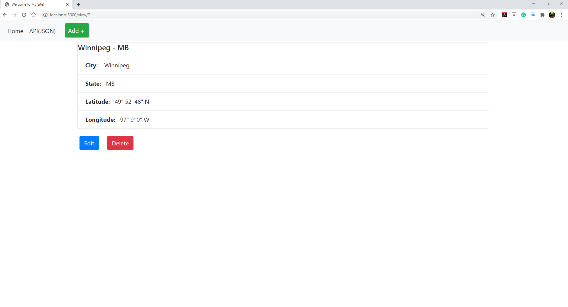

1. ***YOUR*** *project running correctly in the browser displaying a new record added to your home page:*

The add screen is displayed upon clicking the Add+ button on Navbar

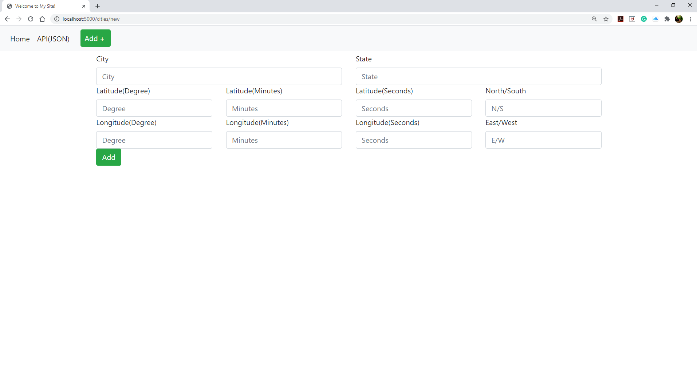

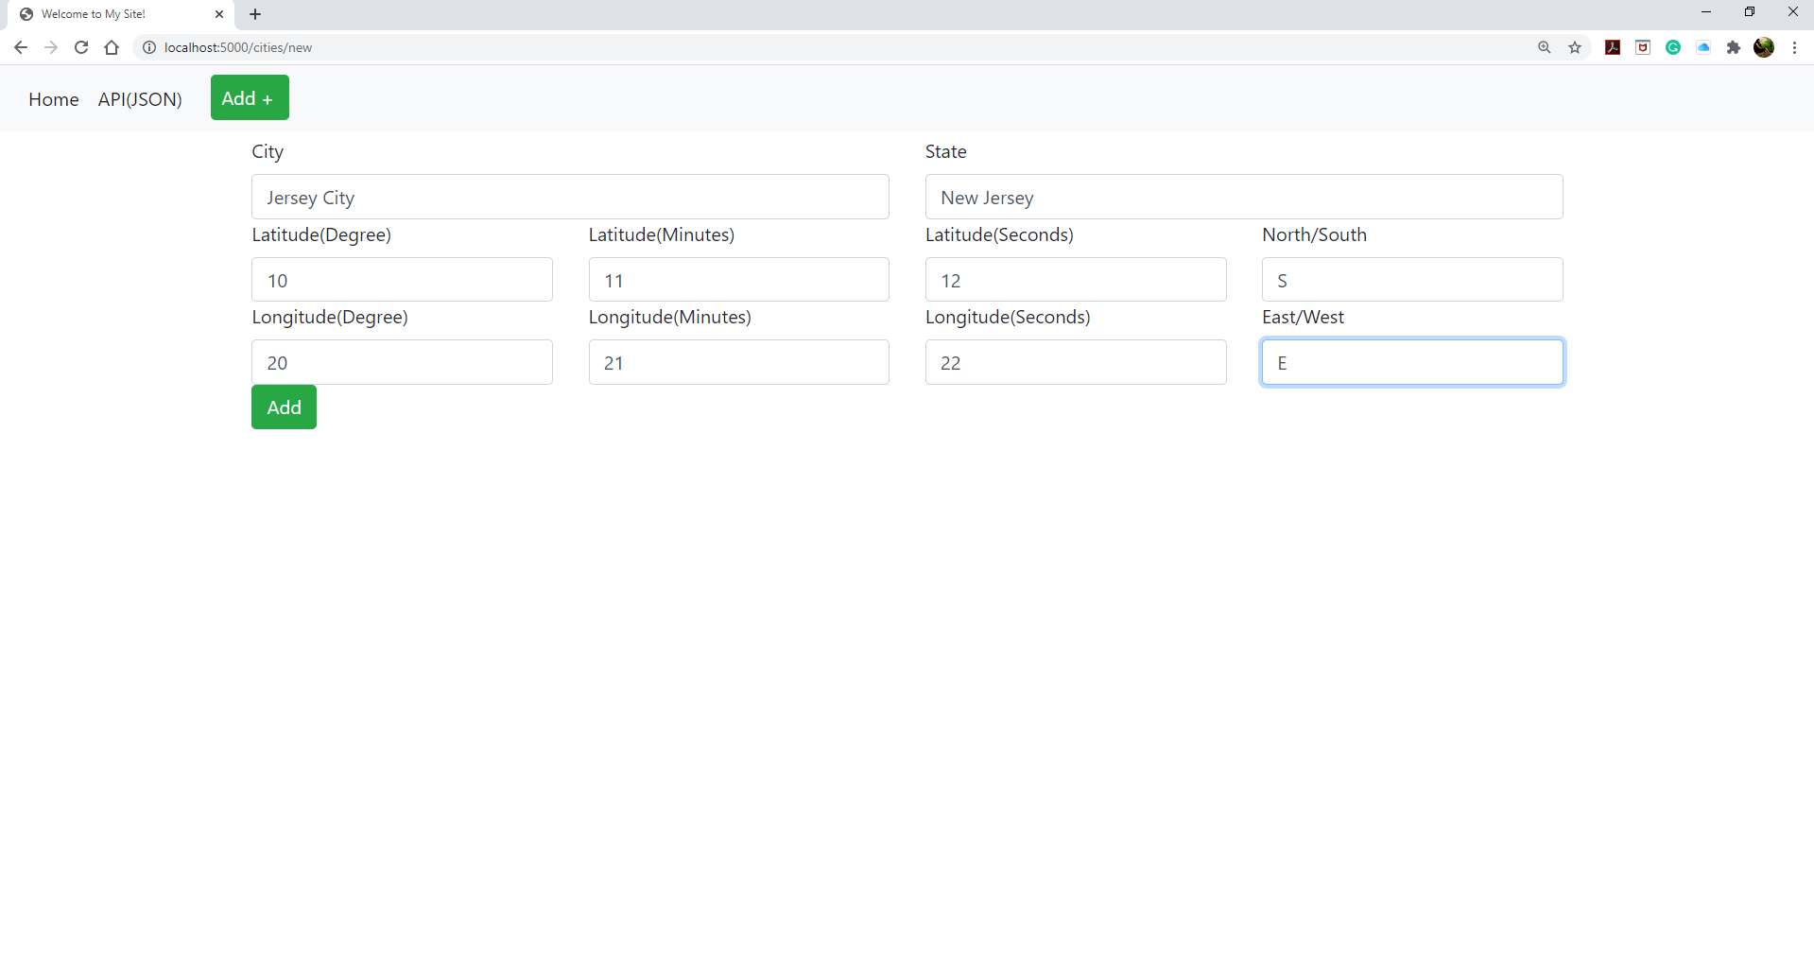

Record added with Id: 101

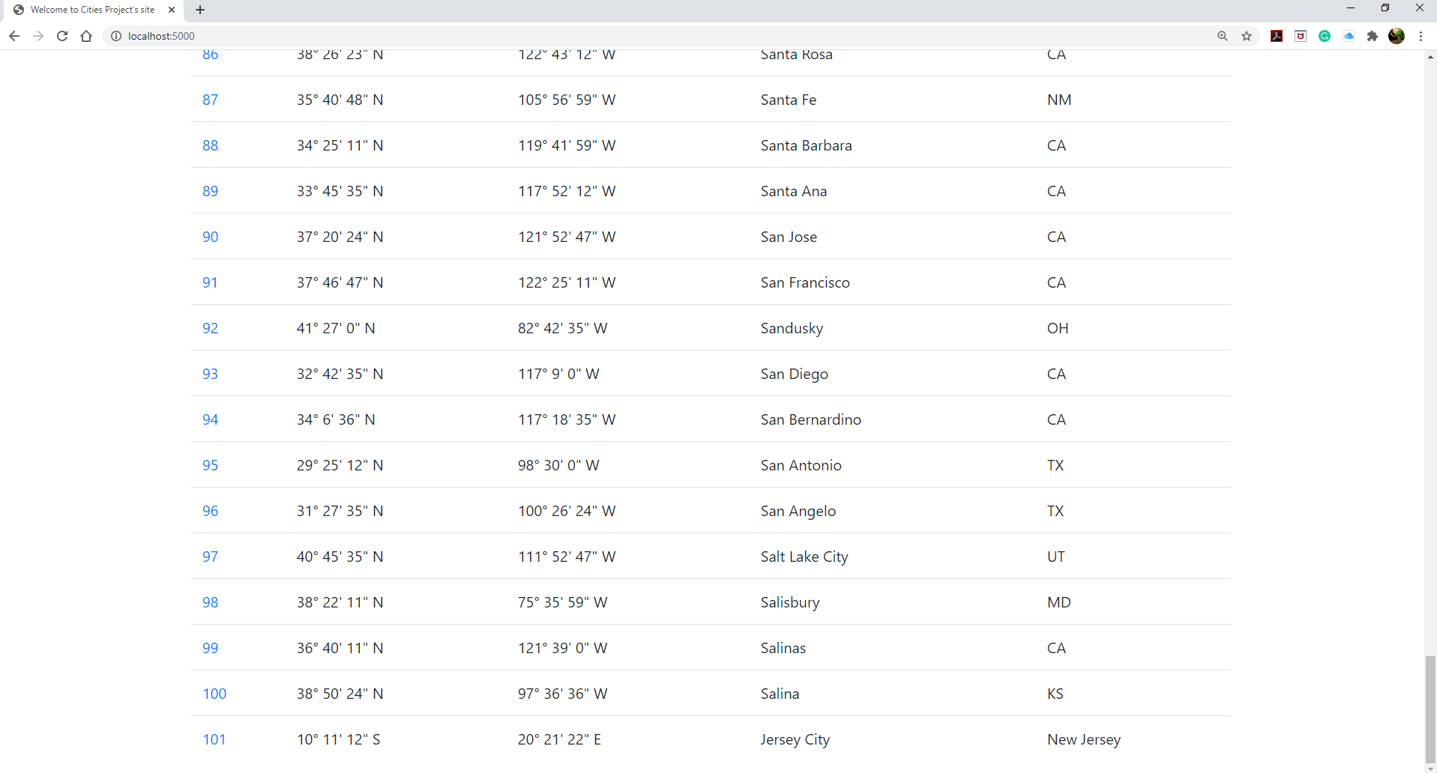

*e.* ***YOUR*** *project running correctly in the browser displaying an updated record added to your home*

*page:*

Following screen is displayed upon clicking the Edit button on view screen

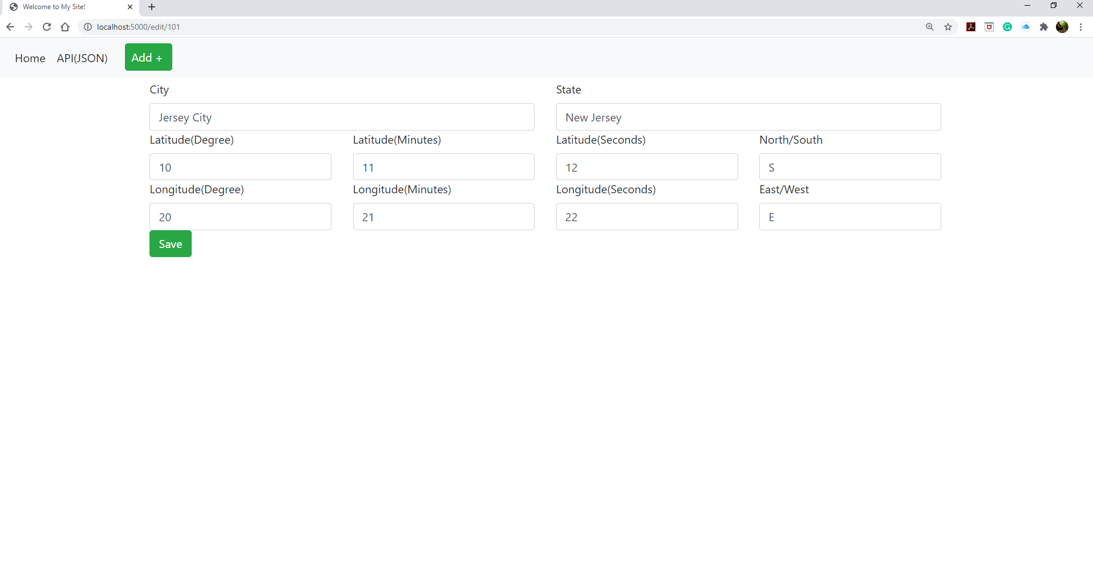

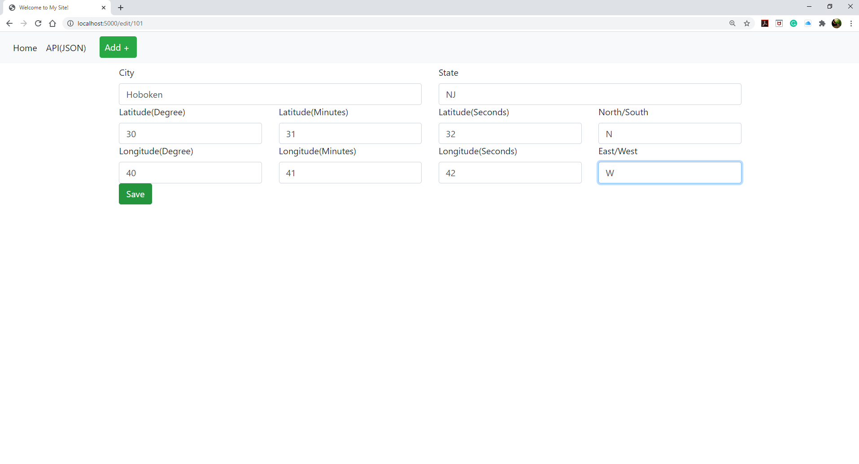

Record Id: 101 updated.

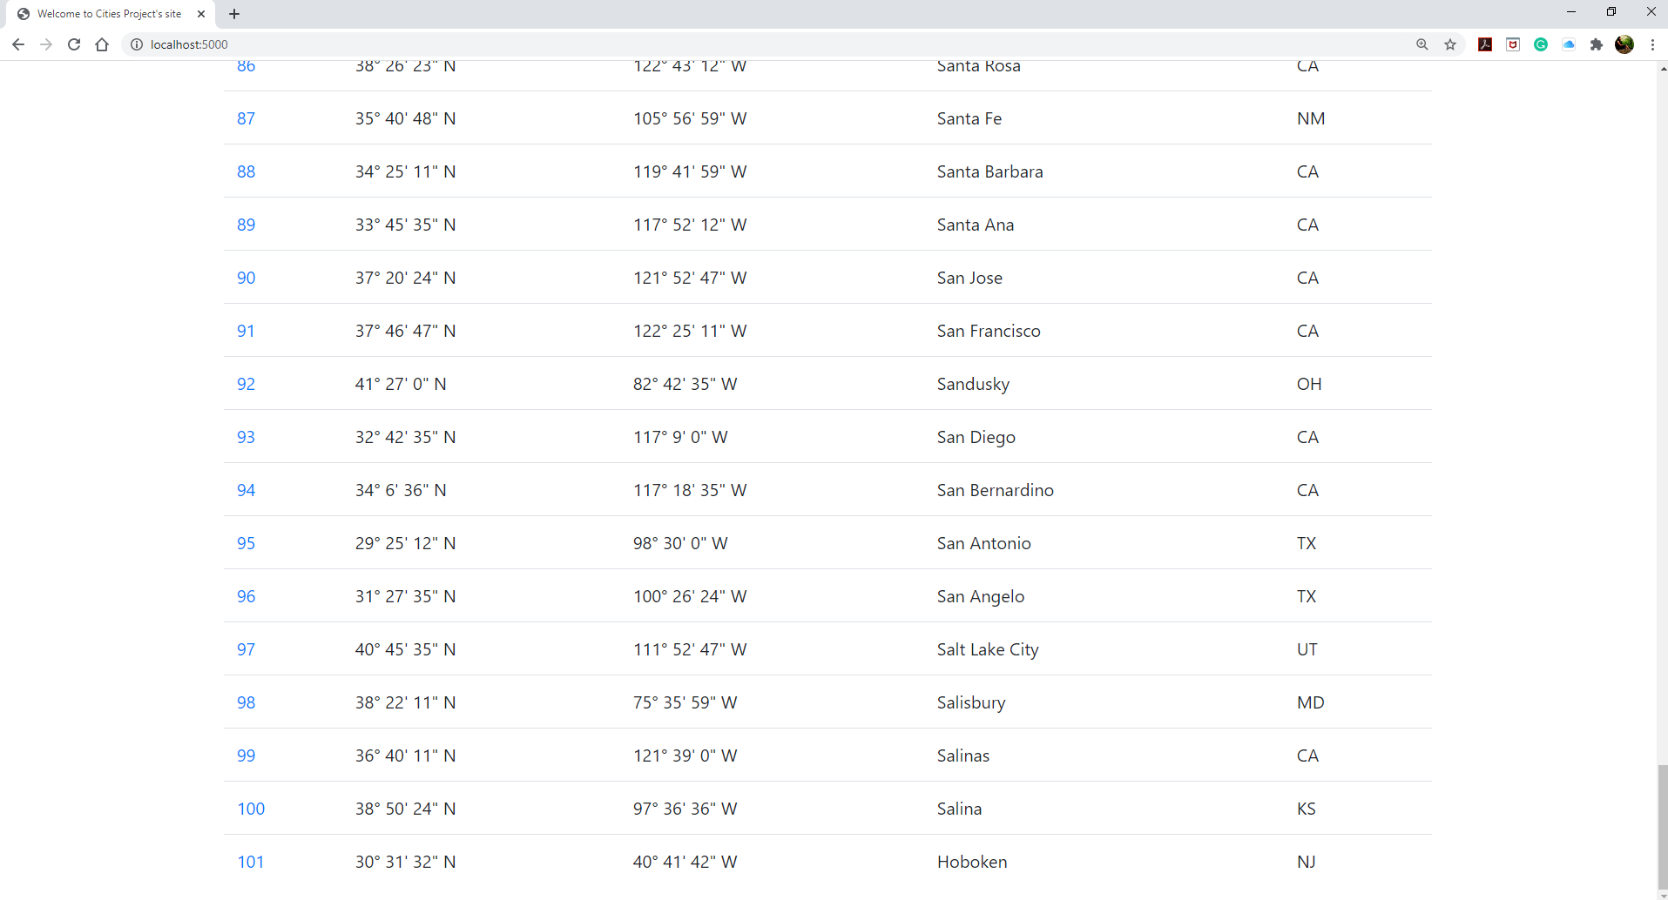

*f.* ***YOUR*** *project running correctly in the browser displaying a deleted record added to your home*

*page:*

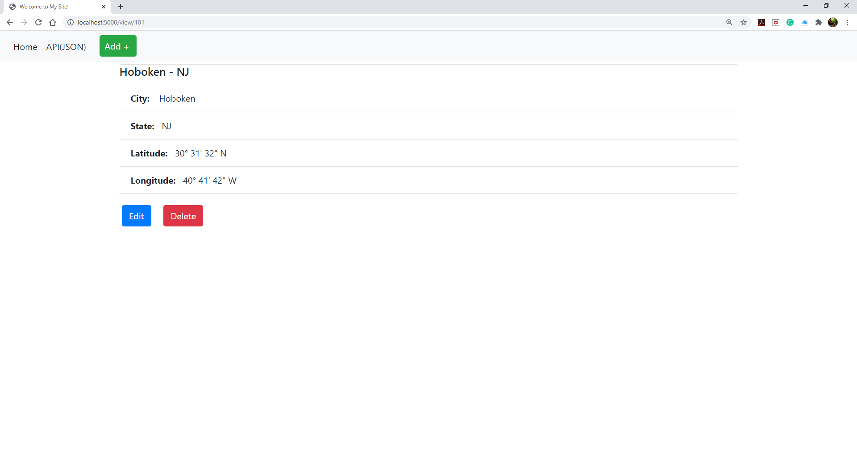

Record ID: 101 is deleted after clicking on Delete button on view screen.

