University of Windsor – Master of Management
BSMM.8730 Data Acquisition and Management | Dr. Andreas S. Maniatis | Fall 2026
D.3.1 Midterm Project Status Report
Charging the Gap: EV Adoption vs. Public Charging Infrastructure in Ontario
Team #8 – Nidhi Chetankumar Tandel (110173229), Temitope Lawal (110083784), Shiv Hari Kulhari (110213259) | November 8, 2026

Introduction
Our project helps municipal planners and charging network operators identify which Ontario regions have electric vehicle (EV) registrations growing faster than public charging capacity. The solution combines structured CSV files, a semi-structured JSON API and unstructured web text in Python, stores the integrated data in a MySQL database, and will present the results in a Power BI dashboard. This report summarizes the progress made since the proposal was approved, the evidence available in our GitHub repository and Jira board, and the work that remains before the final deliverables on December 1.

1. Project Progress Breakdown

1.1 Task Breakdown Structure
The project was broken down into 21 tasks that follow the phases of the Data Analytics Lifecycle and are scheduled in two-week Scrum sprints in Jira. Table 1 lists every task with its dependencies and current status. Fourteen of the 21 tasks are completed, one is in progress and six remain.
ID | Task / milestone | Depends on | Status | Remarks / evidence
T1 | Topic selection, problem statement and D.1 pre-proposal | – | Completed | Submitted Sep 27; instructor feedback received
T2 | Updated D.1: three data types, web scraping, MySQL | T1 | Completed | Resubmitted Oct 2 following feedback
T3 | Jira Scrum board and GitHub repository set-up | T1 | Completed | Backlog, six sprints, folder structure
T4 | Acquire charging stations from NLR/NRCan API (JSON) | T3 | Completed | 4,608 Ontario stations, raw JSON stored
T5 | Download quarterly EV-by-FSA files (Ontario Data Catalogue) | T3 | Completed | All published quarters to Q2 2026
T6 | Download StatCan registrations, FSA population and boundaries | T3 | Completed | Tables 20-10-0025-01, 98-10-0019-01; 92-179-X
T7 | Web scraper 1: catalogue page → quarterly CSV links | T5 | Completed | BeautifulSoup; links saved to CSV
T8 | Web scraper 2: Government of Canada news releases | T3 | In Progress | Search page parsing being fixed; manual URL list as fallback
T9 | Flatten JSON, clean and standardize, derive FSA | T4 | Completed | Null ports → 0, duplicates removed
T10 | Append EV quarters, join population, compute metrics | T5, T6, T9 | Completed | EVs per port, ports per 1,000, gap score
T11 | MySQL schema design (5 tables, keys, v_fsa_gap view) | T10 | Completed | 01_create_schema.sql
T12 | SQL dump, import in MySQL Workbench, verification queries | T11 | Completed | ev_charging_gap populated and checked
T13 | D.4.1 User Requirements and Analysis document | T2 | Completed | 31 functional, 15 non-functional requirements
T14 | D.4.2 Analysis and Design document | T11, T13 | Completed | Submitted Oct 30
T15 | Text extraction into funding_announcements table | T8 | Remaining | Regex rules written; awaits T8 output
T16 | Spatial join for stations without a valid postal code | T6, T9 | Remaining | Sprint 4
T17 | Power BI data model connected to MySQL | T12 | Remaining | Starts this sprint; read-only MySQL user
T18 | Dashboard: map, gap ranking, trends, filters | T17 | Remaining | Sprint 4
T19 | EV projection (linear trend, four quarters) | T10 | Remaining | Sprint 4
T20 | Code comments, README, D.4.3–D.4.5, D.5 report | T15–T19 | Remaining | Due Dec 1
T21 | D.6 in-class presentation | T20 | Remaining | Dec 9

1.2 Sequencing and Progress Since Initiation
The tasks were sequenced so that each phase produces the input of the next. Discovery tasks (T1–T3) defined the problem, the stakeholders and the tools, and set up Jira and GitHub before any data work started. Data acquisition (T4–T8) followed, because cleaning and modelling cannot begin until the sources are available. Preparation and integration (T9–T10) depend on all acquisition tasks except the news-release scraper, which is why the database could be built while the scraper is still being refined. The MySQL schema (T11) was designed only after the cleaned tables and their keys were known, and the database import (T12) is now the foundation for the remaining analysis and dashboard tasks (T15–T21). The requirements and design documents (T13–T14) were written alongside the build so that the remaining work is guided by agreed, testable requirements.
Since project initiation the team has moved from an idea to a working data foundation. All four primary datasets have been acquired from official sources, including 4,608 charging stations retrieved through the API, every quarterly EV-by-FSA file published to Q2 2026, and the Statistics Canada registration, population and boundary files. A Python notebook now flattens, cleans and integrates these sources, calculates the core metrics, and generates a self-contained SQL dump that loads the ev_charging_gap database in MySQL Workbench. The main open item in acquisition is the news-release scraper: the Government of Canada search page did not return results in the expected structure, so the parsing logic is being adjusted and a manually collected list of release URLs is being prepared as a fallback. The next sprint focuses on connecting Power BI to MySQL and building the first dashboard pages, which will turn the current database prototype into the visual prototype of the final application.

2. GitHub Repository and Version Control Evidence
All project work is tracked in the GitHub repository [GitHub repository link], and tasks are managed on the Jira board [Jira board link]. The repository is organized as the project portal: data/raw holds the original files exactly as downloaded, data/processed holds the cleaned outputs of the notebooks, notebooks holds the Python acquisition and wrangling code, sql holds the schema, dump and verification scripts, dashboard will hold the Power BI file, and docs holds the proposal, the requirements and design documents and the screenshots used as evidence. A main README describes the project, the team and the deliverables, and a data README records the source, link, download date and selection of every dataset, which provides traceability for each file. Personal credentials such as the API key are never committed.
Each member commits under their own GitHub account with messages that describe the actual change, such as adding the quarterly EV-by-FSA files, adding the JSON flattening and FSA derivation step, or adding the MySQL schema and verification queries. Commit messages reference the related Jira task where possible, so the history can be followed from requirement to implementation.
Nidhi Tandel, as Project Manager and Data Engineer, set up the repository and Jira board, acquired the API and CSV data, developed the acquisition and wrangling notebook, designed the MySQL schema, produced and imported the SQL dump, and led the D.4.1 requirements document. Temitope Lawal, as Data Analyst and BI Developer, validated the downloaded datasets, defined the cleaning rules and the data dictionary, contributed to the D.4.2 design document, and leads the Power BI model and dashboard that start in the next sprint. Shiv [Last Name], who rejoined the team in October, was brought up to date on the full pipeline, contributed to the D.4.1 and D.4.2 documents, and is assigned to completing the news-release scraper and the EV projection module.

3. Demonstration of Completed Work
The completed tasks in Table 1 will be shown in a live walkthrough, in the same order as the pipeline. First, the GitHub repository will be opened to show its folder structure, the data README and the commit history, together with the Jira board showing the completed and remaining tasks in each sprint. Second, the acquisition and wrangling notebook will be run in Google Colab: it calls the NLR/NRCan API and receives the JSON for 4,608 Ontario stations, scrapes the Ontario Data Catalogue page for the quarterly CSV links, loads the EV, population and registration files, and prints the data-quality checks, including the number of stations without a valid postal code and the FSAs that have EVs but no public charging port.
Third, the MySQL database will be shown in Workbench. The schema contains five related tables – fsa, ev_registrations, charging_stations, vehicle_registrations_prov and funding_announcements – with primary and foreign keys, and the v_fsa_gap view that calculates EVs per public port and ports per 1,000 residents for every FSA and quarter (Figure 1). The verification script returns the row count of every table (Figure 2), the fifteen FSAs with the highest number of EVs per public port in the latest quarter (Figure 3), and the split between Level 2 and DC fast ports by region. Finally, the entity-relationship diagram generated by reverse engineering the database will be shown to demonstrate that the implemented schema matches the D.4.2 design.
Figure 1 –
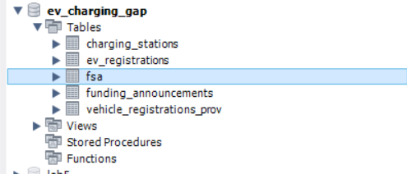

Figure 2 –
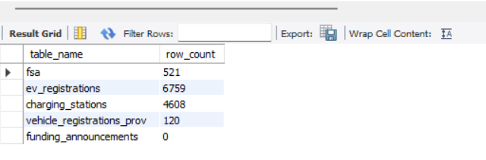
Figure 3 –
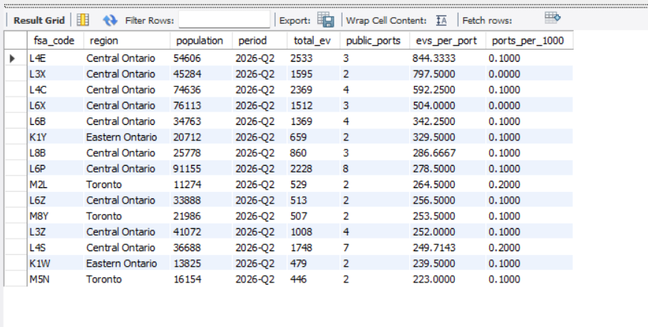

Figure 4 –
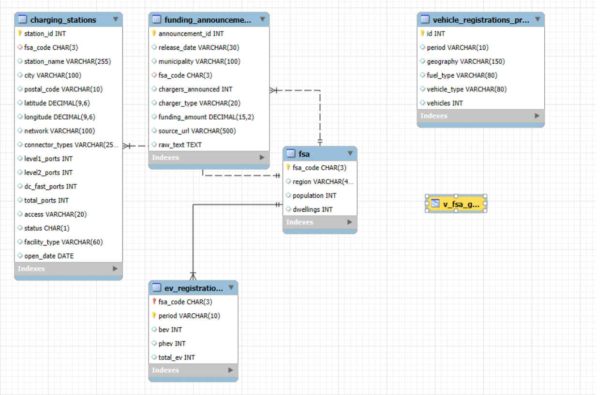

These components show that the data acquisition, preparation and storage layers of the application are working and verified. The remaining work is concentrated in the presentation layer and the unstructured-data module, and the team is on track to deliver the complete application, documentation and dashboard by December 1.

