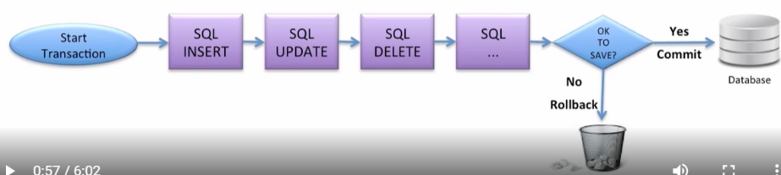

VD:

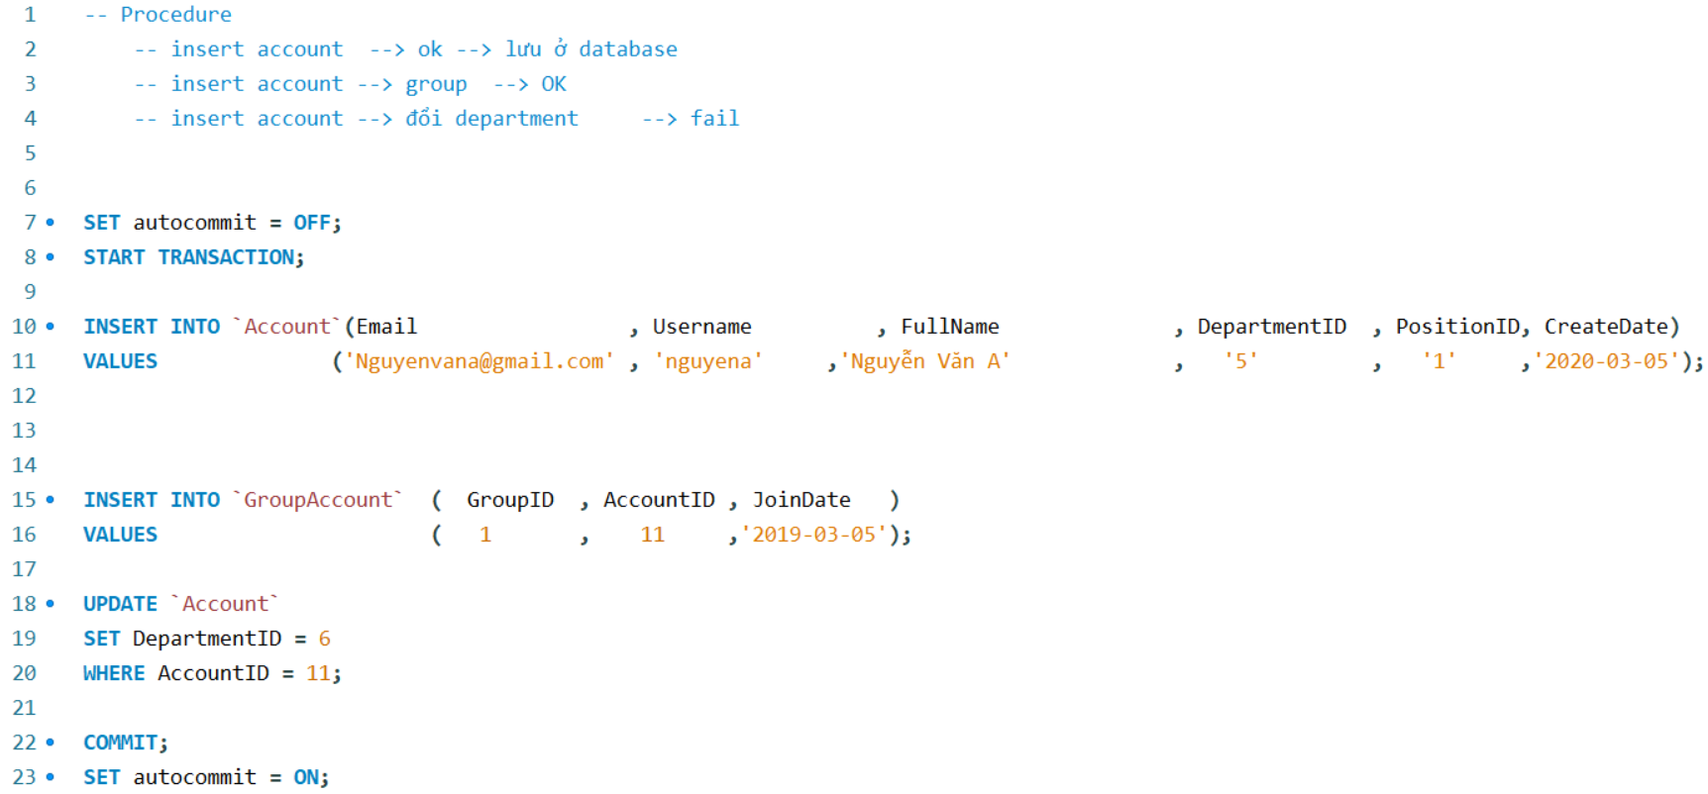

* **Reference**

<https://www.mysqltutorial.org/mysql-transaction.aspx/#:~:text=To%20start%20a%20transaction%2C%20you,you%20use%20the%20ROLLBACK%20statement>.