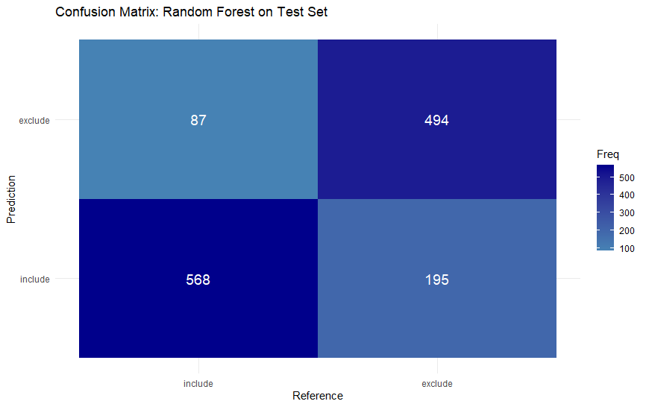
Title and abstract Random Forest model confusion matrix aggregated across cross-validations. Confusion matrix for the Random Forest classifier used in title and abstract screening in the held-out test set. Rows represent model predictions and columns represent the reference labels, showing the number of citations correctly and incorrectly classified as included or excluded.
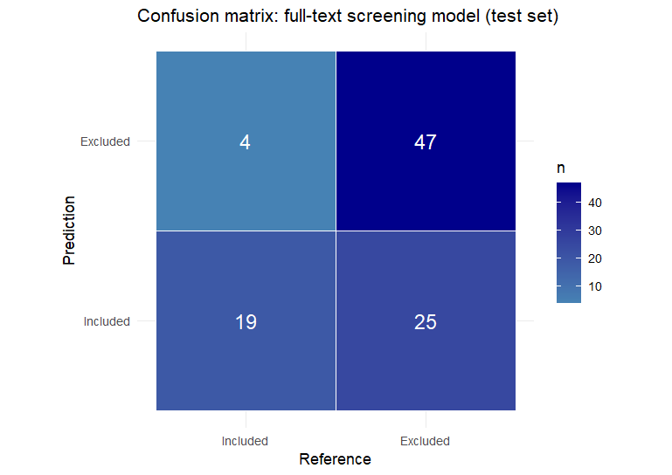
Full text Regularized logistic regression model confusion matrix aggregated across cross-validations. Confusion matrix for the Regularized logistic regression classifier used in full-text screening in the held-out test set. Rows represent model predictions and columns represent the reference labels, showing the number of citations correctly and incorrectly classified as included or excluded.

