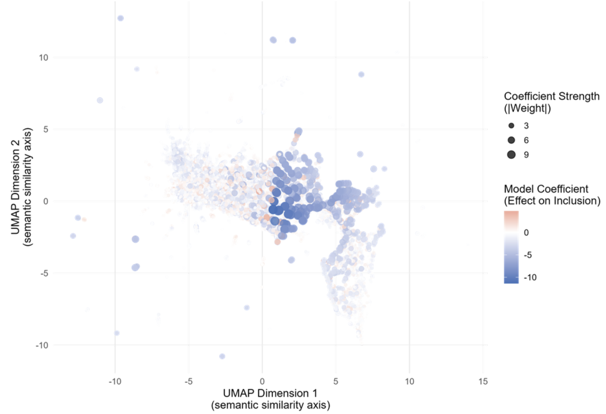
Figure 4. Similarity of weighted terms after dimension reduction and their influence on regularized logistic regression model. Terms are projected using Uniform Manifold Approximation and Projection (UMAP) based on semantic similarity. Point color represents the model coefficient indicating the direction of association with inclusion or exclusion, and point size reflects the absolute coefficient magnitude. The relatively similar point sizes suggest that model predictions are driven by combinations of terms rather than any single word or phrase.

