(a) Title and abstract model
(b) Full-text model
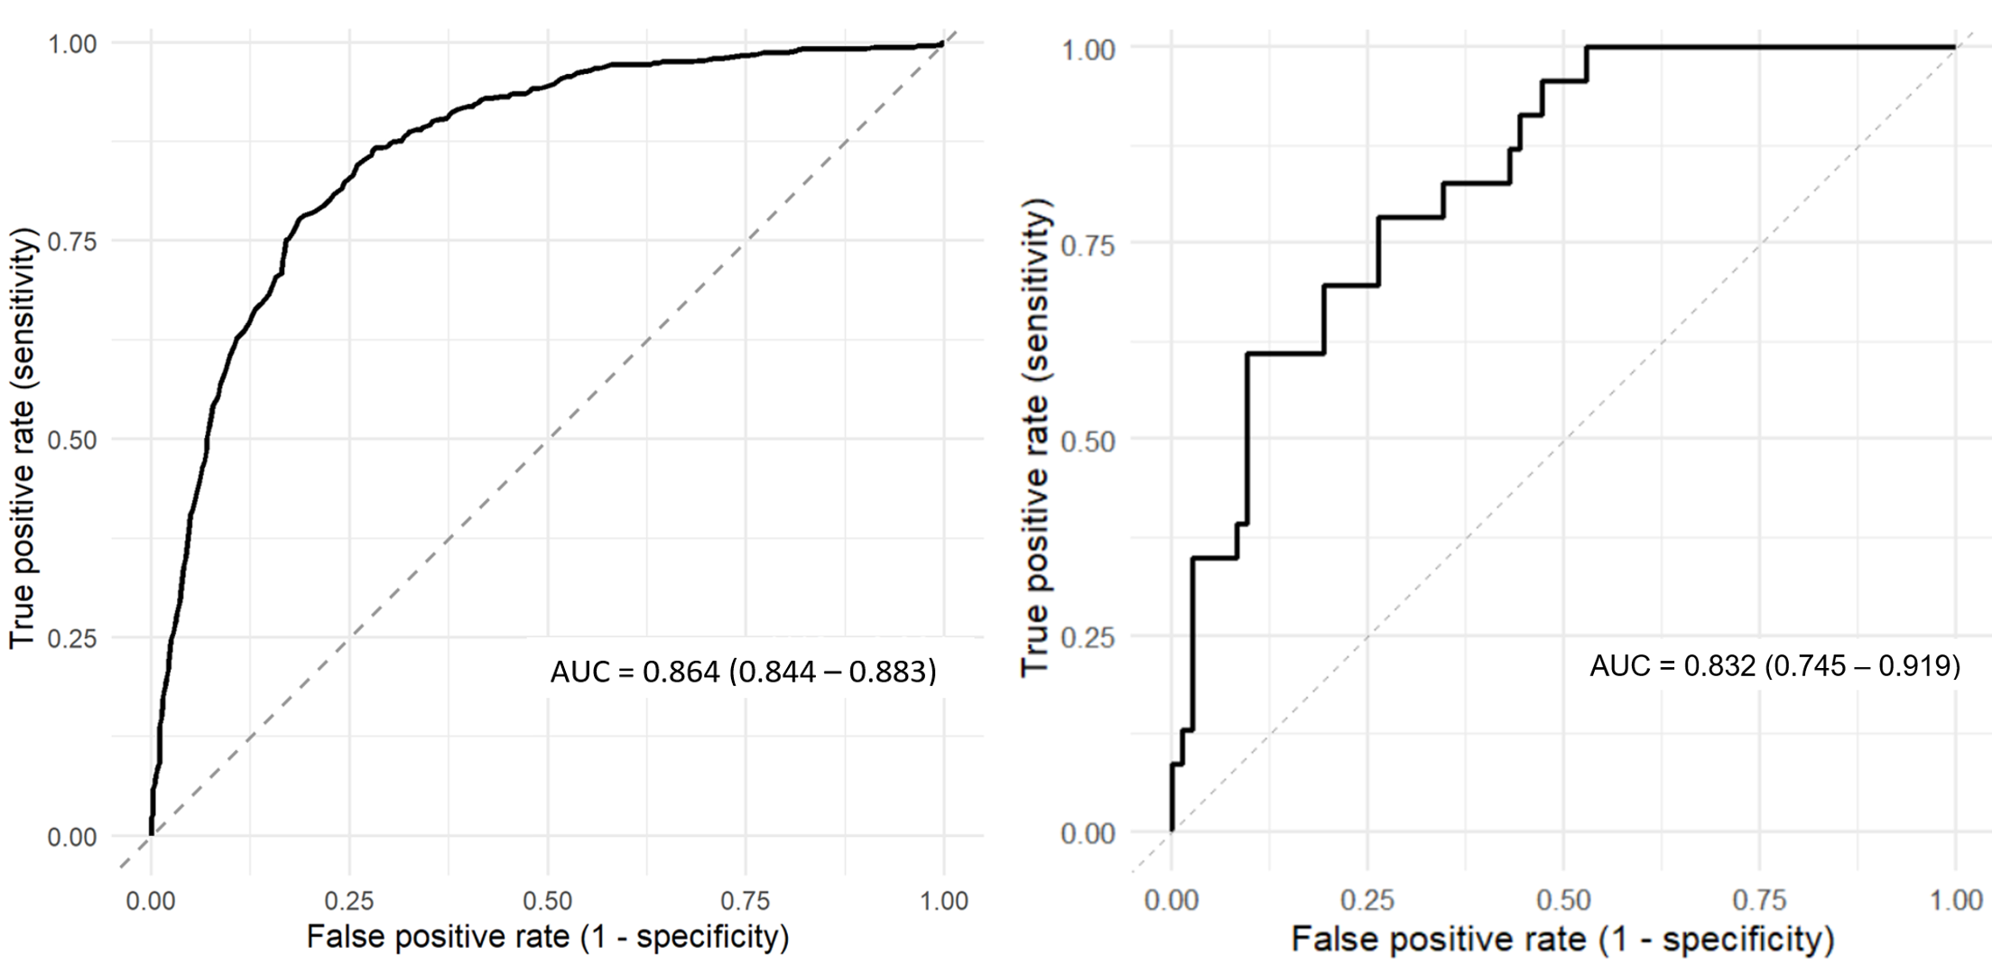
Figure 5. Test-set discrimination performance of the title and abstract Random Forest model and the regularized logistic regression model. The receiver operating characteristic (ROC) curves showing model discrimination on the held-out test set. Panel (a) shows the performance of the Random Forest model trained on titles and abstracts, and panel (b) shows the performance of the regularized logistic regression model trained on full texts. The area under the curve (AUC), including 95% confidence intervals, is reported in each panel.

