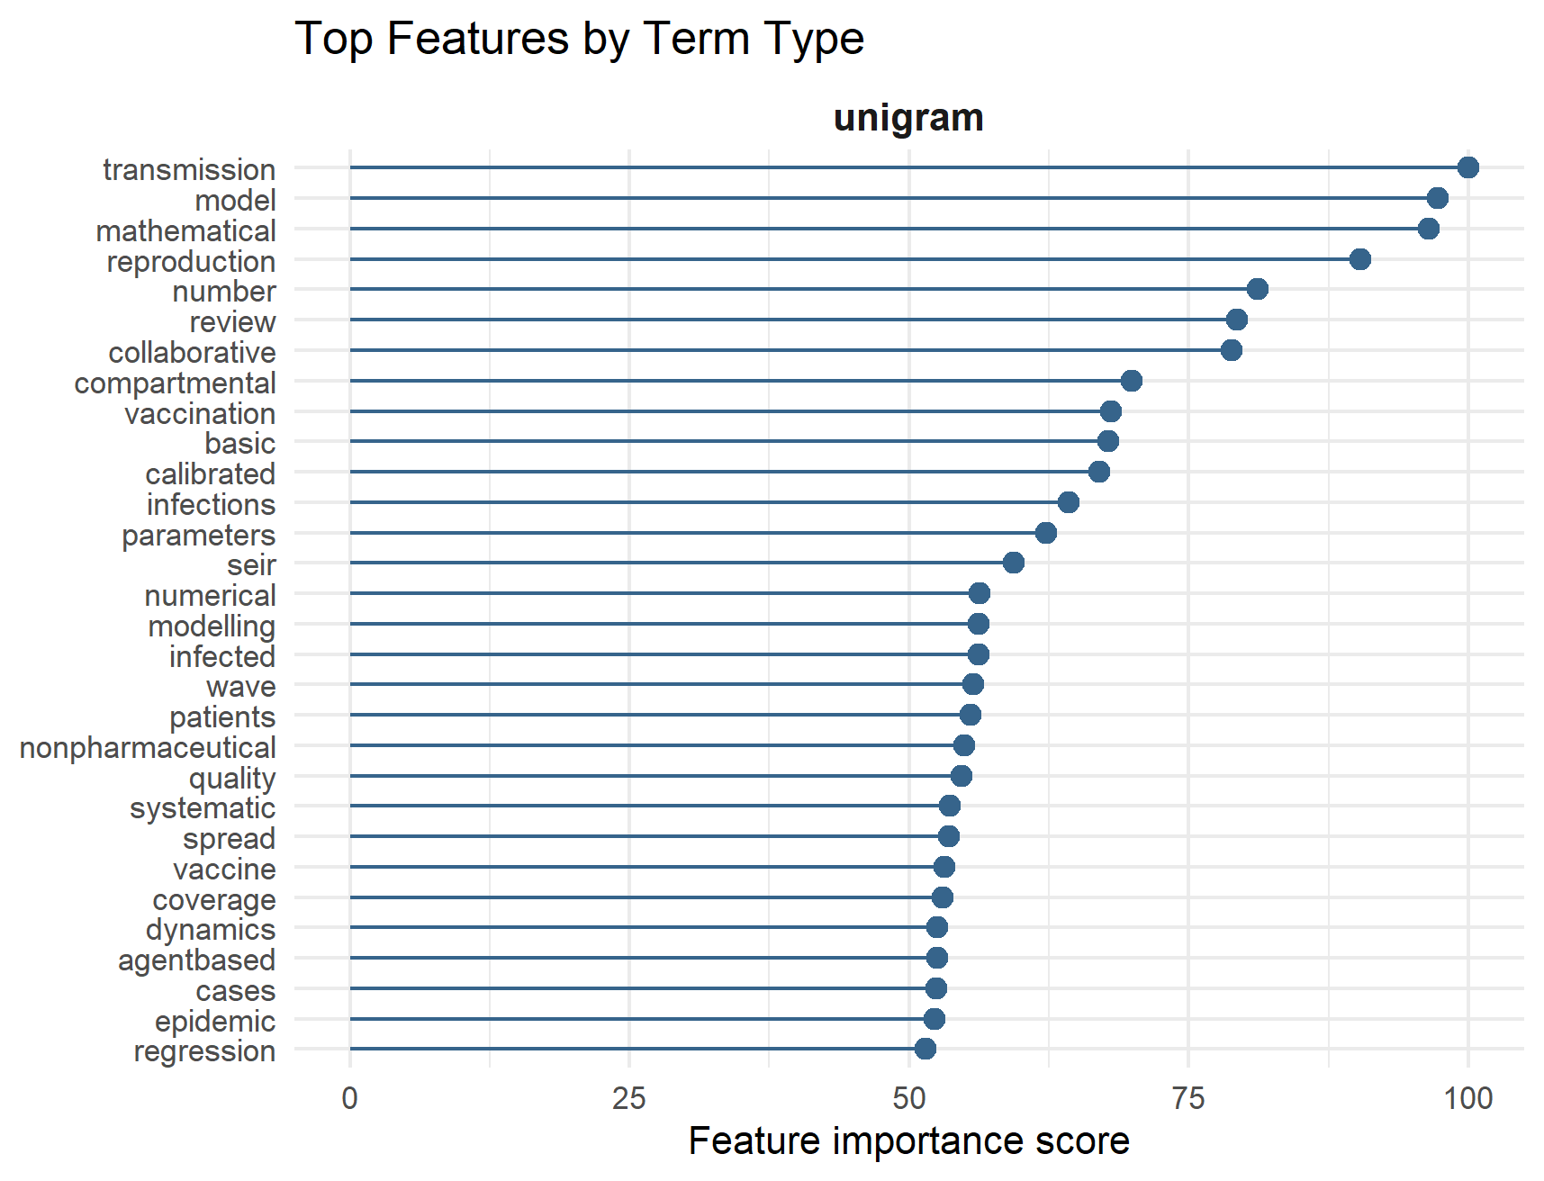
Figure 3. Thirty most influential terms driving Random Forest model performance. Terms are ranked by feature importance derived from the Random Forest classifier trained on titles and abstracts. Higher scores indicate greater contribution of the term to model predictions.

