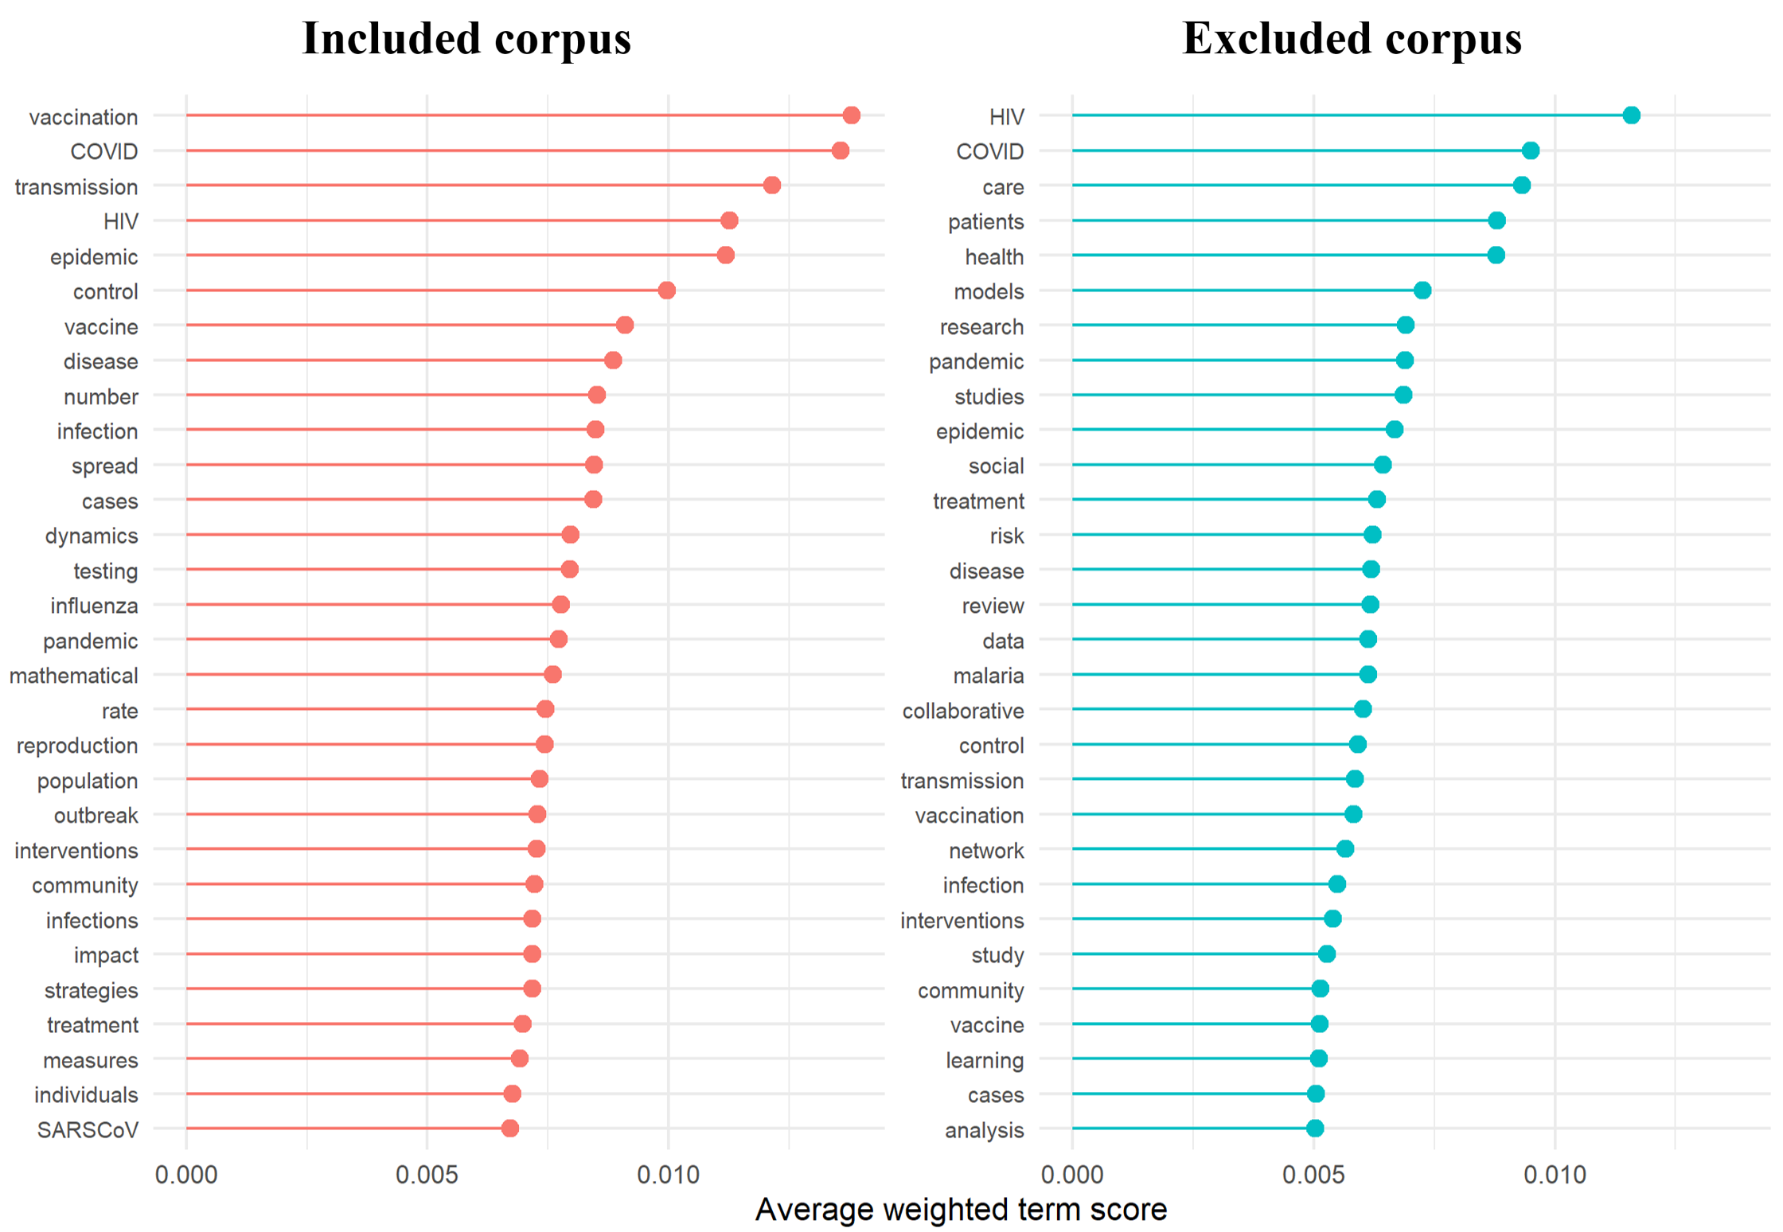
Average weighted term scores among included and excluded training title and abstracts. Dot plots showing the thirty most influential terms based on average weighted terms scores after vectorization of the training titles and abstracts. Terms are displayed separately for citations labeled as included and excluded, illustrating how differences in term weighting may contribute to model discrimination prior to model training.

