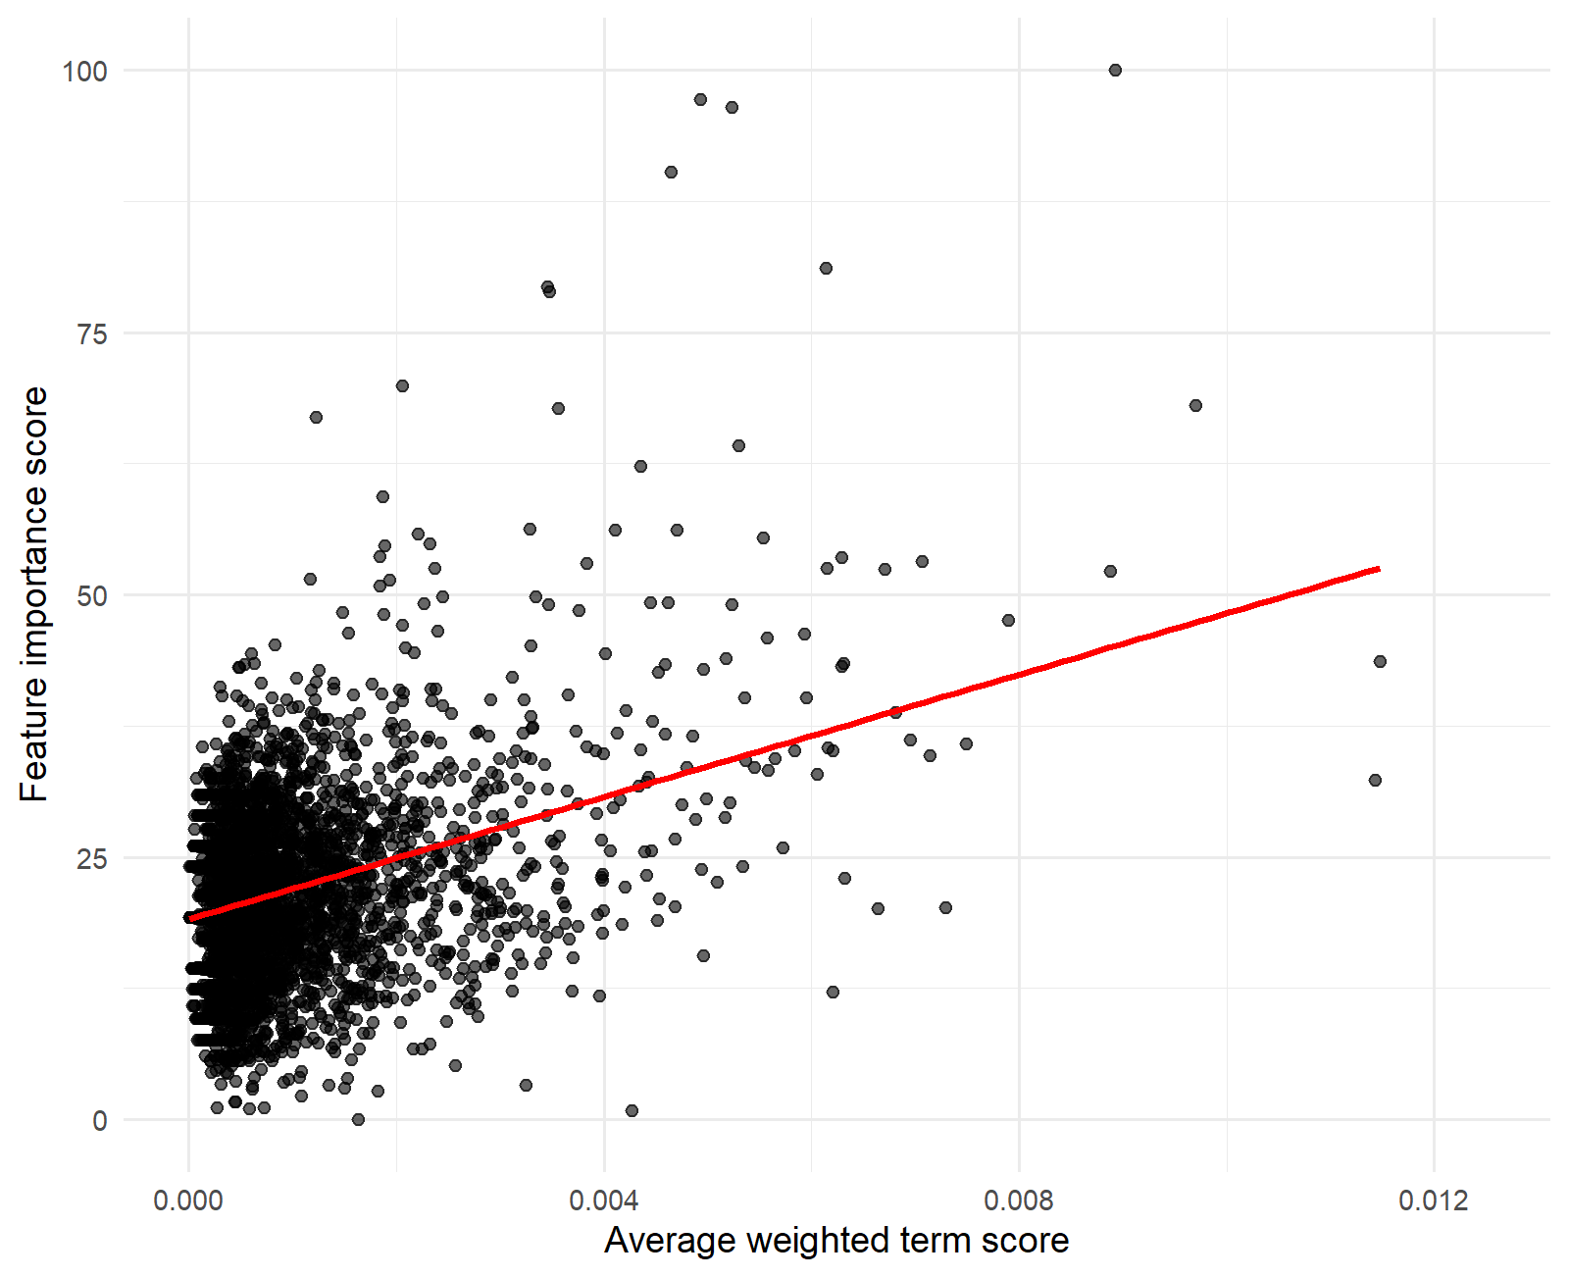
Relationship between average weighted term score and Random Forest feature importance score. Scatter plot showing the relationship between average weighted term scores after vectorization and Random Forest feature importance scores for terms used in the title and abstract screening model. Each point represents a term, and the fitted regression line illustrates the weak association between term distinctiveness and model feature importance; feature importance was not driven solely by highly distinctive terms but by combinations of modeling and participatory terminology.

