Task 1 – execute the algorithm manually, step by step, and fill the tables.
records: |  | additional bookkeeping  (for connection in connections loop)
  node | connection | g | f
  S | None | 0 | 0+5=5
  B | S→B | 2 | 2+3=5
  A | S→A | 1 | 1+5=6
  C | S→C | 1 | 1+6=7
  D | B→D | 3 | 3+3=6
  E | B→E | 7 | 7+2=9
  F | D→F | 5 | 5+1=6
  G | F→G | 6 | 6+0=6
  connection | neighbor | neighbor_cost
  S→A | A | 1
  S→B | B | 2
  S→C | C | 1
  B→A | A | 4
  B→D | D | 3
  B→E | E | 7
  A→D | D | 4
  D→F | F | 5
open list |  | closed list
  [S(5)]
  [B(5), A(6), C(7)]
  [A(6), D(6), C(7), E(9)]
  [D(6), C(7), E(9)]
  [F(6), C(7), E(9)]
  [G(6), C(7), E(9)]
  []
  [S]
  [S, B]
  [S, B, A]
  [S, B, A, D]
  [S, B, A, D, F]
current |  | (Notice the shortcut approach taken in this pseudocode – we are happy with finding some route and stop early when done so.)
  G
final result (path): S→B, B→D, D→F, F→G

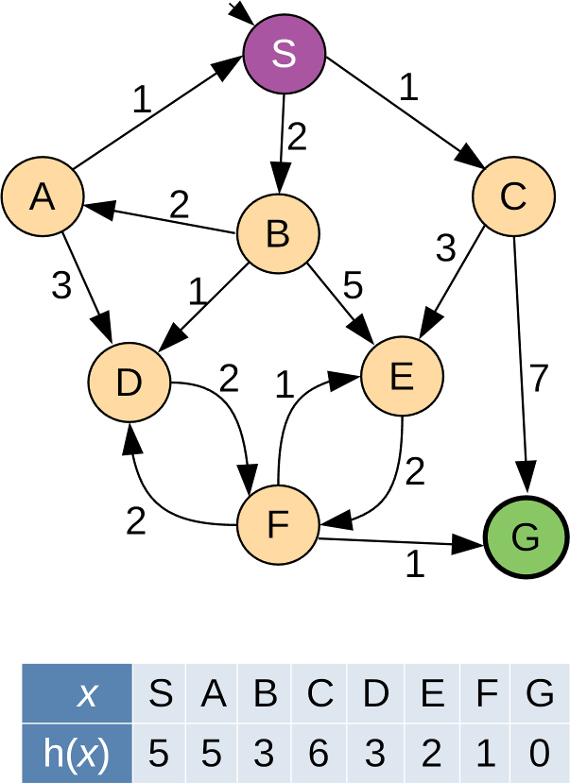

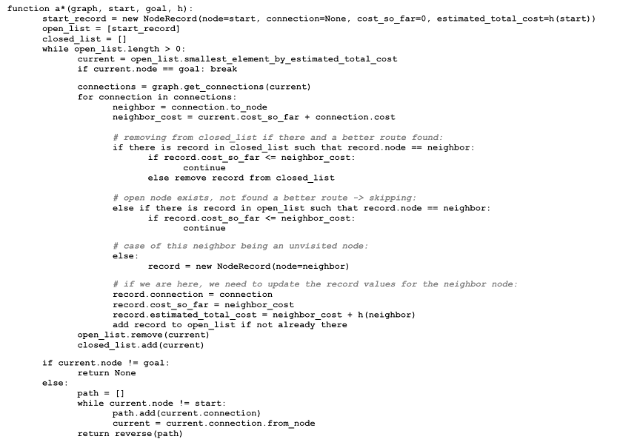

Task 2

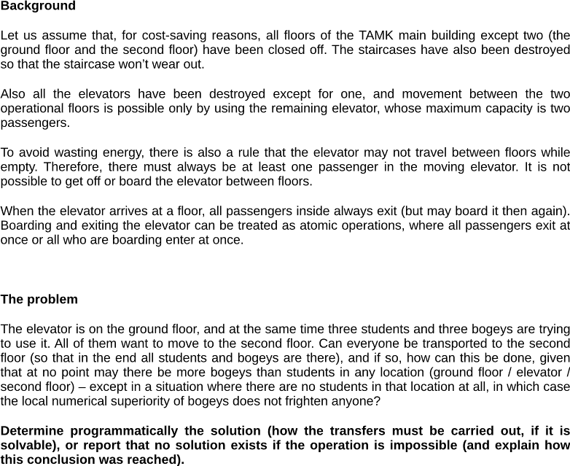

Group members: Anh Nguyen

Answer (briefly):
The problem can be solved. We used BFS to search through all possible states, where each state tracks how many students and bogeys are on each floor and in the elevator. The elevator can carry 1 or 2 passengers and can never travel empty. At no point can bogeys outnumber students at any location, unless there are no students there at all. BFS finds a valid sequence of trips that gets everyone to the second floor.



AI tools only allowed to help with Python syntax, possible libraries you might want to use, etc. You should model the problem and plan and implement the code by yourselves. Report possible use (or lack of such) here briefly:
I ChatGPT used to check the BFS solution showing corner cases in my own code that I can’t understand and do not know.

