5G00GC11-3001 AI and Machine Learning, Home Exercise 1

Download the file ex01.py from Moodle and complete functions df and climb within it with appropriate implementations so that the functions work as described in the file. (The functionality of the original descriptions is, naturally, expected, so modifying the descriptions in the file is not useful.) More instructions/requirements can be found in the code file itself.
Do not alter the parameters, and clean up all unnecessary code from the version to be submitted, including calls to the implemented functions. (It makes, of course, sense to call the functions during development to test and verify their functionality, but in the submitted version, the functions should not be called by your own code.) The file to be submitted should not print anything that is not necessary for the required functionality. Naturally, it should be possible to run the code (at least with valid function parameters) without crashes.
Submit ex01.py – with its original name, completed with your code additions – in the corresponding Moodle submission area by the deadline.


AI usage is to be reported in the code file as instructed there.
Pay attention to the course policy and the copyright laws: do not give task instructions (or even chunks of considerable size of them) to any third-party AI implementation! The instructions given to you are not so long that you should have to ask for summaries, and the AI is not meant to implement the code for you – not even plan for you how the code should be implemented directly based on the task instructions given to you. You should understand what you are to do after reading the instructions and have some idea of your own about how to approach solving the task. (Read the instructions again, if something is unclear after the first time, and if this does not help, please ask the teacher.) The allowed AI usage includes consulting whether you understand a single sentence (or such) correctly, getting help regarding, e.g., Python syntax, pythonic ways of writing code (when you know what you are trying to write), algorithms and their features in general, debugging your code, etc. – but never give the exercise instructions or any other course material to external AI tools!

To clarify: the basic idea applied in this exercise (and probably in others in the future):
Phase |  | Example
1. You get a file with functions with empty bodies. |  | monkey.py
  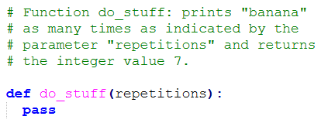
2. You read the function descriptions and write the function bodies accordingly so that the functions work as they should. You test the functionality. |  | monkey.py
  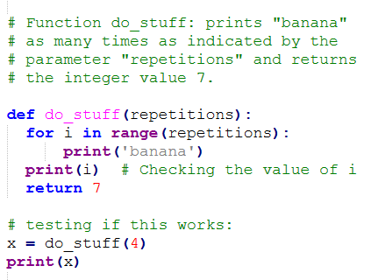
3. You clean the code removing prints and function calls that are not required by the instructions. |  | monkey.py
  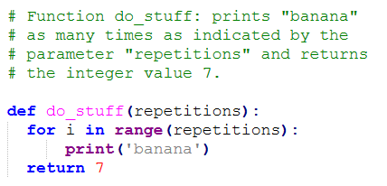
4. You submit the file in Moodle.

5. In addition to just looking at the code, the functionality of your work is checked by importing your functions from external test code and running them with test parameters. |  | test_monkey.py
  