Minh chứng tuần 5
Minh Chứng Hệ Thống CMS:
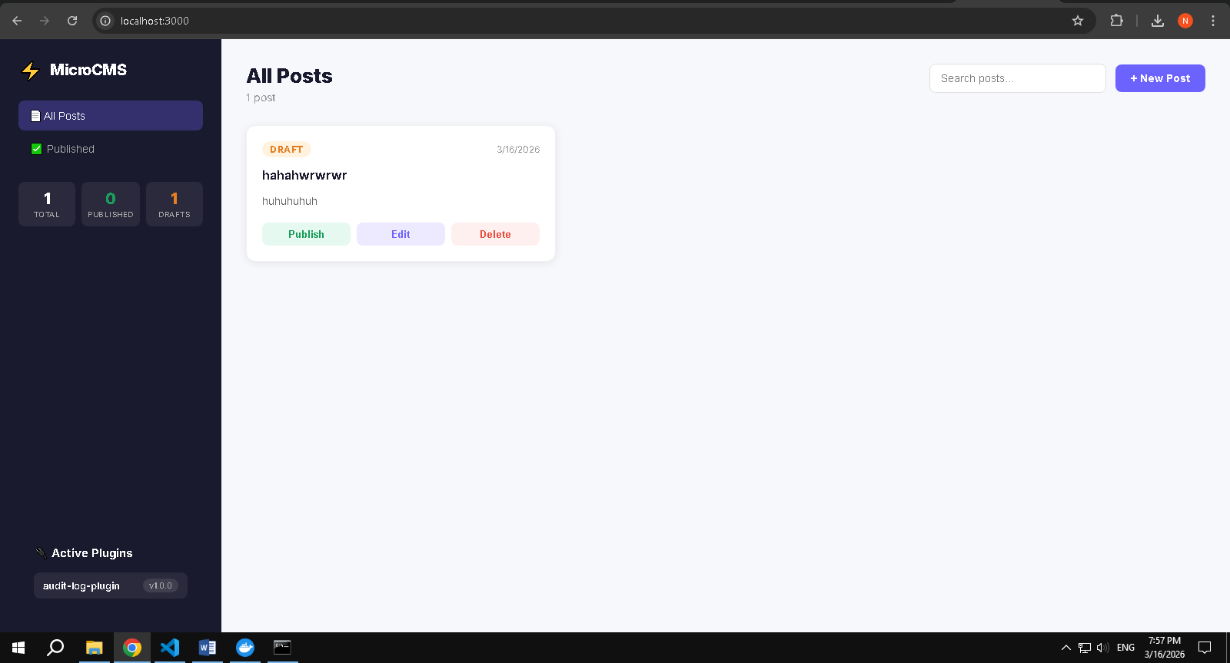
Phần 1: Một số lệnh Docker Compose cơ bản
- Docker compose version
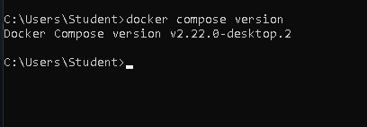

- Docker compose up
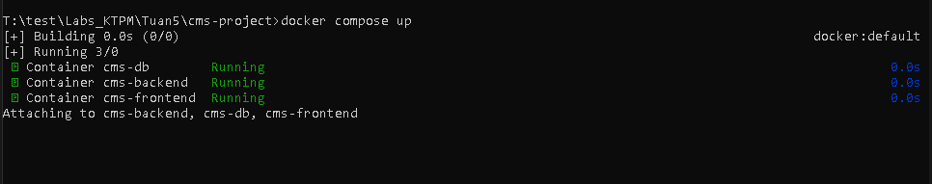
- docker compose up –d
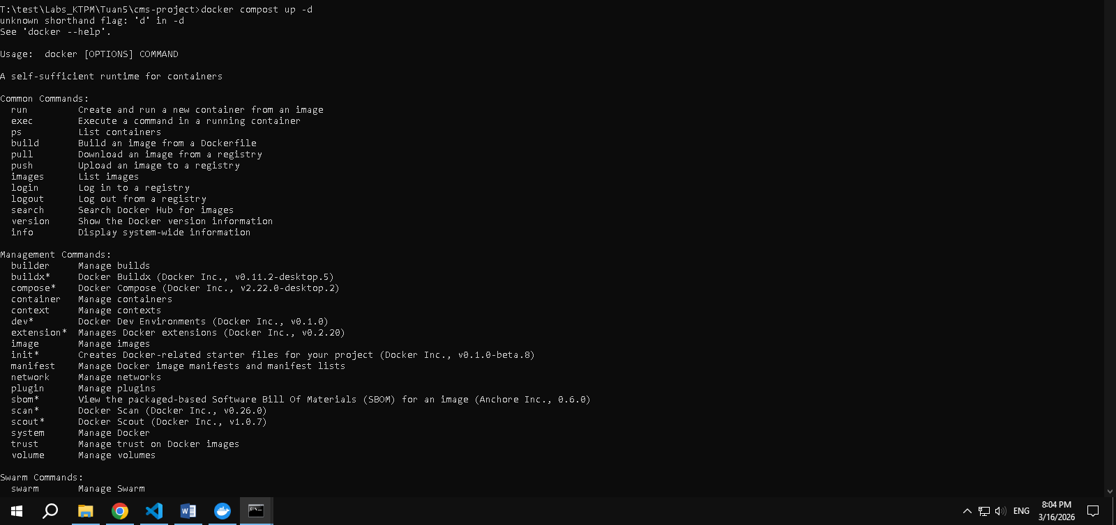

- docker compose ps
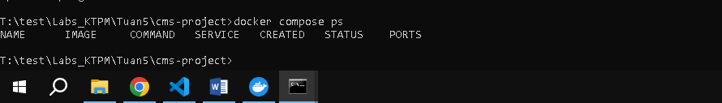
- docker compose down
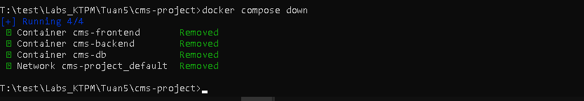
- docker compose restart
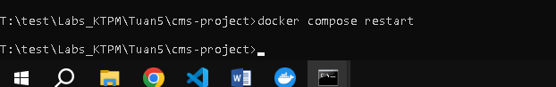
- docker compose logs –f
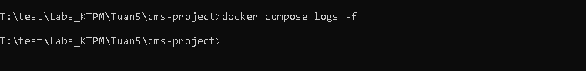
- docker compose build
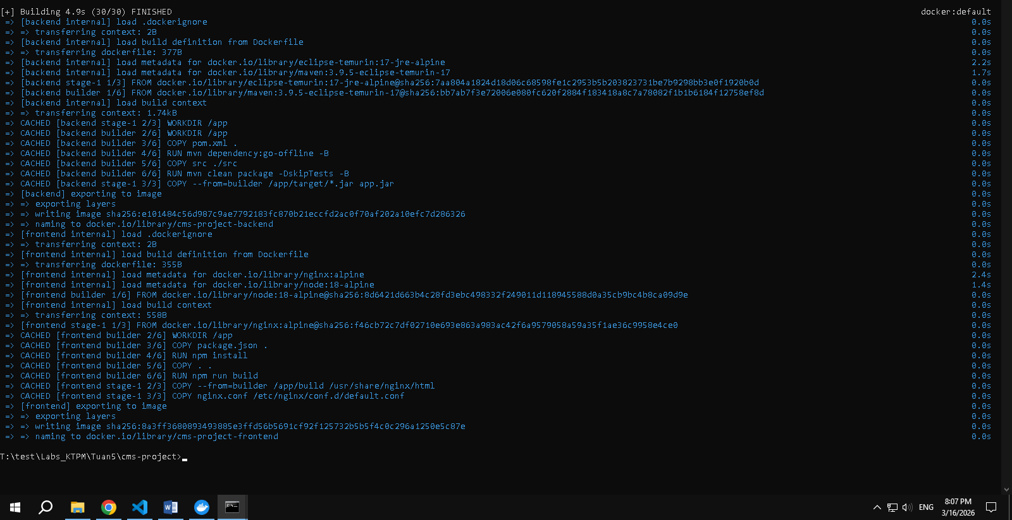
- docker compose logs frontend
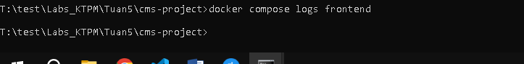
- docker compose down –v
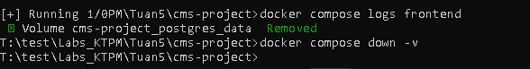
- docker compose run --rm frontend nginx –t
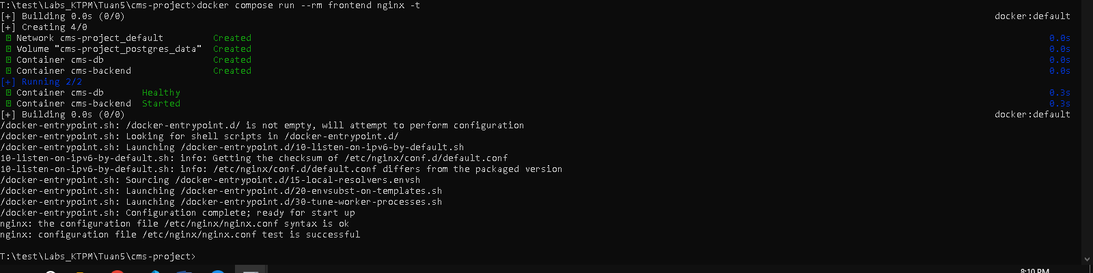

- docker compose stop frontend
- docker compose rm frontend
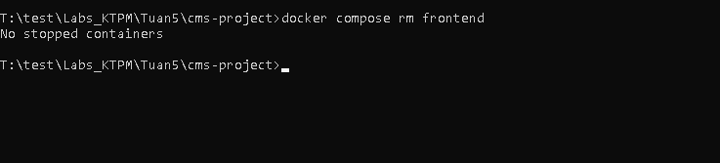
- docker compose config
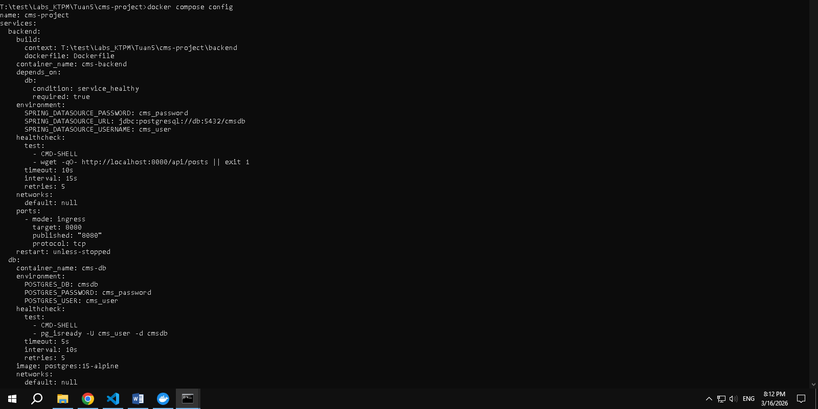
- docker compose up -d --build
