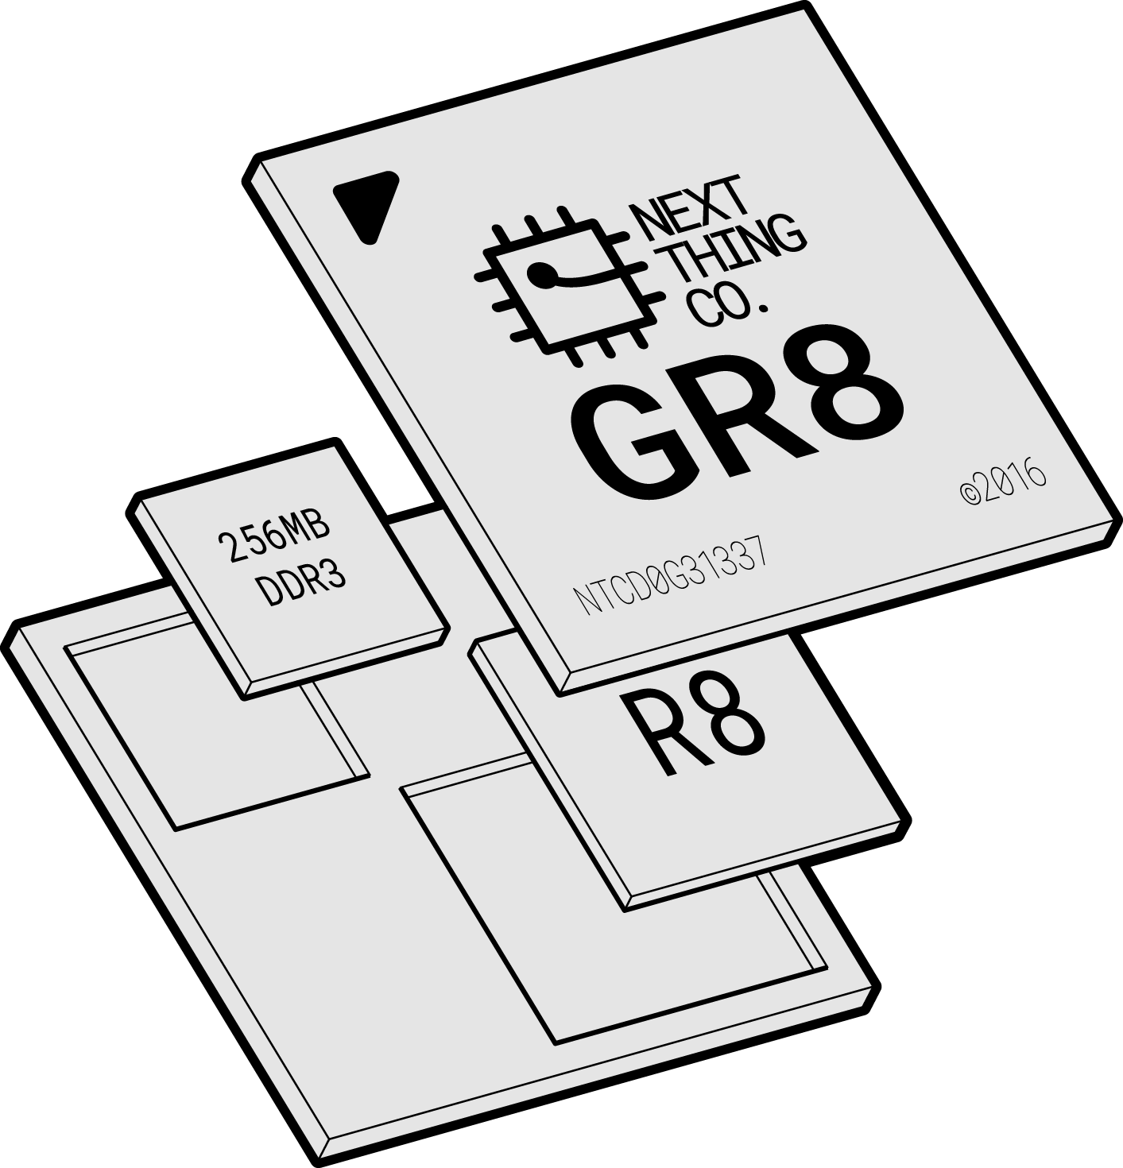

GR8 Datasheet
Version 1.0
2016-10-11

Revision History

Revision | Date | Description
v0.1 | Sep. 01, 2016 | Initial Internal Release
v1.0 | Oct. 11, 2016 | Initial Public Release

Declaration

This page left intentionally blank. \(•◡•)/

.

Table of Contents

1. Overview 7
2. Features 8
2.1. CPU 8
2.2. GPU 8
2.3. Memory 8
2.4. System Peripherals 9
2.5. Video Engine 10
2.6. Display Subsystem 10
2.7. Image Input 10
2.8. Audio Subsystem 10
2.9. External Peripherals 11
2.10. Package 12
3. Block Diagram 13
4. Pin Description 15
4.1. Pin Characteristics 15
4.2. GPIO Multiplexing Functions 20
4.3. Detailed Pin/Signal Description 22
5. Electrical Characteristics 26
5.1. Absolute Maximum Ratings 26
5.2. Recommended Operating Conditions 26
5.3. DC Electrical Characteristics 27
5.4. Oscillator Electrical Characteristics 27
5.5. Power Up/Down and Reset Specifications 28
5.5.1. Power Up Sequence Requirements 28
5.5.2. Power Up Reset Sequence Requirements 28
5.5.3. Resume Power Up Sequence from Super Standby Mode 29
5.5.4. Power Down Sequence Requirements 30
6. Pin Assignment 31
6.1. Pin Map 31
7. Mechanical and Packaging Information 33

About This Documentation

From the desk of Gustavo Huber

When Dave, Thomas, and I started Next Thing Co. in 2013, it was with a simple goal: we wanted to create things that would inspire creativity, and help people chase their own ideas of what needed to exist.

We considered this goal both in terms of how economically accessible we could make our products (they had to be $99 or less), as well as how much “pain” we could remove from the design process for others (they had to be open source and well-documented).

Our first attempt was a software-defined camera named OTTO, built around an off-the-shelf embedded module. But early in development, we knew that our end-goals were at risk. The $39 module made it impossible to ship product priced under $99. It lacked Mainline Linux support, a reliable tool-chain, documentation and functional drivers making software development a cat-and-mouse game of bug tracking. But thanks to lots of long days, and some good friends both in Shenzhen and back home in Oakland, we built and shipped out 500 OTTOs -- a serious feat.

Almost exactly a year later, we shipped out the first of what is now over 100,000 C.H.I.P.s delivered worldwide. At $9, C.H.I.P. was the fruition of our vision from a year prior: accessible, powerful technology, available to everyone for hobby, education, or products. In so many words, we were building the tools that we wished we’d had before.

The reaction was (and continues to be) astounding! Tweets and emails come from far and wide to tell us about impossible projects banged together in an afternoon, classrooms full of proud 10-year-old game developers who had never before written a line of code, and seasoned engineers brought back to memories of discovering their passion on a Commodore 64, 40 years prior. Yet, just as building OTTO showed us the tools we were missing, building C.H.I.P has taught us what it takes to scale production to keep up with [even unprecedented] demand.

So it is with great pleasure that I invite you to explore, without non-disclosure agreements or any other obstructive formalities, this datasheet for GR8: the newest addition to the Next Thing Co. family.

Thanks to the experience and support from our friends at Allwinner and Nanya, GR8 is built from the ground up for clean and reliable design.

With Next Thing Co. and the thriving Chipster community from bbs.nextthing.co at your side, we can’t wait to see what you’ll do with GR8!

/Gustavo
Co-founder, Hardware Guy

Overview
At Next Thing Co., we work to make it easy to integrate computer hardware in products. GR8 provides a powerful application processor and DDR3 SRAM which eliminates the need for high-speed routing and reduces manufacturing complexity. GR8 is a System-in-Package (SiP) that features a 1GHz Allwinner R8 ARMv7 Cortex-A8 processor with NEON SIMD extensions and a Mali-400 GPU. 256MB of Nanya DDR3 SDRAM is combined with the R8 processor into a 14mm x 14mm, 0.8mm pitch 252 ball FBGA package.

In addition to the Mali-400 graphic engine that supports OpenGL ES 1.0 and 2.0. GR8 includes a video engine for encoding and decoding codecs such as VP6/8, AVS, H.264, H.263, MPEG-1/2/4 and a display engine for a hardware cursor, alpha blending, and anti-flicker.

GR8 also features many popular peripheral interfaces: Two-Wire Interface, two UARTs (one 2-wire and one 4-wire), SD Card-ready SPI, two PWM outputs, a 6-bit ADC, I2S digital audio, S/PDIF IEC-60958 digital audio output, two HS/FS/LS USB PHYs (one USB 2.0 Host and one USB 2.0 OTG), a CMOS Sensor Interface.

GR8 is $6 in any quantity and includes the Allwinner AXP209 power management unit. The minimum order quantity for GR8 + AXP209 is one.

We can’t wait to see how you’ll design GR8 in to your next product.

Applications
- Physical Computing
- Voice Recognition
- Smart “Clapper”
- Animated GIF Camera
- Smart Consumer Devices
- Portable Audio Devices
- Cyber Dog Robot Toys

Features

CPU
- ARM CortexTM-A8
- ARMv7 Instruction set plus Thumb-2 Instruction Set
- 32KB Instruction Cache and 32KB Data Cache
- 256KB L2 Cache
- NEONTM SIMD Extensions
- Jazelle RCT Acceleration

GPU
- Mali400
- Supports Open GL ES 1.1/ 2.0 and Open VG 1.1

Memory

Boot ROM
- On-chip Boot ROM
- Supports boot from NAND Flash, SPI NOR Flash, SD Card and USB OTG

NANYA DDR3 SDRAM
- In-package 256MB 16-bit DDR3 memory

NAND Flash
- Compliant with ONFI 2.3 and Toggle 1.0
- Up to 8-bit data bus width
- Supports 2 chip selects, and 2 ready/busy signals
- Up to 64-bit ECC per 512 bytes or 1024 bytes
- Supports 1KB/2KB/4KB/8KB/16KB page size
- Supports SLC/MLC NAND and EF-NAND
- Supports SDR/Toggle DDR/ONFI DDR NAND interface

SD/MMC
- Three SD/MMC Host Controllers (SMHC)
- Compatible with eMMC v4.4, SD Physical Layer Specification v2.0, SDIO Card Specification v2.0
- 1-/4-/8-bit bus width
- Supports block size of 1 to 65535 bytes
- Dedicated DMA for fast and uninterrupted data transfer

System Peripherals

CCM – Clock Control Module
- Seven PLLs driven by a main external Oscillator and an on-chip RC Oscillator
- Supports clock configuration and clock generated for corresponding modules
- Supports software-controlled clock gating and software-controlled reset for corresponding modules

DMA – Direct Memory Access
- Eight channels Normal DMA (NDMA) and eight channels Dedicated DMA (DDMA)
- Supports memory-to-memory, memory-to-peripheral, peripheral-to-memory data transfer types
- Transfer data width of 8/16/32-bit
- Programmable DMA burst size

PWM – Pulse Width Modulation
- Two outputs
- Supports continuous and pulse waveforms
- 0 - 100% adjustable duty cycle
- Up to 24 MHz output frequency

Asynchronous Timer Unit
- Six Asynchronous Timers with interrupt-based operation
- A watchdog timer to generate reset signal or interrupt
- Two 33-bit Audio/Video Sync(AVS) Counter to synchronize video and audio
- One 64-bit Counter

Synchronous Timer Unit
- Two Synchronic Timers with interrupt-based operation

Interrupt Controller
- Normal interrupt requests (nIRQ) and fast interrupt requests (FIQ)
- Supports 96 interrupt sources
- 4-Level priority controller
- External interrupt can be triggered according to edge or level-sensitivity

LRADC– Low Resolution Analog-to-Digital Converter
- Analog to digital converter with 6-bit resolution for key application
- Supports multiple button press detection
- Supports single, normal and continuous work mode
- Sampling frequency up to 250 Hz

Crypto Engine
- Supports AES, DES, 3DES, SHA-1, MD5
- Supports ECB, CBC modes for AES/DES/3DES
- 128 bits, 192 bits and 256 bits key size for AES
- 160-bit hardware Pseudo Random Number Generator (PRNG) with a 175 bit seed

Video Engine

Video Decoding
- Supports multi-format video decoding of VP6/8, AVS, H.264, H.263, and MPEG-1/2/4
- Up to 1080p@30fps resolution

Video Encoding
- Supports encoding in H.264 MP format
- Up to 720p@30fps resolution

Display Subsystem

Display Processing
- Four moveable and size-adjustable layers
- Multi-format image input
- Image enhancement processor
- Alpha blending /anti-flicker
- Hardware cursor
- Output color correction (luminance/hue/saturation)

Display Output
- LCD interface (CPU / Sync RGB)
- Supports CVBS output (TV Out)

Image Input
- Supports 8-bit CMOS sensor interface
- Supports BT656 interface
- Maximum still capture resolution on parallel interface up to 5M
- Maximum video capture resolution on parallel interface up to 1080p@30fps
- Pixel clock up to 150MHz

Audio Subsystem

Audio Codec - Audio Compression / Decompression Module
- On-chip 24-bit DAC for playback and ADC for recording
- Supports analog/digital volume control
- Supports 44.1 kHz, 48 kHz, 96 kHz, and 192 kHz sample rates
- Stereo microphone input
- Stereo headphone amplifier
I2S/PCM – Inter-IC Sound / Pulse Code Modulation
- Selectable I2S or PCM on shared pins
- Full-duplex synchronous serial interface
- Configurable as a master or a slave
- Audio data resolutions of 16, 20, 24
- I2S Audio data sample rate from 8 kHz to 192 kHz
- Left Justified or Right Justified I2S
- PCM supports 8-bit or 16-bit linear, 8-bit u-law, or 8-bit A-law companding sample format
- One 128x24-bits FIFO for data transmit and one 64x24-bits FIFO for data receive
- Programmable FIFO thresholds

OWA - One Wire Audio
- IEC-60958 transmitter functionality
- Channel status insertion
- Hardware parity generation
- One 32×24bits FIFO (TX) for audio data transfer
- Programmable FIFO thresholds

External Peripherals

USB – Universal Serial Bus
- One USB 2.0 OTG controller
- Complies with USB 2.0 Specification
- Supports High-Speed (HS,480 Mbit/s), Full-Speed (FS,12 Mbit/s) and Low-Speed (LS,1.5 Mbit/s) in host mode
- Supports High-Speed (HS, 480 Mbit/s), Full-Speed (FS, 12 Mbit/s) in device mode
- Up to 10 user-configurable endpoints in device mode
- One USB Host controller
- Complies with Enhanced Host Controller Interface(EHCI)Specification, Version 1.0, and the Open Host Controller Interface(OHCI) Specification, Version 1.0a
- Supports High-Speed (HS, 480 Mbit/s), Full-Speed (FS, 12 Mbit/s), and Low-Speed (LS, 1.5 Mbit/s) mode

TWI - Two Wire Interface
- Three TWI (Two-Wire Interface) controllers
- Supports Standard mode (up to 100 kbit/s) and Fast mode (up to 400 kbit/s)
- Configurable as a master or a slave
- Capable of 10-bit addressing transactions

UART - Universal Asynchronous Receiver/Transmitter
- Four UART controllers
  - UART0 with 2 wires
  - UART1 with 4 wires
  - UART2 with 4 wires
  - UART3 with 4 wires
- Compatible with industry-standard 16550 UARTs
- Support for word length from 5 to 8 bits, an optional parity bit, and 1,1.5 or 2 stop bits
- Programmable parity (even, odd and no parity)
SPI
- Two SPI controllers that each have one Chip Select signal
- Full-duplex synchronous serial interface
- Configurable as a master or a slave
- Polarity, phase and clock frequency are configurable

Consumer IR
- One flexible receiver for consumer IR remote control
- Programmable FIFO thresholds

Package
- FBGA 252 Ball SiP, 14 mm x 14 mm, 0.8 mm pitch
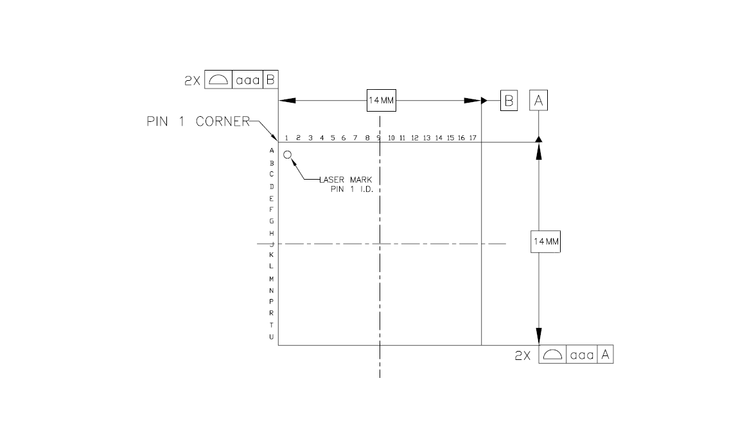

Block Diagram
Figure 3.1 shows the block diagram of the GR8.
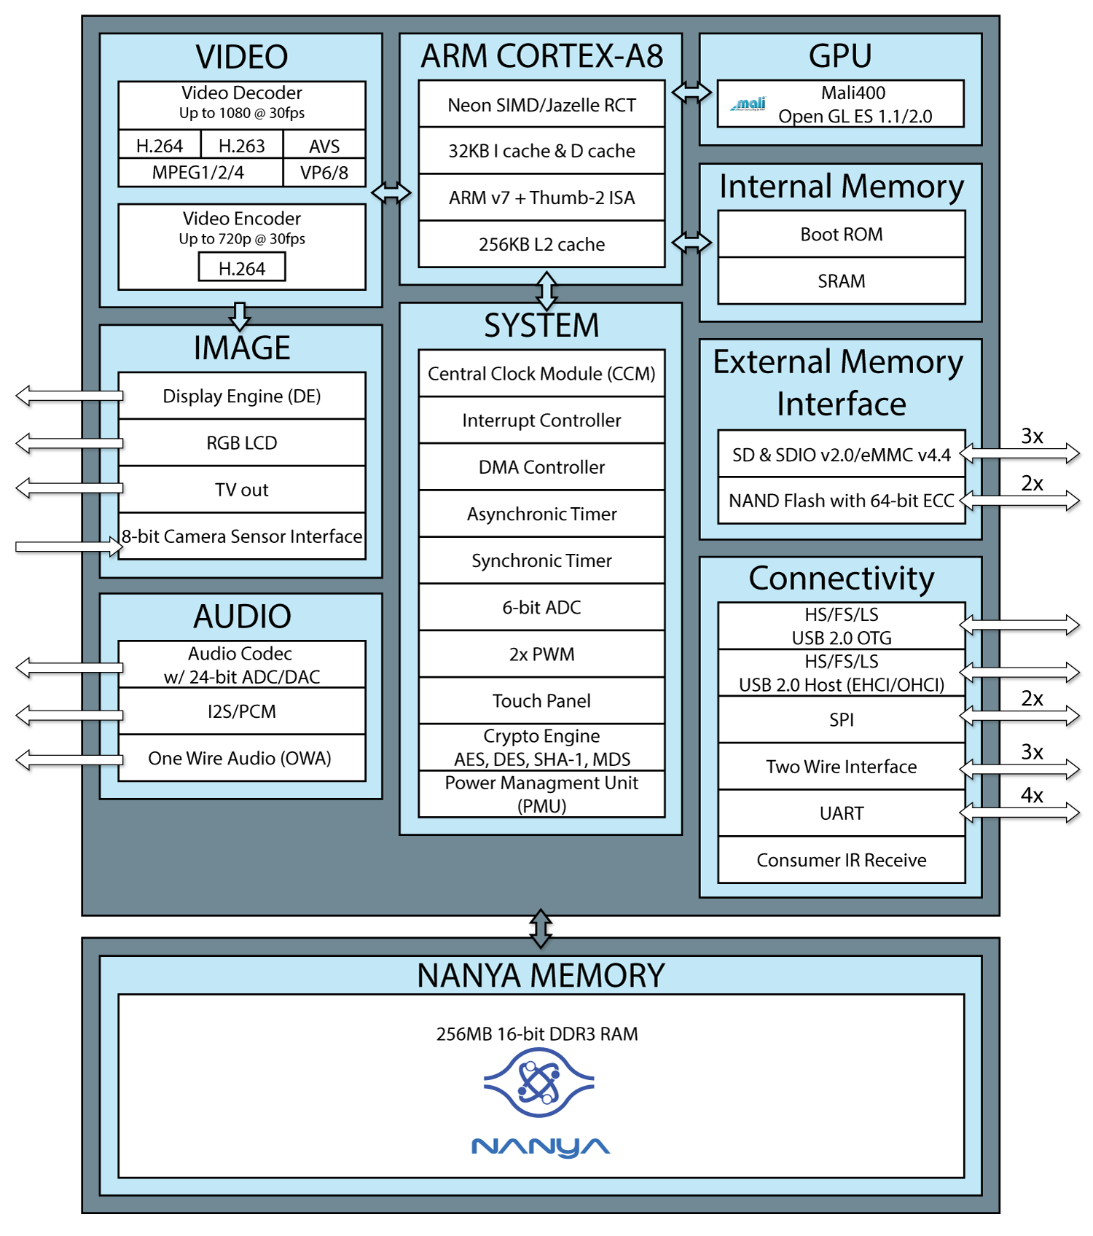

Figure 3.1: GR8 Block Diagram

Figure 3.2 shows the typical application diagram of GR8 processor.

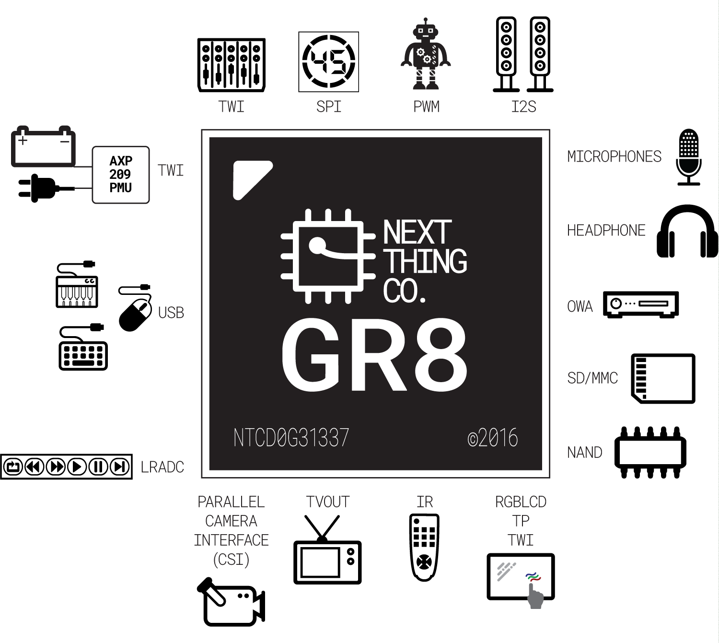
Figure 3.2:. GR8 Typical Application Diagram

Pin Description

Pin Characteristics
Table 4-1 lists the characteristics of GR8’s pins including the following aspects: Pin Number, Pin Name, Type, Reset State, Default Pull Up/Down, and Buffer Strength.

- Pin Number: Ball numbers on the bottom side associated with each signals on the bottom.
- Pin Name: Names of signals multiplexed on each pin No.
- Type: Signal direction
I : Input
O: Output
I/O: Input/Output
A: Analog
AIO: Analog Input/Output
OD: Open Drain
P: Power
G: Ground
- Pin Reset State: The state of the terminal at reset (power up)
Z: High-impedance
- Pull Up/Down: Denotes the presence of an internal pull up or pull down resister
Pull up and pull down resistor can be enabled or disabled via software.
- Buffer Strength: Drive strength of the associated output buffer.
Table 4.1: Pin Characteristics
Pin Number | Pin Name | Default Function | Type | Reset State | Default Pull Up/Down | Buffer Strength (mA)
SDRAM
M16 | SDZQ1 | DRAM | AI | Z | - | -
U11 | SZQ | DRAM | AI | Z | - | -
U12 | SVREF | DRAM | P | - | - | -
K7,K8,K13,L8, L13,L14,M6, M14 | VCC-DRAM | DRAM | P | - | - | -
H8 | VDD-DLL | DRAM | P | - | - | -
PORT B
B11 | PB0 | GPIO | I/O | Z | NO PULL | 20
A11 | PB1 | GPIO | I/O | Z | NO PULL | 20
C12 | PB2 | GPIO | I/O | Z | NO PULL | 20
H4 | PB3 | GPIO | I/O | Z | NO PULL | 20
A12 | PB4 | GPIO | I/O | Z | NO PULL | 20
T6 | PB5 | GPIO | I/O | Z | NO PULL | 20
U7 | PB6 | GPIO | I/O | Z | NO PULL | 20
U8 | PB7 | GPIO | I/O | Z | NO PULL | 20
T7 | PB8 | GPIO | I/O | Z | NO PULL | 20
T9 | PB9 | GPIO | I/O | Z | NO PULL | 20
T8 | PB10 | GPIO | I/O | Z | NO PULL | 20
P4 | PB11 | GPIO | I/O | Z | NO PULL | 20
N4 | PB12 | GPIO | I/O | Z | NO PULL | 20
P5 | PB13 | GPIO | I/O | Z | NO PULL | 20
N5 | PB14 | GPIO | I/O | Z | NO PULL | 20
B10 | PB15 | GPIO | I/O | Z | NO PULL | 20
C10 | PB16 | GPIO | I/O | Z | NO PULL | 20
T5 | PB17 | GPIO | I/O | Z | NO PULL | 20
U5 | PB18 | GPIO | I/O | Z | NO PULL | 20
PORT C
R6 | PC0 | GPIO | I/O | Z | NO PULL | 20
R7 | PC1 | GPIO | I/O | Z | NO PULL | 20
R5 | PC2 | GPIO | I/O | Z | NO PULL | 20
M3 | PC3 | GPIO | I/O | Z | PULL UP | 20
T4 | PC4 | GPIO | I/O | Z | PULL UP | 20
R4 | PC5 | GPIO | I/O | Z | NO PULL | 20
U3 | PC6 | GPIO | I/O | Z | PULL UP | 20
T3 | PC7 | GPIO | I/O | Z | PULL UP | 20
U2 | PC8 | GPIO | I/O | Z | NO PULL | 20
R2 | PC9 | GPIO | I/O | Z | NO PULL | 20
T2 | PC10 | GPIO | I/O | Z | NO PULL | 20
T1 | PC11 | GPIO | I/O | Z | NO PULL | 20
N2 | PC12 | GPIO | I/O | Z | NO PULL | 20
R1 | PC13 | GPIO | I/O | Z | NO PULL | 20
P1 | PC14 | GPIO | I/O | Z | NO PULL | 20
P2 | PC15 | GPIO | I/O | Z | NO PULL | 20
P3 | PC19 | GPIO | I/O | Z | NO PULL | 20
PORT D
F1 | PD2 | GPIO | I/O | Z | NO PULL | 20
L2 | PD3 | GPIO | I/O | Z | NO PULL | 20
E1 | PD4 | GPIO | I/O | Z | NO PULL | 20
F2 | PD5 | GPIO | I/O | Z | NO PULL | 20
E2 | PD6 | GPIO | I/O | Z | NO PULL | 20
E4 | PD7 | GPIO | I/O | Z | NO PULL | 20
F4 | PD10 | GPIO | I/O | Z | NO PULL | 20
J2 | PD11 | GPIO | I/O | Z | NO PULL | 20
G2 | PD12 | GPIO | I/O | Z | NO PULL | 20
K2 | PD13 | GPIO | I/O | Z | NO PULL | 20
E3 | PD14 | GPIO | I/O | Z | NO PULL | 20
D2 | PD15 | GPIO | I/O | Z | NO PULL | 20
F3 | PD18 | GPIO | I/O | Z | NO PULL | 20
G4 | PD19 | GPIO | I/O | Z | NO PULL | 20
D3 | PD20 | GPIO | I/O | Z | NO PULL | 20
C1 | PD21 | GPIO | I/O | Z | NO PULL | 20
C2 | PD22 | GPIO | I/O | Z | NO PULL | 20
B1 | PD23 | GPIO | I/O | Z | NO PULL | 20
C3 | PD24 | GPIO | I/O | Z | NO PULL | 20
B3 | PD25 | GPIO | I/O | Z | NO PULL | 20
C4 | PD26 | GPIO | I/O | Z | NO PULL | 20
B2 | PD27 | GPIO | I/O | Z | NO PULL | 20
PORT E
A8 | PE0 | GPIO | I/O | Z | NO PULL | 20
B7 | PE1 | GPIO | I/O | Z | NO PULL | 20
A6 | PE2 | GPIO | I/O | Z | NO PULL | 20
B5 | PE3 | GPIO | I/O | Z | NO PULL | 20
A5 | PE4 | GPIO | I/O | Z | NO PULL | 20
B6 | PE5 | GPIO | I/O | Z | NO PULL | 20
B4 | PE6 | GPIO | I/O | Z | NO PULL | 20
C7 | PE7 | GPIO | I/O | Z | NO PULL | 20
A3 | PE8 | GPIO | I/O | Z | NO PULL | 20
D5 | PE9 | GPIO | I/O | Z | NO PULL | 20
A2 | PE10 | GPIO | I/O | Z | NO PULL | 20
C5 | PE11 | GPIO | I/O | Z | NO PULL | 20
PORT F
D8 | PF0 | GPIO | I/O | Z | NO PULL | 20
B8 | PF1 | GPIO | I/O | Z | NO PULL | 20
A9 | PF2 | GPIO | I/O | Z | NO PULL | 20
C11 | PF3 | GPIO | I/O | Z | NO PULL | 20
B8 | PF4 | GPIO | I/O | Z | NO PULL | 20
D10 | PF5 | GPIO | I/O | Z | NO PULL | 20
PORT G
N3 | PG0 | GPIO | I/O | Z | NO PULL | 20
H2 | PG1 | GPIO | I/O | Z | NO PULL | 20
M1 | PG2 | GPIO | I/O | Z | NO PULL | 20
J1 | PG3 | GPIO | I/O | Z | NO PULL | 20
H1 | PG4 | GPIO | I/O | Z | NO PULL | 20
F5 | PG5 | GPIO | I/O | Z | NO PULL | 20
J3 | PG6 | GPIO | I/O | Z | NO PULL | 20
H3 | PG7 | GPIO | I/O | Z | NO PULL | 20
L1 | PG8 | GPIO | I/O | Z | NO PULL | 20
R9 | PG9 | GPIO | I/O | Z | NO PULL | 20
P7 | PG10 | GPIO | I/O | Z | NO PULL | 20
U10 | PG11 | GPIO | I/O | Z | NO PULL | 20
R8 | PG12 | GPIO | I/O | Z | NO PULL | 20
T10 | PG13 | GPIO | I/O | Z | NO PULL | 20
System
K3 | UBOOT | - | I | - | PULL UP | -
C6 | JTAG-SEL1 | - | I | - | PULL UP | -
M2 | NMI | - | I/O | - | - | -
L3 | RESET | - | I | - | - | -
Main Clock
A16 | X24MIN | - | AI | - | - | -
B16 | X24MOUT | - | AO | - | - | -
TVOUT
C8 | TVOUT | - | AO | - | - | -
USB
B14 | USB0-DM | - | A I/O | - | - | -
A14 | USB0-DP | - | A I/O | - | - | -
B13 | USB1-DM | - | A I/O | - | - | -
A13 | USB1-DP | - | A I/O | - | - | -
D7 | VCC-USB | - | P | - | - | -
TP
B15 | TPX1 | - | AI | - | - | -
C15 | TPY1 | - | AI | - | - | -
C17 | TPX2 | - | AI | - | - | -
B17 | TPY2 | - | AI | - | - | -
Audio Codec
F16 | AGND | - | G | - | - | -
F12 | AVCC | - | P | - | - | -
G15 | HPBP | - | AO | - | - | -
G17 | HPCOM | - | AO | - | - | -
H17 | HPCOMFB | - | AI | - | - | -
F15 | HPL | - | AO | - | - | -
F17 | HPR | - | AO | - | - | -
E16 | LINEINL | - | AI | - | - | -
E15 | LINEINR | - | AI | - | - | -
D14 | MIC1OUTN | - | AO | - | - | -
D15 | MIC1OUTP | - | AO | - | - | -
D17 | MICIN1 | - | AI | - | - | -
D16 | MICIN2 | - | AI | - | - | -
G16 | VCC-HP | - | P | - | - | -
E14 | VMIC | - | AO | - | - | -
E12 | VRA1 | - | AO | - | - | -
E13 | VRA2 | - | AO | - | - | -
F13 | VRP | - | AO | - | - | -
LRADC
C13 | LRADC0 | - | AI | - | - | -
D13 | LRADC1 | - | AI | - | - | -
Power
J4,K4,K6,L4,L5, L6,M5 | VDD-CPU | - | P | - | - | -
D6,H5,M4 | VCC-IO | - | P | - | - | -
D4,E5,J8 | VDD-SYS | - | P | - | - | -
GND
A1,A15,A17,B12,C14,  C16,C9,D11,D9,E10,  E6,E7,E8,E9,F10,F14,  F6,F7,F8,F9,G10,G14,  G3,G5,G6,G7,G8,G9,  H10,H12,H16,H6,H7,  H9,J10,J11,J17,J5,J6,  K15,K17,K5,L10,L11,  L12,L9,M10,M11,  M12,M13,M15,M17,  M7,M8,M9,N10,N11,  N12,N13,N14,N15,  N16,N17,N6,N7,N8,  N9,P10,P11,P12,P13,  P14,P15,P16,P17,P6,  P8,P9,R10,R11,R12,  R13,R14,R15,R16,  R17,R3,T11,T12,T13,  T14,T15,T16,T17,U1,  U13,U14,U15,U16,  U17,U9 | GND | - | G | - | - | -

GPIO Multiplexing Functions
The following table provides a description of the GR8 GPIO multiplexing functions.
Table 4.2: Multiplexing Functions
Port | Multi0 | Multi1 | Multi2 | Multi3 | Multi4 | Multi5 | Multi6
PORT B
PB0 | Input | Output | TWI0-SCK
PB1 | Input | Output | TWI0-SDA
PB2 | Input | Output | PWM0 |  |  |  | EINT16
PB3 | Input | Output |  |  |  |  | EINT17
PB4 | Input | Output | IR-RX |  |  |  | EINT18
PB5 | Input | Output | I2S-MCLK |  |  |  | EINT19
PB6 | Input | Output | I2S-BCLK |  |  |  | EINT20
PB7 | Input | Output | I2S-LRCK |  |  |  | EINT21
PB8 | Input | Output | I2S-DO |  |  |  | EINT22
PB9 | Input | Output | I2S-DI |  |  |  | EINT23
PB10 | Input | Output |  | OWA-DO |  |  | EINT24
PB11 | Input | Output | SPI2-CS0 | JTAG-MS0 |  |  | EINT25
PB12 | Input | Output | SPI2-CLK | JTAG-CK0 |  |  | EINT26
PB13 | Input | Output | SPI2-MOSI | JTAG-DO0 |  |  | EINT27
PB14 | Input | Output | SPI2-MISO | JTAG-DI0 |  |  | EINT28
PB15 | Input | Output | TWI1-SCK
PB16 | Input | Output | TWI1-SDA
PB17 | Input | Output | TWI2-SCK
PB18 | Input | Output | TWI2-SDA
PORT C
PC0 | Input | Output | NWE | SPI0-MOSI
PC1 | Input | Output | NALE | SPI0-MISO
PC2 | Input | Output | NCLE | SPI0-CLK
PC3 | Input | Output | NCE1 | SPI0-CS0
PC4 | Input | Output | NCE0
PC5 | Input | Output | NRE
PC6 | Input | Output | NRB0 | SDC2-CMD
PC7 | Input | Output | NRB1 | SDC2-CLK
PC8 | Input | Output | NDQ0 | SDC2-D0
PC9 | Input | Output | NDQ1 | SDC2-D1
PC10 | Input | Output | NDQ2 | SDC2-D2
PC11 | Input | Output | NDQ3 | SDC2-D3
PC12 | Input | Output | NDQ4 | SDC2-D4
PC13 | Input | Output | NDQ5 | SDC2-D5
PC14 | Input | Output | NDQ6 | SDC2-D6
PC15 | Input | Output | NDQ7 | SDC2-D7
PC19 | Input | Output | NDQS
Port D
PD2 | Input | Output | LCD-D2 | UART2-TX
PD3 | Input | Output | LCD-D3 | UART2-RX
PD4 | Input | Output | LCD-D4 | UART2-CTS
PD5 | Input | Output | LCD-D5 | UART2-RTS
PD6 | Input | Output | LCD-D6
PD7 | Input | Output | LCD-D7
PD10 | Input | Output | LCD-D10
PD11 | Input | Output | LCD-D11
PD12 | Input | Output | LCD-D12
PD13 | Input | Output | LCD-D13
PD14 | Input | Output | LCD-D14
PD15 | Input | Output | LCD-D15
PD18 | Input | Output | LCD-D18
PD19 | Input | Output | LCD-D19
PD20 | Input | Output | LCD-D20
PD21 | Input | Output | LCD-D21
PD22 | Input | Output | LCD-D22
PD23 | Input | Output | LCD-D23
PD24 | Input | Output | LCD-CLK
PD25 | Input | Output | LCD-DE
PD26 | Input | Output | LCD-HSYNC
PD27 | Input | Output | LCD-VSYNC
Port E
PE0 | Input |  |  | CSI-PCLK | SPI2-CS0 |  | EINT14
PE1 | Input |  |  | CSI-MCLK | SPI2-CLK |  | EINT15
PE2 | Input |  |  | CSI-HSYNC | SPI2-MOSI
PE3 | Input | Output |  | CSI-VSYNC | SPI2-MISO
PE4 | Input | Output |  | CSI-D0 | SDC2-D0
PE5 | Input | Output |  | CSI-D1 | SDC2-D1
PE6 | Input | Output |  | CSI-D2 | SDC2-D2
PE7 | Input | Output |  | CSI-D3 | SDC2-D3
PE8 | Input | Output |  | CSI-D4 | SDC2-CMD
PE9 | Input | Output |  | CSI-D5 | SDC2-CLK
PE10 | Input | Output |  | CSI-D6 | UART1-TX
PE11 | Input | Output |  | CSI-D7 | UART1-RX
Port F
PF0 | Input | Output | SDC0-D1 |  | JTAG-MS1
PF1 | Input | Output | SDC0-D0 |  | JTAG-DI1
PF2 | Input | Output | SDC0-CLK |  | UART0-TX
PF3 | Input | Output | SDC0-CMD |  | JTAG-DO1
PF4 | Input | Output | SDC0-D3 |  | UART0-RX
PF5 | Input | Output | SDC0-D2 |  | JTAG-CK1
Port G
PG0 | Input |  |  |  |  |  | EINT0
PG1 | Input |  |  |  |  |  | EINT1
PG2 | Input |  |  |  |  |  | EINT2
PG3 | Input | Output | SDC1-CMD |  | UART1-TX |  | EINT3
PG4 | Input | Output | SDC1-CLK |  | UART1-RX |  | EINT4
PG5 | Input | Output | SDC1-D0 |  | UART1-CTS |  | EINT5
PG6 | Input | Output | SDC1-D1 |  | UART1-RTS |  | EINT6
PG7 | Input | Output | SDC1-D2 |  |  |  | EINT7
PG8 | Input | Output | SDC1-D3 |  |  |  | EINT8
PG9 | Input | Output |  | UART3-TX |  |  | EINT9
PG10 | Input | Output |  | UART3-RX |  |  | EINT10
PG11 | Input | Output |  | UART3-CTS |  |  | EINT11
PG12 | Input | Output |  | UART3-RTS |  |  | EINT12
PG13 | Input | Output |  | PWM1 |  |  | EINT13
Note: PE0/PE1/PE2/PG0/PG1/PG2 are for input only.

Detailed Pin/Signal Description
Table 4-3 shows the detailed function of every pin/signal based on the different interface.
Table 4.3: Detailed Pin/Signal Description
Pin/Signal Name | Description | Type
TWI
TWI0-SCK | TWI0 Clock | I/O
TWI0-SDA | TWI0 Data/Address | I/O
TWI1-SCK | TWI1 Clock | I/O
TWI1-SDA | TWI1 Data/Address | I/O
TWI2-SCK | TWI2 Clock | I/O
TWI2-SDA | TWI2 Data/Address | I/O
PWM
PWM0 | Pulse Width Module Channel0 Output | O
PWM1 | Pulse Width Module Channel1 Output | O
IR
IR-RX | Consumer Infra-Red Data Receive | I
I2S
I2S-MCLK | I2S Master Clock | O
I2S-BCLK | I2S Bit Clock | I/O
I2S-LRCK | I2S Left/Right Channel Select Clock | I/O
I2S-DO | I2S Data Output | O
I2S-DI | I2S Data Input | I
OWA – One Wire Audio
OWA-DO | OWA Data Output | O
SPI – Serial Peripheral Interface
SPI0-CS0 | SPI0 Chip Select Signal(active low) | I/O
SPI0-CLK | SPI0 Clock Signal | I/O
SPI0-MISO | SPI0 Master Data In, Slave Data Out | I/O
SPI0-MOSI | SPI0 Master Data Out, Slave Data In | I/O
SPI1-CS0 | SPI1 Chip Select Signal(active low) | I/O
SPI1-CLK | SPI1 Clock Signal | I/O
SPI1-MISO | SPI1 Master Data In, Slave Data Out | I/O
SPI1-MOSI | SPI1 Master Data Out, Slave Data In | I/O
UART – Universal Asynchronous Receiver/Transmitter
UART0-TX | UART0 Data Transmit | O
UART0-RX | UART0 Data Receive | I
UART1-TX | UART1 Data Transmit | O
UART1-RX | UART1 Data Receive | I
UART1-CTS | UART1 Data Clear to Send | I
UART1-RTS | UART1 Data Request to Send | O
UART2-TX | UART2 Data Transmit | O
UART2-RX | UART2 Data Receive | I
UART2-CTS | UART2 Data Clear to Send | I
UART2-RTS | UART2 Data Request to Send | O
UART3-TX | UART3 Data Transmit | O
UART3-RX | UART3 Data Receive | I
UART3-CTS | UART3 Data Clear to Send | I
UART3-RTS | UART3 Data Request to Send | O
JTAG – Debug / Test
JTAG-DO[1:0] | JTAG Data Output | O
JTAG-DI[1:0] | JTAG Data Input | I
JTAG-MS[1:0] | JTAG Mode Select Input | I
JTAG-CK[1:0] | JTAG Clock Input | I
NAND Flash
NWE | NAND Flash Write Enable | O
NALE | NAND Flash Address Latch Enable | O
NCLE | NAND Flash Command Latch Enable | O
NCE[1:0] | NAND Flash Chip Select | O
NRE | NAND Flash Read Enable | O
NRB[1:0] | NAND Flash Ready/Busy Status Indicator Signal | I
NDQ[7:0] | NAND Flash Data Bit | I/O
NDQS | NAND Flash Data Strobe | I/O
LCD
LCD-D[7:2] | LCD Data Bit[7:2] | O
LCD-D[15:10] | LCD Data Bit[15:10] | O
LCD-D[23:18] | LCD Data Bit[23:18] | O
LCD-CLK | LCD Clock Signal | O
LCD-DE | LCD Data Enable | O
LCD-HSYNC | LCD Horizontal Sync | O
LCD-VSYNC | LCD Vertical Sync | O
CSI – Camera Sensor Interface
CSI-PCLK | CSI Pixel Clock | I
CSI-MCLK | CSI Master Clock | O
CSI-HSYNC | CSI Horizontal Sync | I
CSI-VSYNC | CSI Vertical Sync | I
CSI-Data[7:0] | CSI Data Bit | I
SD/MMC
SDC0-D[3:0] | SDC0 Data Bit[3:0] | I/O
SDC0-CLK | SDC0 Clock | O
SDC0-CMD | SDC0 Command Signal | I/O
SDC1-D[3:0] | SDC1 Data Bit[3:0] | I/O
SDC1-CLK | SDC1 Clock | O
SDC1-CMD | SDC1 Command Signal | I/O
SDC2-D[7:0] | SDC2 Data Bit[7:0] | I/O
SDC2-CLK | SDC2 Clock | O
SDC2-CMD | SDC2 Command Signal | I/O
External Interrupt
EINT[28:0] | External Interrupt Input | I
System
UBOOT | Boot Mode Select | I
JTAG-SEL1 | JTAG Mode Select | I
NMI | Non-Maskable Interrupt | I/O
RESET | Reset Signal | I
Clock
X24MIN | Clock Input of 24MHz Crystal | AI
X24MOUT | Clock Output of 24MHz Crystal | AO
TV-OUT
TV-OUT | TV Output | AO
USB
USB0-DM | USB0 D- Signal | A I/O
USB0-DP | USB0 D+ Signal | A I/O
USB1-DM | USB1 D- Signal | A I/O
USB1-DP | USB1 D+ Signal | A I/O
VCC-USB | USB Power Supply | P
Touch Panel
TPX1 | Touch Panel X1 Input | AI
TPY1 | Touch Panel Y1 Input | AI
TPX2 | Touch Panel X2 Input | AI
TPY2 | Touch Panel Y2 Input | AI
Audio Codec
AGND | Audio Codec Analog Ground | G
AVCC | Audio Codec Power Supply | P
HPBP | Headphone Bypass Output | AO
HPCOM | Headphone Common Reference Output | AO
HPCOMFB | Headphone Common Reference Feedback Input | AI
HPL | Headphone Left Channel Output | AO
HPR | Headphone Right Channel Output | AO
LINEINL | Line In Left Channel Input | AI
LINEINR | Line In Right Channel Input | AI
MIC1OUTN | Microphone Negative Output | AO
MIC1OUTP | Microphone Positive Output | AO
MICIN1 | Microphone Input | AI
MICIN2 | Microphone Input | AI
VCC-HP | Headphone Power Supply | P
VMIC | Bias Voltage Output for Main Microphone | AO
VRA1 | Reference Voltage Output | AO
VRA2 | Reference Voltage Output | AO
VRP | Reference Voltage Output | AO
LRADC
LRADC0 | ADC Input Channel0 for Key | AI
LRADC1 | ADC Input Channel1 for Key | AI

Electrical Characteristics

Absolute Maximum Ratings
Absolute Maximum Ratings are those values beyond which damage to the device may occur. Table 5-1 specifies the absolute maximum ratings over the operating junction temperature range of commercial and extended temperature devices. Functional operation of the device at these or any other conditions beyond those indicated in the operational sections of this standard may damage to the device.
Table 5.4: Absolute Maximum Ratings
Symbol | Parameter |  | Min | Max | Unit
I_{I/O} | In/Out Current for Input and Output |  | -40 | 40 | mA
VCC-IO | Supply Voltage for I/O |  | -0.3 | 3.6 | V
VDD-SYS | Supply Voltage for System |  | -0.3 | 1.5 | V
VDD-DLL | Supply Voltage for DRAM DLL |  | -0.3 | 1.5 | V
VDD-CPU | Supply Voltage for CPU |  | -0.3 | 1.5 | V
AVCC | Supply Voltage for Analog Part |  | -0.3 | 3.6 | V
VCC-DRAM | Supply Voltage for DRAM |  | -0.3 | 1.98 | V
VCC-USB | Supply Voltage for USB |  | -0.3 | 3.6 | V
VCC-HP | Supply Voltage for Headphone |  | -0.3 | 3.6 | V
T_{STG} | Storage Temperature |  | -40 | 125 | °C
V_{ESD} | Electrostatic Discharge | Human Body Model(HBM)⁽¹⁾ | -4000 | 4000 | V
V_{ESD} | Electrostatic Discharge | Charged Device Model(CDM)⁽²⁾ | -500 | 500 | V
I_{Latch-up} | Latch-up I-test performance current-pulse injection on each IO pin⁽³⁾ |  | Pass
I_{Latch-up} | Latch-up over-voltage performance voltage injection on each IO pin⁽⁴⁾ |  | Pass
1). Test method: JEDEC JS-001-2014(Class-3A). JEDEC document JEP155 states that 500V HBM allows safe manufacturing with a standard ESD control process.
2). Test method: JEDEC JS-002-2014(Class-C2A). JEDEC document JEP157 states that 250V CDM allows safe manufacturing with a standard ESD control process.
3). Current test performance: Pins stressed per JEDEC JESD78D (Class I, Level A) and passed with I/O pin injection current as defined in JEDEC.
4). Over voltage performance: Supplies stressed per JEDEC JESD78D (Class I, Level A) and passed voltage injection as defined in JEDEC.

Recommended Operating Conditions
All GR8 modules are used under the operating conditions contained in Table 5.2.
Table 5.5: Recommended Operating Conditions
Symbol | Parameter | Min | Typ | Max | Unit
Ta | Ambient Operating Temperature | -20 | - | +70 | °C
VCC-IO | Supply Voltage for I/O | 1.7 | 1.8~3.3 | 3.6 | V
VDD-SYS | Supply Voltage for System | 1.1 | 1.2 | 1.3 | V
VDD-DLL | Supply Voltage for DRAM DLL | 1.1 | 1.2 | 1.3 | V
VDD-CPU | Supply Voltage for CPU | 1.1 | 1.2 | 1.4 | V
AVCC | Supply Voltage for Analog Part | - | 3.0 | - | V
VCC-DRAM | Supply Voltage for DRAM | 1.425 | 1.5 | 1.575 | V
VCC-USB | Supply Voltage for USB | 3.0 | 3.3 | 3.6 | V
VCC-HP | Supply Voltage for Headphone | 3.0 | - | 3.3 | V

DC Electrical Characteristics
Table 5.3 summarizes the DC electrical characteristics of GR8.
Table 5.6: DC Electrical Characteristics
Symbol | Parameter | Min | Typ | Max | Unit
V_{IH} | High-Level Input Voltage | 0.7 * VCC-IO | - | VCC-IO + 0.3 | V
V_{IL} | Low-Level Input Voltage | -0.3 | - | 0.3 * VCC-IO | V
R_{PU} | Input Pull-up Resistance | 50 | 100 | 150 | KΩ
R_{PD} | Input Pull-down Resistance | 50 | 100 | 150 | KΩ
I_{IH} | High-Level Input Current | - | - | 10 | uA
I_{IL} | Low-Level Input Current | - | - | 10 | uA
V_{OH} | High-Level Output Voltage | VCC-IO -0.2 | - | VCC-IO | V
V_{OL} | Low-Level Output Voltage | 0 | - | 0.2 | V
I_{OZ} | Tri-State Output Leakage Current | -10 | - | 10 | uA
C_{IN} | Input Capacitance | - | - | 5 | pF
C_{OUT} | Output Capacitance | - | - | 5 | pF

Oscillator Electrical Characteristics
GR8 contains one 24.000MHz oscillator.
The 24.000MHz frequency is used to generate the main source clock for PLL and the main digital blocks, the clock is provided through X24MIN. Table 5-4 lists the 24.000MHz crystal specifications.
Table 5.7: 24MHz Crystal Characteristics
Symbol | Parameter | Min | Typ | Max | Unit
1/(t_{CPMAIN}) | Crystal Oscillator Frequency Range | - | 24.000 | - | MHz
t_{ST} | Startup Time | - | - | - | ms
 | Frequency Tolerance at 25 °C | -50 | - | +50 | ppm
 | Oscillation Mode | Fundamental |  |  | –
 | Maximum Change Over Temperature Range | -50 | - | +50 | ppm
P_{ON} | Drive Level | - | - | 300 | uW
C_{L} | Equivalent Load Capacitance | 12 | 18 | 22 | pF
R_{S} | Series Resistance(ESR) | - | 25 | - | Ω
 | Duty Cycle | 30 | 50 | 70 | %
C_{M} | Motional Capacitance | - | - | - | pF
C_{SHUT} | Shunt Capacitance | 5 | 6.5 | 7.5 | pF
R_{BIAS} | Internal Bias Resistor | 0.4 | 0.5 | 0.6 | MΩ

Power Up/Down and Reset Specifications
The section provides information about the GR8 power up and power down sequence requirements.

Power Up Sequence Requirements
These requirements must be applied to meet the GR8 device power-up requirements (system power off to power on).
- Power up all domains simultaneously.
- The RESET pin must be held on low until all power domains are stable.
Figure 5-1 shows the power up sequence.
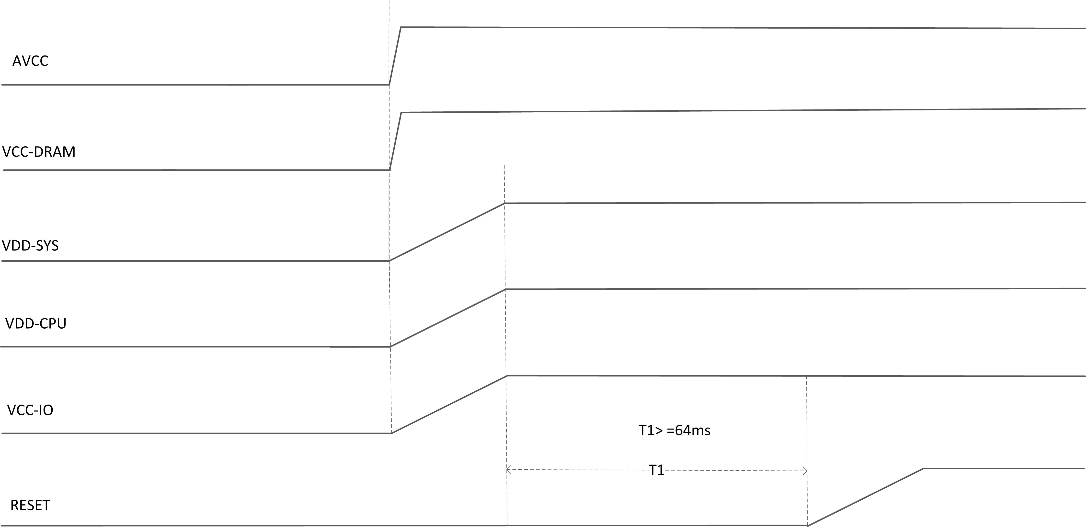
Figure 5.3: Power Up Sequence

Power Up Reset Sequence Requirements
The device has a system reset signal to reset the board. When asserted, the following steps give an example of power up reset sequence supported by the GR8 device.
- AVCC, VDD-CPU and VCC-DRAM can be powered up simultaneously.
- VDD-SYS can be powered up after VDD-CPU is powered up, the time difference is T2 ms.
- VCC-IO can be powered up after VDD-SYS is powered up, the time difference is T3 ms.
- The RESET pin must be held on low until all power domains are stable.
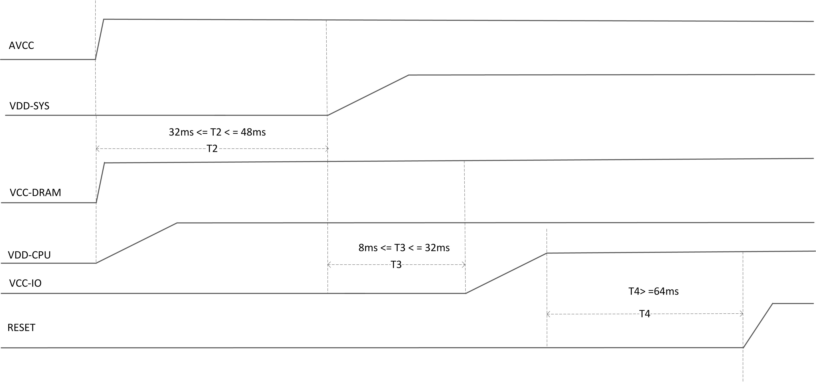
Figure 5.4: Power Up Reset Sequence

Resume Power Up Sequence from Super Standby Mode
To resume a power up sequence when the device is in Super Standby mode:
- VCC-DRAM and AVCC remains powered up always.
- VDD-CPU can be powered up firstly.
- VDD-SYS can be powered up after VDD-CPU is powered up, the time difference is T5 ms.
- VCC-IO can be powered up after VDD-SYS is powered up, the time difference is T6 ms.
- The RESET pin must be held on low until all power domains are stable.
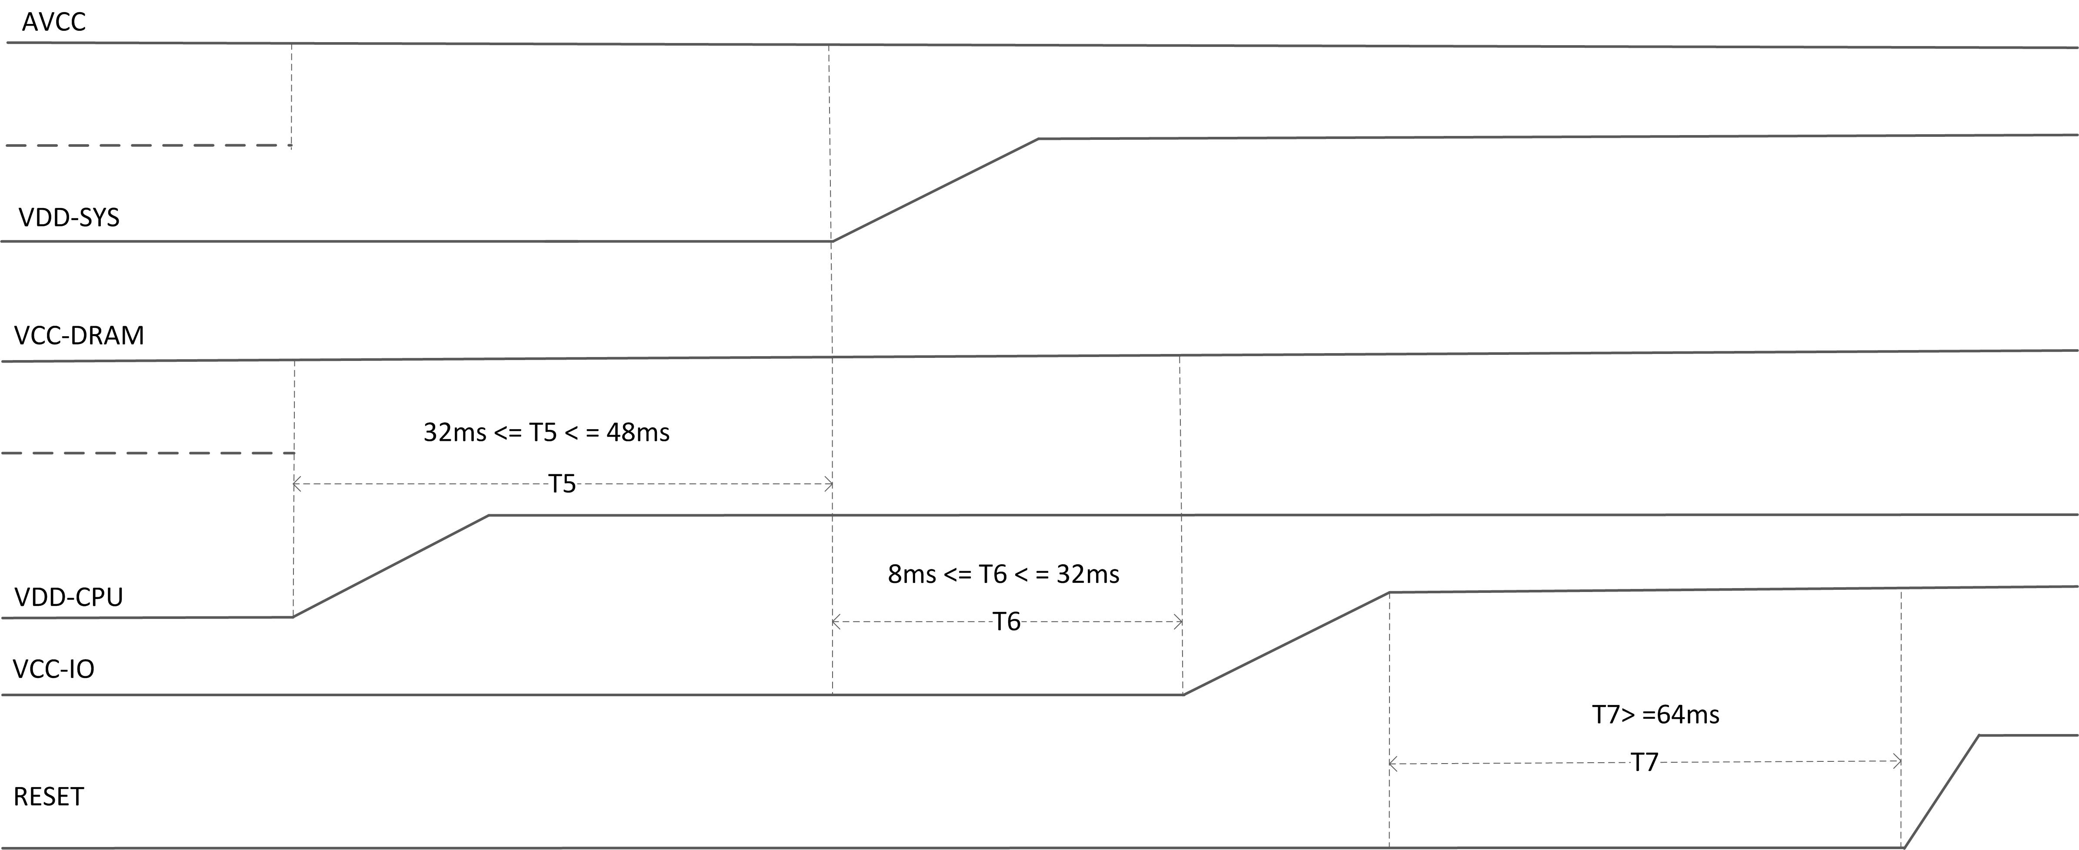
Figure 5.5: Exit Super Standby and Resume Power Up Sequence

Power Down Sequence Requirements
To reduce power consumption, the GR8 can be partially powered down. The section lists the power down requirements in each mode. In Super Standby mode,
- VCC-DRAM and AVCC must be kept powered up.
- VDD-CPU, VDD-SYS and VCC-IO are powered down simultaneously.
- The falling time of VCC-IO is longest. The ramping down rate is decided by the load on the power supply.
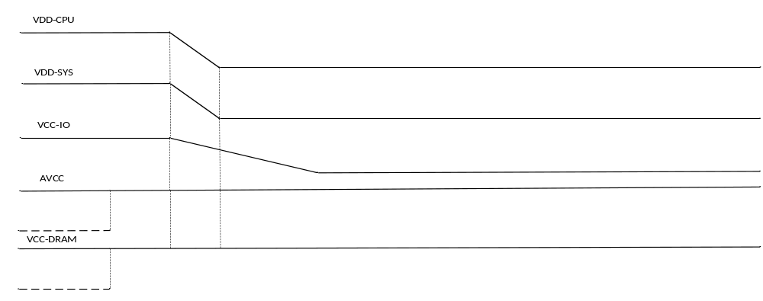
Figure 5.6: Power Down and Enter Super Standby Sequence
Figure 5-5 gives an example of the power-down sequence supported by the GR8 device.
- VDD-CPU, VDD-SYS and VCC-IO are powered down simultaneously.
- VCC-DRAM and AVCC can be powered down after delay 16ms.
- The falling time of VCC-IO is longest. The ramping down rate is decided by the load on the power supply.
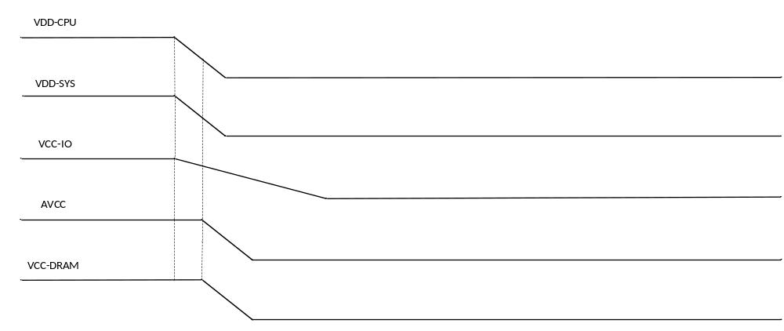

Figure 5.7: Power Down Sequence

Pin Assignment

Pin Map
The following pin map is a top view of the GR8’s 252-pin FBGA package. Patterns in the map below indicate the I/O ports grouping. The most notable of which is in the bottom left corner and contain the necessary ground sink for all the powerful logic, memory and analog circuitry. Analog circuitry is grouped in the top right of the map while power rails can be found in the middle-left.

GPIO is arranged in six ports located throughout the ball-out. PORT B is on top, middle and bottom, PORT C is on the bottom, PORT D is on the left, PORT E is on top, PORT F is located at the top-middle and finally PORT G is on the middle-left and bottom of the ball out.

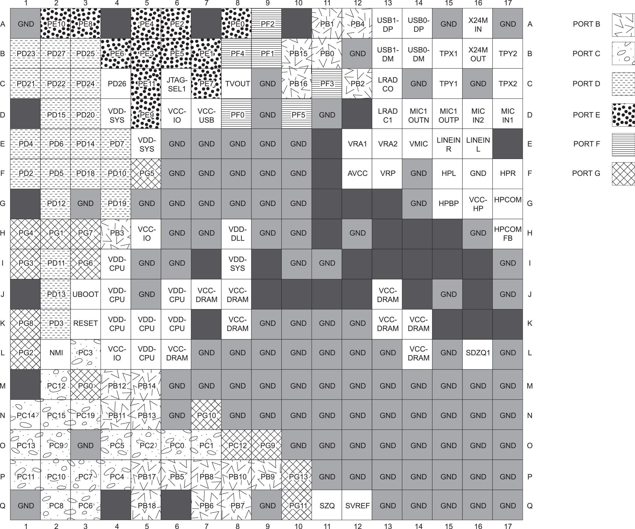

Mechanical and Packaging Information
The following diagram shows the package dimension of GR8 processor, includes the top, bottom, side views and details of the 14 mm x 14 mm package.
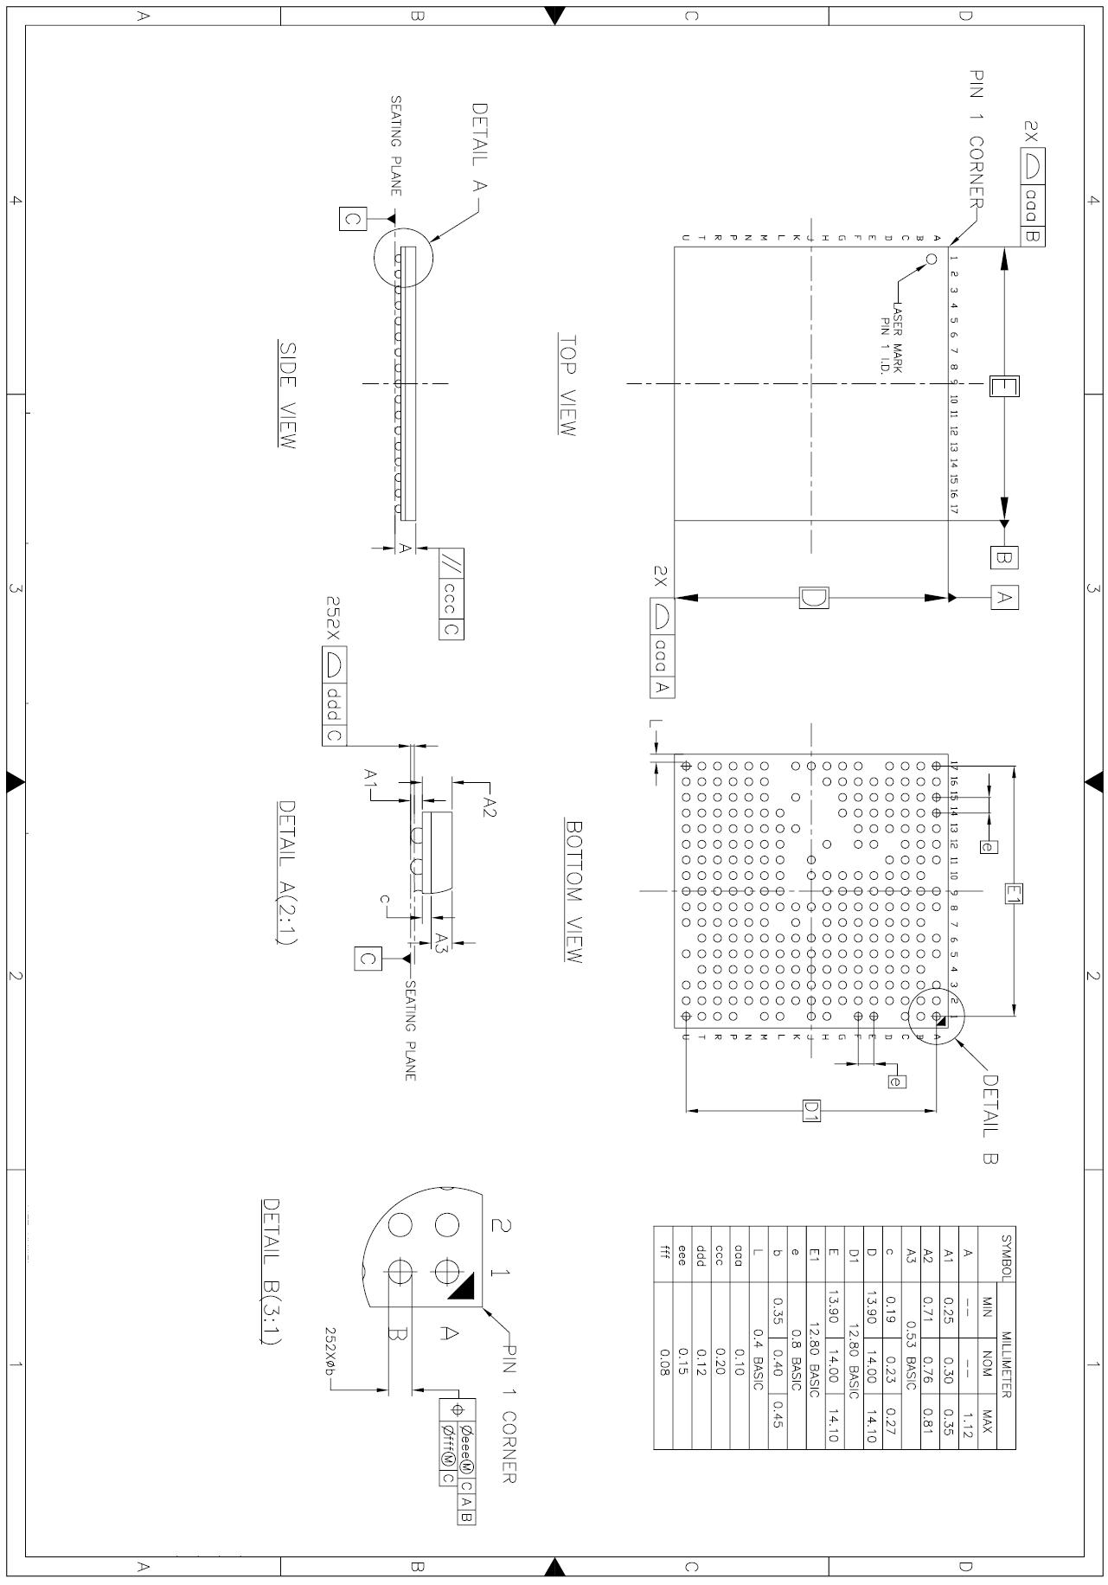

Copyright © 2016 Next Thing Co. All Rights Reserved.

Join the discussion @ http://bbs.nextthing.co/c/CHIP-Pro

Contact Us

Sales:
Sales@NextThing.co

Technical Questions:
Hardware@NextThing.co

www.getchip.com

