**CS4610 Assignment 3a Report**

By: Nathaniel Callahan

**CS4610 Assignment 3a Report**

Based on the previous assignment, extend the system to support the following features

1. Interactively change the field of view and the aspect ratio of the camera

Using a switch statement the user can press 5 increase or 6 decrease the fov and hit 7 to increase or 8 to decrease the aspect ratio.

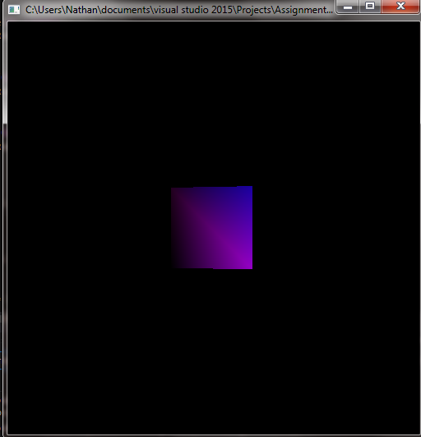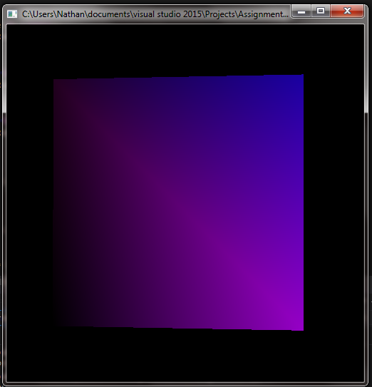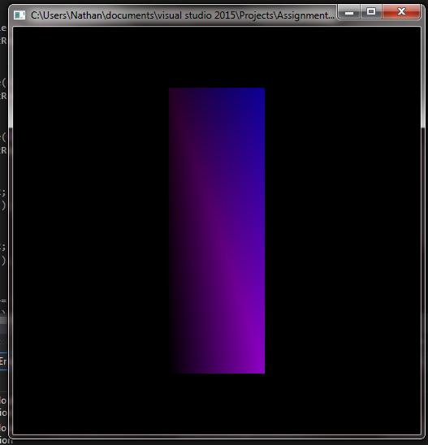

1. Interactively change the values of the near and far clipping plane.

For zNear hit 0 to increase and – to decrease the zNear value. For zFar to increase the value hit [ and to decrease the value hit ].

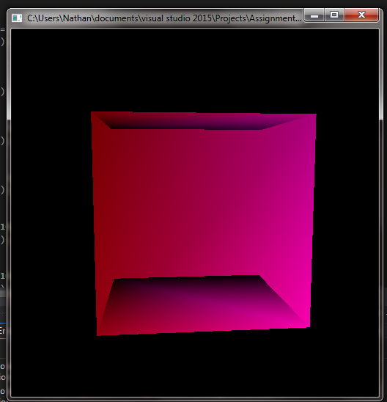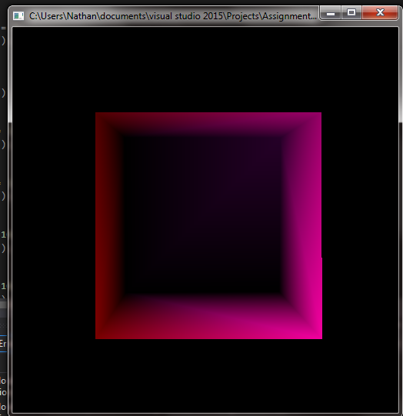

1. Support two light sources and Interactively turn lights on and off

One light source is red and the other is blue. To turn off the first light source hit the 1 key. To turn off the other light source hit the 2 key. To turn the fist light source back on hit the 3 key, and hit the 4 key to turn the second light source back on. The printed copy will be difficult to see the differences in light, please refer to the online copy of the project report. For each light to turn it off I used glDisable(lighti) and to turn it on I used glEnable(lighti).

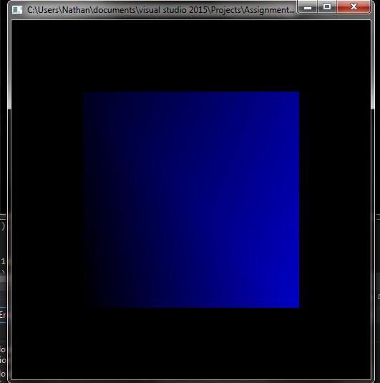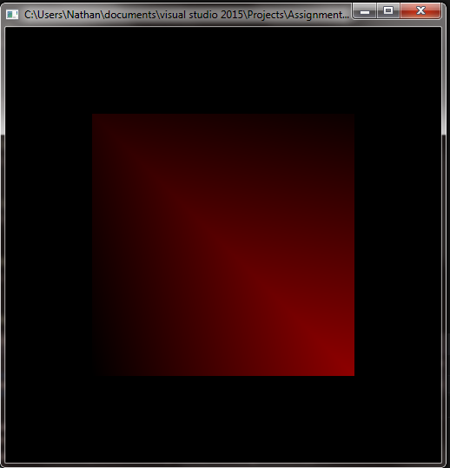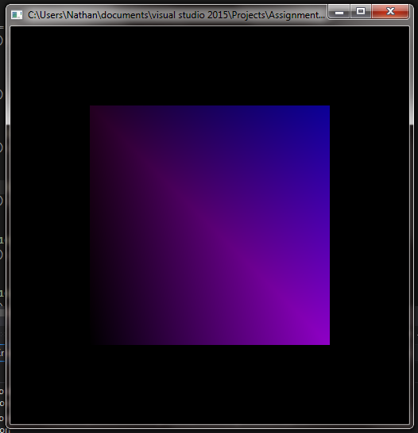

1. Support Flat and Gouraud shading models.

To do this I used the glShadeModel() method. To make the shading flat I used glShadeModel(GL_FLAT) and to make the mode smooth I used glShadeModel(GL_SMOOTH).

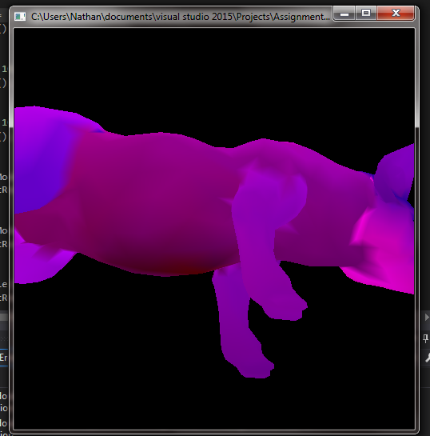 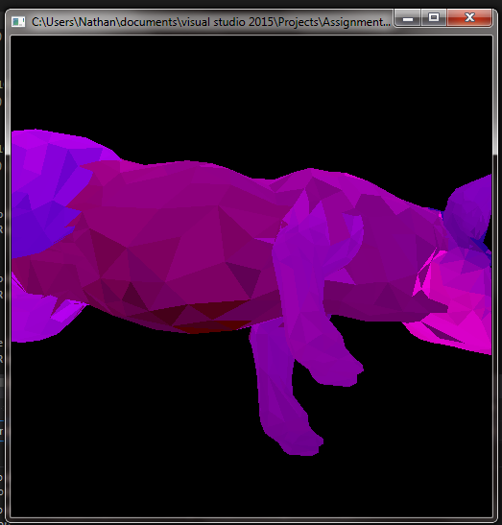

1. Interactive change the (RGBA) values associated with: (1) the global ambient light, (2) ambient diffuse and specular component of the light sources, and (3) ambient diffuse and specular material properties of the objects.

For each property I used a switch stament for changing the RGBA values. One button would increase the values and the other button would decrease the values: i and o for the first one, n and m for the second one, and j and k for the third one. I grouped the last three points of the assignment because to the user it looks almost like each one does the same thing.

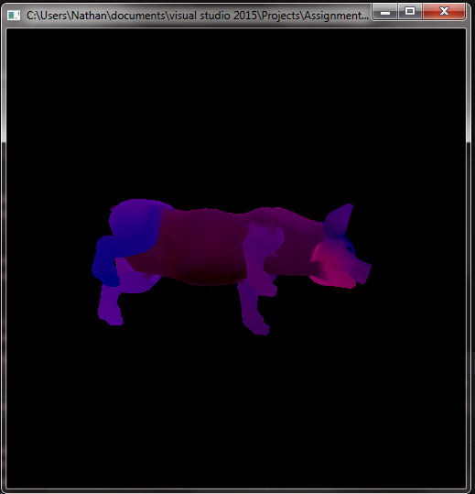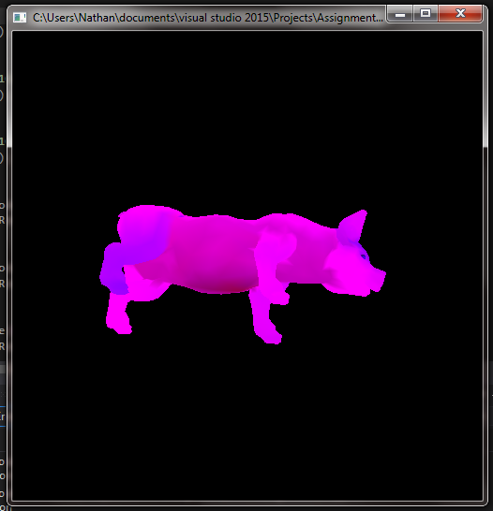

All tasks can be perfomred on any any of the objecst (cube, pig, teapot) and on any display (points, lines, and surfaces).

To change the scale the buttons to push are: z and x.

To change RGBA: i, o, j, k, n, m.

Lights: 1,2,3,4

Pov, aspect ratio, zFar/zNear: 5,6,7,8,0,-,[,].

Reset values: 9

(all in a switch statement)

As far as I can tell there are no remaining issues for part a of this assignment to be reported. The most difficult part of this assignment wat the interactive change of the RGBA material properties.