**CS4610 Assignment 3b Report**

By: Nathaniel Callahan

**CS4610 Assignment 3b Report**

The goals of this assignment are to be familiar with the OpenGL command of the texture mapping.

Texture Mapping

A texture was mapped to the cube object only in this assignment. I used both the checker-board and the mandrill images to texture the cube. The mandrill image was much more difficult to put on the cube than the checker-board image. To get the image into OpenGL I downloaded the stb_image.h library to use the image as a texture. In the openFile() function, the function stbi_load() is what is used in the library to load in the image. Then the glut parameters are set for the image. I used the example code provided by the TA to set the image values.

The last part of the code went into the display() function. When there are faces, the glTexCorrd2f() is used to map the image to the faces of the object. After this the image is displayed on the object as its texture.

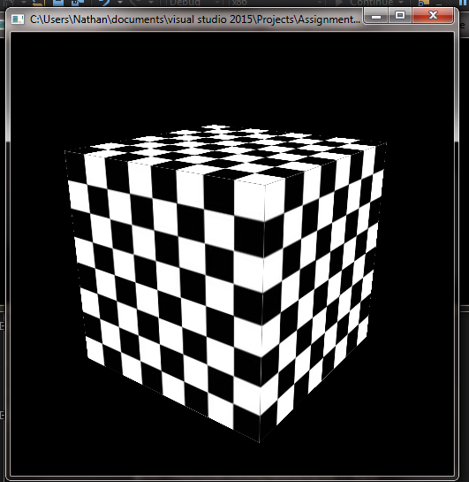 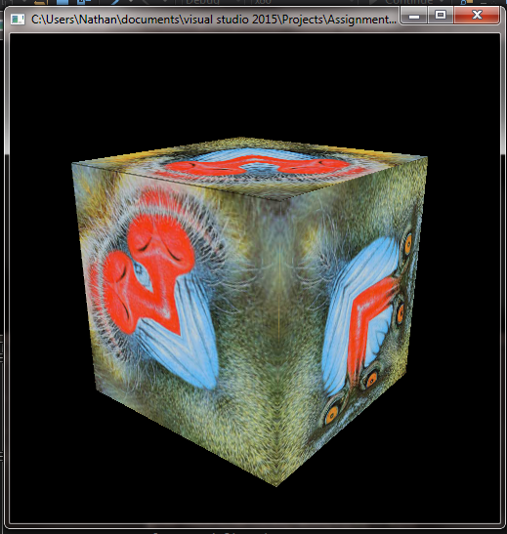

The only big problem I had was making sure the entire mandrill image showed up on each side of the cube. Each side only has half of the face. Luckily, it is not required to map the face completely on correctly in this assignment. A solution would be to pay better attention to where I’m putting the image on each face of the triangle.