Name:P.lokesh reddy
emailid=lokeshreddyp2011@gmail.com
JAVA W4A2

ASSIGNMENT-14

1)Write a java program to read four numbers and to print big number among them?
Program:

import java.util.*;
class Biggestnumber
{
public static void main(String as[])
{
int a,b,c,d;
Scanner s=new Scanner(System.in);
System.out.println("enter four numbers");
a=s.nextInt();
b=s.nextInt();
c=s.nextInt();
d=s.nextInt();
if(a>b)
{
System.out.println("a is biggest number");
}
else
{
System.out.println("b is biggest number");
}
if(c>d)
{
System.out.println("c is biggest number");
}
else
{
System.out.println("d is biggest number");
}
}
}
output:

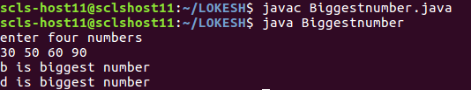

2)Write a java program to read a number and to print whether number is even or odd?

Program:

import java.util.*;
class Evennumber
{
public static void main(String as[])
{
int a;
Scanner s=new Scanner(System.in);
System.out.println("enter one number");
a=s.nextInt();
int n=a%2;

if(n==0)
{
System.out.println("n is even number");
}
else
{
System.out.println("n is odd number");
}
}
}
output:

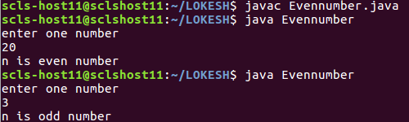

3)Write a java program to read a number and to print prime number or not?

Program:

import java.util.*;
class Primenumber1
{
public static void main(String as[])
{
int a;
Scanner s=new Scanner(System.in);
System.out.println("enter one number");
a=s.nextInt();
int count=0;
for(int i=1;i<=a;i++)
{
if(a%i==0)
count++;
}
if(count==2)
{
System.out.println(a+" is prime number");
}
else
{
System.out.println(a+" is not a prime number number");
}
}
}

output:

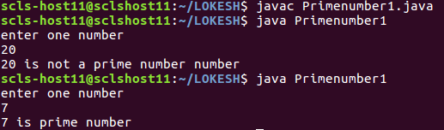

4)Write a java program to read a number n and to print n factorial?

Program:
import java.util.*;
class Factorialnumber2
{
public static void main(String as[])
{
int a;
int i,factorial=1;
Scanner s=new Scanner(System.in);
System.out.println("enter one number");
a=s.nextInt();
for(i=1;i<=a;i++)
{
factorial=factorial*i;
}
System.out.println("factorial is "+factorial);

}
}
output:

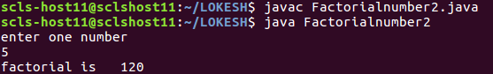

5)Write a java program to read the number and to print sum of the digits of the number?
Program:

import java.util.*;
class Sumofnumbers
{
public static void main(String as[])
{
Scanner s=new Scanner(System.in);
System.out.println("enter one number");
int n=s.nextInt();
int a=0;
while(n!=0)
{
a=a+(n%10);
n=(n/10);
}
System.out.println("a is "+a);
}

}
output:

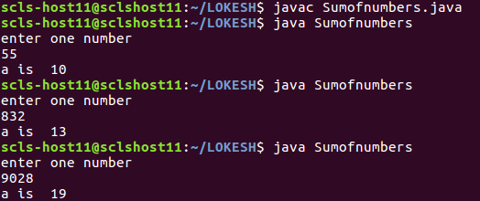

6)Write a java program to read a number and to print reverse of a number?
Program:

import java.util.*;
class Reverseofnumbers
{
public static void main(String as[])
{
Scanner s=new Scanner(System.in);
System.out.println("enter one number");
int n=s.nextInt();
int a=0;
while(n!=0)
{
a=a*10;
a=a+(n%10);
n=(n/10);
}
System.out.println("a is "+a);
}

}
output:

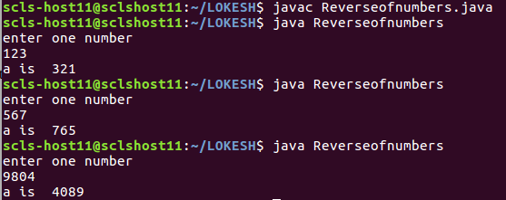

7)Write a java program to read the number and to check whether number is palendrome or not?
Program:

import java.util.*;
class Palendromeofnumbers
{
public static void main(String as[])
{
Scanner s=new Scanner(System.in);
System.out.println("enter one number");
int n=s.nextInt();
int a=0;
while(n!=0)
{
a=a*10;
a=a+(n%10);
n=(n/10);
}
System.out.println("a is "+a);
}

}
output:

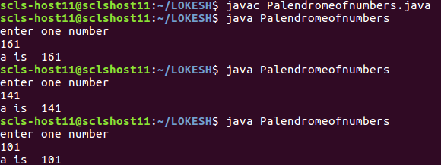

8)Write a java program to read the data into an array and print the same?
Program:

import java.util.*;
class Array
{
public static void main(String as[])
{

Scanner s=new Scanner(System.in);
int a[]=new int[3];
for(int i=0;i<3;i++)
{
a[i]=s.nextInt();

}
for(int i=0;i<3;i++)
{

System.out.println(a[i]);
}
}
}

output:

