

**[Agent-based Simulation of COVID-19 Transmission](https://pats.cs.cf.ac.uk/project?p=37&c=my)**

**Author:** Tian Zhang (c1912705)

**Supervisor:** Bailin Deng

**Module:** CMT400

MSc Computing

School of Computer Science and Informatics

Cardiff University

October 2020

# 

# Abstract

# Acknowledgments

I would like to thank my supervisor, Dr. Bailin Deng, for his dedicated advice and guidance. Dr. Deng continuously provided encouragement and was always willing and enthusiastic to assist in any way he could throughout the project. I would also like to thank my family for providing both financial and spiritual support for my postgraduate edu

# Table of Contents

Abstract i

Acknowledgments ii

Table of Contents iii

List of Figures iv

Chapter 1 - Introduction 1

Chapter 2 - Background 2

Chapter 3 - Aim and Objectives 3

Chapter 4 - Problem 4

4.1 Environment Selection 4

4.2 Factor Selection 5

4.3 Simulation Customisation 5

4.4 Visualisation Design 5

Chapter 5 - Approach 7

Chapter 6 - Implementation 8

Chapter 7 - Results and Analysis 9

Chapter 8 - Conclusions 10

Chapter 9 - Reflection 11

References 12

# List of Figures

# Chapter 1 - Introduction

# Chapter 2 - Background

# Chapter 3 - Aim and Objectives

This project is aiming to develop an agent-based model to simulate and analyse the transmission between a certain amount of people under different conditions. Thus there are a few objectives set below to regulate the development:

1. The model should be set up using a highly-scalable framework.
2. All the components of the model should be clearly established, with explicit attributes and functions.
3. The model should include as many factors as possible to form a fully-integrated simulation.
4. The model should provide the user with a lucid visualisation to understand the progress of the simulation.
5. There should be a user-friendly approach for the user to configure each simulation.
6. The model should be able to conduct multiple tests running in batches for data collection, and generate appropriate diagrams for data analysis.

# Chapter 4 - Problem

## 4.1 Framework Selection

Currently, there are many ABM simulation frameworks available on the Internet, which are written in different programming languages and have various capability. It is essential to find a proper one that could meet the requirement while being simple enough to learn considering the limited time given. There are some dominant frameworks listed below for the reader's reference:

**NetLogo:** NetLogo is a multiagent programmable modelling environment written in Lisp. Students, teachers and researchers have widely used NetLogo for years, so the environment possesses well-developed documentation and loads of existing scientific models.

**FLAME:** The FLAME framework (c???) concentrates on creating agent-based models that run on high-performance computers (HPCs). Models of this framework are created based upon a model of computation called (extended finite) state machines, which determines the behaviour of the software execution.

**MASON:** MASON (c???) is a discrete-event multiagent simulation library core in Java contributed by the George Mason University's Evolutionary Computation Laboratory and the GMU Center for Social Complexity together, designed for both light-weight and large-scale simulations. It contains both a model library and an optional suite of visualisation tools in 2D and 3D.

**SPARK:** SPARK (Simple Platform for Agent-based Representation of Knowledge) (c???) is a cross-platform, free software for multi-scale agent-based modelling (ABM) by the team at CIRM at the University of Pittsburgh. It has advantages for the field of biomedical model development at the systems level. SPARK aims to provide a light-weight, convenient, extensible and computationally efficient platform for ABM modellers.

## 4.2 Factor Selection

According to the background material introduced in chapter 2 regarding the COVID-19 outbreak, it is imperative to abstract the simulation model from all the complex situations. The question of which factors should be considered into the scene then becomes an essential concern to be figured out in the first place, for it could influence the final results of the simulation extensively.

## 4.3 Simulation Customisation

Since it would not be enough to run the model for only once, the way to provide the user with an easy-configured simulation needs to be settled as well. Should the user configure each run by executing some code? Or should all the parameters be stored in a file separated from the code? This issue, in some sense, determines the target users of this project.

## 4.4 Visualisation Design

Another problem worth thinking is how the simulation should be presented to the users to help them directly get to the conclusion. Proceeding technical data analysis afterwards is one thing, however, making the simulation accessible to normal users when running it on site could be a different story. The fact is that some current ABM environments do generate the visualisation like the one shown in (F???), which is quite hard to read.

# Chapter 5 - Approach

# Chapter 6 – Implementation

## 

## 

6-1

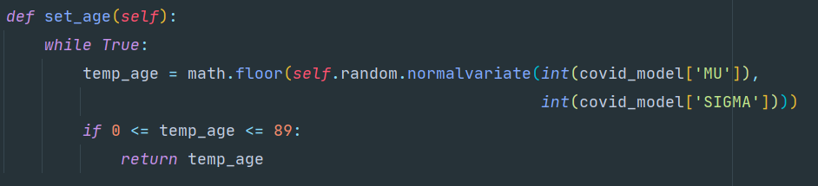

6-2

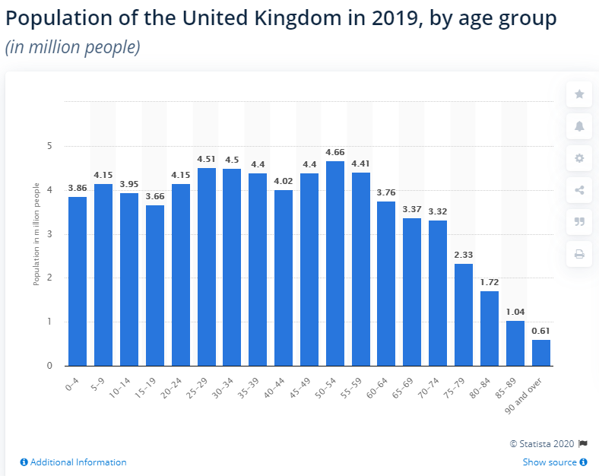

Population

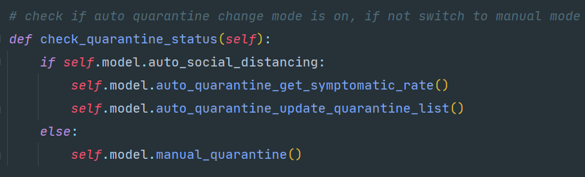

6-3

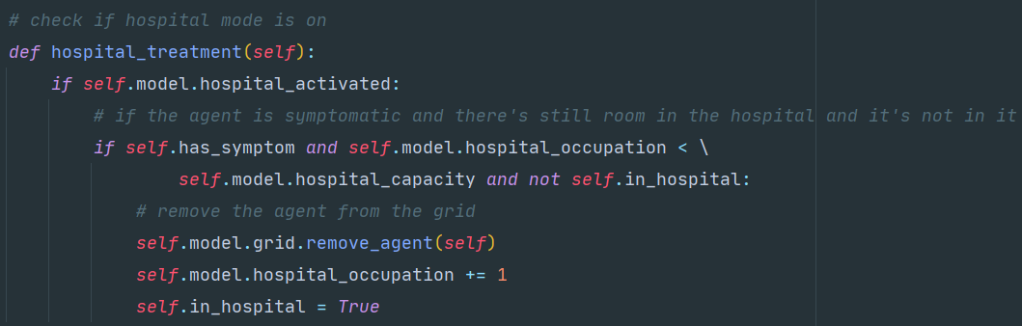

6-4

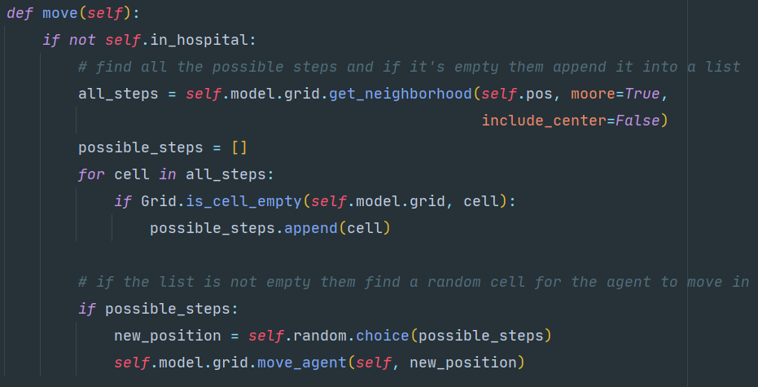6-5

6-6

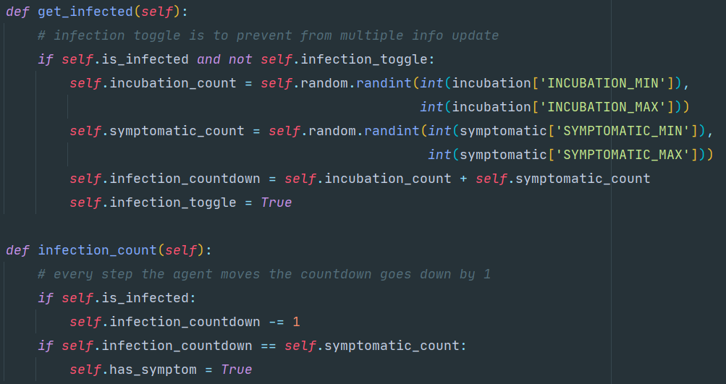6-7

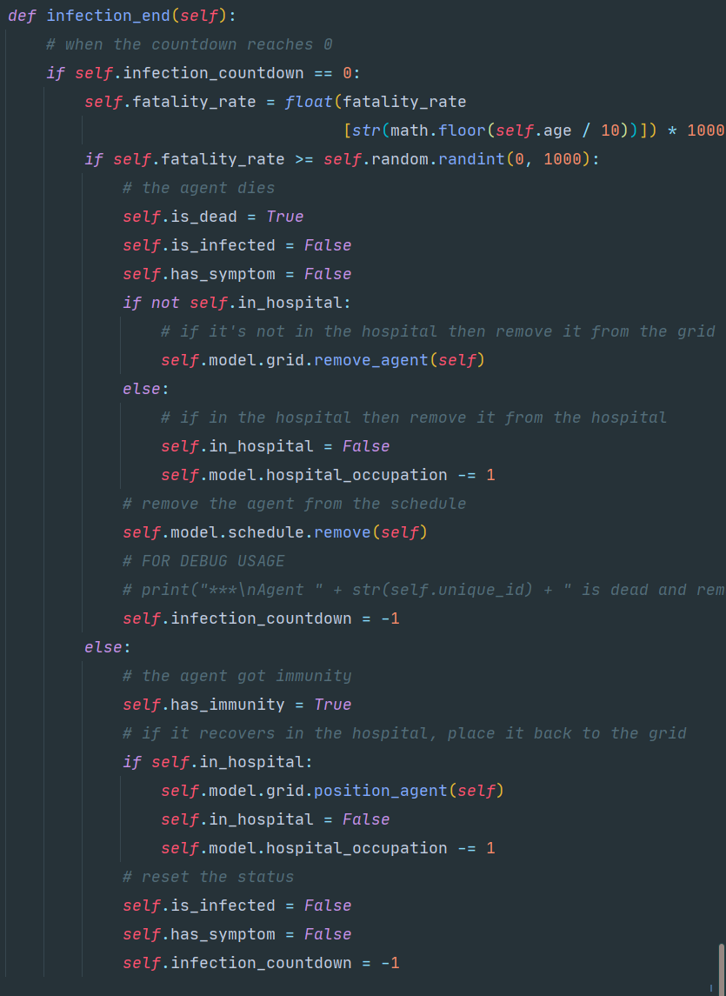6-8

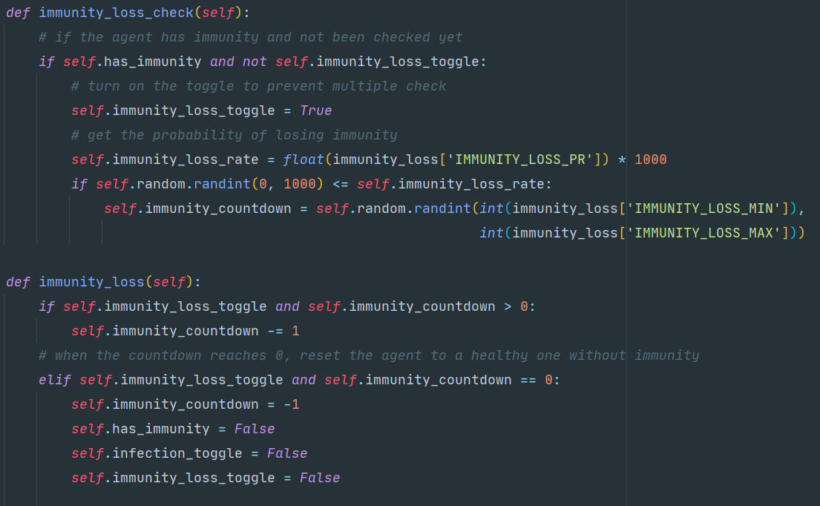

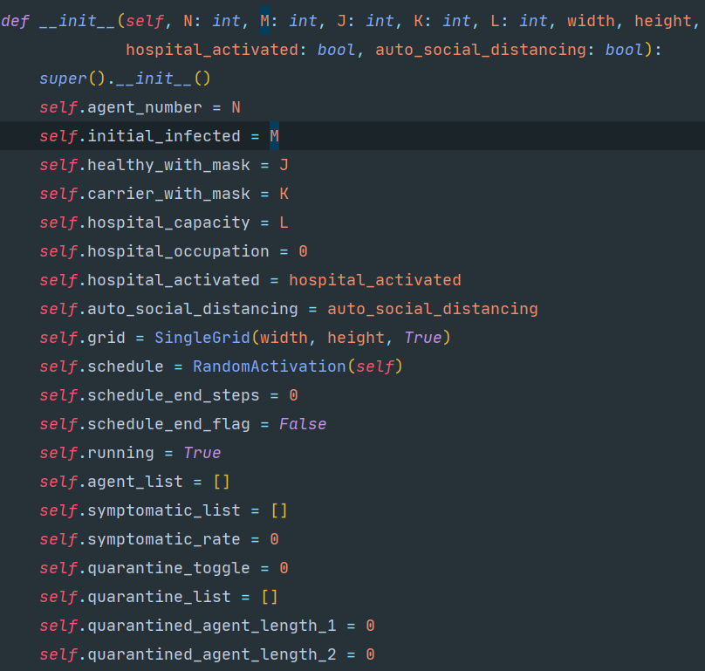

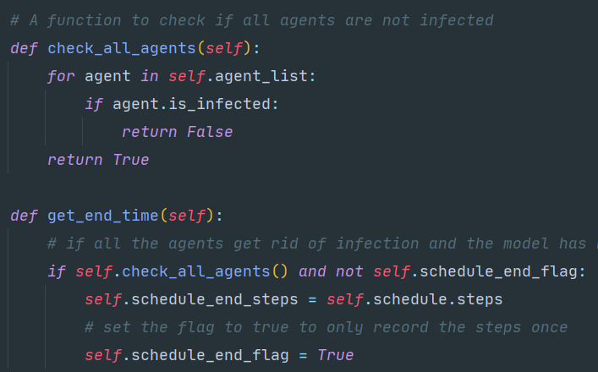

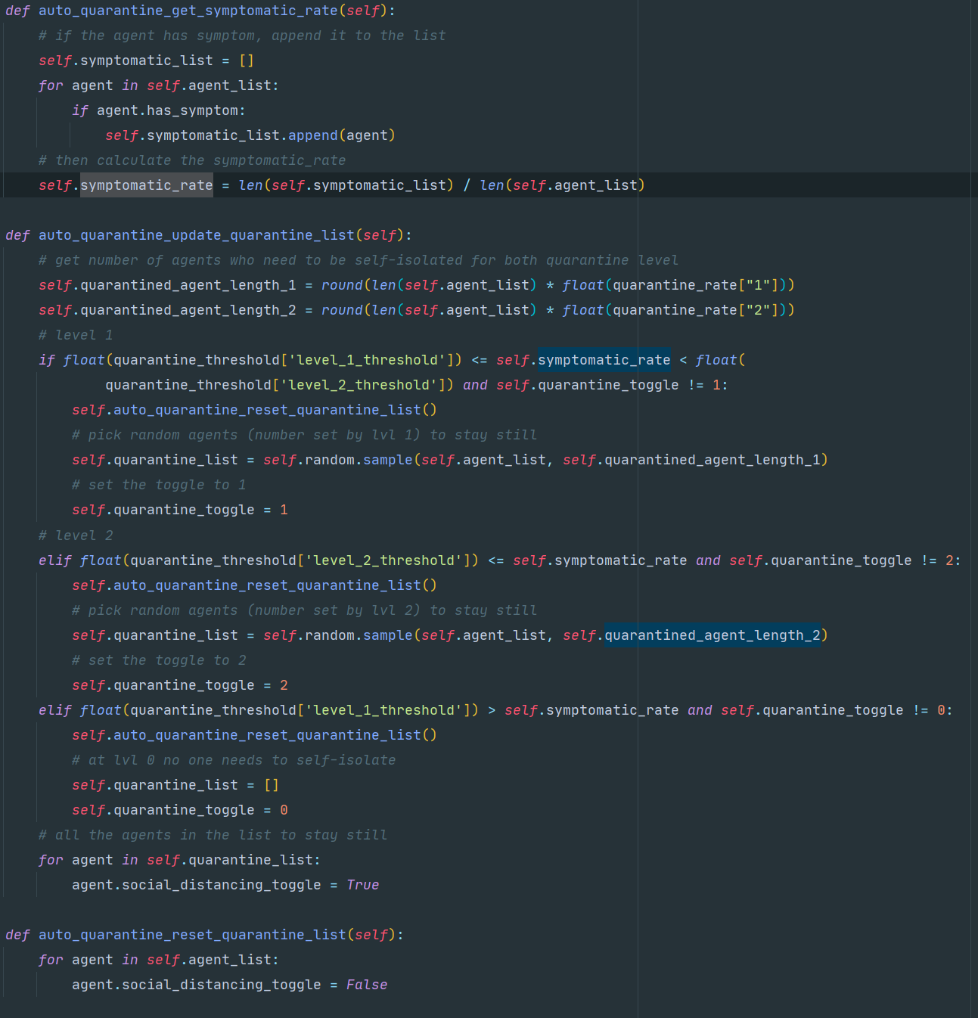

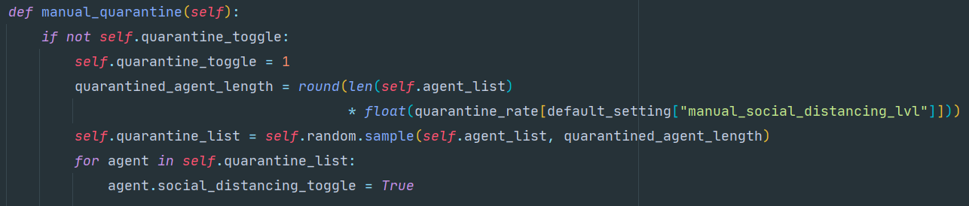

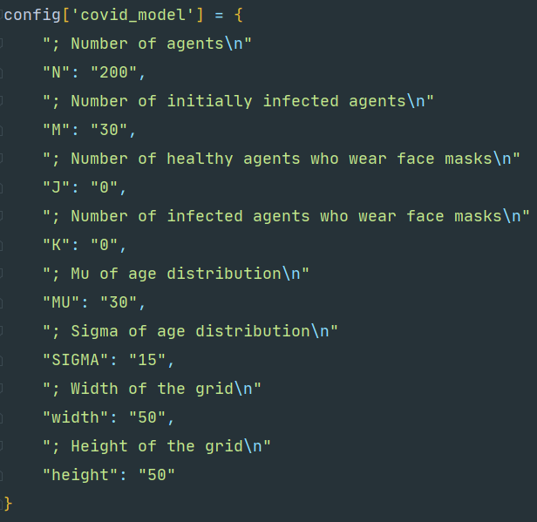

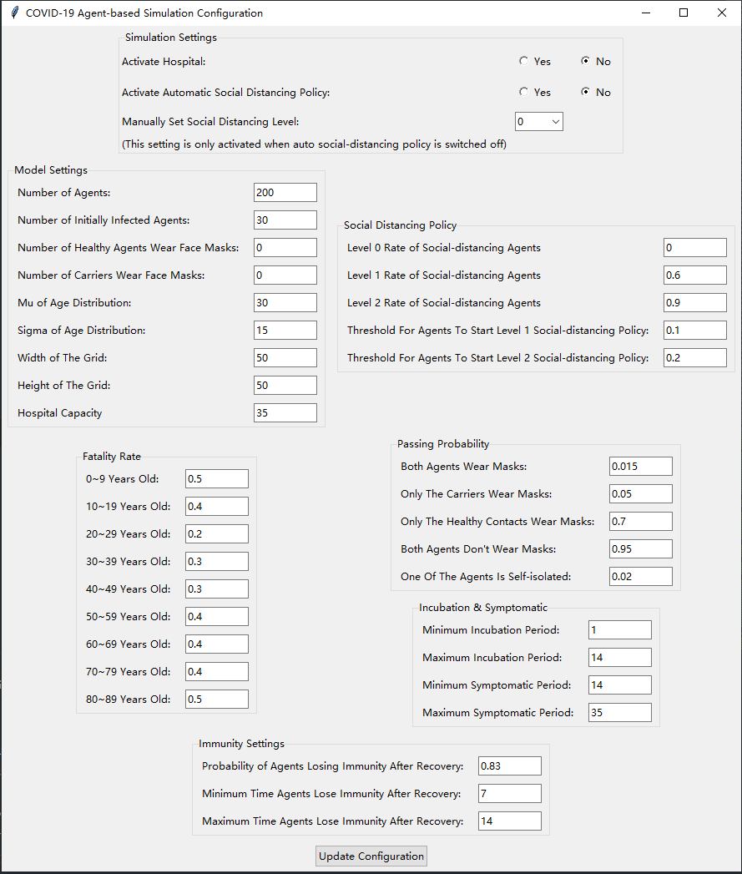

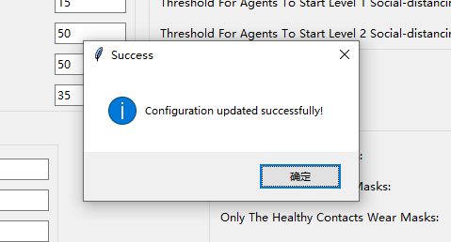

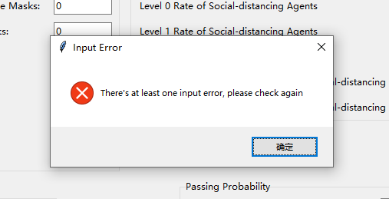

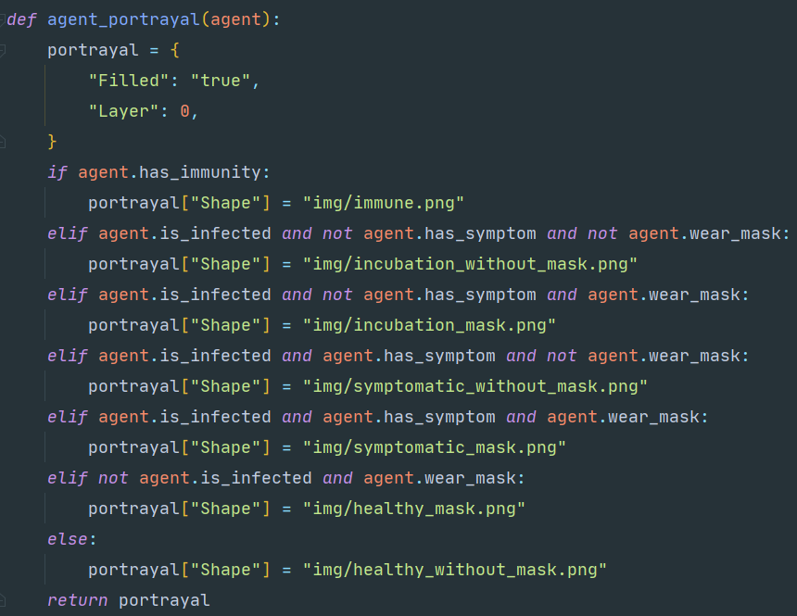

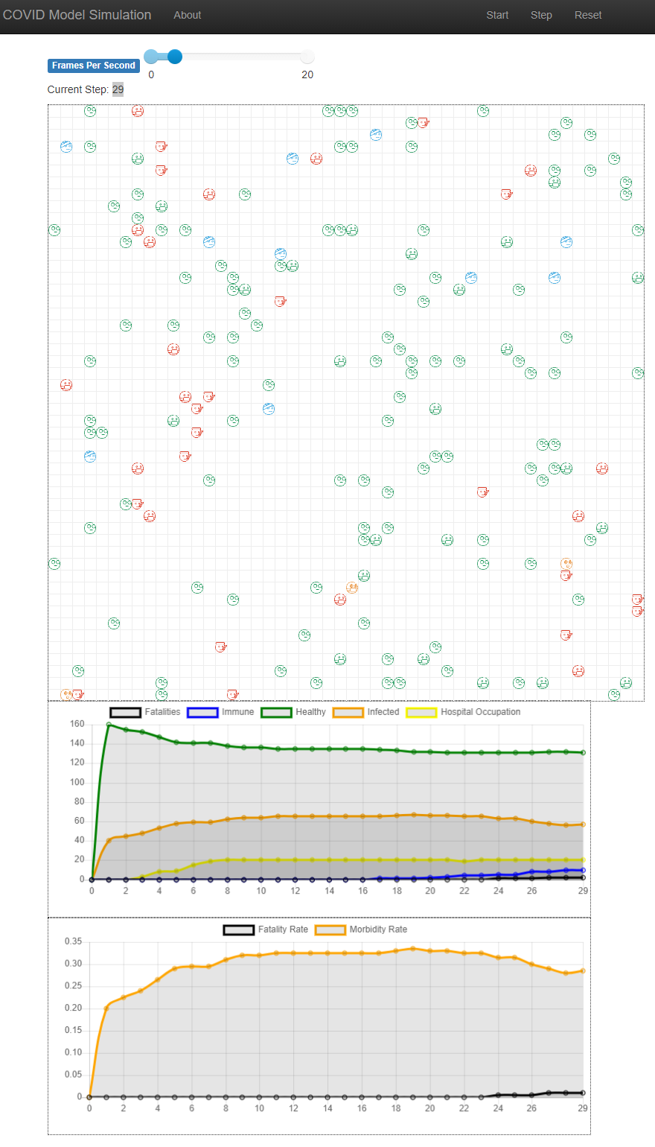

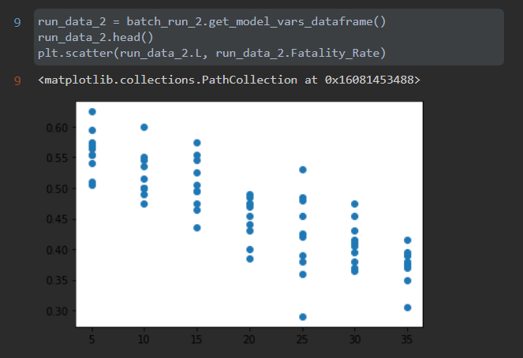

# Chapter 7 - Results and Analysis

## 

# Chapter 8 - Conclusions

# Chapter 9 - Reflection

# References