CET Curl Error with Time Alignment
Definition and implementation specification for finger dexterity evaluation
Decision. CET is the benchmark metric for comparing generated and reference finger curl while allowing small timing differences. It measures each articulated finger joint relative to its own parent bone, excludes the global wrist root, and uses one constrained Dynamic Time Warping path for the complete hand. Lower CET is better.

Metric at a glance
Question | CET definition
What is compared | Parent-relative flexion angles for all articulated finger joints
How timing is handled | Constrained Dynamic Time Warping aligns nearby generated and reference frames
Reported unit | Mean absolute angular error in degrees per evaluated joint
Direction | Lower is better; 0 degrees means identical aligned curl angles
Excluded motion | Global hand translation and the MANO wrist or root rotation

Why parent relative angles are required
A world-space joint position changes when the entire hand translates or turns. That motion must not be counted as finger curl. For every articulated finger joint j, CET forms two bone vectors: one from the parent joint to j and one from j to its child. The angle between those vectors describes local bending.
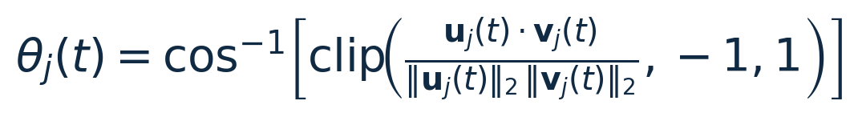
Interpretation. With both bone vectors directed away from the wrist, a straight chain has an angle near 0 degrees. The angle increases as the joint bends. The clip operation prevents numerical errors from sending the arccosine input slightly outside the interval from minus one to one.

Why wrist motion does not affect CET
Suppose the complete hand is translated by a and rotated by an orthonormal matrix R. Translation cancels when bone vectors are formed. Rotation preserves vector lengths and dot products, so the joint angle is unchanged.
Therefore, turning the wrist cannot be confused with curling a finger. In OakInk2 and TaMF, each hand pose contains one global root rotation and 15 articulated MANO joint rotations. CET excludes the root and evaluates the 15 articulated joints. If both hands are evaluated together, J equals 30.

The curl representation
At frame t, CET keeps the joint angles as a vector instead of averaging them into one curl number. This prevents one joint from bending too much while another bends too little and the errors cancelling each other.

Important MCP and thumb detail
The simple 3D angle above measures total change of direction. At the MCP joints and the thumb base, that change can contain both flexion and sideways abduction. If CET is intended to measure curl only, use the local MANO flexion component or project the child bone into the anatomical flexion plane before calculating the angle.

Here n_palm is the palm normal, u is the parent bone direction, and b is the lateral axis. Removing the component along b suppresses sideways finger spread. The same convention must be used for generated and reference motion.

Recommended OakInk2 input
- Preferred: use the 15 parent-relative MANO joint rotations and extract their anatomical flexion components.
- Geometry fallback: reconstruct the 21 MANO joints and calculate angles from adjacent bones using the formulas above.
- Never include: the global translation or the root or wrist rotation in the curl vector.

Frame to frame curl cost
Let G contain T_G generated frames and R contain T_R reference frames. The cost of matching generated frame t to reference frame s is the weighted mean absolute difference between their corresponding joint angles.
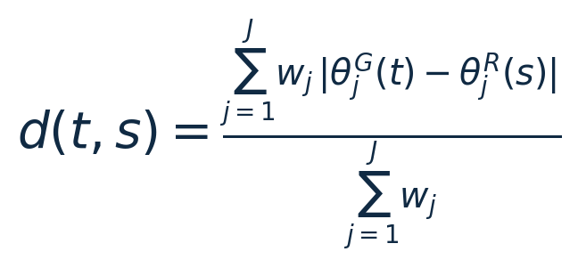
Symbol | Meaning
theta G j of t | Generated parent-relative flexion angle for joint j at frame t
theta R j of s | Reference parent-relative flexion angle for joint j at frame s
w j | Non-negative joint weight; start with w j equal to 1 for every joint
d of t and s | Mean angular disagreement between these two frames, in radians

One frame cost includes every evaluated joint. Consequently, all fingers share the same temporal alignment and their coordination is preserved. Running DTW independently for each finger is not the default because it could make incorrectly synchronized fingers appear correct.

Dynamic Time Warping path
DTW selects a monotonic path through the frame-cost matrix. The path begins at the first frames and ends at the last frames. Each step advances the generated sequence, the reference sequence, or both.
- Allowed steps: (1, 0), (0, 1), and (1, 1).
- Monotonicity: time can move forward but never backward.
- Continuity: the path cannot jump over frames.

DTW recurrence
Initialize D(1,1) as d(1,1). Values outside the matrix are infinity. Store the predecessor that gives the minimum so the final path and its length L can be recovered by backtracking from (T_G,T_R).

Limit how much timing can move
Unrestricted DTW could align a curl that occurs at the wrong part of the action. CET therefore uses a normalized Sakoe Chiba band. A candidate pair is valid only when it satisfies the following condition.
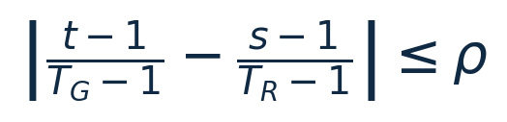
The parameter rho is the largest permitted timing displacement as a fraction of the sequence duration. For example, rho equal to 0.10 allows an event to shift by roughly 10 percent of the motion. Pairs outside the band receive infinite cost. The chosen rho is part of the metric definition and must be reported with every result.

Final CET score
Meaning. CET is the average parent-relative curl disagreement along the best permitted alignment path. Multiplication by 180 divided by pi converts radians to degrees. A CET of 0 degrees means that every aligned finger-joint curl angle is identical.
Result | Interpretation
CET equals 0 degrees | Identical joint curl after permitted alignment
Small CET | Generated curl closely matches the reference
Large CET | Wrong curl depth, wrong joints, missing curl, or timing outside the allowed band

Optional timing diagnostic
CET should remain an angular-error metric. To understand how much alignment it required, record the following diagnostic beside it. This value is not CET and should not be merged into CET without defining a new weighted metric.
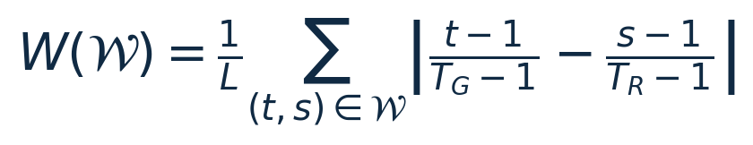
W equals 0 when matched frames have the same normalized time. A larger W means that more temporal warping was needed. This separates two questions: whether the curl was correct and whether it happened at the expected time.

Exact evaluation procedure
Step | Operation | Requirement
1 | Reconstruct or read the hand pose | Use MANO pose or reconstruct 21 joints for every valid frame.
2 | Remove the global root | Do not include translation or wrist or root orientation in the evaluated joint set.
3 | Calculate local flexion | For each articulated joint, compute its angle relative to its parent bone. Isolate the flexion component at MCP and thumb-base joints when possible.
4 | Match sampling | Resample generated and reference sequences to the same frame rate. Apply identical filtering, if any, to both.
5 | Build the cost matrix | Calculate d(t,s) from all evaluated finger joints together.
6 | Apply constrained DTW | Use the declared rho, the three allowed steps, and the recurrence in this document.
7 | Normalize and convert | Divide the cumulative cost by path length L and convert radians to degrees.
8 | Aggregate the dataset | Report the mean CET across samples and also the median and standard deviation or confidence interval.

Required reporting fields
- Joint set: 15 joints per hand or 30 joints for both hands, including the exact thumb convention.
- Angle source: MANO local rotations or reconstructed bone geometry.
- Weights: the complete w j list; equal weighting is the initial recommendation.
- Timing limit: rho and the sequence frame rate.
- Aggregation: number of samples, mean, median, and variability.

What CET measures and what it does not
CET measures | CET does not establish
Whether each finger joint bends by the correct amount | Whether the fingertips touch the correct object region
Whether a curl occurs within the permitted timing window | Whether the grasp is physically stable
Whether fingers coordinate under one shared alignment | Whether force, torque, or kinetic energy is realistic
Finger articulation independent of wrist placement | Whether the complete action matches its text prompt

Canonical short definition
CET is the constrained DTW mean absolute error between generated and reference parent-relative finger-flexion angles, reported in degrees per articulated joint. It excludes global wrist translation and rotation and uses one shared alignment path across all evaluated fingers.

