Finger articulation in TaMF motion generation
  - Research findings from Curl Error with Time Alignment
OakInk2 TaMF thesis research | 6 October 2026

Executive summary
CET provides a direct measure of how closely TaMF reproduces reference finger flexion after limited temporal alignment. In this partial batch, the final outputs show a typical error near 9°, with localized anatomical errors and a small set of much larger mismatches. The evidence supports targeting finger articulation explicitly in the next stage of the thesis. It does not establish whole-motion or interaction quality.

Typical accuracy conceals a substantial tail.
Across 91 unique motions, mean CET is 9.97° and median CET is 9.12°. The middle half lies between 7.11° and 11.74°, while the largest error reaches 32.34°.

The pinky is the clearest anatomical target.
Its mean error is 12.05°, the largest of the five fingers, and it has the largest finger CET in 32 of 91 motions. The pinky MCP and PIP joints average 15.07° and 13.40°.

Articulation demand has several distinct meanings.
Mean flexion depth has only a weak association with CET (Pearson r = 0.15). Activity rate has a positive association (r = 0.51), whereas accumulated activity has a negative association (r = −0.30). Deep or active motions are not automatically failures.

Concrete failures include both dynamic and nearly static fingers.
Closing a microwave gate (389) combines the largest reference range and activity rate with CET 17.33°. Pressing its button (552) has CET 32.34° despite only 2.27° mean reference range over a 0.225 s segment.

The relative-error concern is valid when carefully defined.
Motion 934 has pinky CET 9.26° and mean absolute reference flexion 46.07°: a 20.10% error-to-flexion magnitude ratio. This is additional descriptive analysis, not a percentage of articulation lost.
Thesis objective: reduce CET while preserving the intended action and object interaction, with deliberate coverage of demanding finger motions and strong baseline successes.
Scope: 91 unique hand-motion segments from 20 source sequences, including 52 right-hand and 39 left-hand segments. This is a partial evaluation batch, not the complete OakInk2 test set. All findings below describe this batch. Sources [1–3].

Evaluation setup and CET formulation
The primary result is the final TaMF output evaluated against ground truth. Technically, this is the saved R-stage output, decoded from refine_pose_repr; the report uses this stage only. The evaluation contains 91 successful unique motions and no failure rows. Original motion IDs are representative indices from the generation cache, not row numbers in a new table. [1,2]

From hand pose to an articulation error
For each ground-truth and predicted motion, extract 15 signed anatomical bend angles from parent-relative MANO rotations. Align the two angle sequences with one constrained dynamic time warping path, then average the absolute angular differences over that path and all joints. A shared path prevents independently shifting different fingers to conceal poor coordination.
Temporal alignment allows a corresponding finger action to occur slightly earlier or later. The saved evaluation permits at most 0.10 normalized-time displacement. Translation and wrist root rotation do not enter CET. Spread, twist, thumb opposition, contact, and physical grasp stability are not directly scored.

Definition used by the evaluator
Let θᴾ(t,j) and θᴳ(s,j) denote predicted and ground-truth signed bend angles in radians. All 15 weights wⱼ equal one. For normalized saved-frame times uₜ and vₛ:
$d(t,s) = Σⱼ wⱼ |θᴾ(t,j) − θᴳ(s,j)| / Σⱼ wⱼ$
$P* = arg minₚ Σ₍ₜ,ₛ₎∈ₚ d(t,s), with |uₜ − vₛ| ≤ 0.10$
$CET = (180/π) × [Σ₍ₜ,ₛ₎∈ₚ* d(t,s)] / |P*|$
Paths include both endpoints and allow steps (1,1), (1,0), and (0,1). Dynamic programming minimizes cumulative cost and then divides by the recovered path length; it does not directly minimize average path cost. Per-joint and per-finger CET use this same path. [1]
0° means perfect agreement of the aligned bend angles. Larger CET means worse finger-flexion agreement. No perceptual or clinical pass threshold has been calibrated here.

Anatomical and sampling conventions
The evaluator uses the fixed, side-specific manotorch anatomical template and the signed Z bend component of its XYZ decomposition. For template basis Aⱼ and local rotation Lⱼ, Qⱼ = AⱼᵀLⱼAⱼ and bendⱼ = atan2(−Qⱼ[0,1], Qⱼ[0,0]). Thumb joints are CMC, MCP, IP; other fingers use MCP, PIP, DIP. This is a reproducible model convention, not a validated clinical measurement.
Only valid frames enter the score. Saved mocap frame IDs define time using a 120 Hz clock; stride varies by segment. CET uses the saved samples without resampling or smoothing. Every unique motion has equal weight, and reported standard deviations use the population convention. The older specification document discusses geometric alternatives and resampling; those are not the implementation used for these results. [1,5]

Overall finger articulation accuracy
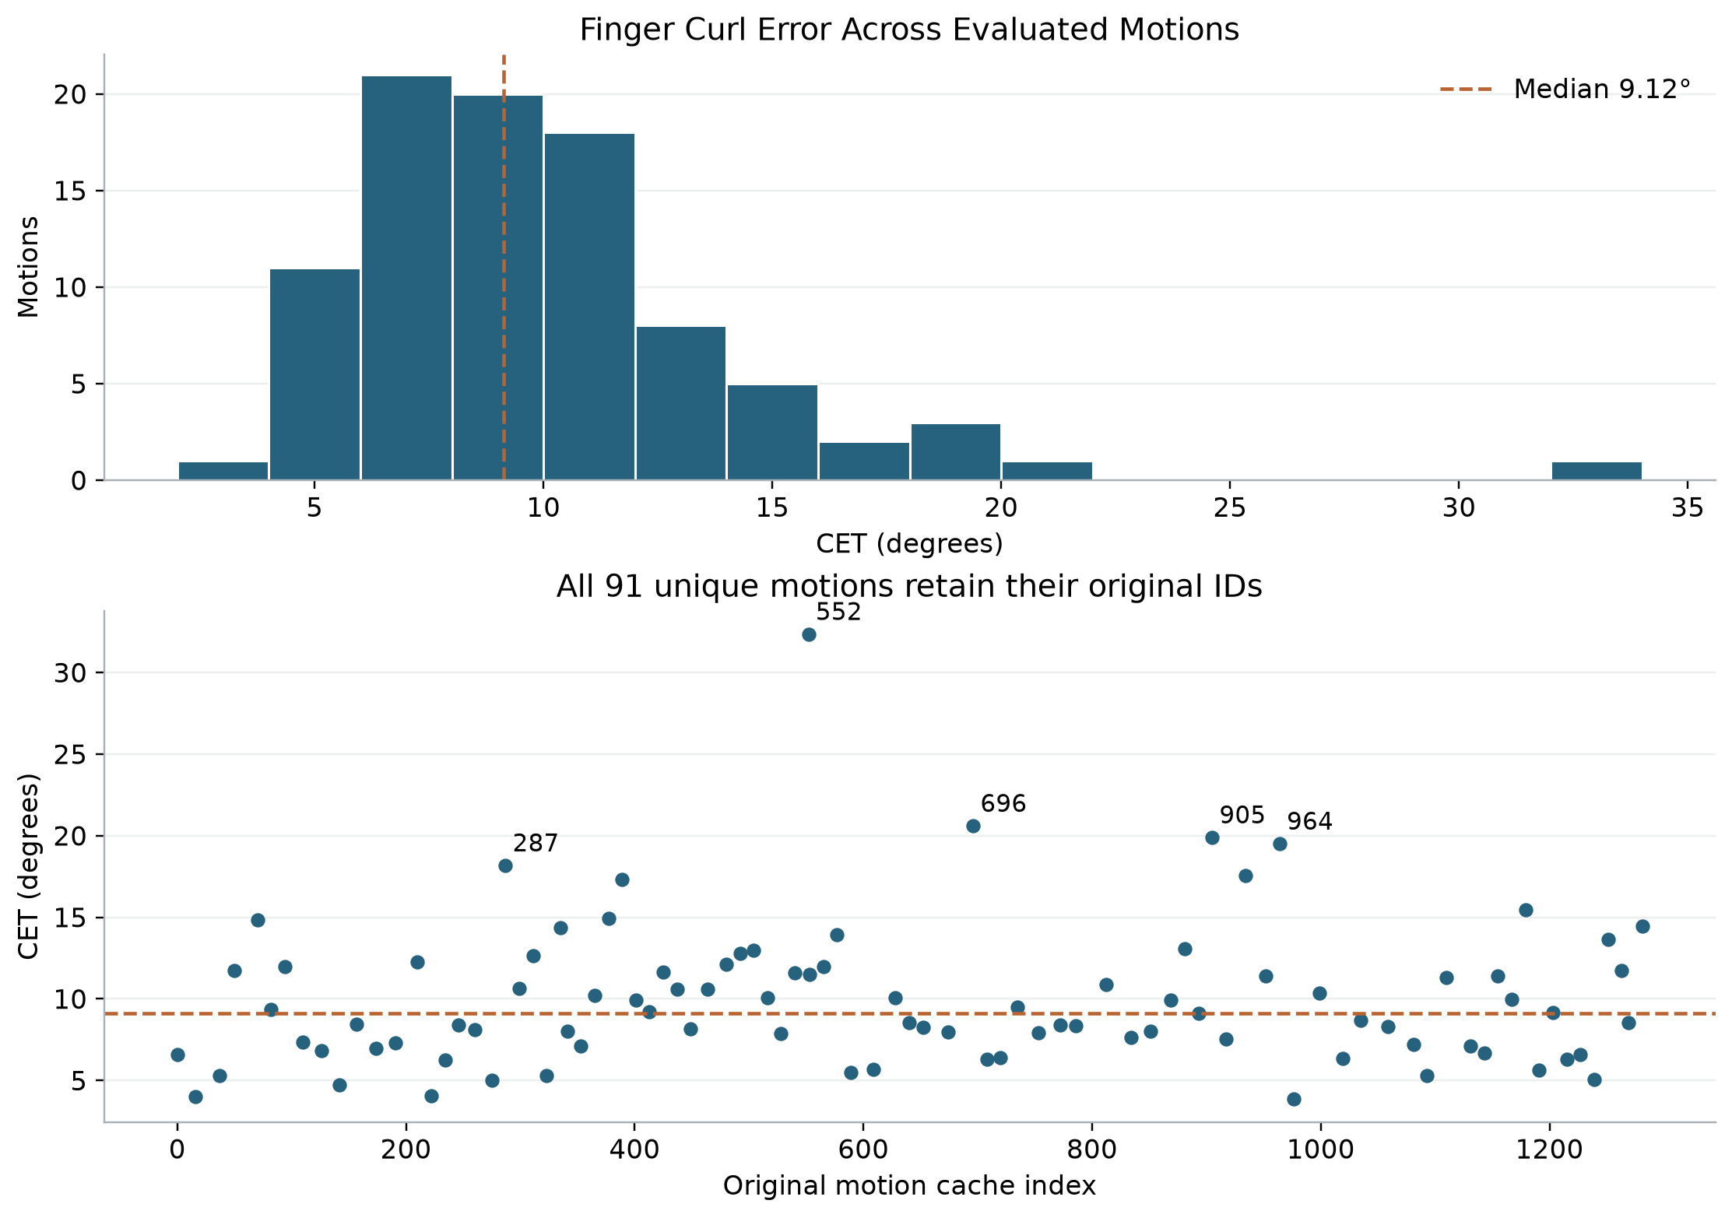
Figure 1. Final-output CET distribution and per-motion scores. Each point represents one unique motion; labels mark the five largest errors. Lower CET is better. Source: saved motion results [2].
Mean | Median | Population SD | Minimum | Maximum
9.97° | 9.12° | 4.36° | 3.88° | 32.34°
The 10th, 25th, 75th, 90th, and 95th percentiles are 5.48°, 7.11°, 11.74°, 14.85°, and 17.85°, respectively. Of the 91 motions, 53 have CET below 10°. These summaries weight motions equally rather than weighting by clip duration.
Most outputs lie well below the worst outlier, but the average alone obscures meaningful differences between motions. The minimum belongs to motion 976, a right-hand tongs action; motion 552 has the maximum. Neither numerical threshold should be interpreted as a validated perceptual boundary.
Why this matters: evaluating only the mean would hide both strong reference examples and concentrated failures that can guide model development.

Where the articulation error occurs
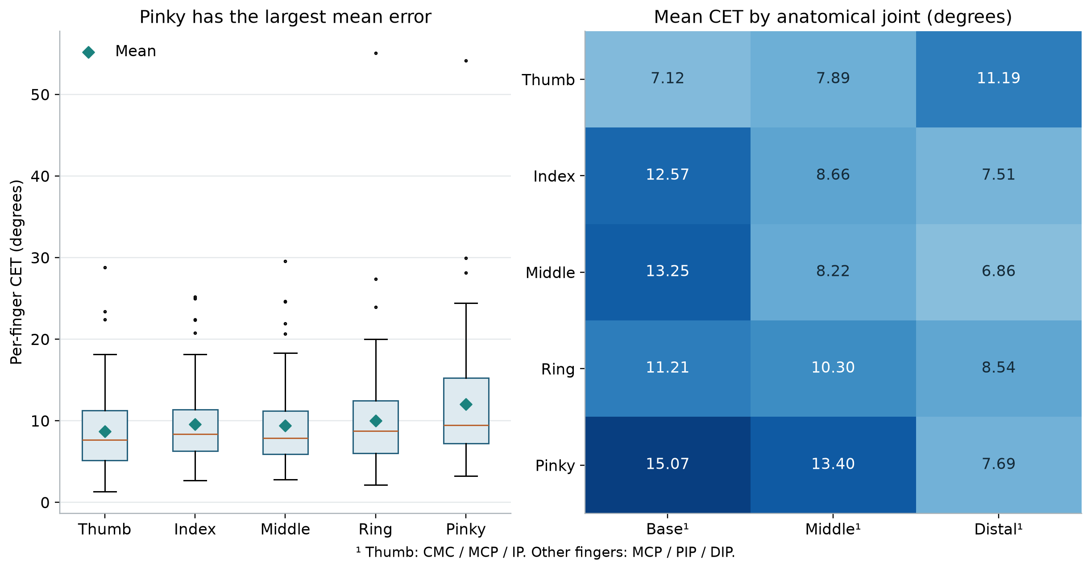
Figure 2. Per-finger distributions and equal-motion mean CET for all 15 joints. Diamonds denote finger means; box plots show medians, interquartile ranges, and outliers. Pinky is the evaluator’s little finger. Source [2].
Mean CET by finger is 8.74° for the thumb, 9.58° for the index, 9.44° for the middle, 10.02° for the ring, and 12.05° for the pinky. Their medians are 7.65°, 8.37°, 7.92°, 8.74°, and 9.47°, respectively. The pinky therefore has both the highest mean and the highest median, though the distributions overlap.
The pinky is the largest-error finger in 32 motions, compared with 19 for the thumb, 16 for the index, 15 for the ring, and 9 for the middle finger. This is a repeated batch-level pattern, not a statement that the pinky is worst in every action.
The largest joint means are pinky MCP 15.07°, pinky PIP 13.40°, and middle MCP 13.25°. Across the four non-thumb fingers, each MCP mean exceeds its own PIP and DIP mean. Distal-joint means are lower, ranging from 6.86° for middle DIP to 8.54° for ring DIP.
Why this matters: a whole-hand average dilutes anatomically concentrated errors. Pinky flexion and proximal finger joints are evidence-based targets for further investigation.
Possible causes include the training distribution, model constraints, and the anatomical angle convention. This analysis does not isolate those causes. Thumb comparisons also cover bend only, not its full opposition behavior.

Curl amount is not curl error
Ground-truth descriptors characterize the reference motion by itself. CET compares the prediction with that reference after alignment. A deeply flexed hand can remain almost still, and a shallow flexion can move repeatedly. These are different properties of articulation.
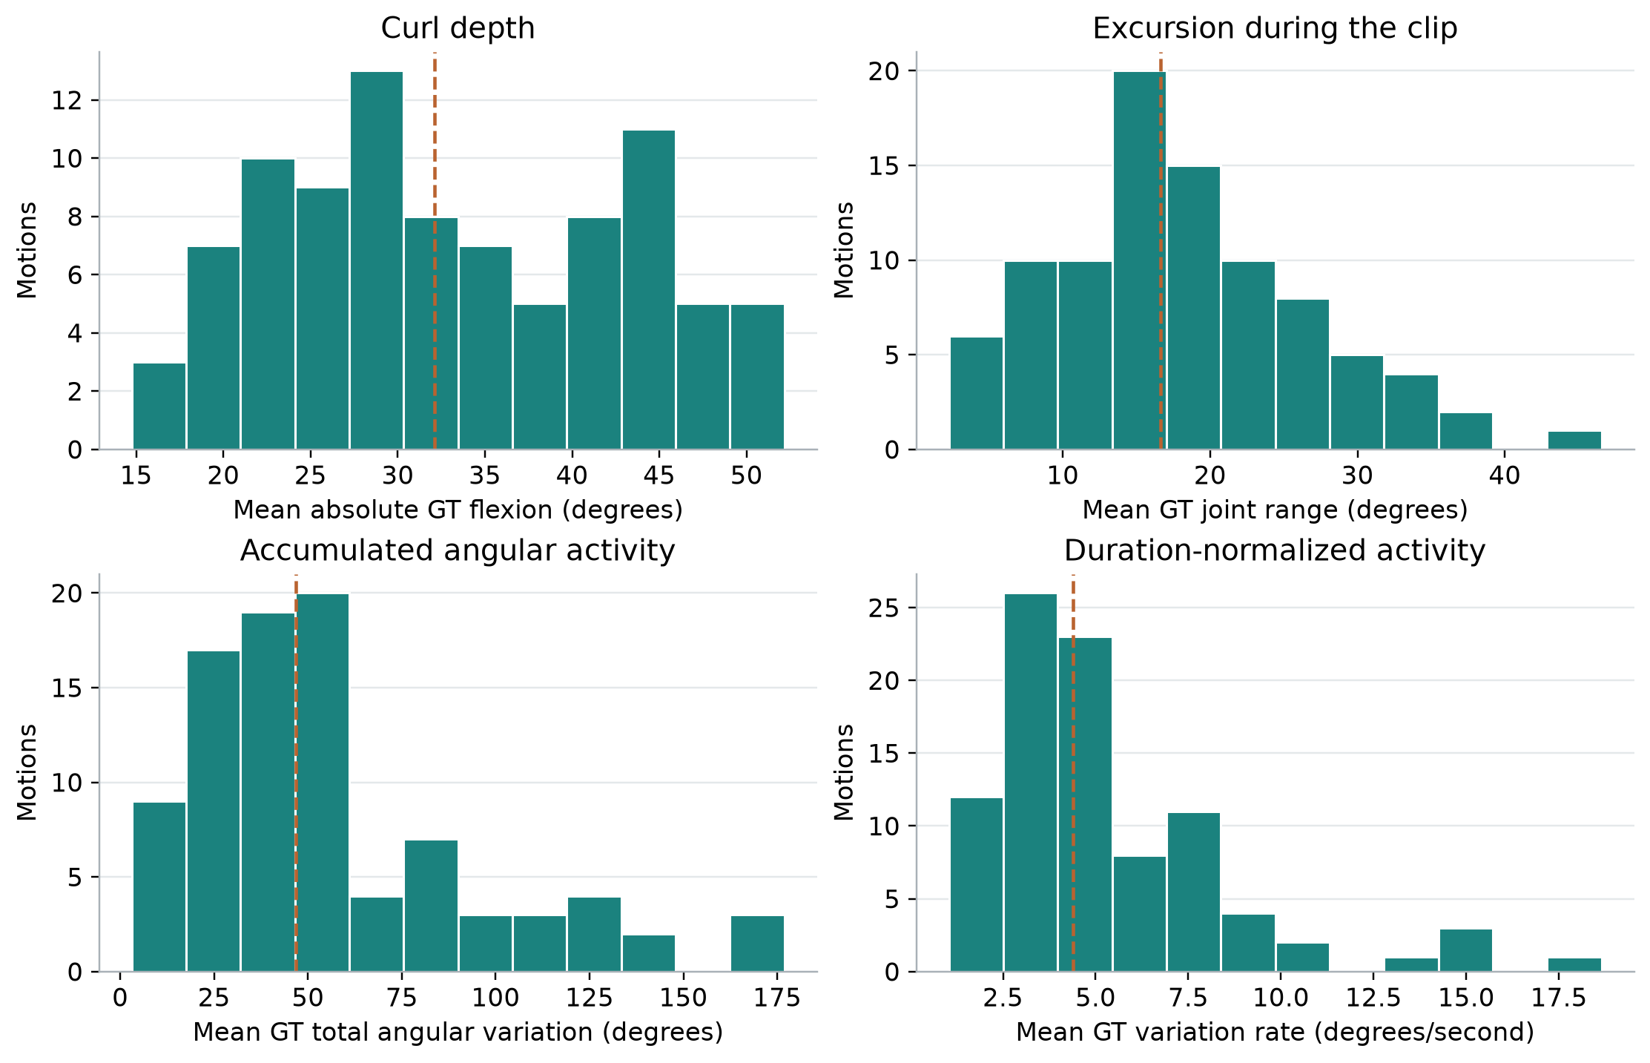
Figure 3. Reference articulation distributions across 91 motions. Dashed lines mark medians. Each hand descriptor is the mean of the 15 joint statistics, not a sum over joints. None of these four quantities is an error. Source [2].
Mean absolute flexion describes depth relative to zero bend: its batch median is 32.11° and its range is 14.75–52.18°. Flexion range describes within-clip excursion: median 16.63°, range 2.27–46.56°. The mean of joint maximum absolute flexion has median 40.38° and range 19.82–65.69°.
Total angular variation is the sum of absolute successive angle changes for each joint, followed by averaging across joints. Its median is 46.79°. Dividing by elapsed clip duration yields a variation rate with median 4.40°/s. Total variation is accumulated angular movement, not physical energy.
Why this matters: use depth to describe how curled the hand is, range to describe excursion, and variation to describe activity. Reserve “curl error” for CET.

Articulation demand and CET
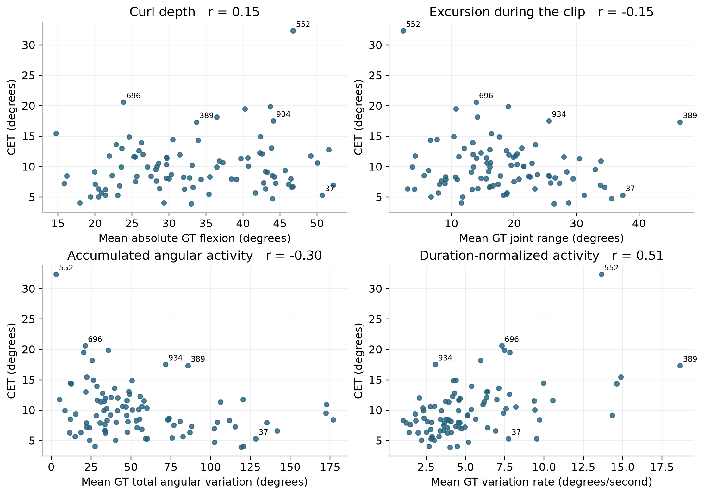
Figure 4. Reference descriptors versus CET. Labels identify selected original motion IDs. Pearson r summarizes each association descriptively; no fitted relationship or causal claim is implied. Sources [2,3].
Depth is weakly associated with CET: Pearson r = 0.15 and Spearman ρ = 0.11. Range also has little association (r = −0.15, ρ = −0.10). Accumulated variation is negatively associated with CET (r = −0.30, ρ = −0.29), whereas variation rate is positively associated (r = 0.51, ρ = 0.47).
Removing the largest-CET motion, 552, reduces the rate correlation to r = 0.44. The association is therefore not solely due to that point, but duration remains a confound: rate and duration correlate at r = −0.50. Source sequences repeat, sampling stride varies, and action groups are small.
Why this matters: the data does not support a blanket claim that more curl or accumulated activity causes larger error. Activity rate is a useful candidate stratification variable for the next evaluation.
For descriptive case selection, “high” means at or above the batch 75th percentile of the specified descriptor, and “low” means at or below its 25th percentile. These are within-batch labels, not universal dexterity thresholds. High CET starts at 11.74° and low CET ends at 7.11° under this convention.

Verified motions behind the conspicuous errors
The five highest-CET motions are original cache IDs 287, 552, 696, 905, and 964. Their saved action descriptions and reference descriptors reveal different kinds of difficulty. High error does not imply that the reference fingers performed a large amount of curling. [2]
Motion and action | CET | GT depth / range | GT activity rate
287 · left  Place the donut inside the plate. | 18.16° | 36.43° / 14.17° | 5.97°/s
552 · left  Press the button on the microwave oven. | 32.34° | 46.77° / 2.27° | 13.65°/s
696 · right  Rearrange the spoon from one position to another position. | 20.59° | 23.85° / 13.94° | 7.31°/s
905 · right  Rearrange the fryingpan from one position to another position. | 19.88° | 43.68° / 19.08° | 7.47°/s
964 · right  Press the button on the scale. | 19.49° | 40.28° / 10.71° | 7.83°/s
Depth means mean absolute reference flexion; range means mean joint excursion. All angular hand descriptors average the 15 joint statistics. Descriptions are retained from saved metadata.

Where their errors concentrate
Motion 287 is led by pinky CET 28.15°; its largest joint errors are middle MCP 43.37°, index MCP 41.76°, and pinky PIP 40.64°. Motion 552 concentrates error in ring and pinky flexion, examined in the case studies.
Motion 696 has broadly elevated non-thumb finger errors, led by pinky CET 24.42°, with index MCP at 49.54°. Motion 905 is led by middle-finger CET 29.59°; middle MCP is 55.31°, pinky MCP 45.43°, and thumb IP 40.96°. Motion 964 is led by pinky CET 29.97°; middle MCP, ring MCP, and pinky MCP are 54.39°, 48.94°, and 41.23°.
These are verified high-error examples, not a homogeneous set of high-articulation motions. Motion 552 is deeply flexed but has the smallest range and total variation in the batch.

Useful high-articulation comparison cases
Motion 389 has the largest range (46.56°) and fastest variation rate (18.65°/s), with CET 17.33°. Motion 37 combines deep flexion (50.68°), large range (37.38°), and high accumulated activity (128.39°), yet has CET only 5.31°. These contrasting cases prevent the analysis from selecting only failures.

Case studies of demanding articulation
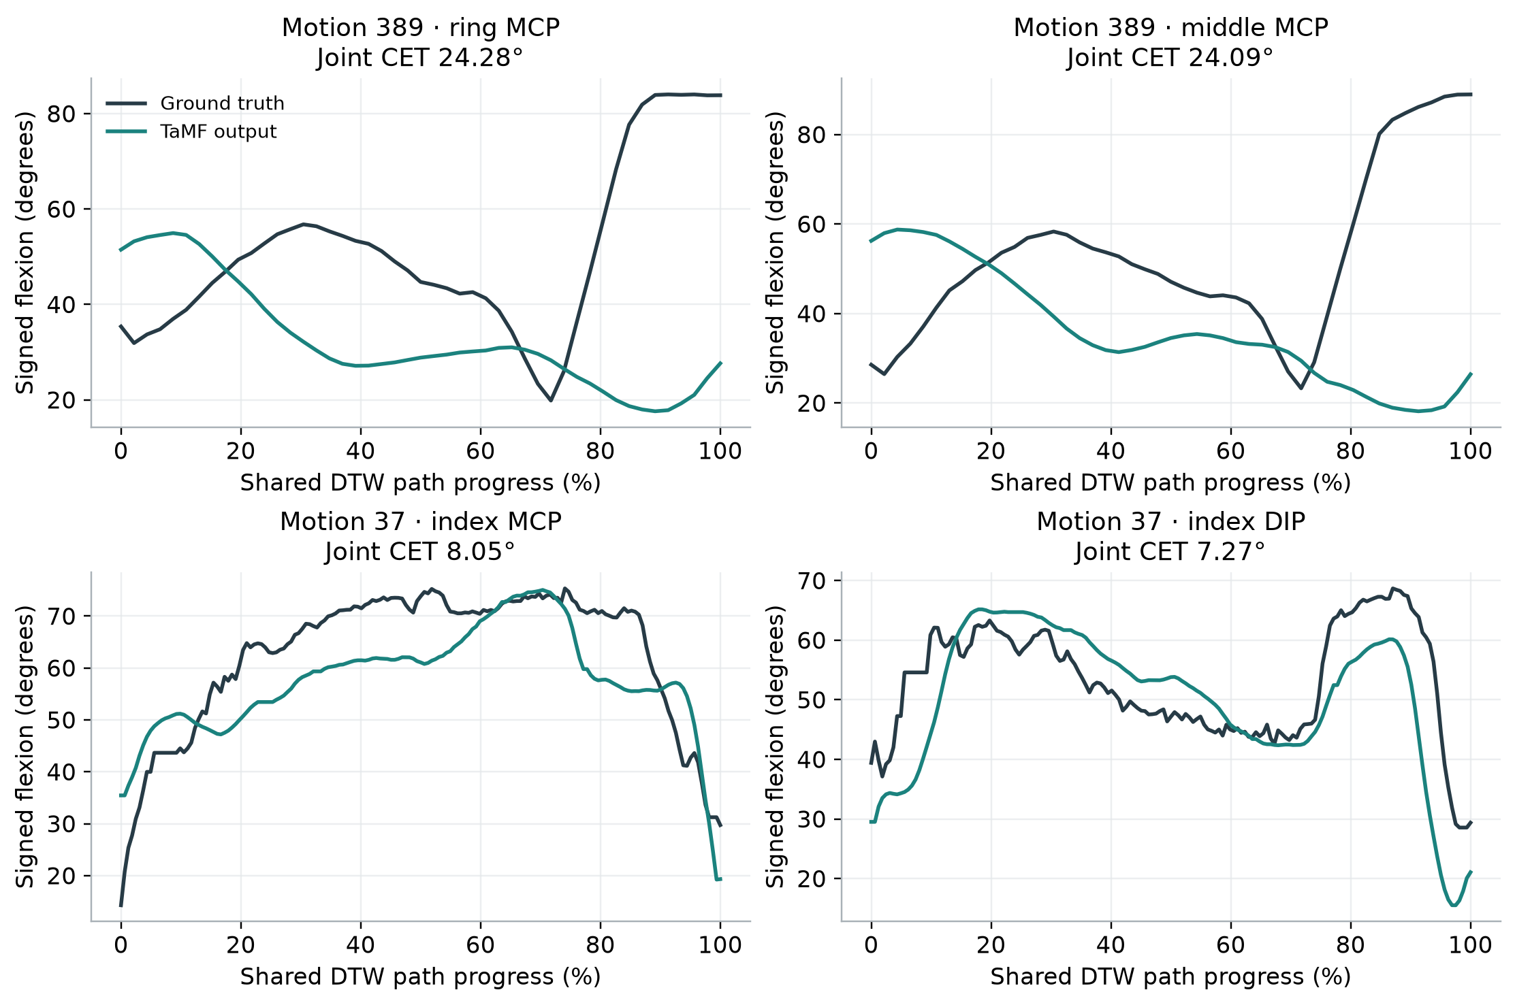
Figure 5. Two highest-error joints for each of two demanding motions. Ground truth and TaMF use the saved shared DTW pairs; horizontal position is path progress, not elapsed physical time. The curves show signed bend, whereas CET averages absolute differences. Source [3].

Motion 389 Close the microwave gate Right hand
The metadata reads “Close the gate of the microwave oven.” Over 4.60 s, GT depth is 33.72°, range 46.56°, total variation 85.79°, and rate 18.65°/s. CET is 17.33°. All five finger scores lie between 16.48° and 18.27°; ring MCP and middle MCP contribute 24.28° and 24.09°. This is a high-range, high-rate example with broadly distributed error.

Motion 37 Pour juice into a bowl Right hand
The metadata reads “Pour the juice from the tall blue mug to the bowl.” Over 16.575 s, GT depth is 50.68°, range 37.38°, total variation 128.39°, and rate 7.75°/s. CET is 5.31°. Index is the highest-error finger at 7.22°; index MCP is 8.05°. This output is a useful positive control despite substantial reference articulation.
Why this matters: substantial articulation can be reproduced comparatively well. The thesis should improve difficult cases while retaining successes such as motion 37.

Case studies of posture disagreement
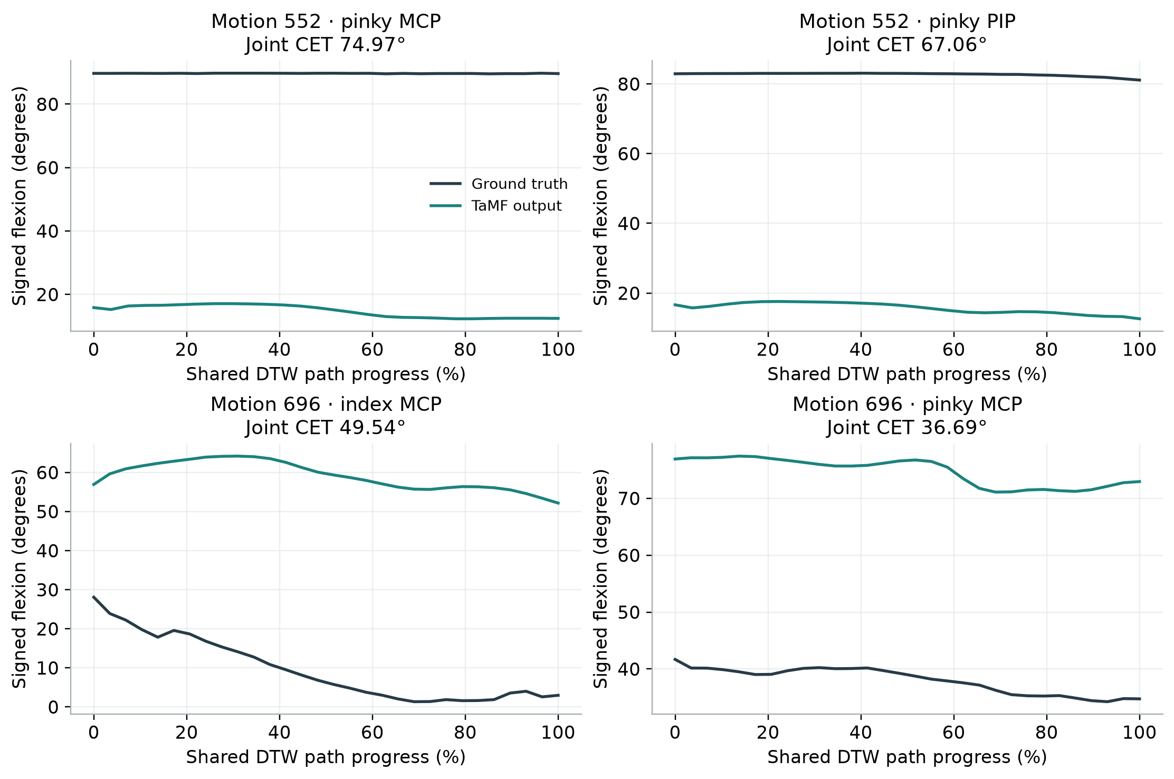
Figure 6. Aligned traces of the two largest-error joints in motions 552 and 696. The near-constant reference bend in motion 552 demonstrates that high CET can reflect posture disagreement rather than a missed large curl excursion. Source [3].

Motion 552 Press the microwave button Left hand
CET is 32.34°, with ring CET 55.08° and pinky CET 54.14°. Pinky MCP and PIP errors are 74.97° and 67.06°. Reference depth is 46.77°, but range is only 2.27° and total variation only 3.07°. The 0.225 s duration inflates the duration-normalized rate to 13.65°/s. Labeling this “high activity” without the duration and range would be misleading.

Motion 696 Reposition a spoon Right hand
The metadata reads “Rearrange the spoon from one position to another position.” CET is 20.59° over 2.90 s. GT depth is 23.85°, in the lowest quartile, with range 13.94°, total variation 21.20°, and rate 7.31°/s. Pinky CET is 24.42°; index MCP is the largest joint error at 49.54°, followed by pinky MCP at 36.69°. This is a low-depth, low-total-activity example with high CET, not a low-rate example.
Why this matters: a future articulation objective must address incorrect finger posture as well as dynamic curling. Activity alone is not an adequate failure detector.

A localized failure during pouring
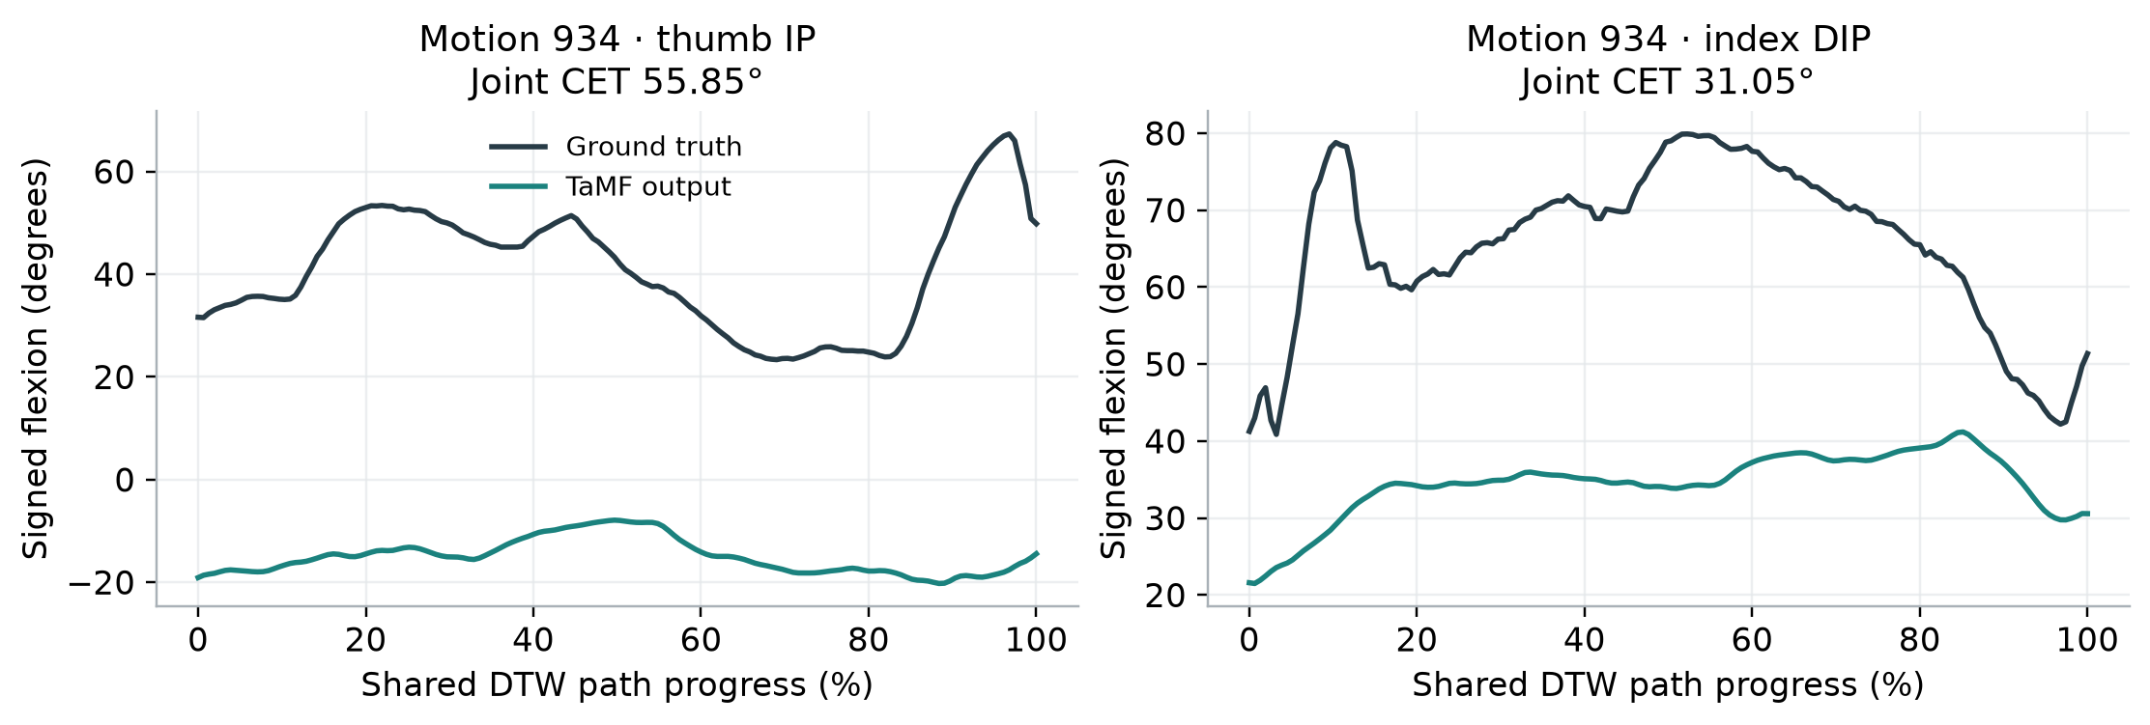
Figure 7. Motion 934 has a particularly large thumb IP error and a substantial index DIP error. These joint traces explain the high hand-level CET more clearly than a single motion score. Source [3].

Motion 934 Pour seasonings into a frying pan Right hand
The saved description reads “Pour the seasonings from the green striped bottle to the fryingpan.” The segment lasts 23.25 s. GT mean absolute flexion is 44.10°, range is 25.58°, total variation is 71.68°, and variation rate is 3.08°/s. CET is 17.54°, placing it above the batch 75th percentile.
Thumb CET is 28.83° and index CET is 24.98°, while pinky CET is 9.26°. Thumb IP alone contributes 55.85° of per-joint error; index DIP and MCP contribute 31.05° and 28.09°. Its relatively slow activity rate therefore does not imply accurate finger articulation. The rate is near, but slightly above, the lower-quartile cutoff of 3.05°/s.

What the traces support
Large angle separation persists after the permitted temporal alignment, so the mismatch is not eliminated by allowing nearby events to shift in time. The evidence identifies local bend disagreement. It does not tell us whether the object was grasped securely or the overall pouring interaction was correct.

What the pinky percentage means here
The pinky error is smaller than the thumb and index errors in this case, yet it remains appreciable relative to its reference flexion magnitude. Dividing pinky CET 9.2595° by pinky GT mean absolute flexion 46.0690° gives 0.20099, or 20.10%. The next section formalizes this additional analysis.
Why this matters: the highest-error finger changes by motion. Targeting only the pinky would miss a large thumb and index mismatch in this example.

Absolute error and relative flexion magnitude
For a finger f, define an additional descriptive ratio Nf = 100 × CETf / Df, where Df is the GT mean absolute flexion averaged over that finger’s three joints and original valid frames. Both quantities are in degrees and summarize the same anatomical joints. CET still uses DTW-path weighting; Df uses original-frame weighting. This ratio contextualizes angular magnitude, not the percentage of movement reproduced.
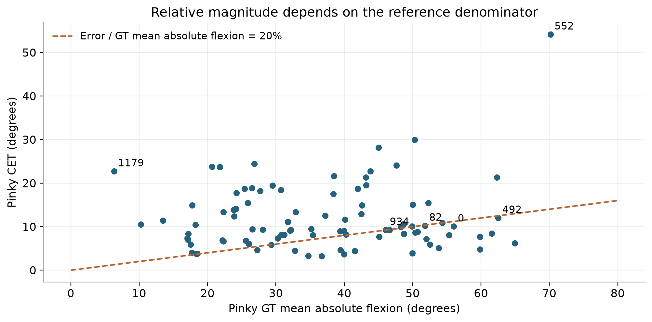
Figure 8. Pinky CET versus reference flexion depth. The dashed line marks a 20% error-to-depth ratio. Labels are original motion IDs. Near-zero reference depth can produce very large ratios, so absolute error and denominator must accompany any percentage. Additional analysis from [2].
Motion | Pinky CET | Pinky GT depth | Error / depth
0 | 10.05° | 56.02° | 17.94%
82 | 10.23° | 51.83° | 19.73%
492 | 12.01° | 62.53° | 19.20%
934 | 9.26° | 46.07° | 20.10%
Ratios are computed from unrounded source values. These examples support the approximately 20% concern under this specific definition, but it is not a batch-wide ceiling: the ratio of mean pinky CET to mean pinky GT depth is 32.79%. A ratio of means is different from a mean of motion-level ratios.
A finger can hold a deep curl with little movement, so depth is not a dynamic excursion measure. CET divided by total angular variation is also dimensionless, but compares a mean aligned error with an accumulated quantity that depends on duration and oscillations. It is not an interpretable fraction of reproduced movement. Dividing degrees by degrees/second would have units of seconds and cannot be reported as a percentage.
Why this matters: moderate absolute errors can be meaningful relative to reference flexion, but the denominator must be explicit and scientifically interpretable.

Main findings and limits of the evidence
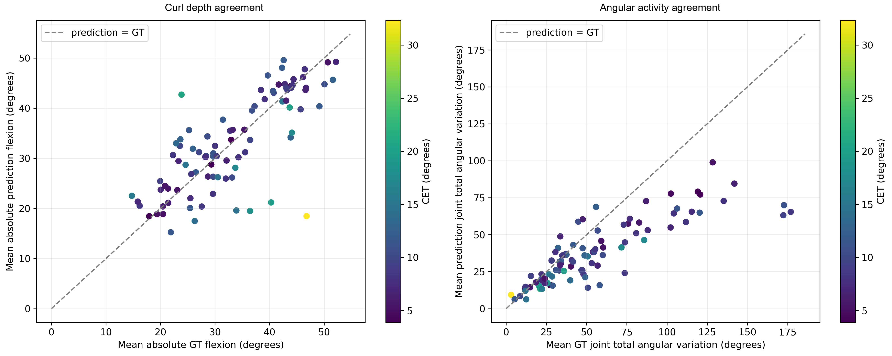
Figure 9. Agreement in flexion depth and accumulated angular activity. Each point is one motion, colored by CET. The diagonal denotes equality. Reused from notebook export 019 with titles simplified in a new copy; data and axes are unchanged. Source [4].
TaMF output has lower accumulated angular variation than GT in 74 of 91 motions. The median per-motion output/GT variation ratio is 0.758. This is consistent with reduced angular movement at the saved sampling, but does not by itself prove missing dexterity: noise, smoothing, sampling stride, and sequence duration influence variation. It is a descriptor comparison, not an alternative CET score.

Action patterns are exploratory
Press-button motions have mean CET 19.49° (n = 4), rearranging 12.82° (n = 8), and cutting 7.22° (n = 8). Removing motion 552 leaves a press-button mean of 15.20° across three motions. These small, unbalanced groups span only 20 source sequences overall and cannot establish a general ranking of action difficulty. Primitive suffixes identify occurrences, not necessarily distinct action classes.

What this batch establishes
The analysis shows residual aligned bend error, a repeated pinky/proximal-joint pattern, and heterogeneous performance across articulation demands. It includes strong high-articulation examples and low-excursion failures. These findings are more specific than a claim that TaMF is uniformly weak at dexterity.

What this batch cannot establish
The 91 selected unique segments are not the complete OakInk2 test set and are not 91 independent source sequences. Availability and deduplication determine the batch. Correlations are descriptive, not causal. No side-by-side analysis of conventional metric values was performed, so this report does not empirically demonstrate that those metrics miss these exact failures.
CET excludes global hand pose and several articulation components. Low CET does not guarantee the intended action, correct contact, or physical interaction. The available evidence supports an articulation-specific research target rather than a general verdict on TaMF motion quality.

Thesis direction and evidence provenance
CET exposes and quantifies residual finger-flexion disagreement that broader hand-motion evaluation may leave unresolved. The next thesis stage should reduce this error while preserving the intended motion and object interaction.

A focused experimental direction
Use CET as an articulation outcome, complemented by per-finger and per-joint scores. Prioritize the pinky and proximal joints without excluding motion-specific thumb or index failures. Evaluate separately across depth, excursion, accumulated activity, and activity rate, using prespecified strata rather than selecting only conspicuous failures.
Retain demanding successes such as motion 37 as controls. Include motion 389 for dynamic difficulty and motions 552 and 696 for posture disagreement. Check that a lower CET does not come from flattening motion or exploiting alignment: retain reference and predicted activity descriptors, inspect timing, and assess contact and action fidelity alongside articulation.
A subsequent controlled model or training-objective comparison should use matched motions, report uncertainty with source-sequence dependence in mind, and extend coverage beyond this partial batch. The hypothesis is testable: articulation-focused training can reduce final-output CET, especially on demanding finger motions, without sacrificing the interaction.

Source record
[1] Scripts/evaluate_cet.py and Scripts/CET.md. The implemented anatomical convention, shared DTW path, rho = 0.10, equal joint weights, valid-frame sampling, and aggregation rules are the methodological authority.
[2] common/partial_batch/test_one__0399/cet/20261006T015545971089Z/ — motions.json, motions.csv, and summary.json. Saved final-output evaluation dated 6 October 2026. Descriptions, IDs, hand sides, all scores, and GT descriptors come from this run.
[3] The same run’s arrays/*.npz. All 91 CET and per-joint values were checked against absolute differences on the saved DTW paths. Case-study plots use these arrays, without a new model evaluation.
[4] notebooks/exports/cet_graphs_20261006T025302388891Z/ and visualize_cet_results.ipynb. The exported plot collection was inspected for figure selection. Figure 9 reuses export 019; the other figures simplify or extend the saved-result analysis.
[5] notebooks/CET_Curl_Error_with_Time_Alignment.docx. Conceptual metric specification, interpreted in light of the actual evaluator. Its geometric alternatives and resampling guidance are not claimed as executed steps.
Reproducibility materials are in cet_findings_report/analysis/: verified_motion_analysis.csv, statistics.json, analyze.py, and figures.py. Source-file SHA-256 hashes accompany the statistics. All newly created assets and deliverables are confined to cet_findings_report; the evaluator, notebook, saved results, and existing exports were not modified.

