**UiPath**

**I. Features**

Email automation

Scrap data

Can work with spreadsheet, workbook, pdf

Auto simple reCAPTCHA popup (I’m not a robot)

Auto download, upload files

*** Some disadvantages of UiPath: does not have image processing (ML, face recognition, etc), barcode reader. Cannot work with physical form. Does not support voice commands (can be useful in call centers)

**II. When and which processes should be applied RPA**

- Repetitive: The process is predictable. The same process repeats consistently

- Rules-based: based on a series of simple "if then" rules. Rules based work is perfectly suited for RPA. On another hand, robots are not so good in handling unexpected situations or making judgment based decisions. However, with support of AI, ML, and OCR; RPA is now more advanced in making judgement

- Structure Input: When the inputs are easily accessible without human intervention. For example, CSV, Excel table or API calls

- Structure output: Same as the "Structured Inputs"

- Total volume: RPA is valueable if the total volume or number of transactions of the tasks are high. Example, screening thousands of CVs, or scraping hundreds of invoices.

- Volume variability: Volume of work to be done by the process- with variablility refering to peaks and troughs of work to be done for the process. Peaks result in needing to hire more people for a job and troughs means you would keep them idle which is costly. A robot can solve this problem of variablility.

- Off-hour processing: The more time required to do the process, the better for RPA.

- Error prone: The more prone to human error, the better for RPA.

- Dupplicate data: The more duplicate data, the better for RPA.

- Process stability: If a process changes frequently, more updates will have to be made to the robot. Ongoing robot maintainance costs can get expensive.

- System stability: same as process stability

**III. Market share of RPA**

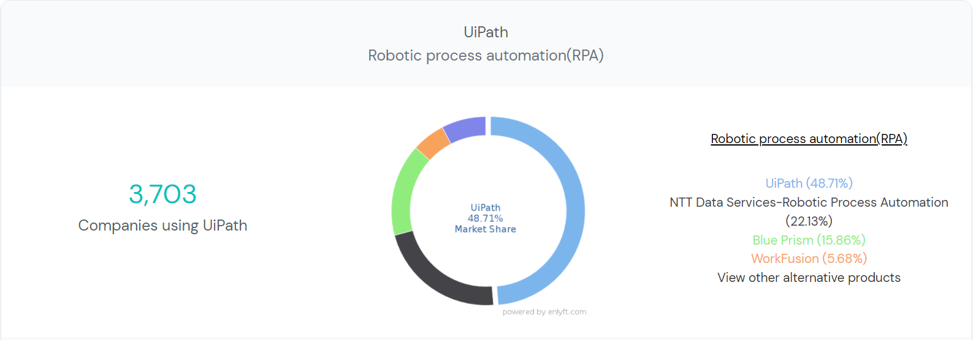

**VI. RPA in finances**

- Travel and Entertainment expense report (T&E expense reports):

+ For reimbursed: sometimes employees have to pay their own money when they have a meeting with the customers: paying for meals, rooms or entertainment. RPA can help scanning bill and reimbursed money for the employee

- Extract data from invoices, order receipts and purchase order: using 3-way-checking between invoices, order receipt and purchase order for

+ Chargeback

+ Discount, voucher, point accumulation