Nguyễn Tấn Hưng

1150080018

LAB1

TH1:

TH2:

TH3:

LAB2:

TH1:

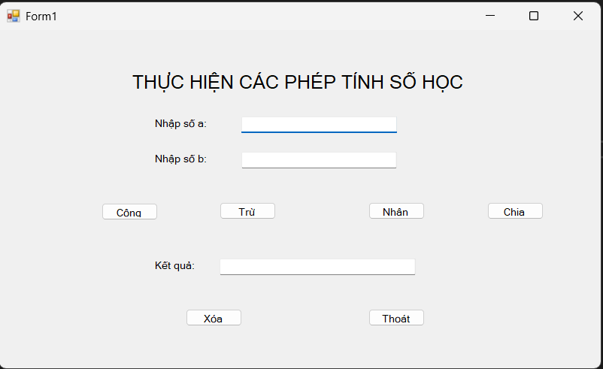

TH2:

TH3:

