Nguyễn Tấn Hưng

1150080018

LAB3

TH1

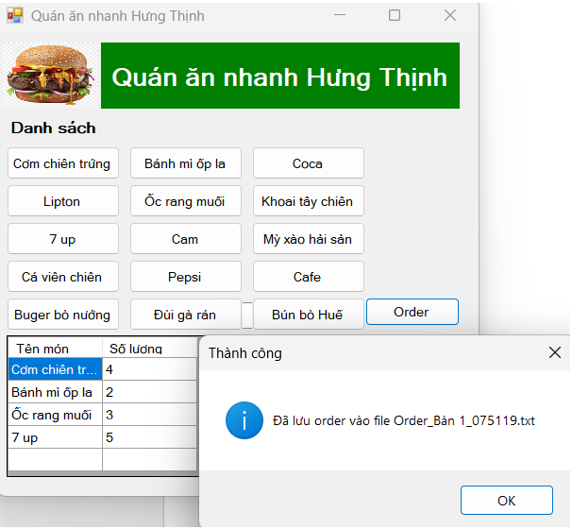

TH2

LAB4