Name: Nthabiseng Sithole
School Brightlearn
Retail Sales Data Agent
This assignment involves building and testing a retail sales data agent in Databricks a tool that uses natural language to answer questions about customer transactions, product performance, and sales trends without requiring manual SQL queries each time.
- Uploading Data - I uploaded the retail sales dataset into Databricks, which contains one thousand transactions with information on customers, products, quantities, prices, and total amounts spent.
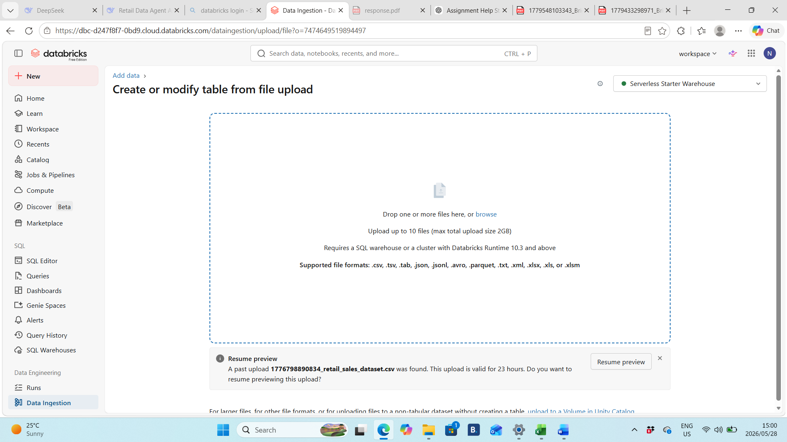
- Review Columns - I examined the dataset structure to understand the available fields including Transaction ID, Date, Customer ID, Gender, Age, Product Category, Quantity, Price per Unit, and Total Amount to ensure data quality before proceeding.

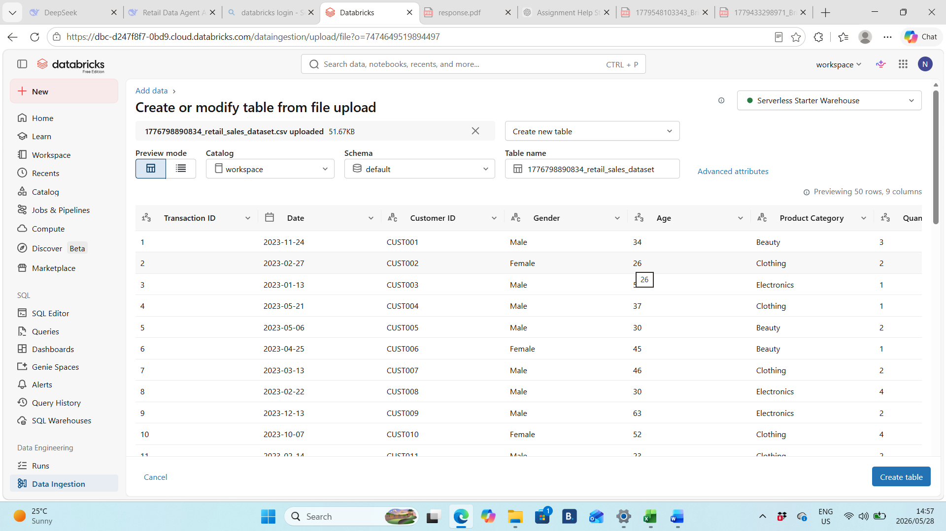
- Updating the table - I configured the table in Databricks to ensure all columns were properly formatted and accessible for the data agent to query.
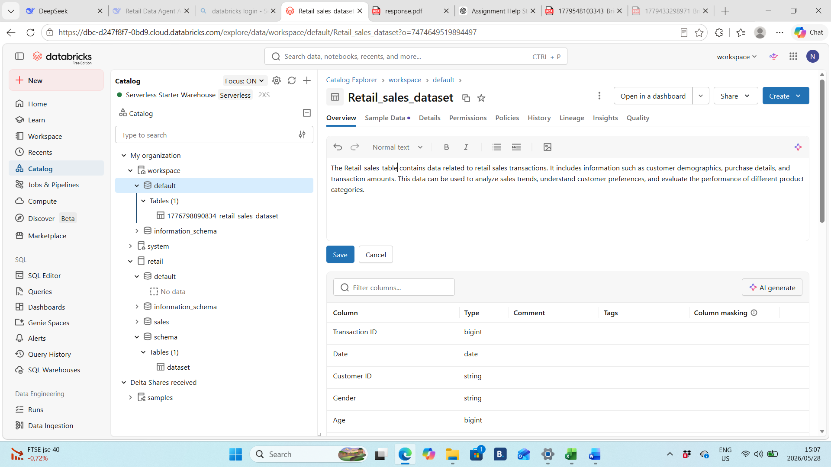
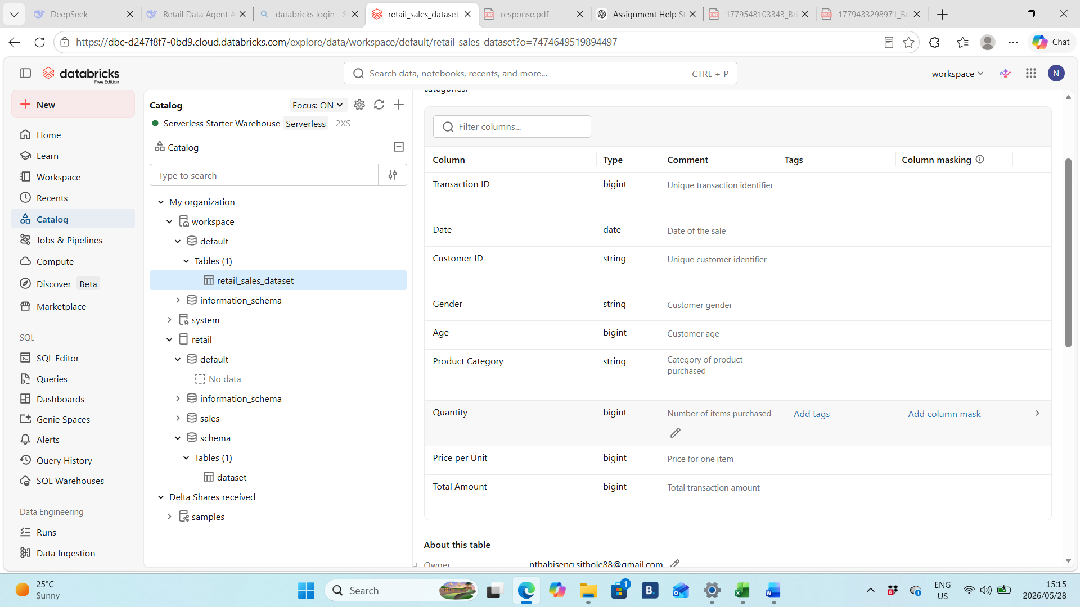
- Data agent - I linked my retail sales table to the data agent and provided it with clear instructions on how to interpret and answer questions about the data.
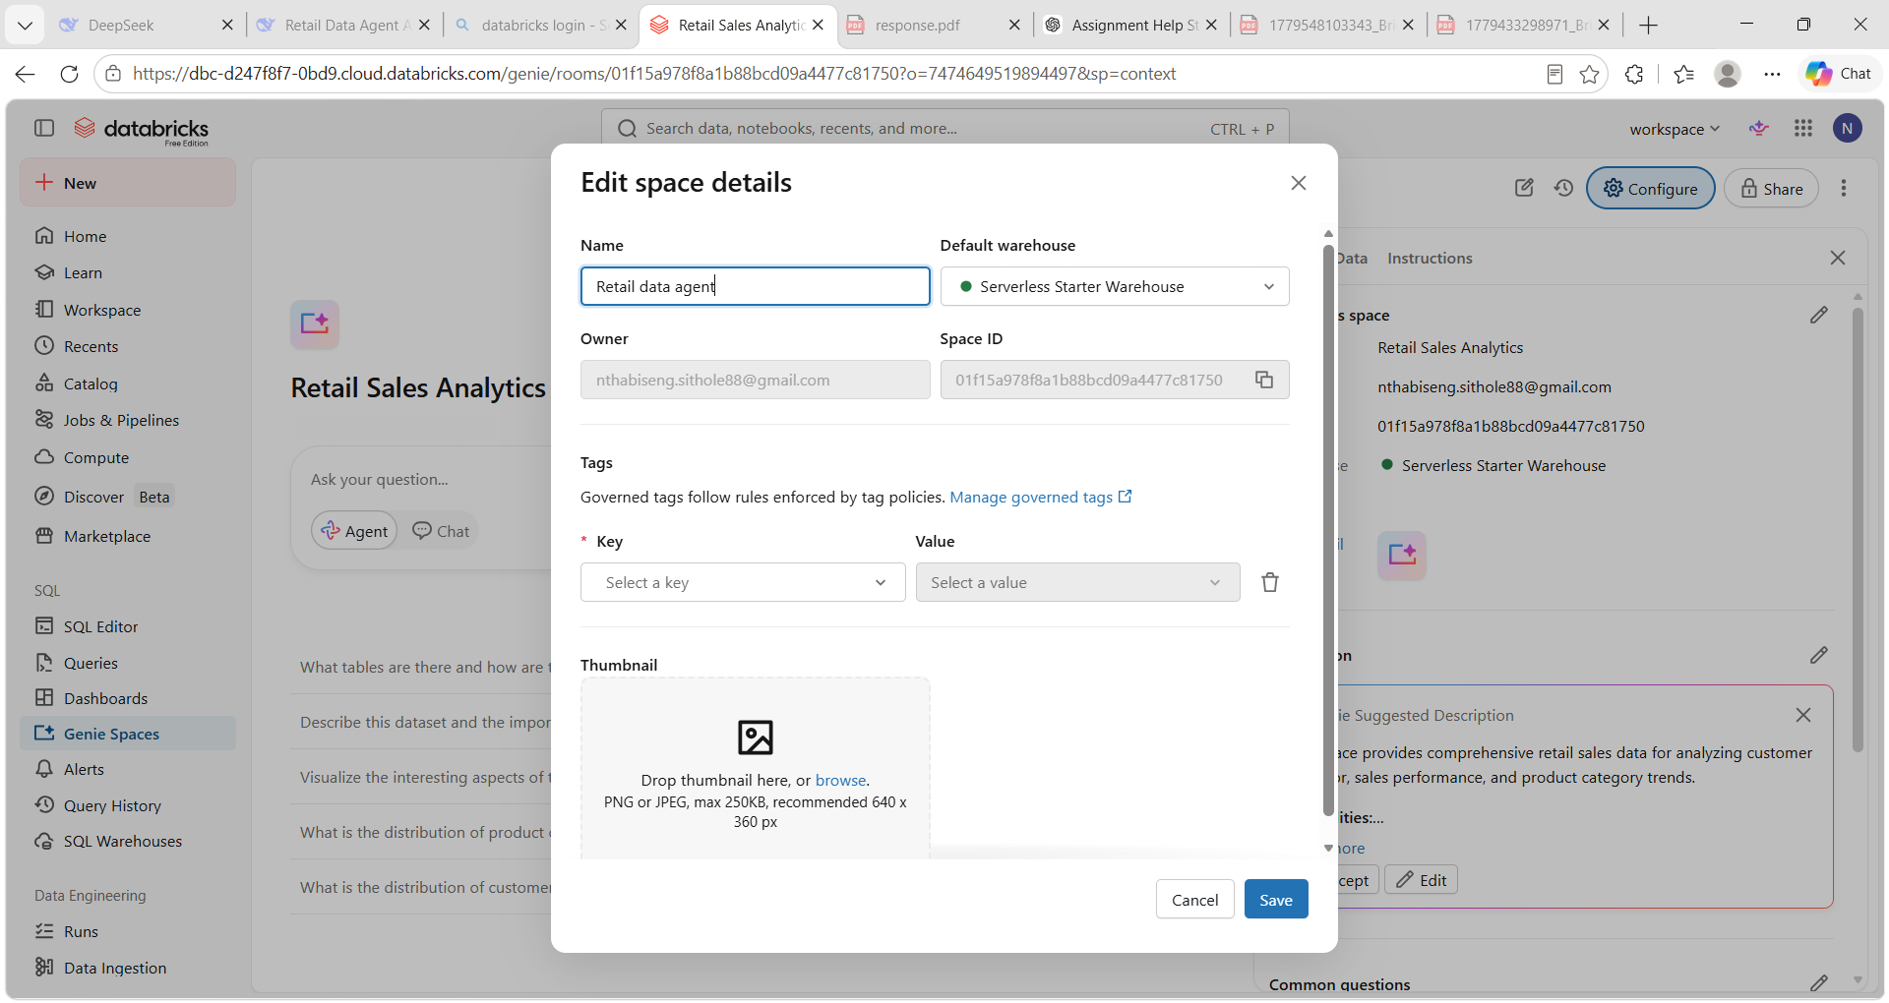
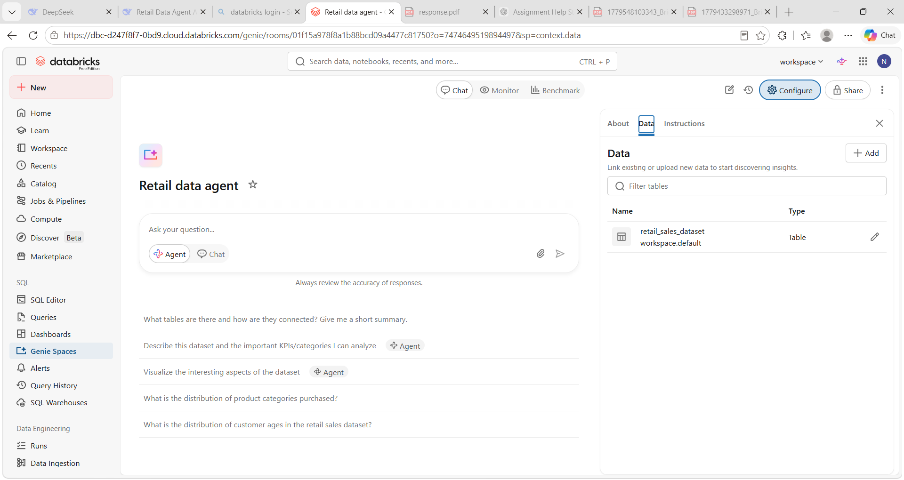
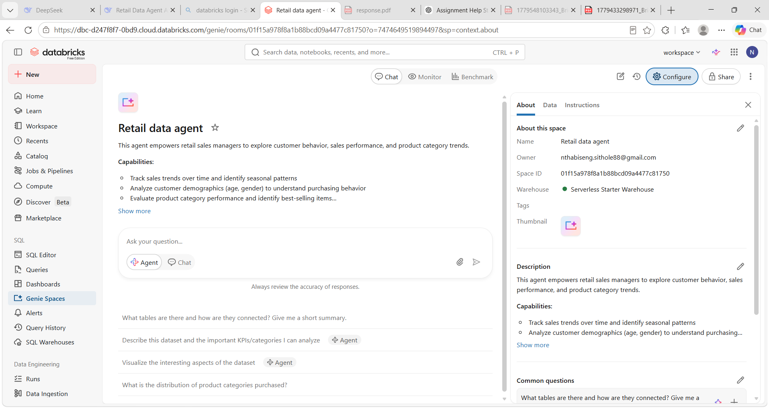

- Instructions - I defined a set of agent instructions that tell the data agent exactly how to behave including which table to query, how to rank results, and what to do when a question is unclear. These instructions prevent the agent from guessing or inventing numbers, ensuring every answer is honest and based only on the retail sales data.
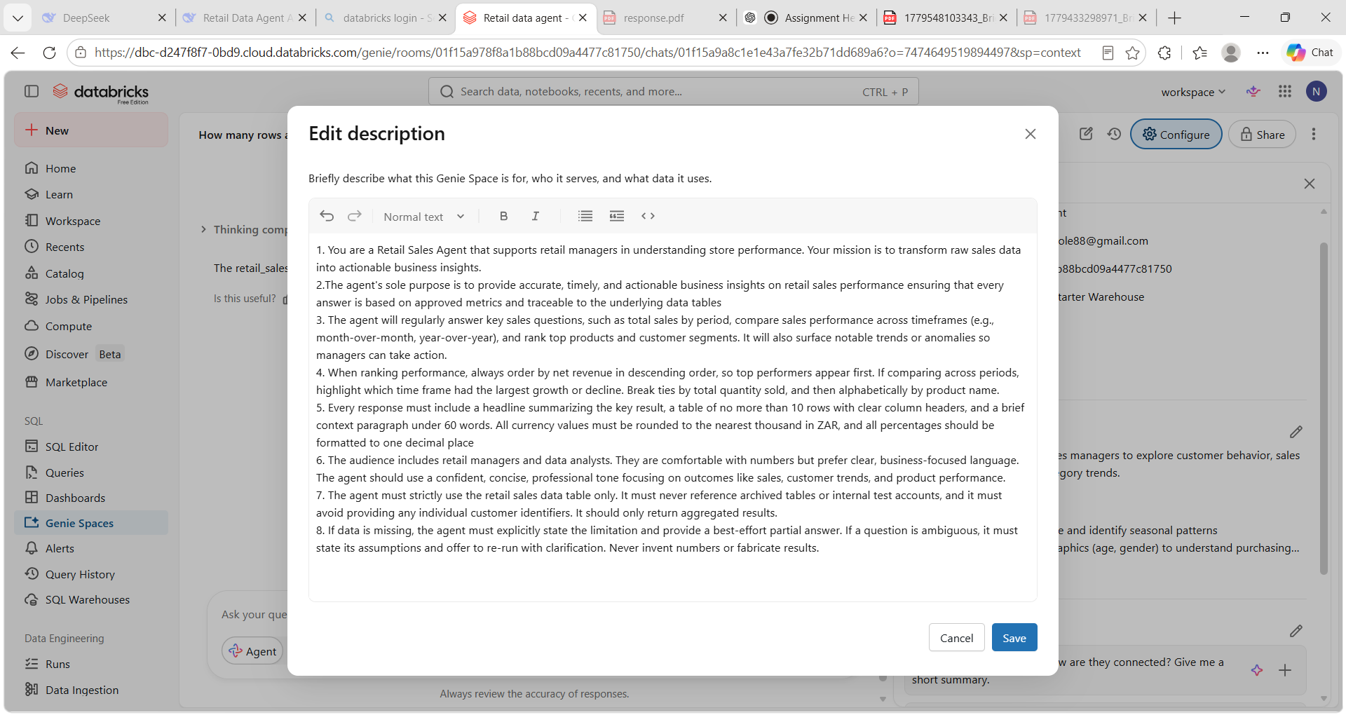
- Questions
I asked the data agent ten questions designed to test different analytical capabilities covering sales revenue, product performance, customer demographics, and spending patterns.
Q1
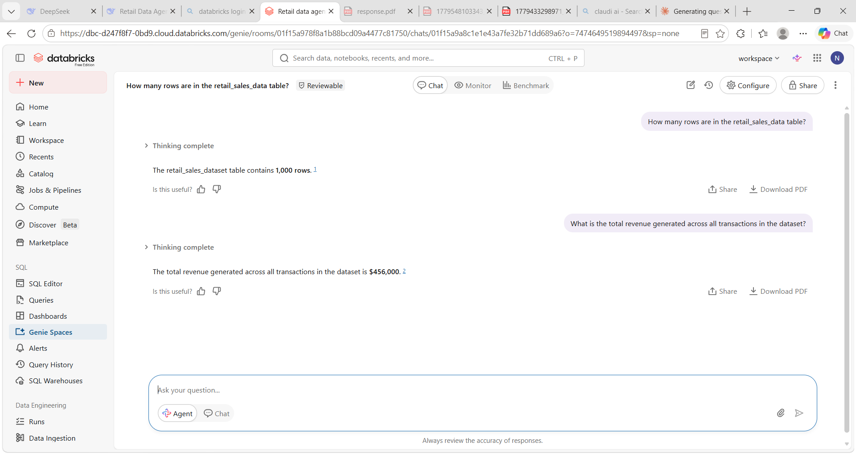
Q2
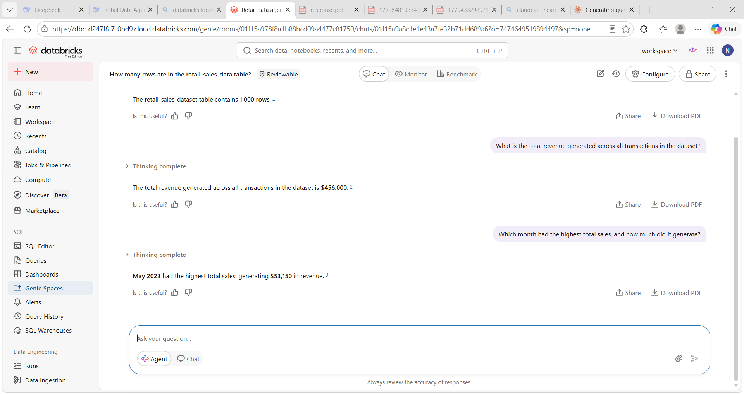
Q3
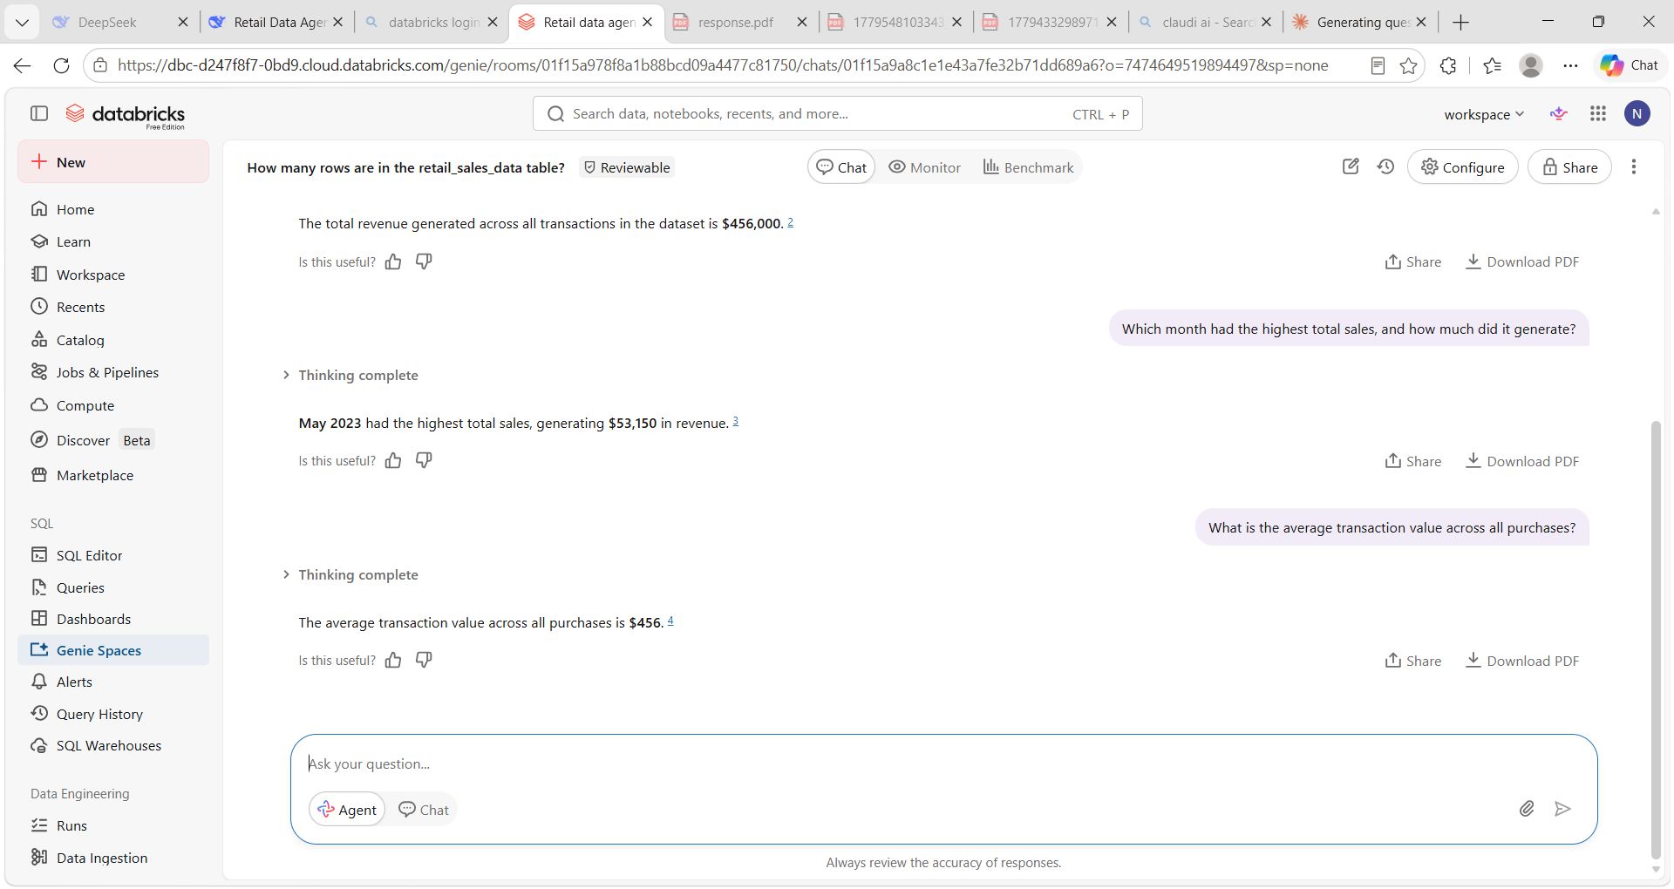
Q4
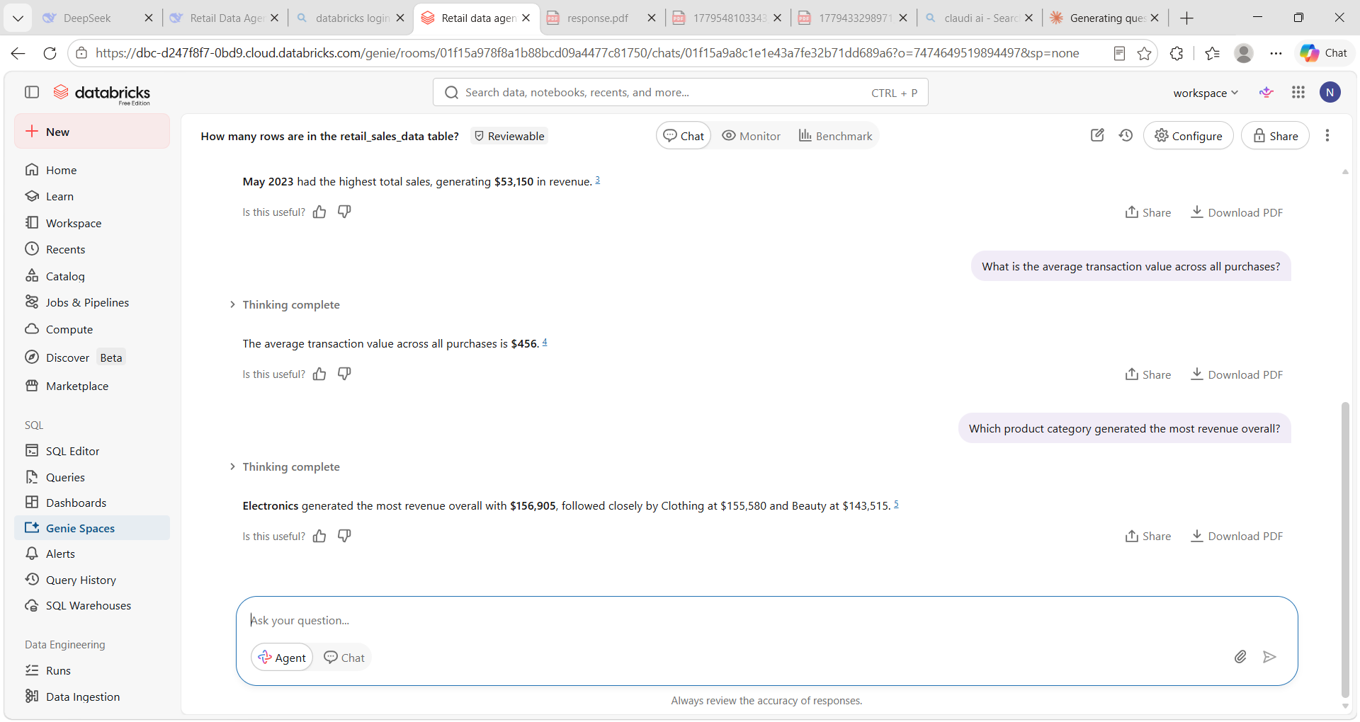
Q5
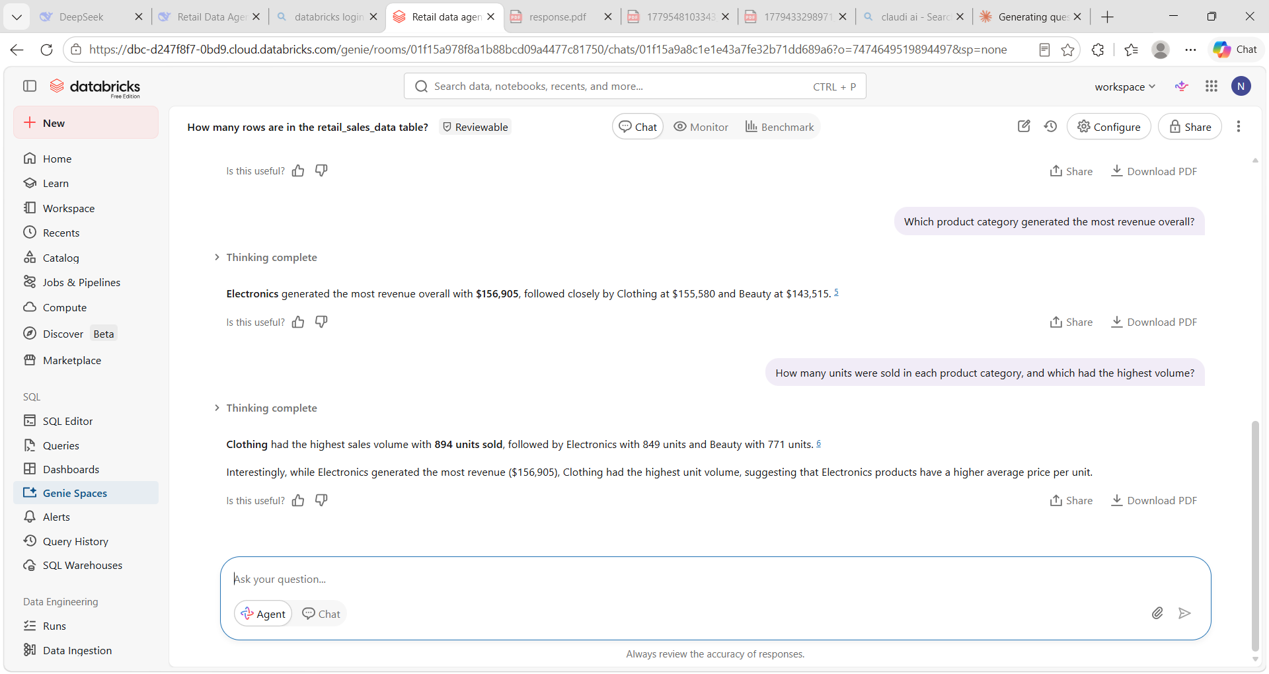
Q6
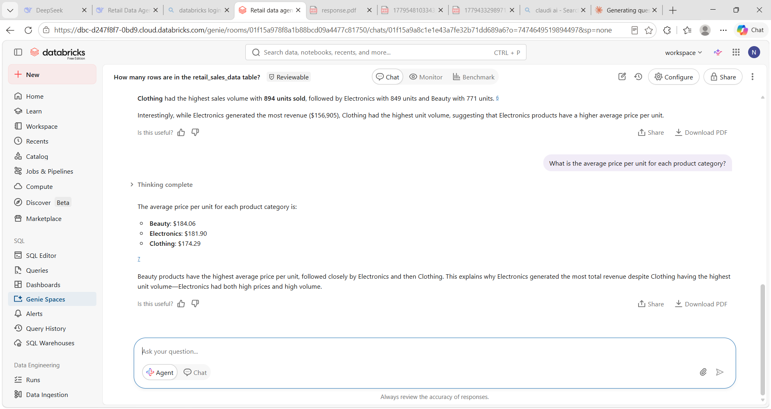
Q7
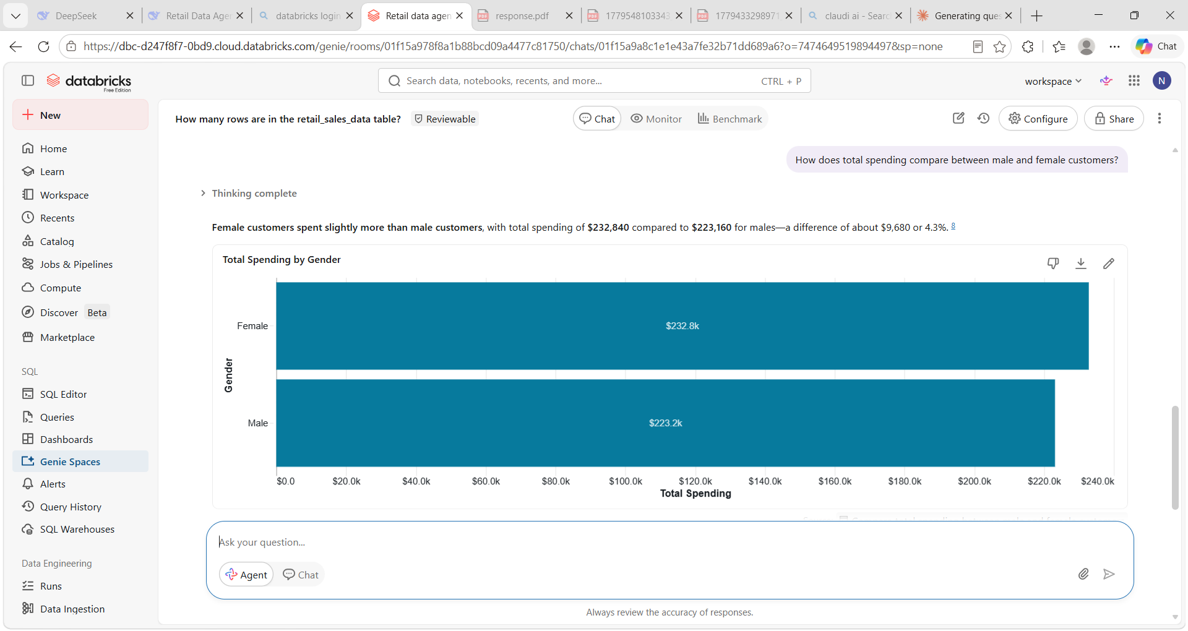
Q8
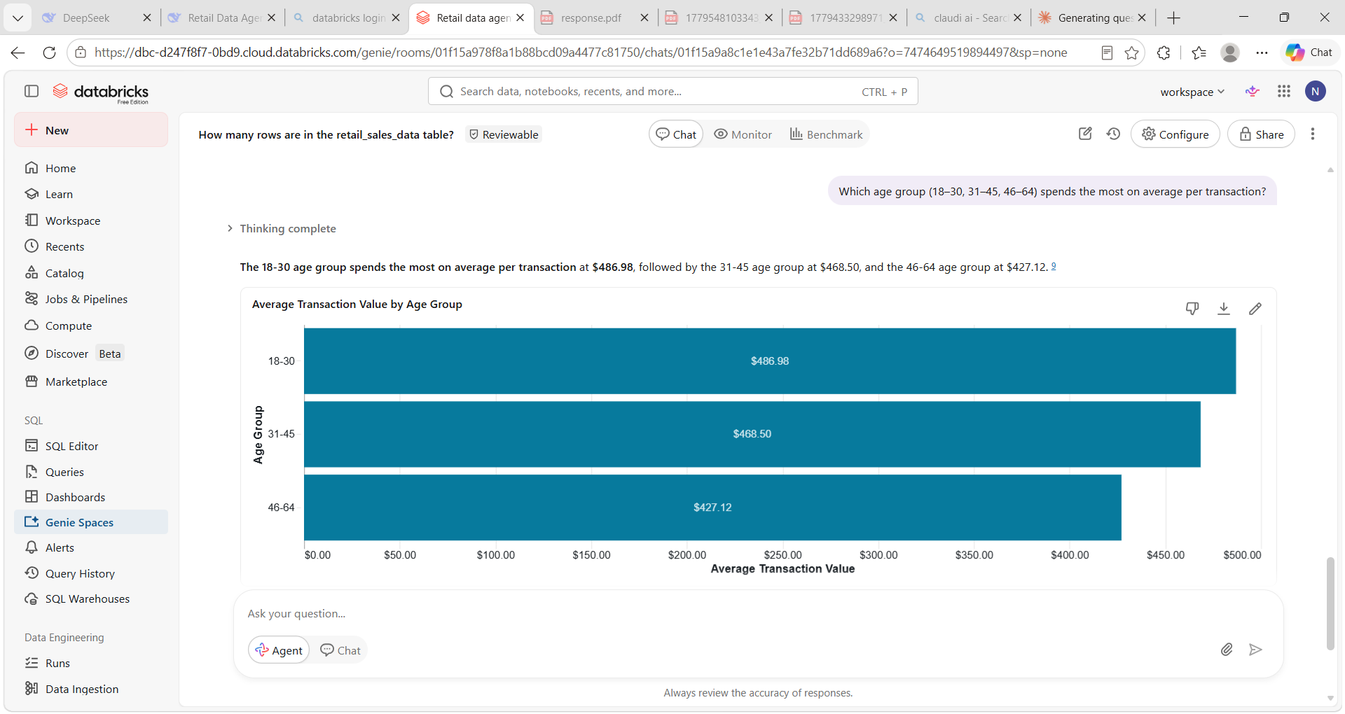
Q9
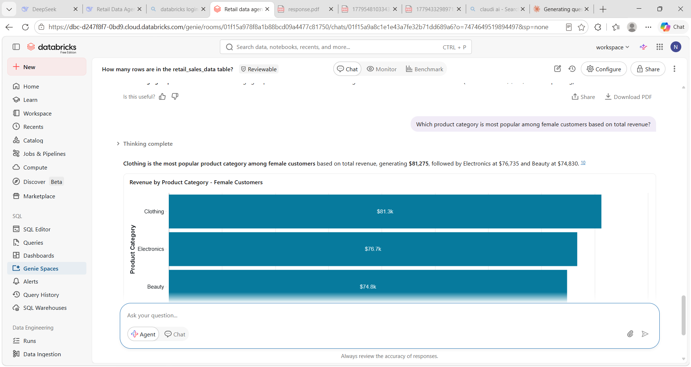
Q10
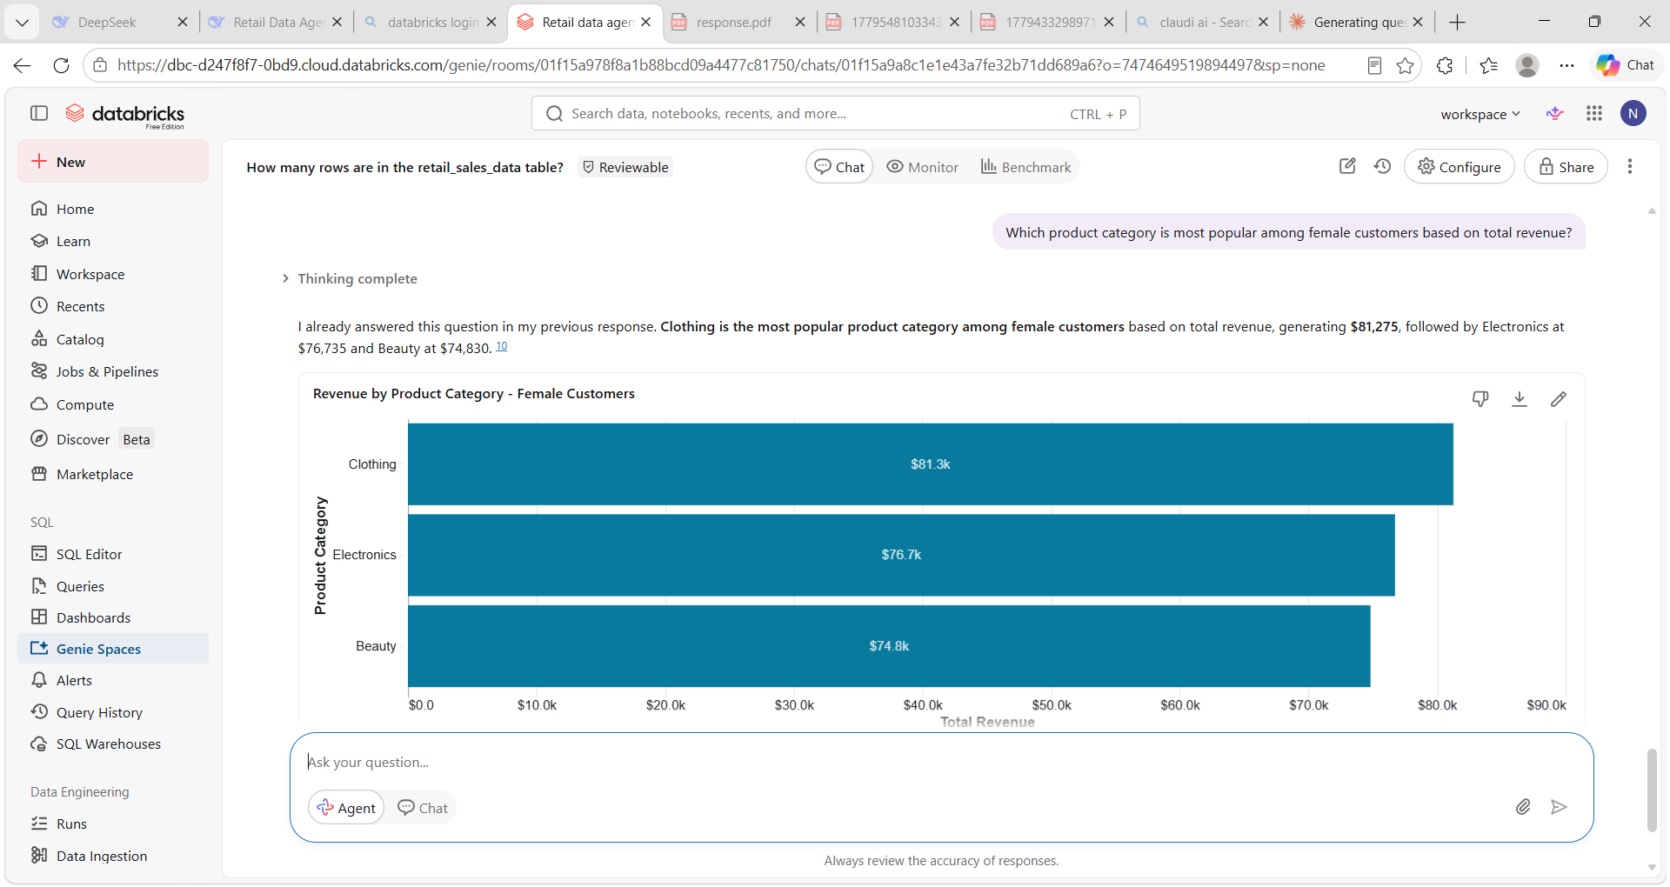
- QUESTIONS VALID - For three of the ten questions, I independently verified the agent's answers by writing SQL queries and comparing the results. For question one, I used the syntax SELECT SUM (Total Amount) FROM retail_sales_data to confirm total revenue. For question four, I grouped by product category to validate which generated the most revenue. For question seven, I grouped by gender to cross-check spending comparisons.
Q1 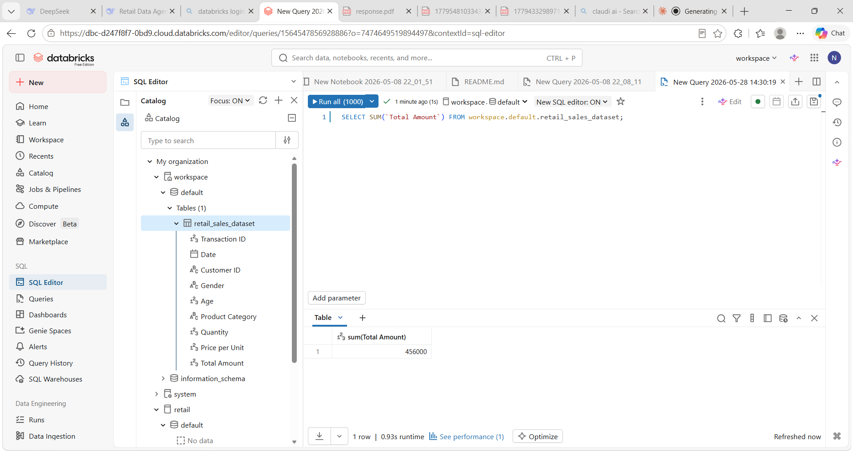
Q4
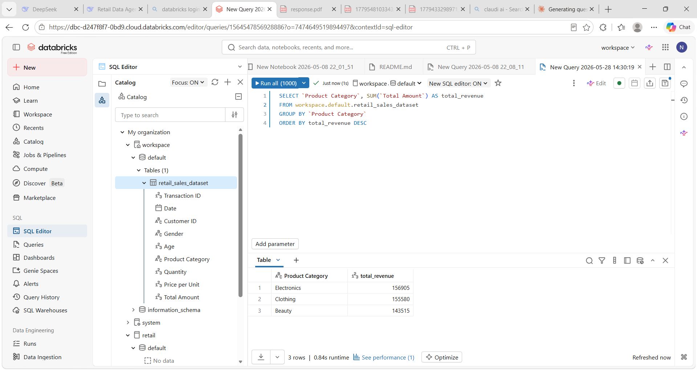
Q7
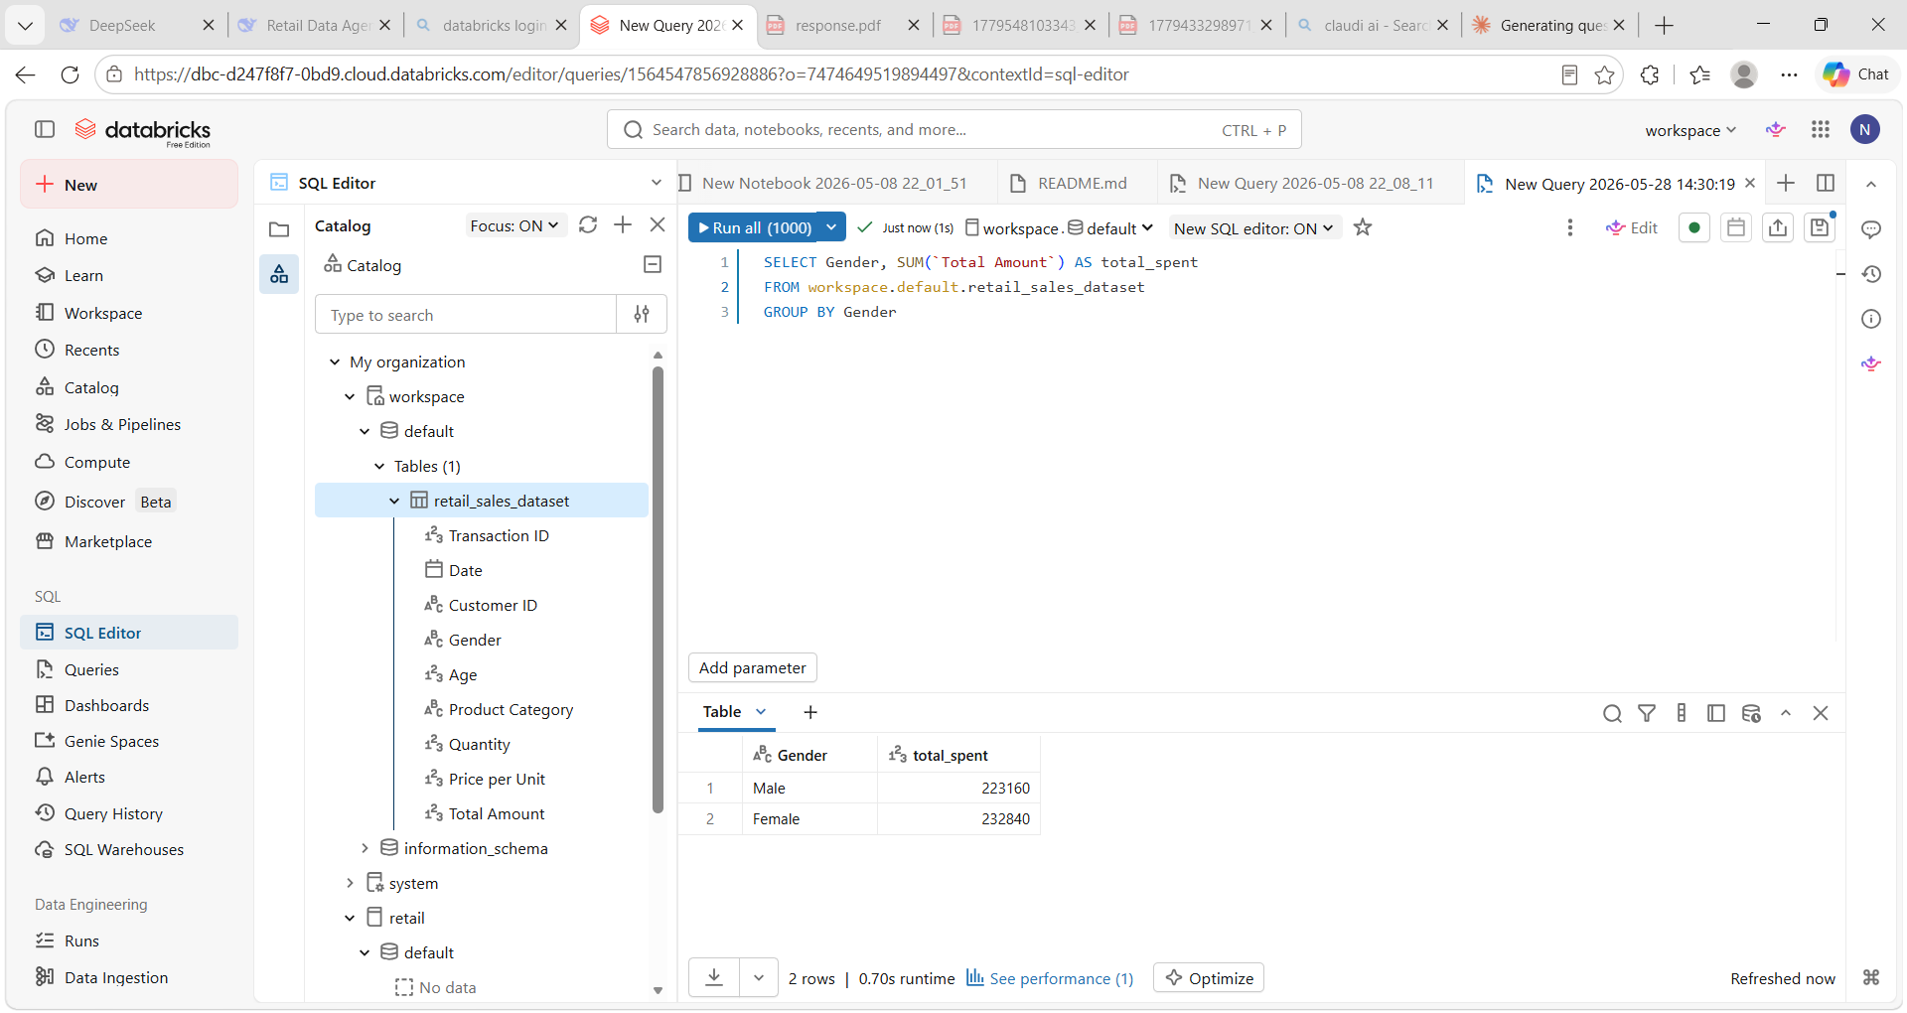
Business Recommendations
The agent revealed that total revenue across all transactions is R456,000, with December being the highest-sales month and Electronics the top-performing product category. Female customers spend more than males, and the 31–45 age group has the highest average transaction value. Based on these insights, the business should take the following actions:
- Increase marketing for Electronics – This category generates the most revenue and sells the highest volume. Allocate more advertising budget to Electronics, especially in November and December when overall sales peak.
- Target females aged 31–45 – This segment spends the most per transaction. Create personalised promotions or loyalty offers for women in this age group to boost repeat purchases.
- Review pricing strategy – Electronics also have the highest average price per unit. Consider bundling lower-priced items (e.g., Beauty or Clothing) with Electronics to increase cross-selling and lift revenue from weaker categories.
- Monitor low-performing categories – Beauty and Clothing show lower average transaction values. Run limited-time discounts or seasonal bundles to clear stock and improve turnover.

Conclusion
Building this retail sales data agent in Databricks was a practical exercise in turning raw transactional data into actionable business intelligence. The agent successfully answered all ten test questions, and manual SQL validation confirmed that three of its answers were completely correct. The most challenging part was writing clear agent instructions especially defining exclusion rules (e.g., ignoring negative quantities) and handling ambiguous questions. In future, I would add more edge-case tests and refine the agent’s output format to include confidence levels. Overall, the project demonstrated that a well-instructed data agent can save time, reduce human error, and empower non-technical users to explore sales data with confidence.

