Introduction to Computer Science for Personal use

[Document subtitle]

Administrator

[Company name]  [Company address]

Course Outline: Basic Introduction to Computer Science

Table of Contents

1. Introduction to Computer Science 2

1.1 What is Computer Science? 2

1.2 How is Computer Science Different from IT? 2

1.3 What is a computer? 3

1.4 What is a computer System? 3

1.4.1 Components of a computer system 4

2 Computer Architectures 6

2.1 What is an Architecture? 6

2.2 What is Computer Architecture? 6

2.3 Types of architectures 6

2.3.1 Von Neumann Architecture (a) 7

2.3.2 Harvard Architecture (b) 8

2.3.4 Differences between these Architectures: 8

2.4 Further Readings: 8

3 Hardware Components 10

3.1 CPU (Central Processing Unit) 10

3.1.1 The Central Processing Unit (CPU) has the following characteristics: 10

3.1.2 Parts of the CPU 10

3.2 GPU (Graphic Processing Unit) 14

3.2.1 What is a GPU? 14

3.2.2 How does a graphics card work with other components? 14

3.2.3 GPU vs. Graphics Card: What’s the Difference? 15

3.3 Computer Storage Devices 17

3.1 Cache Memory 17

3.2 Primary Memory (Main Memory) 18

3.3 Secondary Memory 19

4 How the computer Works 21

4.1 Introduction Global Summary of Computer System 21

4.2 Human Computer Interaction (HCI) 21

4.3 Definitions Of terms 22

4.4 How Instructions are treated from the user to the computer 23

# Introduction to Computer Science

## 1.1 What is Computer Science?

Computer science is the study of computation, information, and automation using theoretical disciplines (such as algorithms, data structures, theory of computation, and information theory) to applied disciplines (including the design and implementation of hardware and software).

## 1.2 How is Computer Science Different from IT?

Computer science focuses on the development and testing of software and software systems. It involves working with mathematical models, data analysis and security, algorithms, and computational theory. Computer scientists define the computational principles that are the basis of all software.

Information technology (IT) focuses on the development, implementation, support, and management of computers and information systems. IT involves working both with hardware (CPUs, RAM, hard disks) and software (operating systems, web browsers, mobile applications). IT professionals make sure that computers, networks, and systems work well for all users.

Some common job titles for computer scientists include:

* Computer Programmer,
* Information Technology Specialist
* Data Scientist, Web Optimization Specialist,
* Product Manager
* Engineers: Systems, Software, Hardware & Quality Assurance.
* Developers: Web Developers (Front-End, back-End and Full-Stack), Desktop, Mobile and Video Game
* Analysts: Security Analyst, Systems Analyst, Business Intelligence Analyst
* Administrators: Network, Database Administrator
* Chief Information Officer
* Health Information Technician

## 1.3 What is a computer?

A computer is a machine that can be programmed or instructed to carry out sequences of arithmetic or logical operations (computation) automatically. These programs enable computers to perform a wide range of tasks.

## 1.4 What is a computer System?

First a system set of principles or procedures according to which something is done; an organized scheme or method. A system is also a set of things working together as parts of a mechanism or an interconnecting network; a complex whole.

Therefore, a Computer System In its most basic form, a computer system is a programmable electronic device that can accept input; store data; and retrieve, process and output information.

**Parts of a Computer system:**

A computer system primarily comprises a central processing unit (CPU), memory, input/output devices and storage devices. All these components function together as a single unit to deliver the desired output.

A computer system comes in various forms and sizes. It can vary from a high-end server to personal desktop, laptop, tablet computer, or a smartphone as which shall see later on in Von Neumann Architecture.

### 1.4.1 Components of a computer system

The components of a computer system are typically divided into hardware and software parts, which are both essential in making a computer system functional.

#### 1.4.1.1 Hardware (Physical Part)

The hardware components include the computer that can be touched and seen (inside or outside), such as a circuit board and storage devices; and any peripherals attached to the computer.

These components can be either classified as input devices, such as a mouse or keyboard, or output devices, such as a monitor or a printer. While output devices reflect or display user data, input devices are designed to accept user data.

Example: Motherboard, mouse, monitor, scanner, memory devices etc

#### 1.4.1.2 Software (Instructions and Programs)

Software components are the set of instructions that are stored and run on the computer hardware. The software controls how a computer system works. It can be grouped into the following two categories:

**System software:** Programs that are needed for the computer to function, including the OS, programming language translators and library routines.

**Utilities software:** Utility software is a program specifically designed to help manage and tune system or application software which may enhance or provide additional facilities to carry out tasks that are beyond the capabilities of the operating system. Example:

* Anti-virus utilities scan for computer viruses and block or remove them.
* Computer access control software grants or denies requests for access to system resources.
* Diagnostic programs determine and report the operational status of computer hardware and software. Memory testers are one example.
* Network utilities analyze the computer's network connectivity, configure network settings, check data transfer or log events.
* Package managers are used to configure, install or keep up to date other software on a computer.
* performance in a computer system.

**Application Software:** Programs that let a user perform particular tasks, including word processing, database management, spreadsheet calculations, web browsing, gaming, programming and graphic design. Additionally, it may also include specific programs such as accounts, payroll and air traffic control. Examples:

Microsoft Office, PowerPoint, Zuma Deluxe (game), Adobe Photoshop, google chrome, vlc and so on.

# 2 Computer Architectures

## 2.1 What is an Architecture?

Architecture, the art and technique of designing and building, as distinguished from the skills associated with construction.

## 2.2 What is Computer Architecture?

Computer architecture is concerned with balancing the performance, efficiency, cost, and reliability of a computer system. Therefore, it is defined as the end-to-end structure of a computer system that determines how its components interact with each other in helping execute the machine’s purpose (i.e., processing data).

## 2.3 Types of architectures

* **Instruction set architecture (ISA):** defines the machine code that a processor reads and acts upon as well as tshe word size, memory address modes, processor registers, and data type.
* **Microarchitecture:** also known as "computer organization", this describes how a particular processor will implement the ISA. The size of a computer's CPU cache for instance, is an issue that generally has nothing to do with the ISA.
* **Systems design:** includes all of the other hardware components within a computing system, such as data processing other than the CPU (e.g., direct memory access), virtualization, and multiprocessing (examples: Client-server architecture, Single instruction, multiple data (SIMD) architecture, Multicore architecture).

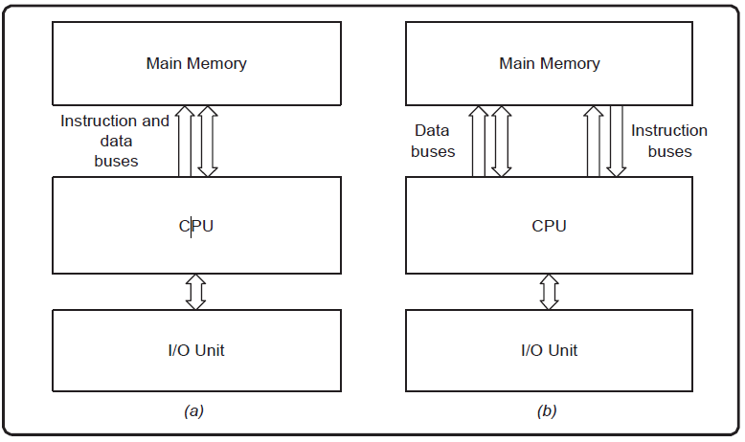

Examples of Computer Architecture: Von Neumann Architecture (a) and Harvard Architecture (b).

### 2.3.1 Von Neumann Architecture (a)

Mathematician John von Neumann and his colleagues proposed the von Neumann architecture in 1945, which stated that a computer consists of: a processor with an arithmetic and logic unit (ALU) and a control unit; a memory unit that can communicate directly with the processor using connections called buses; connections for input/output devices; and a secondary storage for saving and backing up data.

The central computation concept of this architecture is that instructions and data are both loaded into the same memory unit, which is the main memory of the computer and consists of a set of addressable locations. The processor can then access the instructions and data required for the execution of a computer program using dedicated connections called buses – an address bus which is used to identify the addressed location and a data bus which is used to transfer the contents to and from a location.

### 2.3.2 Harvard Architecture (b)

Another popular computer architecture, though less so than the von Neumann architecture, is Harvard architecture.

The Harvard architecture keeps instructions and data in separate memories, and the processor accesses these memories using separate buses. The processor is connected to the ‘instructions memory’ using a dedicated set of address and data buses, and is connected to the ‘data memory’ using a different set of address and data buses.

This architecture is used extensively in embedded computing systems such as digital signal processing (DSP) systems, and many microcontroller devices use a Harvard-like architecture.

### 2.3.4 Differences between these Architectures:

Homework: Give the differences between Von Neumann and Harvard Architectures and give their differences with others.

## 2.4 Further Readings:

As Summary, Computer architecture is the arrangement of the components that comprise a computer system and the engine at the core of the processes that drive its functioning. It specifies the machine interface for which programming languages and associated processors are designed.

Complex instruction set computer (CISC) and reduced instruction set computer (RISC) are the two predominant approaches to the architecture that influence how computer processors function.

CISC processors have one processing unit, auxiliary memory, and a tiny register set containing hundreds of unique commands. These processors execute a task with a single instruction, making a programmer’s work simpler since fewer lines of code are required to complete the operation. This method utilizes less memory but may need more time to execute instructions.

A reassessment led to the creation of high-performance computers based on the RISC architecture. The hardware is designed to be as basic and swift as possible, and sophisticated instructions can be executed with simpler ones.

NB: Read also Wikipedia on Computer Architectures.

# 3 Hardware Components

## 3.1 CPU (Central Processing Unit)

The central processing unit (CPU), is the physical heart of the entire computer system, to which various components, such as input/output devices and auxiliary storage units, are connected. The CPU is also known as the brain of the computer.

### 3.1.1 The Central Processing Unit (CPU) has the following characteristics:

* The CPU is regarded as the computer’s brain.
* The CPU is responsible for all data processing operations.
* It saves information such as data, intermediate results, and instructions (program).
* It directs the operation of all computer components.

### 3.1.2 Parts of the CPU

The CPU itself is made up of the three components listed below.

* Memory or Storage Unit
* Control Unit
* Arithmetic Logic Unit.

#### Memory or Storage Unit

This unit has the capability of storing instructions, data, and intermediate results. When necessary, this unit sends data to other computer units.

It is also referred to as an internal storage unit, main memory, primary storage, or Random-Access Memory (RAM). Its size has an impact on its speed, power, and capability. In a computer, there are two types of memories: primary memory and secondary memory.

The memory unit’s functions are as follows:

1. It saves all of the data and instructions needed for processing.
2. It saves intermediate processing results.
3. It saves the final results of processing before they are sent to an output device.

The main memory is where all inputs and outputs are routed.

#### The Control Unit

This unit manages the operations of all computer components but does not perform any actual data processing. To function properly, all CPU components must be synchronized. The control unit performs this function at a rate determined by the clock speed and is in charge of directing the operations of the other units through the use of timing signals that run throughout the CPU.

**This unit’s functions are as follows:**

* It is in charge of controlling the transfer of data and instructions among the various components of a computer.
* It manages and coordinates all of the computer’s units.
* It reads instructions from memory, interprets them, and directs the computer’s operation.
* It communicates with Input/Output devices to transfer data.
* It neither processes nor stores data.

#### Arithmetic Logic Unit

This unit is divided into two subsections, namely,

Sections of Arithmetic and Logic

##### Arithmetic Unit

The arithmetic unit’s function is to perform arithmetic operations such as addition, subtraction, multiplication, and division. All complex operations are carried out by repeatedly performing the aforementioned operations.

##### Logic Unit

The logic unit’s function is to perform logic operations on data such as comparing, selecting, matching, searching and merging.

When adding two numbers, for example, one is placed in the A register and the other in the B register. The addition is performed by the ALU, and the result is stored in the accumulator. The data to be compared is placed into the input registers if the operation is logical. The comparison result, a 1 or 0, is stored in the accumulator. The accumulator content is then placed into the cache location reserved by the program for the result, whether it is a logical or arithmetic operation.

The ALU also performs another type of operation. The result is a memory address, which is used to calculate a new memory location to begin loading instructions. The outcome is stored in the instruction pointer register.

##### Instruction registers and pointer

The instruction pointer identifies the memory location in which the CPU will execute the next instruction. When the current instruction is completed, the CPU loads the next instruction into the instruction register from the memory location specified by the instruction pointer.

#### Cache

The CPU never has direct access to RAM. Modern CPUs have one or more cache layers. The CPU’s calculation speed is much faster than the RAM’s ability to feed data to the CPU.

Cache memory is faster than system RAM and, because it is located on the processor chip, hence closer to the CPU. The cache stores data and instructions to keep the CPU from having to wait for data to be retrieved from RAM. When the CPU requires data—and program instructions are considered data—the cache checks to see if the data is already in residence and returns it to the CPU.

If the requested data is not in the cache, it is retrieved from RAM and used to move more data from RAM into the cache using predictive algorithms. The cache controller analyses the requested data and attempts to predict what additional data from RAM will be required. It loads the expected data into the cache. By storing some data closer to the CPU in a faster-than-RAM cache, the CPU can stay busy and avoid wasting cycles waiting for data.

Our simple CPU has three cache levels. Levels 2 and 3 are intended to predict what data and program instructions will be required next, and to move that data from RAM to a location closer to the CPU so that it is ready when needed. These cache sizes typically range from 1 MB to 32 MB, depending on the processor’s speed and intended use.

Source: https://www.hubspire.com/what-is-a-cpu-and-what-is-its-function/

## 3.2 GPU (Graphic Processing Unit)

A graphics card is a device that is connected to your motherboard and generates the images that you see on your monitor. It has its own processor, called the graphics processing unit (GPU), and its own memory, called the video memory (VRAM).

### 3.2.1 What is a GPU?

The Graphics Processing Unit (GPU) is a specialized computer chip (sometimes circuit, component) that is responsible for performing complex calculations, rendering graphics and alter memory to accelerate the creation of images (graphics).

Note: GPUs were originally designed to accelerate the rendering of 3D graphics. Over time, they became more flexible and programmable, enhancing their capabilities. This allowed graphics programmers to create more interesting visual effects and realistic scenes with advanced lighting and shadowing techniques. Other developers also began to tap the power of GPUs to dramatically accelerate additional workloads in high performance computing (HPC), deep learning, and more.

### 3.2.2 How does a graphics card work with other components?

A graphics card works with other components in your computer system to deliver a smooth and realistic visual experience. The CPU, or the central processing unit, sends instructions and data to the GPU, which then processes them and sends the output to the monitor. The RAM, or the random-access memory, also communicates with the GPU and provides temporary storage for the data that the CPU and the GPU need.

What factors affect the performance of a graphics card?

The performance of a graphics card depends on several factors, such as the clock speed, the memory size, the memory bandwidth, the architecture, and the cooling system. The clock speed is the frequency at which the GPU operates, measured in megahertz (MHz) or gigahertz (GHz). The higher the clock speed, the faster the GPU can process data. The memory size is the amount of VRAM that the graphics card has, measured in megabytes (MB) or gigabytes (GB). The more VRAM, the more data and textures that the GPU can store and access. The memory bandwidth is the speed at which the GPU can transfer data to and from the VRAM, measured in gigabytes per second (GB/s). The higher the memory bandwidth, the more data that the GPU can handle at once. The architecture is the design and structure of the GPU, which determines how efficiently it can perform different tasks. The cooling system is the mechanism that prevents the GPU from overheating, which can affect its performance and lifespan

### GPU vs. Graphics Card: What’s the Difference?

While the terms GPU and graphics card (or video card) are often used interchangeably, there is a subtle distinction between these terms. Much like a motherboard contains a CPU, a graphics card refers to an add-in board that incorporates the GPU. This board also includes the raft of components required to both allow the GPU to function and connect to the rest of the system.

GPUs come in two basic types: integrated and discrete.

#### Integrated Graphics Processing Unit

The majority of GPUs on the market are actually integrated graphics. So, what are integrated graphics and how does it work in your computer? A CPU that comes with a fully integrated GPU on its motherboard allows for thinner and lighter systems, reduced power consumption, and lower system costs.

Intel® Graphics Technology, which includes Intel® Iris® Xe graphics at the forefront of integrated graphics technology. With Intel® Graphics, users can experience immersive graphics in systems that run cooler and deliver long battery life.

#### Discrete Graphics Processing Unit

Many computing applications can run well with integrated GPUs. However, for more resource-intensive applications with extensive performance demands, a discrete GPU (sometimes called a dedicated graphics card) is better suited to the job.

These GPUs add processing power at the cost of additional energy consumption (provided by the Power Supply Unit) and heat creation. Discrete GPUs generally require dedicated cooling for maximum performance.

#### How to choose a graphics card for your computer system?

Choosing a graphics card for your computer system depends on your needs, preferences, and budget. You should consider what kind of applications and games you want to run, what resolution and frame rate you want to achieve, and how much power consumption and noise you can tolerate. You should also compare different models and brands of graphics cards, and check their specifications, features, reviews, and prices. You should also make sure that your graphics card is compatible with your motherboard, CPU, RAM, PSU, and monitor.

Sources:

<https://www.intel.com/content/www/us/en/products/docs/processors/what-is-a-gpu.html>

<https://www.linkedin.com/advice/0/what-function-graphics-card-computer-system-qh6lf>

## 3.3 Computer Storage Devices

Computer memory stores information, such as data and programs for immediate use in the computer. The term memory is often synonymous with the term primary storage or main memory. An archaic synonym for memory is store.

It is used to store data and instructions. Generally, the memory is divided into large number of small parts called cells. Each location or cell has a unique address, which varies from zero to memory size minus one. For example, if the computer has 64k words, then this memory unit has 64 * 1024 = 65536 memory locations. The address of these locations varies from 0 to 65535.

Memory is primarily of three types:

* Cache Memory
* Primary Memory/Main Memory
* Secondary Memory

### 3.1 Cache Memory

Cache memory is a very high-speed semiconductor memory which can speed up the CPU. It acts as a buffer between the CPU and the main memory. It is used to hold those parts of data and program which are most frequently used by the CPU. The parts of data and programs are transferred from the disk to cache memory by the operating system, from where the CPU can access them.

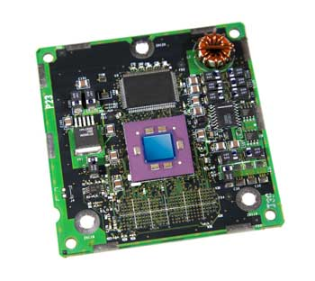

##### Advantages

The advantages of cache memory are as follows −

* Cache memory is faster than main memory.
* It consumes less access time as compared to main memory.
* It stores the program that can be executed within a short period of time.
* It stores data for temporary use.

##### Disadvantages

The disadvantages of cache memory are as follows −

* Cache memory has limited capacity.
* It is very expensive.

### 3.2 Primary Memory (Main Memory)

Primary memory holds only those data and instructions on which the computer is currently working. It has a limited capacity and data is lost when power is switched off. It is generally made up of semiconductor device. These memories are not as fast as registers. The data and instruction required to be processed resides in the main memory. It is divided into two subcategories RAM and ROM.

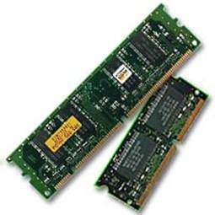

#### Characteristics of Main Memory

These are semiconductor memories.

It is known as the main memory.

* Usually volatile memory.
* Data is lost in case power is switched off.
* It is the working memory of the computer.
* Faster than secondary memories.
* A computer cannot run without the primary memory.

### 3.3 Secondary Memory

This type of memory is also known as external memory or non-volatile. It is slower than the main memory. These are used for storing data/information permanently. CPU directly does not access these memories, instead they are accessed via input-output routines. The contents of secondary memories are first transferred to the main memory, and then the CPU can access it. For example, disk, CD-ROM, DVD, etc.

#### Characteristics of Secondary Memory

* These are magnetic and optical memories.
* It is known as the backup memory.
* It is a non-volatile memory.

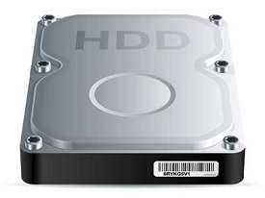

* Data is permanently stored even if power is switched off.
* It is used for storage of data in a computer.
* Computer may run without the secondary memory.
* Slower than primary memories.

**Note:**

Most Storage devices are classified under 2 types, which are volatile and non-volatile memories.

Volatile memory is computer memory that requires power to maintain the stored information and Non-volatile memory can retain the stored information even when not powered. Examples include read-only memory, flash memory, most types of magnetic computer storage devices (e.g., hard disk drives, floppy disks and magnetic tape), optical discs, and early computer storage methods such as paper tape and punched cards.

**Homework: Define and give the uses of the following terms cpu cores, vram, ddr rams, psu, sdd.**

**Sources:**

[**https://www.tutorialspoint.com/computer_fundamentals/computer_memory.htm**](https://www.tutorialspoint.com/computer_fundamentals/computer_memory.htm)

[**https://en.wikipedia.org/wiki/Computer_memory**](https://en.wikipedia.org/wiki/Computer_memory)

# 4 How the computer Works

## 4.1 Introduction Global Summary of Computer System

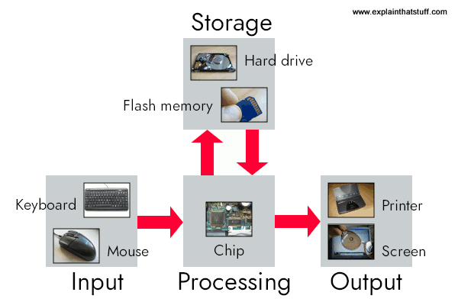

Artwork: A computer works by combining input, storage, processing, and output. All the main parts of a computer system are involved in one of these four processes.

## 4.2 Human Computer Interaction (HCI)

HCI, which stands for Human-Computer Interaction, refers to studying and designing how humans interact with computers and other technological systems. It encompasses understanding users’ behavior, needs, and preferences and designing interfaces and interactions that are intuitive, efficient, and enjoyable. HCI involves a multidisciplinary approach, drawing from psychology, design, computer science, and ergonomics fields. By considering factors such as usability, accessibility, and user experience, HCI aims to create user-centered technology that enhances human capabilities, ultimately improving the interaction and communication between humans and machines.

## 4.3 Definitions Of terms

**Instructions:**

In computer science, an instruction is a single operation of a processor defined by the processor instruction set. At the lowest level, each instruction is a sequence of 0s and 1s that describes a physical operation the computer is to perform.

**Instruction set:**

An instruction set, or instruction set architecture (ISA), is a list of all the commands (instructions), with all their variations, that a processor can execute.

Instructions include:

* Arithmetic such as add and subtract
* Logic instructions such as and, or, and not
* Data instructions such as move, input, output, load, and store
* Control flow instructions such as go to, if ... go to, call, and return.

**Algorithms:**

In Computer Science, an algorithm is a list set of step-by-step instructions, used to solve problems or perform tasks, based on the understanding of available alternatives with ambiguity.

**Programs:**

A program is a set of instructions that a computer uses to perform a specific functions or tasks.

**User:**

A user is a person who utilizes a computer or network service.

## 4.4 How Instructions are treated from the user to the computer

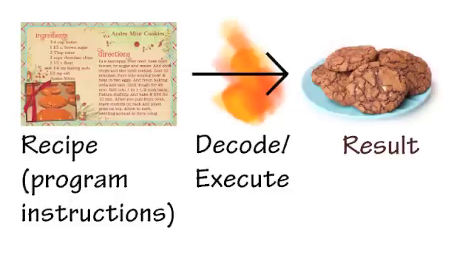

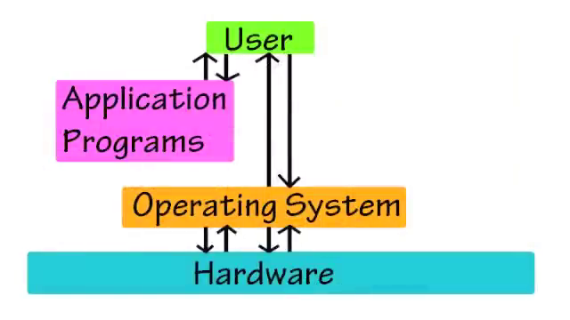

Homework: check the video Introduction to Computer Architecture on YouTube by <3 given to you.