R-1.1 **Answer:**

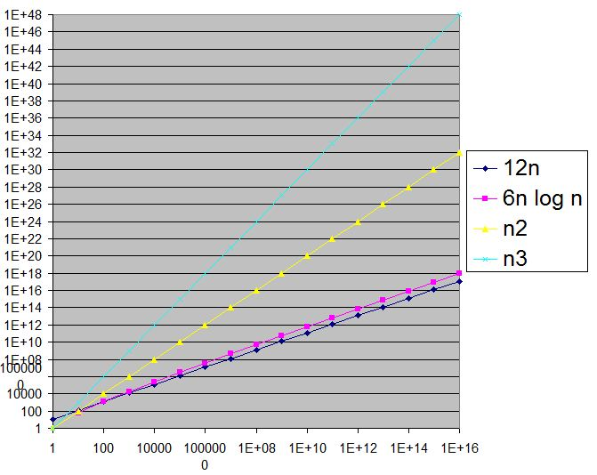

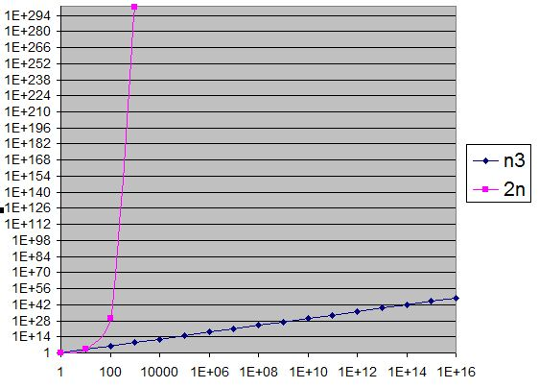

R-1.2 **Answer:**

For n0 = 100,

10nlogn = 10 * 100 * 10 = 10000

n2 = (100)2 = 10000

For n0 >100, A is better than B.

R-1.6 **Answer:**

1/n < log log n < √n < 5n < n log n < 2n log2 n < 4n3/2 < 4log n < n2 log n < n3 < 2n < 4n

R-1.10 **Answer:**

|  |  |
| --- | --- |
| **Algorithm** Loop1(n)  s ← 0  for i← 1 to n do  s← s+ i | O(1)  O(n)  O(n)  Total running time = O(n) |

R-1.14 **Answer:**

|  |  |
| --- | --- |
| Algorithm Loop5(n)  s ← 0  for i← 1 to n2 do  for j← 1 to i do  s← s+ i | O(1)  O(n2)  O(n4)  O(n4)  So total running time = O(n4) |
| From the definition, Y = logb x  =>x = bY  =>xa = ( bY)a  =>logb Xa  = Ya  =>logb Xa  = alogb X | |