|  |  |  |
| --- | --- | --- |
|  | Name: Md. Habibur Rahman Rony  Student ID: 984582  Weekday: Week 3- Day 12 |  |

Answer to the Q. No. R-6.1:

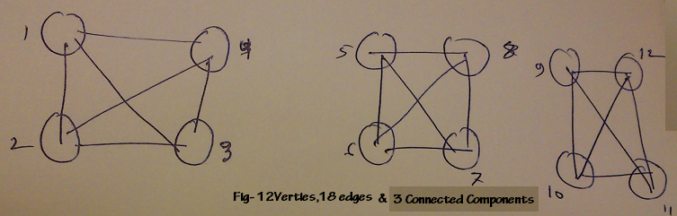

It is possible because according to the graph property of 2, we know that in an undirected graph with no self-loops and no parallel edges,

m <=n(n -1)/2.

m <=n(n -1)/2

66<=12(12-1)/2

66<=66

Answer to the Q. No. R-6.4:

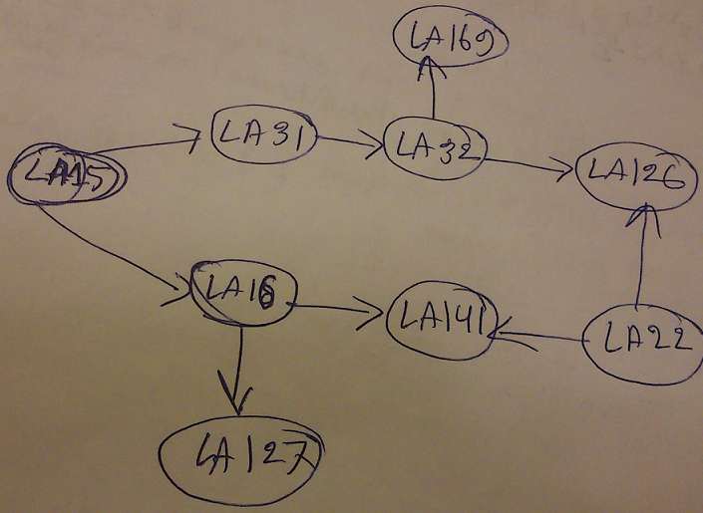

So the sequence will be: {LA15, LA22, LA16, LA31, LA32, LA141, LA126, LA127, LA169}

Answer to the Q. No. R-6.7:

1. The adjacency list structure is preferable. Indeed, the adjacency matrix structure wastes a lot of space. It allocates entries for 100,000,000 edges while the graph has only 20,000 edges.
2. Adjacency matrix, since this graph is dense, i.e., its number of edges is of the order of the maximum possible number of edges in that graph (which is about 50,000,000)
3. Adjacency matrix, since looking up the adjacency is done in constant time.