|  |  |  |
| --- | --- | --- |
|  | Name: Md. Habibur Rahman Rony  Student ID: 984582  Weekday: Week 3- Day 13 |  |

Answer to the Q. No.1:

Algorithm initResult(G)

S<-new Sequence

Algorithm preComponentVisit(G,v)

S.insertLast(v)

Algorithm result(G)

return S

Answer to the Q. No.2(a):

|  |  |
| --- | --- |
| Algorithm BFS(G)  Input graph G  Output labeling of the edges and partition  of the vertices of G    initResult( G )  for all u in G.vertices( )  preInitVertex(u)  setLabel(u, UNEXPLORED)  for all e in G.edges()  preInitEdge(e)  setLabel(e, UNEXPLORED)  for all v in G.vertices()  if getLabel(v) = UNEXPLORED  preComponentVisit(G, v)  BFS(G, v)  postComponentVisit(G,v)  result(G) | Algorithm BFS(G, s)  L <- new empty List  L.insertLast(s)  setLabel(s, VISITED)  while !L.isEmpty()  v <- L.remove (L.first())  vertexVisit(v)   for all e in G.incidentEdges(v)  if getLabel(e) = UNEXPLORED then  w <- opposite(v,e)  if getLabel(w) = UNEXPLORED then  preDiscoveryTraversal(G, v, e, w)  setLabel(e, DISCOVERY)  setLabel(w, VISITED)  L.insertLast(w)  postDiscoveryTraversal(G, v, e, w)  else  setLabel(e, CROSS)  crossTraversal(G,v,e,w)  finishVertexVisit(G,s) |

Answer to the Q. No.2(b):

|  |
| --- |
| Algorithm findPathBFS(G,u,v)  S<-new Sequence  path<-null  pathFound<-false  z<-v  for all n in G.vertices() do  setLabel(p,UNEXPLORED)  for all l in G.edges() do  setLabel(l,UNEXPLORED)  BFS(G,u)  if !pathFound = false then  return NO_SUCH_PATH  else  return path  Algorithm vertexVisit(v)  if v=s then  v.setPath(v) {path is a property of node}  Algorithm preDiscoveryTraversal(G, v, e, w)  if !pathFound then  w.setPath(v.getPath()+e+w)  Algorithm postDiscoveryTraversal(G, v, e, w)  if z=w then  pathFound=true  path<-w.getPath() |

Answer to the Q. No.2(c):

|  |
| --- |
| **Algorithm** vertexVisit(s)  if v=s then  setParent(s,null,null)  **Algorithm** preDiscoveryTraversal(G, v, e, w)  if !cyleFound=false  setParent(w,v,e) {set parent and related edge}  **Algorithm** crossTraversal(G,v,e,w)  cyleFound=true  S<-new Stack()  Q<-new Queue()  while getParent(v)!=getParent(w) then  S.push(v)  S.push(getParentConnectedEdge(v))  Q.enqueue(w)  Q.enqueue(getParentConnectedEdge(w))  v<- getParent(v)  w<-getParent(w)  cyclePath<-new Sequence()  cyclePath.insertLast(getParent(v))  while !S.isEmpty() then  cyclePath.insertLast(s.pop())  cyclePath.insertLast(e)  while !Q.isEmpty() then  cyclePath.insertLast(Q.dequeue()) |

Answer to the Q. No.2(d):

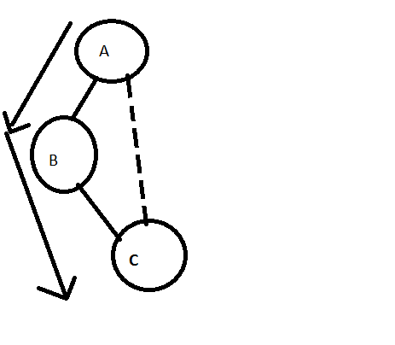

If we see above example, where DFS is used to traverse a graph, To find path from node A to C,

It will traverse from node A to B, then from B to C. Even though shortest path is from A to C. So it’s not guaranteed that template version or non-template version of DFS algorithm will find minimum edges path between two vertices.

Answer to the Q. No.3:

|  |
| --- |
| Algorithm findShortestPath(G,s,d)  z<-d {z is a subclass variable}  **initResult( G )**  *DijkstraDistances*(*G, s*)  **result(G)**  **Algorithm** *DijkstraDistances*(*G, s*)  *Q* <- new heap-based priority queue  for all *v* <- *G.vertices*()  **preInitVertex(u)**  if *v* = *s*  *setDistance*(*v,* 0)  else  *setDistance*(*v,* INFINITY)  *Q.insertItem*(*getDistance*(*v*)*, v*)  while !*Q.isEmpty*()  *u* <- *Q.removeMin*()  **vertexVisit(v)**  for all *e* in *G.incidentEdges*(*u*)  { relax edge *e* }  *z* <- *G.opposite*(*u,e*)  **preDiscoveryTraversal(G, u, e, z)**  *r* <- *getDistance*(*u*) + *weight*(*e*)  if *r* < *getDistance*(*z*)  *setDistance*(*z,r*)  ***beforeDistanceChange(G,u,e,z)***  *Q.replaceKey*(*z,r*)  ***afterDistanceChange(G,u,e,z)***  **postDiscoveryTraversal(G, u, e, z)**  **Algorithm** *afterDistanceChange(G,u,e,z)*  *setParent(z,u,e)* {set parent and related edge}  **Algorithm** result(G)  S<-new Sequence()  while getparent(d)!=s do  S.insertLast(d)  e<-getParentConnectedEdge(d)  S.insertLast(e)  d<- getparent(d)  S.insertLast(d)  S.insertLast(getParentConnectedEdge(d))  S.insertLast(s) |

Answer to the Q. No.4:

|  |
| --- |
| **Algorithm** initResult( G )  connectedComponent<-1 { connectedComponent is a subclass variable}  **Algorithm** postComponentVisit(G,v)  connectedComponent<- connectedComponent+1  **Algorithm** startVertexVisit(s)  setLabel(s, connectedComponent) |