|  |  |  |
| --- | --- | --- |
|  | Name: Md Habibur Rony  Student ID: 984582  Weekday: Week 1- Day 1 |  |

Answer to the Q No. R-1.1:

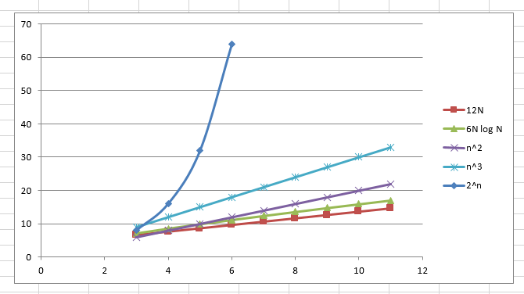

Answer to the Q No. R-1.2:

|  |  |  |
| --- | --- | --- |
| For n0 = 30 for n>=30, A is better than B | | |
| **n** | **A = 10n log n** | **B = n2** |
| 2 | 6.020599913 | 4 |
| 3 | 14.31363764 | 9 |
| 4 | 24.08239965 | 16 |
| 5 | 34.94850022 | 25 |
| 6 | 46.68907502 | 36 |
| 7 | 59.1568628 | 49 |
| 8 | 72.24719896 | 64 |
| 9 | 85.88182585 | 81 |
| 10 | 100 | 100 |
| 11 | 114.5531954 | 121 |
| 12 | 129.5017495 | 144 |
| 13 | 144.8126358 | 169 |
| 14 | 160.457925 | 196 |
| 15 | 176.4136889 | 225 |
| 16 | 192.6591972 | 256 |
| 17 | 209.1763166 | 289 |
| 18 | 225.9490509 | 324 |
| 19 | 242.9631842 | 361 |
| 20 | 260.2059991 | 400 |
| 21 | 277.6660519 | 441 |
| 22 | 295.3329898 | 484 |
| 23 | 313.1974023 | 529 |
| 24 | 331.250698 | 576 |
| 25 | 349.4850022 | 625 |
| 26 | 367.8930705 | 676 |
| 27 | 386.4682163 | 729 |
| 28 | 405.2042488 | 784 |
| 29 | 424.0954194 | 841 |
| 30 | 443.1363764 | 900 |

Answer to the Q No. R-1.10:

|  |  |
| --- | --- |
| **Algorithm Loop1(n)** | **Big - Oh** |
| s ← 0 | O(1) |
| for *i* ← 1 to *n* do | O(n) |
| *s* ← *s* + *i* | O(n) |
| T(n) | O(n) |

Answer to the Q No. R-1.14:

|  |  |
| --- | --- |
| **Algorithm Loop5(n)** | **Big - Oh** |
| s ← 0 | O(1) |
| for *i* ← 1 to *n*2 do | O(n2) |
| for *j* ← 1 to i do | O(n4) |
| *s* ← *s* + *i* | O(n4) |
| T(n) | O(n4) |

Answer to the Q No. R-1.6:

|  |  |  |
| --- | --- | --- |
|  | ~~n=4~~ | n=30 |
| 1/n | ~~0.2203~~ | .033 |
| log log n | ~~1~~ | 0.16941 |
| √n | ~~2~~ | 5.477225575 |
| 5n |  | 4.906890596 |
| n log n | ~~2.408~~ | 44.313637 |
| 2n log2 n | ~~2.8998~~ | 130.91323 |
| 4 n3/2 | ~~32~~ | 164.3167673 |
| 4 log n | ~~16~~ | 900 |
| n2 log n | ~~9.63~~ | 1329.40912 |
| n3 | ~~64~~ | 27000 |
| 2n | ~~16~~ | 1073741824 |
| 4n | ~~256~~ | 1.15292E+18 |

1/n < log log n < √n < 5n< n log n < 2n log2 n < 4n3/2 < 4log n

< n2 log n < n3 < 2n < 4n

Prove: logbxa  = a logbx

