|  |  |  |
| --- | --- | --- |
|  | Name: Md Habibur Rony  Student ID: 984582  Weekday: Week 2- Day 8 |  |

Answer to the Q. No. R-3.8:

(2, 4) tree has the two properties

* Every internal node has at most 4 children
* All the external nodes have the same depth

The multi way search tree of fig 3.17.a tree is not (2, 4) tree. Because all external node don’t have the same depth.

Answer to the Q. No. R-3.10:

For input set {21, 9, 18, 1, 20, 27} the (2,4) tree is -

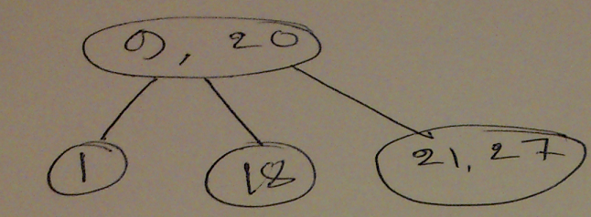

The same input but in different order set {27, 18, 1, 9, 21, 20} the (2, 4) tree is -

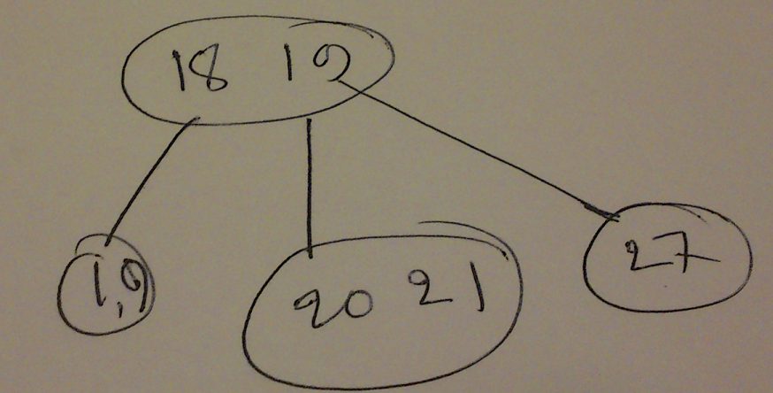

So, it proves that Professor Amongus is wrong.

Answer to the Q. No. C-4.11:

|  |  |
| --- | --- |
| Algorithm electionWinner(S)  Input**:** Sequence S of votes of the candidates  Ouput**:** Id of winner candidate    d **<- new** Dictionary**(**HashTable**)**  **for** i<--0 to i<s.size **do**  id<--S[i]  if d.containKey(id)= false then  d**.**insertItem**(**id**,1)**  **else**  **d[id]<-- d[id].value+1**  **i<--i+1**  **curentVaote<--d[0].value**  winnerId **<--d[0].key**  **for** each item in d **do**  if currentVote<item.value then  currentVote <-- item.value  winnerId <--item.key  **return** winnerId | O(1)  O(n)  O(n)  O(n)  O(n)  O(n)  O(n)  O(1)  O(1)  O(k)  O(k)  O(k)  O(k)  O(1)  T(n) nlog(k) |

Answer to the Q. No. C-4.22:

|  |  |
| --- | --- |
| Algorithm FindSumElement(A, B, x)  Input: Two Sequence A, B and integer x  Output: true if find otherwise false    RBT **<-** RedBlackTree().Insert(A)  ForEach b in B do  if RBT.findElement(x-b) != null then  return true  return false | O(logn)  O(n)  O(n)  O(1)  O(1)  T(n)= O(nlogn) |