1. [1]**What is the configuration of your machine?**

I am using macOS with 16GB of RAM as below.

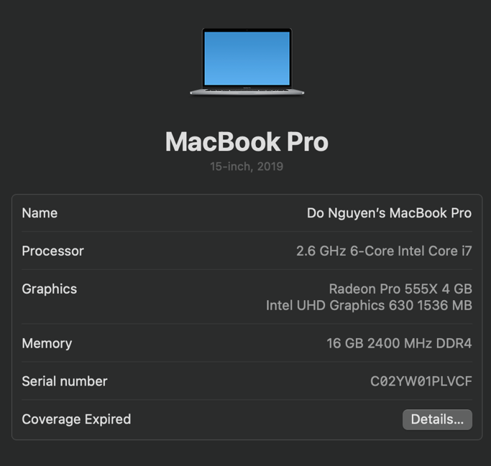   
**Did you set up Cloudera development environment on your machine?**Yes, I did; I am using Docker.

1. [2]**What is the meaning of $HOME in your newly setup environment?**  
           Text

   Description automatically generated
2. [2]**What is the meaning of *SUDO* in Unix/Linux environment?**

In Unix/Linux environment, "sudo" is a command that allows a user with administrative privileges to execute commands as another user, typically the "root" user. The term "sudo" stands for "superuser do", which reflects its function of enabling a regular user to perform actions that would normally require administrative privileges.

The sudo command is commonly used in Unix/Linux systems to improve security and control access to critical system functions. When a user issues a sudo command, they are prompted to enter their own password to authenticate their identity, and then the system checks if the user has the necessary permissions to execute the requested command.

By using sudo, system administrators can grant limited access to specific system functions to non-administrative users, without giving them full administrative privileges. This helps to minimize the risk of accidental or intentional damage to the system, and to ensure that critical system functions are only executed by authorized personnel.

1. [5]**Write and briefly explain any 5 Unix/Linux commands.**

**ls**: The "ls" command is used to list the files and directories in the current working directory. For example, "ls -l" displays the files in long format, showing file permissions, ownership, size, and modification time.

**cd**: The "cd" command is used to change the current working directory. For example, "cd /home/user/documents" changes the current working directory to the "documents" directory under the "user" directory in the home directory.

**mkdir**: The "mkdir" command is used to create a new directory. For example, "mkdir new_directory" creates a new directory named "new_directory" in the current working directory.

**rm**: The "rm" command is used to remove files or directories. For example, "rm file.txt" removes the file named "file.txt", and "rm -r directory" removes the directory named "directory" and all of its contents.

**sudo**: The "sudo" command allows a user with administrative privileges to execute commands as another user, typically the "root" user. For example, "sudo apt-get update" updates the package list using the "apt-get" command as the root user.  
