* Create Microservice1

* Create SQS

* Edit Policy of SQS

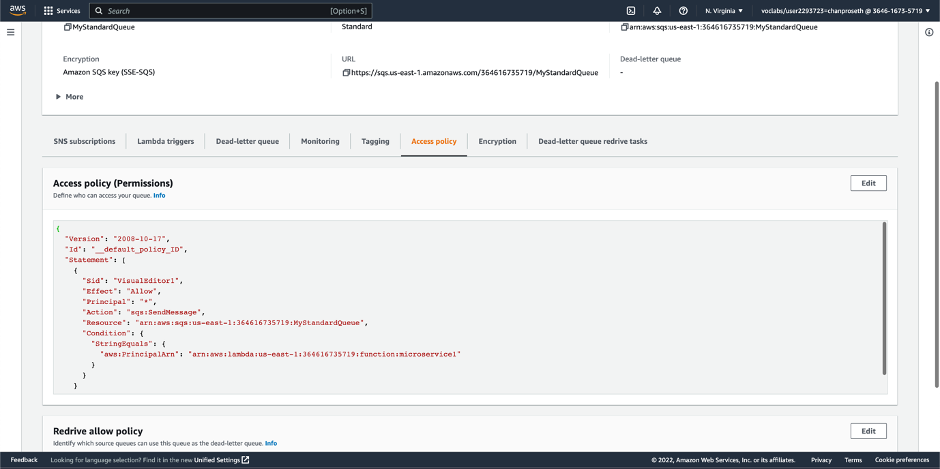

* Create Microservice2

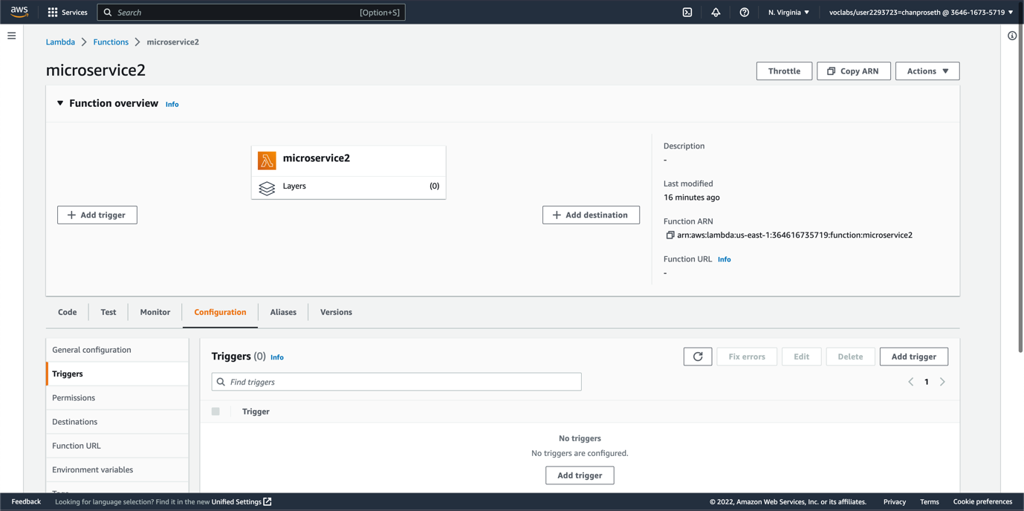

* Add trigger from SQS to microservice2

* Create SNS and subscribe to email

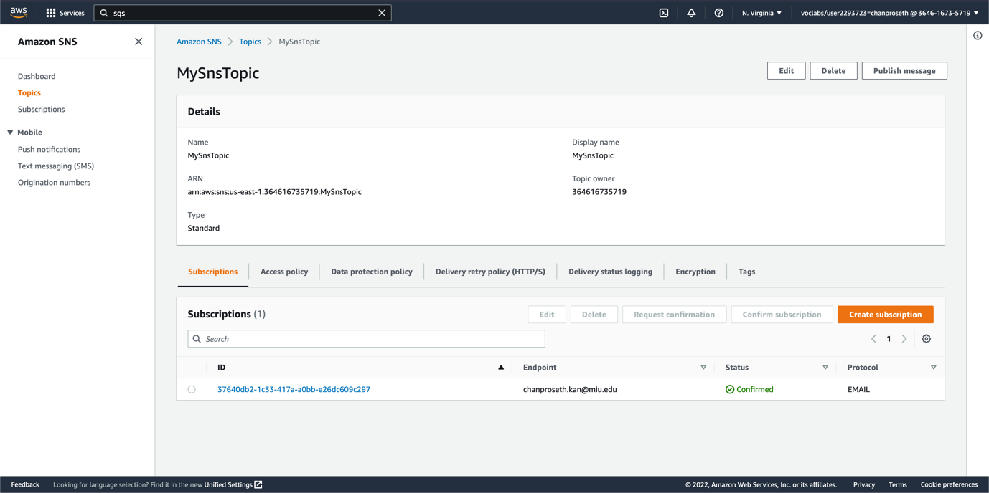

* Edit policy for SNS

* Add code to send message to SQS

* Add Code to publish message to email

* Result

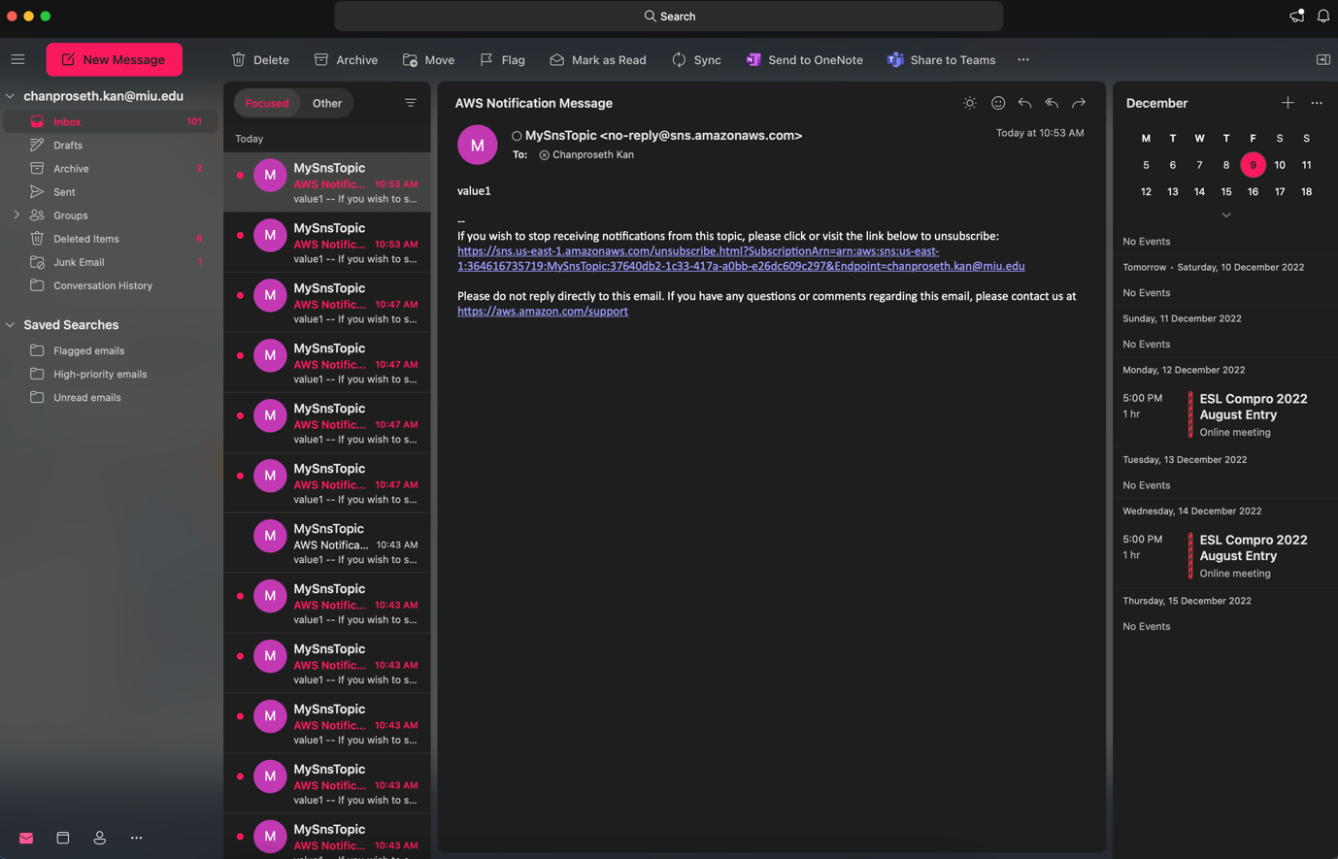

* Step function

* Result

