* Create Lambda f1

* Create/Publish version 1 and 2

* Sample test in version 2

* Sample test in version 1

* Create Alias and do 50:50 routing (Canary) for lambda version 1 and 2

* Result of hitting multiple request test

* Create SG for ALB

* Create SG for Lambda

* Default VPC after create lambda without specify vpc

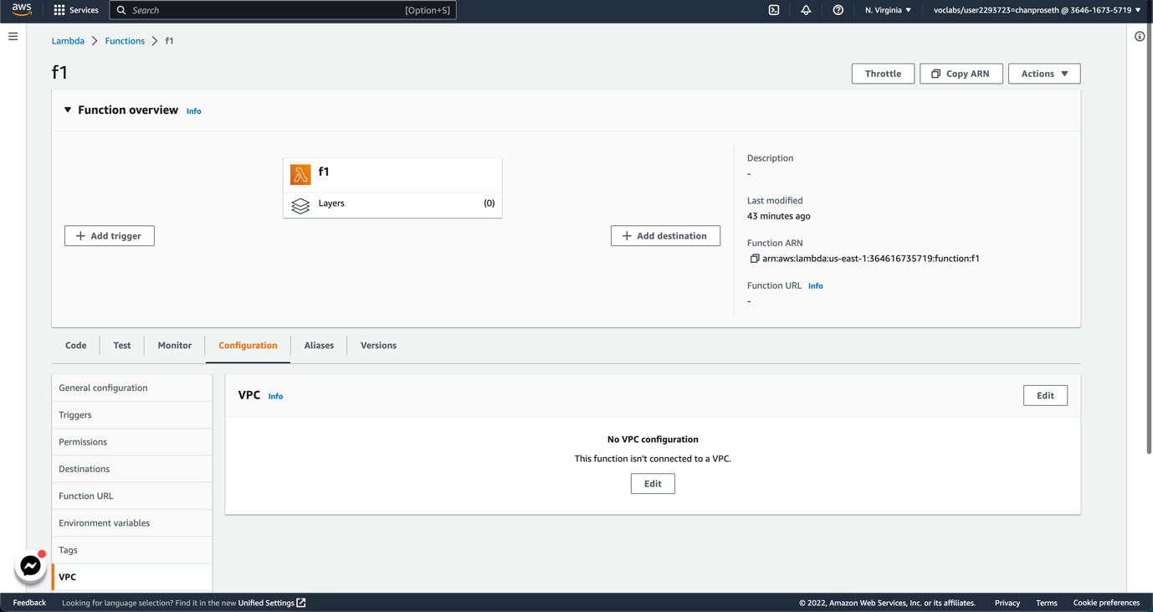

* Edit VPC, choose SG for lambda and choose subnet

* Create Application load balancer

* Create TG for Lambda

* After connect to the link, it will ask to download

* After add the *headers: {"content-type": "text/html"}*

* Create new Lambda f2

* Add SQS trigger and filter criteria

* Add on success and failure Destination to SNS and send email

* Use this command in CLI (note: don’t forget to change function name and arn for kinesis accordingly)

aws lambda create-event-source-mapping --function-name f3 --event-source arn:aws:kinesis:us-east-1:364616735719:stream/MyDataStream --batch-size 100 --starting-position LATEST

* Use this command to insert records

* Check the event mapping source in lambda it should shows in trigger

