Lab 8 – Genetic Algorithms & AI
- Study the following paper that uses GA to solve the Knapsack problem.
http://www.micsymposium.org/mics_2004/Hristake.pdf

Make sure you understand it very well. The main goal here is to enable you to understand some published paper well and relate it to the content of the lecture covered in the class. This paper will also enable you to do some research work as would be needed in future e.g. when you join an industry.

Nothing is due for this BUT your understanding will be helpful to answer questions on GA in the Final exam. Also, your understanding of the paper will help you solve Problem #2 below.

Ans.
See below (under #2 solution) how information of 0-1 Knapsack solution is used to come up with the solution for #2.

- You have 5000 MP3 files sitting on your computer's hard disk. Unfortunately, the hard disk has started making noises, and you decide that you had better back up the MP3s. Equally unfortunately, you can only burn CDs, not DVDs, on your computer. You need to minimize the number of CDs that you use, so you decide to design a genetic algorithm to choose which MP3s to put onto each CD in order to fill each CD as completely as possible. Design a genetic algorithm to solve the problem. You will need to consider how you would encode the inputs, which genetic operators are suitable, and how you would make the genetic algorithm deal with the fact that you have multiple CDs, not just one CD. (Note: You can use some ideas from #1 above).

Ans.
Note that this problem is very similar to the 0-1 Knapsack problem that was solved in the paper mentioned in #1.

We can use “benefits” for the Knapsack problem as the “importance” for each file (name or number) to be backed up. Similarly, we can use file “size” as the “Volume” of each item in the Knapsack problem.

So, all the steps in the paper are applicable here. For simplicity, we can just use Roulette-Wheel selection method etc.

Multiple GA Cycles:
Since there are multiple CDs and we would like to optimize each CD by making it as full as possible, we can run the GA in a loop until enough CDs are used to complete 5000 files. If needed, we can put a limit on the # of CDs by using a value like L. After each CD is full e.g. CD number i, we need to take those files written to CD number i, i.e. files_CD_i out from the existing chromosomes. So, new number of items in the new population (chromosomes in (i+1)-th GA iteration) will be Current_Num_files – files_CD_i. Then repeat the process in the same way. Note - Current_Num_files = 5000 at the first iteration.

Population Size:
Population size says how many chromosomes are in population (in one generation). If there are too few chromosomes, GA have a few possibilities to perform crossover and only a small part of search space is explored. On the other hand, if there are too many chromosomes, GA slows down. Research shows that after some limit (which depends mainly on encoding and the problem) it is not useful to increase population size, because it does not make solving the problem faster.

A population size a few x more than the number of dimension is usually used to ensure enough size of the search space so that local minimum can be avoided resulting a better near-optimal solution. However, since the initial # of files is 5000, it probably would be too much if we use a population size of 5000. Typically, population size of 100-200 would suffice. This is something we would need to determine using trial and error. Since, there are multiple GA cycles (one GA cycle for each CD), population size should be reduced for each CD gradually. This will help improve computation time and possibly lesser number of generations needed for each GA cycle (i.e. for each CD).

Representation of the items / files:
We use 3-dimensional array to represent the whole population of the chromosomes as done in the paper.

Each file is represented in an array with each cell having Benefit (B ) and size (S) as shown below (and as done in the paper) for 4 files (initially we have 5000 files):

0 1 2 3
B1, S1 | B2, S2 | B3, S3 | B4, S4

Included in the CD (‘1’) or not (‘0’). E.g. the following chromosome

Indicates that 1st and 4th files are included in the CD.

Other Parameters and Process
We can use same parameters for all other parameters and same methods including flow charts etc as done in the paper.

- For each of the following Agents, develop a PEAS description of the task environment:

- Robot soccer player
- Internet book-shopping Agent
- Autonomous Mars rover
- Mathematician’s Theorem Proving Assistant

Ans.

- Consider a Natural Language based Medical Assistant Agent.
Draw its architecture along with the environment. Mention important goals and utility functions.
- For the following tree, list the order in which the nodes are visited using Depth-First
Search.

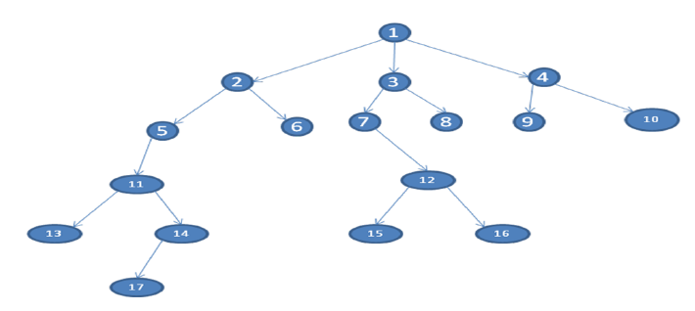
Ans. DFS : 1 2 5 11 13 14 17 6 3 7 12 15 16 8 4 9 10

- The travelling salesman problem (TSP) is an NP-Complete (i.e. complex – needs exponential time to solve). TSP asks the following question: "Given a list of cities and the distances between each pair of cities, what is the shortest possible route that visits each city and returns to the origin city?
Try to solve this problem using GA. Then implement your solution in Python. You would need to import numpy, pandas, random and operator.

Ans. The following link (blog has a good solution – Explained the solution & code in the lab.
https://towardsdatascience.com/evolution-of-a-salesman-a-complete-genetic-algorithm-tutorial-for-python-6fe5d2b3ca35

