**Building a Zerodha front page:**

**Introduction**

What the use of things in industry

1. Html ->very minimal
2. Css -> minimal
3. Js -> heavy

Framework was used after the 2010s

**What are browsers? How do they render websites?**

The goal of a website is to allow one person to talk to another computer

The goal of the browser is to allow people to hit the server (using QRL) and get back some HTML CSS and javascript and render it in the computer of a person

Developers of Chrome have the job of writing code which renders the HTML code and render it correctly

A browser is something like Chrome, the goal is that if the browser gets HTML it should render it inside its window

Where does this html file come from?

**What purpose of html/css/js**

The creator of the website said that we need three languages to implement most of the things in the website, buttons, etc

Other language can also be used

Even websites like Facebook etc can be written in raw HTML,css, JS

**HTML Basics**

1. Tags

<html>, head, title, body, div, span,h1,h6,p,img, a, input, button,b, i, center

1. Attribute

Simple index.html

hi there

*<!-- file:///C:/Users/NTC/Desktop/Dev/Week0/index.html -->*

*<!-- this will be the URL visible to us-->*

Even without any tag, we can write text on the website but we can't add any image

Without a tag, there will be no gap between the text

We can also see these codes in inspect in Chrome developer tools

<div>

hi there

</div>

<div>

hi there 2

</div>

Still, we do not know where these HTML come from we will know later

They will automatically add html head and body tag

<html>

<head>

<title>Zerodha</title>

*<!-- Whatever is written get at the top of the tab -->*

</head>

*<!-- metadata information, title -->*

<body>

*<!-- main content of the website -->*

<div >

*<!-- Take 100 percent space of the website horizontally -->*

<span>

*<!-- take space only which is required -->*

hello

</span>

<span>

hello2

</span>

</div>

</body>

</html>

P, div, simple no outer tag will be same in HTML output

Adding Image tag

<div>

hi there

*<!-- div takes complete width -->*

</div>

<center>

*<!-- will center it, not much used -->*

<img src="/ZerodhaLandingPage/Screenshot (131).png" alt="">

</center>

<a> Tag

<a href="<https://google.com>" target=”_blank”>Go to the google</a>

target=”_blank” it will open in a new tab

(No need to memorize it just google it)

**If we wrap an image inside <a> tag then on clicking it we will be redirected to the the place where we want to**

<b>,<i>,<button>

When we click on button something should happen, we will later add some functionality when we press it

<b>

<i>hi there</i>

</b>

<button>Sign in here</button>

<input> tag

<input placeholder="Username" type="text"></input>

*<!-- We can make input look better if we use css -->*

**Attribute**

Eg, In the image, if we hover over it then we may see some text, this is due to some attribute used inside the <img> tag

<img src=”a.png”>

<a href=”google.com”>

<button onclick=””>

(inside onclick we will write some javascript)

<input id=”username”>

**Using HTML only Zerodha landing page**

**<div>**

**<img width="150" src="logo.svg" alt="">**

**<span>Signup</span>**

**<span>About</span>**

**<span>Products</span>**

**<span>Pricing</span>**

**<span>Support</span>**

**</div>**

**<br><br><br>**

**<center>**

**<img width="900" src="Screenshot (131).png" alt="">**

**</center>**

**<br><br><br>**

**<center>**

**<h1>Invest in everything</h1>**

**</center>**

**<br>**

**<center>**

**<h3>Online platform to invest in stocks, derivatives, mutual funds, and more</h3>**

**</center>**

**<br>**

**<center>**

**<button>Sign up now</button>**

**</center>**

**Output:**

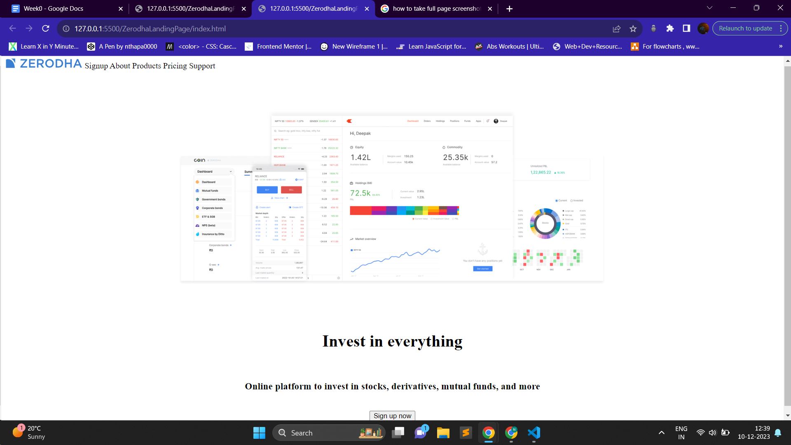

**CSS Basics**

1. It lets us add style to our websites (colors, font sizes, background color)

2. Used for positioning things on the page (div, span, text)

Eg in our Zerodha landing page we want to center some elements and proper positioning of the navbar and also change the text size and many more things

**How to add styles?**

<h1 style=”color:red; background: green;”>hi there</h1>

We remember many only a few and then rest we google it

<h1 style="color: green;background-color: aqua; border-radius:10px;border:2px solid black; padding:10px;">

Hey Bro

</h1>

*<!-- Are background color and background the same, not always with the help of the background color we can only add colors but with background, we can add several other things -->*

**Common Styling Attributes**

color

background

*<!-- Are background color and background the same, not always with the help of the background-color we can only add colors but with background, we can add several other things -->*

border-radius

border

(div or box , adding border(line) to our div)

padding/margin  
(there is some space inside the bottom or top of a box)

Padding is inside the div(border)

Margin is added outside the div to add some space

Box-shadow

**We can use Chrome developer tools to debug the space required in the div or box** Any changes made to the website will be gone once we refresh the page

<h1 style="font-size: 50px; color: green;background-color: aqua; border-radius:10px;border:1px solid black; padding: 10px;box-shadow: 2px 10px 10px black;">

Hey Bro

</h1>

*<!-- box box-shadow*

*the first attribute means in which direction should it go left or right, - means left, + ve means the shadow will go to the right*

*As a developer we don’t have to play with it we will get a Figma file from where we have to copy the setting*

*-->*

**Output**

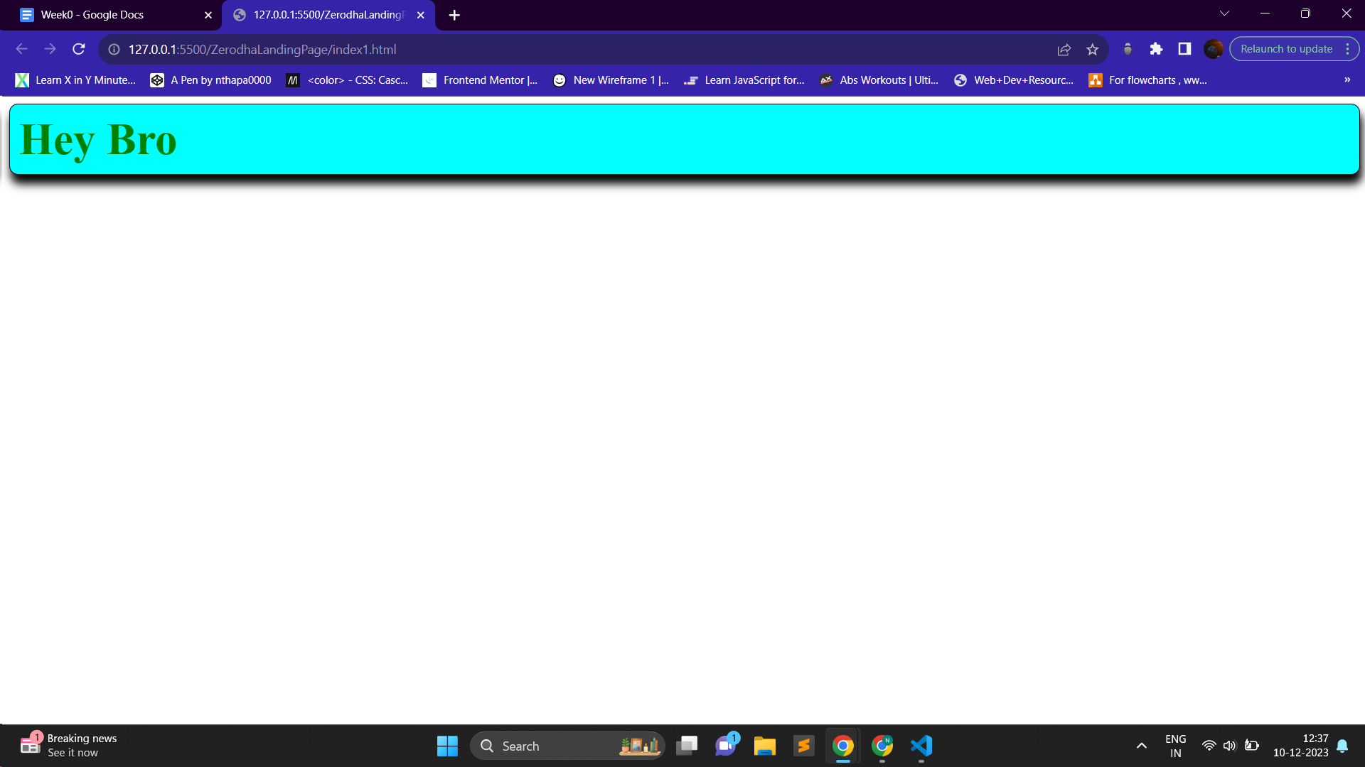

**How to position?**

divs always take up all the space available horizontally

spans only take up as much space as needed

Can we make div take up space only they need?

If yes then how can we position div far away from each other in a single line

<div style="margin-left: 100px; margin-right: 100px ; ">

<img src="logo.svg" width="200px">

<span style="float: right;">Sign up</span>

</div>

*<!-- How to take sign up to tehe right side*

*1. Using float property(Not recommended)*

*2. Positioning of the children should be done using flexbox(Right way)*

*-->*

1. Using float is shown
2. Using Flexbox

display: flex (on parent )

make all the div siblings reside in the same line

justify-content

* flex-start
* flex-end
* center
* space-between
* space-around
* space-evenly

<div style="display: flex; justify-content: space-between;" >

<div>hi there</div>

<div>hi there2</div>

<div>hi there3</div>

<div>hi there4</div>

</div>

*<!-- display:flex -->*

*<!-- just by writing this the children will appear to next to each other , similar to span -->*

*<!-- now to place the children inside the div we will use the attribute called justify-content, by default it is*

*flex-start (one by one from the left , adjacent to it)*

*justify-content: flex-start;*

*flex-end;(all the children must be on the right of the screen)*

*center;(all the children must be in the center of the screen)*

*space-between;(the children must be equally spaced between the left and right of the screen)*

*space-around;(the children must be equally spaced between the left and right of the screen and also the first and last child must be half the space of the other children)*

*space-evenly;(the children must be equally spaced between the left and right of the screen and also the first and last child must be equal to the space of the other children) -->*

Website:

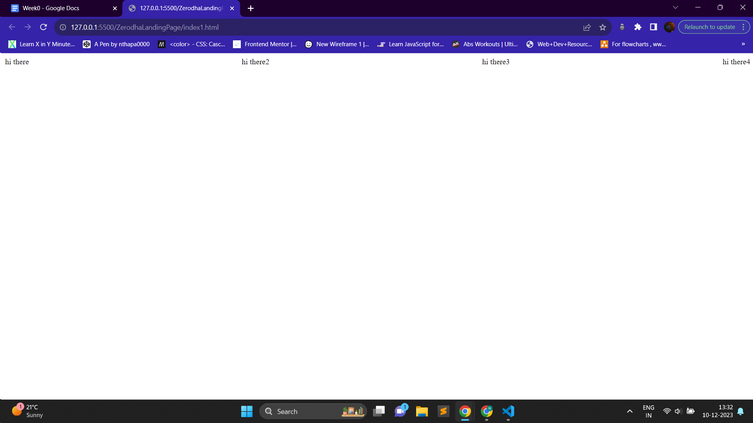

<div style="display: flex; justify-content: space-between;margin-left: 100px; margin-right: 100px;">

<img src="logo.svg" alt="" width="200px" />

*<!-- nested flex -->*

<div style="display: flex;">

<div>

Sign up

</div>

<div>

About us

</div>

</div>

</div>

*<!-- space between is useful if we have only two components, once if we add the third div/component in the navbar space-between is not the correct choice -->*

*<!-- Absolute positioning can also be used, but for most websites flexbox is used -->*

**Shift+Alt + F :** To beautify the code

**Zerodha landing page after adding css**

***<!-- for knowing the styling of the box shadow , others we can simply inspect the Zerodha landing page in Chrome -->***

**<div**

**style="**

**display: flex;**

**justify-content: space-between;**

**padding-left: 100px;**

**padding-right: 100px;**

**box-shadow: 2px 1px 2px #eee;**

**"**

**>**

***<!-- now simply with this code we can see that the shadow isnt going completely till end in horizontally , its basically due to padding or margin the question which arises is that we want the space inside the div or outside the div ?***

***margin: add space outside the div***

***padding: add space inside the div***

***-->***

**<img**

**src="logo.svg"**

**alt=""**

**width="120px"**

**height="20px"**

**style="padding-top: 20px"**

**/>**

***<!-- nested flex -->***

**<div style="display: flex">**

**<div style="padding: 20px; color: #666; cursor: pointer">Signup</div>**

***<!-- designer give us hex code of the colors -->***

**<div style="padding: 20px; color: #666; cursor: pointer">About</div>**

**<div style="padding: 20px; color: #666; cursor: pointer">Products</div>**

**<div style="padding: 20px; color: #666; cursor: pointer">Pricing</div>**

**<div style="padding: 20px; color: #666; cursor: pointer">Support</div>**

**</div>**

**</div>**

**<div style="display: flex; justify-content: center; padding-top: 40px">**

**<img src="Screenshot (131).png" alt="" width="1000" />**

**</div>**

***<!-- to center image we can use <center> tag but not recommended -->***

**<div style="padding-top: 20px; display: flex; justify-content: center">**

**<h1 style="font-weight: 500;font-size: 40;">Invest in everything</h1>**

**</div>**

**<div style="padding-top: 2px; display: flex; justify-content: center">**

**<h2 style="font-weight: 400;;">**

**Online platform to invest in stocks, derivatives, mutual funds, and more**

**</h2>**

**</div>**

***<!-- cursor: pointer;***

***when someone hover cursor should be pointer -->***

**<div style="display: flex; justify-content: center;padding-top: 10px;">**

**<div**

**style="**

**background-color: #387ed1;**

**margin-top: 25px;**

**border: 1px solid rgba(0, 0, 0, 0) !important;**

**border-radius: 3px;**

**padding: 10px 30px;**

**color: white;**

**font-size: 15px;**

**cursor: pointer;**

**"**

**>**

**Sign up now**

**</div>**

**</div>**

**Website looks like:**

