Key Highlights for Decision-Makers
- Fill in manually (2–3 bullet points).
- Fill in manually (2–3 bullet points).
- Fill in manually (2–3 bullet points).

Immediately Notifiable Diseases and Events
- Cholera: Week 34 reported 4 suspected, 0 tested, and 0 confirmed cases. Cumulative (Week 1–34): 16,684 suspected, 4,410 tested, 2,034 confirmed.
- Anthrax: Week 34 reported 8 suspected, 2 tested, and 1 confirmed cases. Cumulative (Week 1–34): 283 suspected, 36 tested, 5 confirmed.
- Plague: Week 34 reported 0 suspected, 0 tested, and 0 confirmed cases. Cumulative (Week 1–34): 13 suspected, 1 tested, 0 confirmed.
- Monkeypox: Week 34 reported 0 suspected, 0 tested, and 0 confirmed cases. Cumulative (Week 1–34): 8 suspected, 4 tested, 0 confirmed.

Other Diseases and Events
- Malaria: Week 34 reported 144,640 suspected, 138,717 tested, and 40,329 confirmed cases. Cumulative (Week 1–34): 8,011,914 suspected, 7,570,205 tested, 3,693,242 confirmed.
- Diarrhoea Non Bloody: Week 34 reported 0 suspected, 2,435 tested, and 2,171 confirmed cases. Cumulative (Week 1–34): 0 suspected, 46,953 tested, 50,502 confirmed.
- Fill in manually.
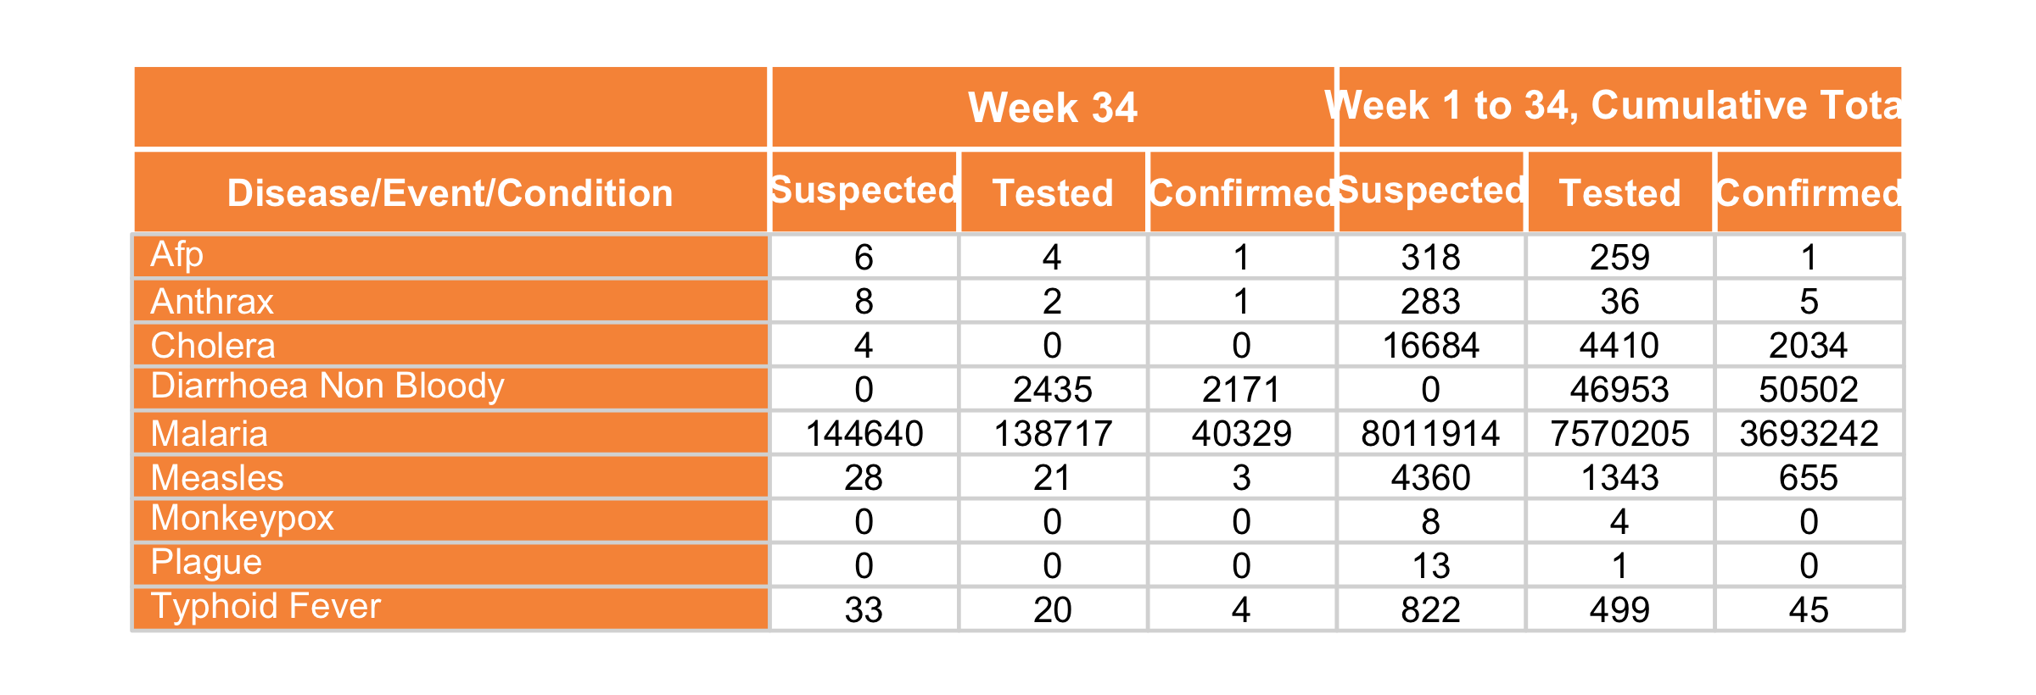

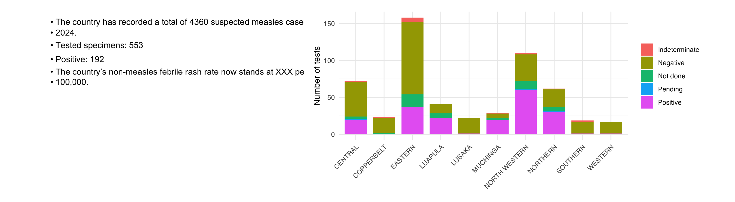
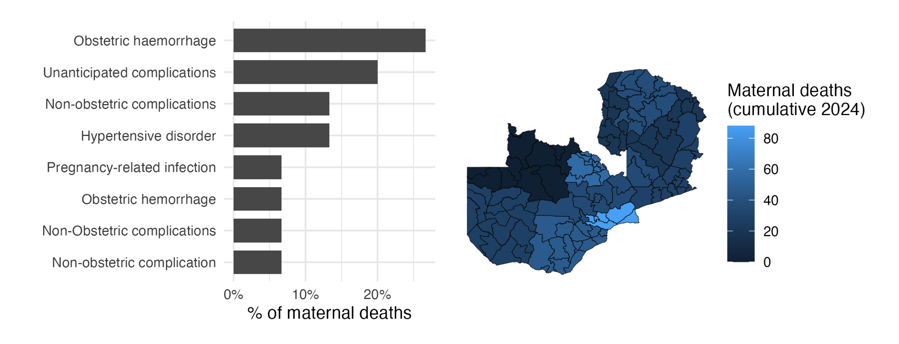
- The bar chart on the left summarizes the causes of deaths of 15 maternal deaths recorded in week 34.
- Hypertensive disorder, Non-obstetric complications, and Obstetric haemorrhage continue to be the leading causes of maternal deaths this year.
- Cumulatively, in 2024, 395 maternal deaths have been recorded across the country, as depicted on the map.
- Provinces with darker shades indicate those with a higher number of reported maternal deaths.

