Assignment:11.3
2403A52L05-B50
E. Sai Nithin
Task 1: Smart Contact Manager (Arrays & Linked Lists)
Scenario: SR University’s student club requires a simple Contact Manager Application to store members’ names and phone numbers. The system should support efficient addition, searching, and deletion of contacts.

Tasks
- Implement the contact manager using arrays (lists).
- Implement the same functionality using a linked list for dynamic memory allocation.
- Implement the following operations in both approaches:
  - Add a contact
  - Search for a contact
  - Delete a contact
- Use GitHub Copilot to assist in generating search and delete methods.
- Compare array vs. linked list approaches with respect to:
  - Insertion efficiency
  - Deletion efficiency

Prompt:
Generate a python code by using DSA. SR University’s student club requires a simple Contact Manager Application to store members’ names and phone numbers. The system should support efficient addition, searching, and deletion of contacts. Implement using arrays and linked list and also include in arrays add a contact,search for a contact, delete for a contact.
Code:
class ArrayContactManager: def init (self):
self.contacts = []

def add_contact(self, name, phone):
self.contacts.append({'name': name.strip(), 'phone': phone.strip()}) def search_contact(self, name):
key = name.strip().lower()
return [c for c in self.contacts if c['name'].lower() == key] def delete_contact(self, name):
key = name.strip().lower() before = len(self.contacts)
self.contacts = [c for c in self.contacts if c['name'].lower() != key] return before - len(self.contacts)
class Node:
def init (self, name, phone): self.name = name.strip() self.phone = phone.strip() self.next = None
class LinkedListContactManager: def init (self):
self.head = None
def add_contact(self, name, phone): new_node = Node(name, phone) if not self.head:
self.head = new_node return
curr = self.head while curr.next:
curr = curr.next curr.next = new_node
def search_contact(self, name): key = name.strip().lower()

out = []
curr = self.head while curr:
if curr.name.lower() == key:
out.append({'name': curr.name, 'phone': curr.phone}) curr = curr.next
return out
def delete_contact(self, name): key = name.strip().lower() dummy = Node('', '') dummy.next = self.head
prev, curr = dummy, self.head deleted = 0
while curr:
if curr.name.lower() == key: prev.next = curr.next deleted += 1
else:
prev = curr curr = curr.next
self.head = dummy.next return deleted
if name == ' main ':
a = ArrayContactManager() a.add_contact('Alice', '111')
a.add_contact('Bob', '222')
print('Array search Bob:', a.search_contact('Bob'))
print('Array delete Bob:', a.delete_contact('Bob'), 'left', a.contacts) l = LinkedListContactManager()

l.add_contact('Alice', '111')
l.add_contact('Bob', '222')
print('Linked search Bob:', l.search_contact('Bob')) print('Linked delete Bob:', l.delete_contact('Bob')) print('Linked search Bob after:', l.search_contact('Bob'))
Output:
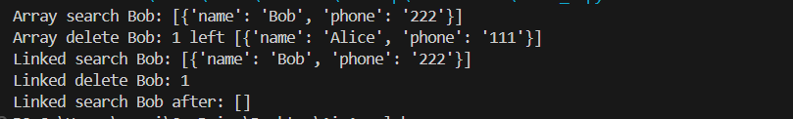
Explanation:
In this code we can code and output we can see that we have entered the contacts,array search bob, array delete boband so on.
TASK:02 Book Search System (Queues & Priority Queues)
Scenario:The SRU Library manages book borrow requests. Students and faculty submit requests, but faculty requests must be prioritized over student requests.
Tasks
- Implement a Queue (FIFO) to manage book requests.
- Extend the system to a Priority Queue, prioritizing faculty requests.
- Use GitHub Copilot to assist in generating: enqueue() method , dequeue() method
- Test the system with a mix of student and faculty requests.

Prompt:
Generate a python code for SRU Library manages book borrow requests. Students and faculty submit requests, but faculty requests must be prioritized over student requests. Also include Implement a Queue (FIFO) to manage book requests. Extend the system to a Priority Queue, prioritizing faculty requests. enqueue() method , dequeue() method Test the system with a mix of student and faculty requests.In data structures.

Code:
import heapq
from collections import deque from itertools import count class Req:

def init (self,id,type,title):
self.id, self.type, self.title = id,type.lower(),title
def repr (self): return f"{self.type[0].upper()}{self.id}:{self.title}" class FIFO:
def init (self): self.q = deque() def enqueue(self,r): self.q.append(r)
def dequeue(self): return self.q.popleft() if self.q else None class PQueue:
def init (self): self.h, self.c = [], count() def enqueue(self,r):
p=0 if r.type=="faculty" else 1 heapq.heappush(self.h,(p,next(self.c),r))
def dequeue(self): return heapq.heappop(self.h)[2] if self.h else None reqs = [Req("1","student","DS"), Req("1","faculty","AI"),
Req("2","student","Calc"), Req("2","faculty","ML"), Req("3","student","Net")] f, pq = FIFO(), PQueue()
for r in reqs:
f.enqueue(r); pq.enqueue(r)
fifo_out = [f.dequeue() for _ in range(len(reqs))] pri_out = [pq.dequeue() for _ in range(len(reqs))] print(f"{'FIFO':<20}{'PRIORITY':<20}")
print("-"*40)
for a,b in zip(fifo_out, pri_out): print(f"{str(a):<20}{str(b):<20}")
Output:
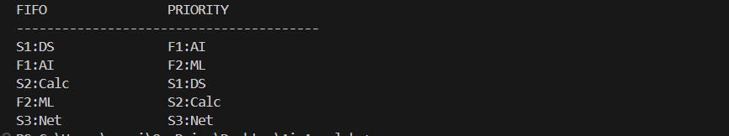

Explanation:
In this code we can see that which faculty is selecting which student and we can also see that which subject they are choosing.
Task 3: Emergency Help Desk (Stack Implementation) Scenario
SR University’s IT Help Desk receives technical support tickets from students and staff. While tickets are received sequentially, issue escalation follows a Last-In, First-Out (LIFO) approach.
Tasks
- Implement a Stack to manage support tickets.
- Provide the following operations:
o push(ticket)
o pop()
o peek()
- Simulate at least five tickets being raised and resolved.
- Use GitHub Copilot to suggest additional stack operations such as:
  - Checking whether the stack is empty
  - Checking whether the stack is full (if applicable)

Prompt:
Generate a python code for SR University’s IT Help Desk receives technical support tickets from students and staff. While tickets are received sequentially, issue escalation follows a Last-In, First-Out (LIFO) approach. Implement a Stack to manage support tickets.Provide the following operations: push(ticket), pop(),peek().Simulate at least five tickets being raised and resolved. Use GitHub Copilot to suggest additional stack operations such as:Checking whether the stack is empty,Checking whether the stack is full (if applicable) By using data structures.
Code:
class Ticket:
def init (self, i, u, iss): self.i = i
self.u = u self.iss = iss

def repr (self):
return f"{self.i}:{self.u}:{self.iss}" class Stack:
def init (self, c=None): self.s = []
self.c = c
def push(self, t):
if self.c is not None and len(self.s) >= self.c: raise OverflowError("Stack full")
self.s.append(t) def pop(self):
return self.s.pop() if self.s else None def peek(self):
return self.s[-1] if self.s else None def is_empty(self):
return not self.s def is_full(self):
return self.c is not None and len(self.s) == self.c st = Stack(10)
for x in [
("T1", "student", "Wi-Fi down"),
("T2", "staff", "Printer error"),
("T3", "student", "Password reset"),
("T4", "staff", "VPN timeout"),
("T5", "student", "Email sync")]: st.push(Ticket(*x))
print("peek:", st.peek())
print("empty:", st.is_empty(), "full:", st.is_full()) while not st.is_empty():

print("resolved:", st.pop()) Output:
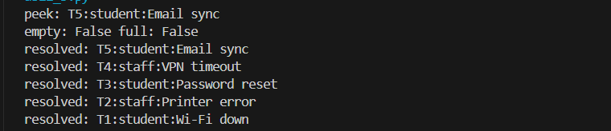

Expalnation:
Stack class manages helpdesk tickets in LIFO order with `push`, `pop`, `peek`, `is_empty`,
`is_full` and resolves newest tickets first.
Task 4: Hash Table Objective.To implement a Hash Table and understand collision handling. Task Description
Use AI to generate a hash table with:
- Insert
- Search
- Delete Starter Code
class HashTable:
pass

Prompt:
Generate a python code for : Hash Table Objective To implement a Hash Table and understand collision handling.
Task DescriptionUse AI to generate a hash table with: Insert , Search, Delete Starter Code
class HashTable:
pass

Code:
class HashTable:
def init (self, size=7): self.size = size

self.buckets = [[] for _ in range(size)] def _idx(self, key):
return hash(key) % self.size def insert(self, key, value):
idx = self._idx(key) bucket = self.buckets[idx]
for i, (k, _) in enumerate(bucket): if k == key:
bucket[i] = (key, value) return
bucket.append((key, value)) def search(self, key):
idx = self._idx(key)
for k, v in self.buckets[idx]: if k == key:
return v return None
def delete(self, key): idx = self._idx(key)
bucket = self.buckets[idx]
for i, (k, _) in enumerate(bucket): if k == key:
bucket.pop(i) return True
return False h = HashTable() h.insert("a", 1)
h.insert("b", 2)
h.insert("a", 3 )

print(h.search("a"))
print(h.search("b"))
print(h.delete("b"))
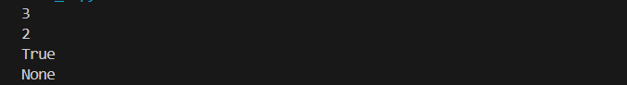
print(h.search("b")) Output:

Explanation:
HashTable uses fixed-size buckets + chaining so `insert/search/delete` map keys to bucket by
`hash(key)%size` and handle collisions in per-bucket list. Task 5: Real-Time Application Challenge
Scenario
Design a Campus Resource Management System with the following features:
- Student Attendance Tracking
- Event Registration System
- Library Book Borrowing
- Bus Scheduling System
- Cafeteria Order Queue Student Tasks
- Choose the most appropriate data structure for each feature.
- Justify your choice in 2–3 sentences.
- Implement one selected feature using AI-assisted code generation.

Prompt:
Generate a python code for Real-Time Application Challenge Design a Campus Resource Management System with the following
features:Student Attendance Tracking,Event Registration System,Library Book Borrowing,Bus Scheduling System,Cafeteria Order Queue
Student Tasks:Choose the most appropriate data structure for each feature.

Justify your choice in 2–3 sentences.Implement one selected feature using AI-assisted code generation.

Code:
from collections import deque from dataclasses import dataclass @dataclass
class Order: id: int student: str items: list
def str (self):
return f"#{self.id} {self.student}: {', '.join(self.items)}" class CafeteriaQueue:
def init (self): self._queue = deque() self._next_id = 1
def place_order(self, student_name, items):
order = Order(self._next_id, student_name, items) self._next_id += 1
self._queue.append(order) print("Order placed:", order) return order.id
def serve_order(self): if not self._queue:
print("No pending orders.") return None
order = self._queue.popleft() print("Order served:", order) return order

def pending_orders(self): return list(self._queue)
if name == " main ": q = CafeteriaQueue()
q.place_order("Aisha", ["Sandwich", "Juice"])
q.place_order("Ravi", ["Samosa", "Tea"])
q.place_order("Mina", ["Pasta", "Water"])
q.place_order("Anil", ["Burger", "Soda"])
q.place_order("Sara", ["Salad", "Smoothie"]) print("Pending:", q.pending_orders()) q.serve_order()
q.serve_order()
print("Pending after serving two:", q.pending_orders())

Output:
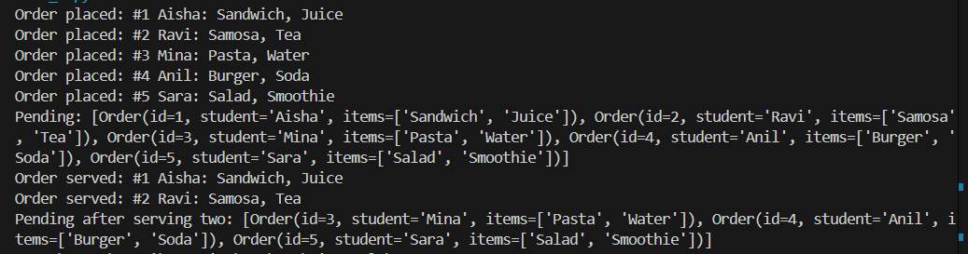
Expalantion:
Cafeteria queue uses `deque` for FIFO order so orders are placed and served in real-world sequence.

