ASSIGNMENT-13.5
2403A52L05-B50
E. Sai Nithin
Task Description #1 (Refactoring – Removing Global Variables)
• Task: Use AI to eliminate unnecessary global variables from the
code.
• Instructions:
o Identify global variables used across functions.
o Refactor the code to pass values using function parameters.
o Improve modularity and testability.
• Sample Legacy Code:
rate = 0.1
def calculate_interest(amount):
return amount * rate
print(calculate_interest(1000))
• Expected Output:
o Refactored version passing rate as a parameter or using a
configuration structure.
PROMPT:
“Refactor the above code to eliminate global variables by passing values as parameters or using configuration objects.”
CODE AND OUTPUT:
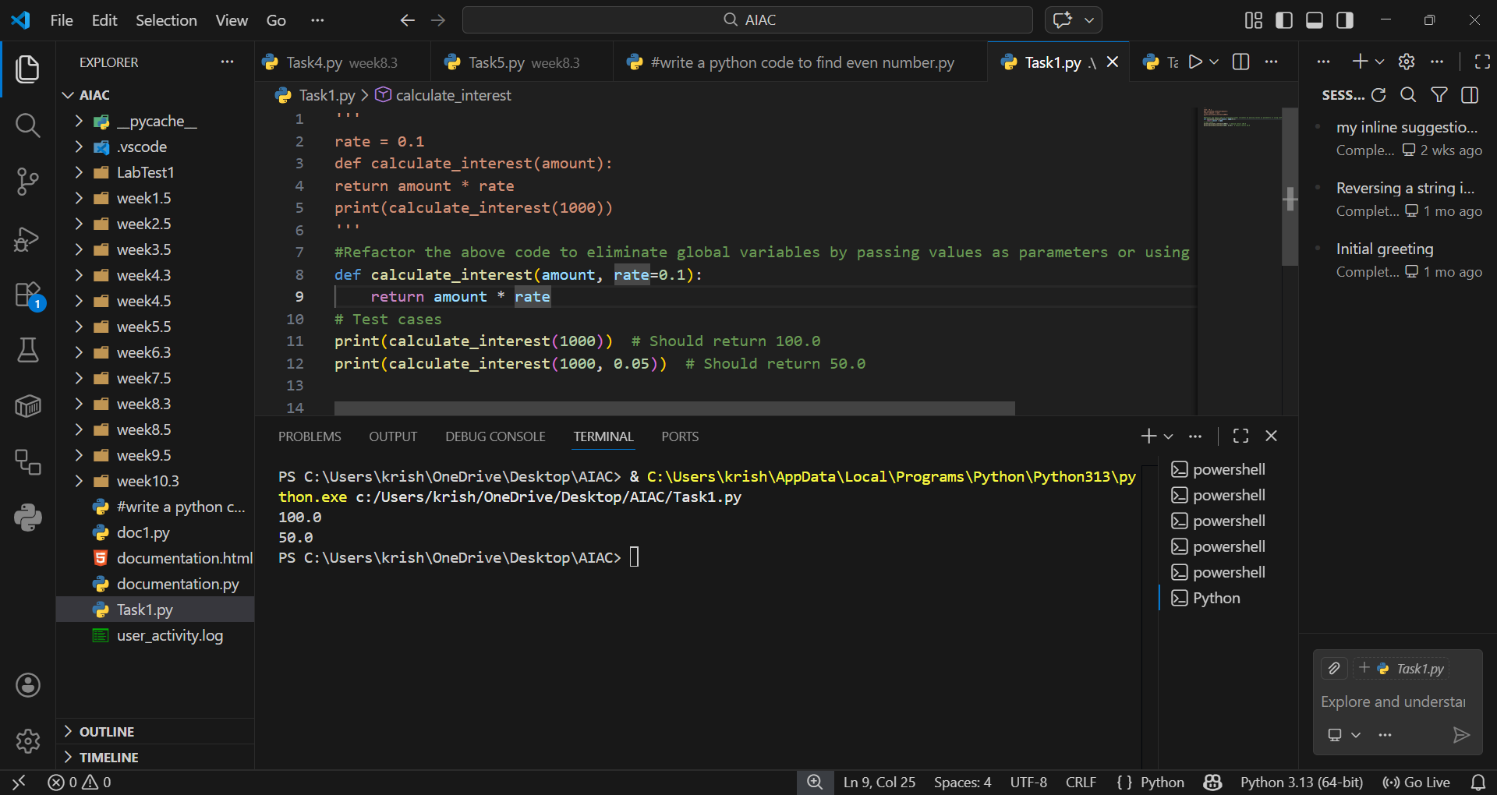
EXPLANATION:
This ensures modularity and testability by avoiding hidden dependencies. Functions become reusable since they rely only on inputs, not external state. It improves clarity and makes unit testing easier.

Task Description #2 : (Refactoring Deeply Nested Conditionals)
• Task: Use AI to refactor deeply nested if–elif–else logic into a
cleaner structure.
• Focus Areas:
o Readability
o Logical simplification
o Maintainability
Legacy Code:
score = 78
if score >= 90:
print("Excellent")
else:
if score >= 75:
print("Very Good")
else:
if score >= 60:
print("Good")
else:
print("Needs Improvement")
Expected Outcome:
o Flattened logic using guard clauses or a mapping-based
approach.

PROMPT:
“Simplify nested if–elif–else logic using guard clauses or mapping structures for readability and maintainability.”
CODE:
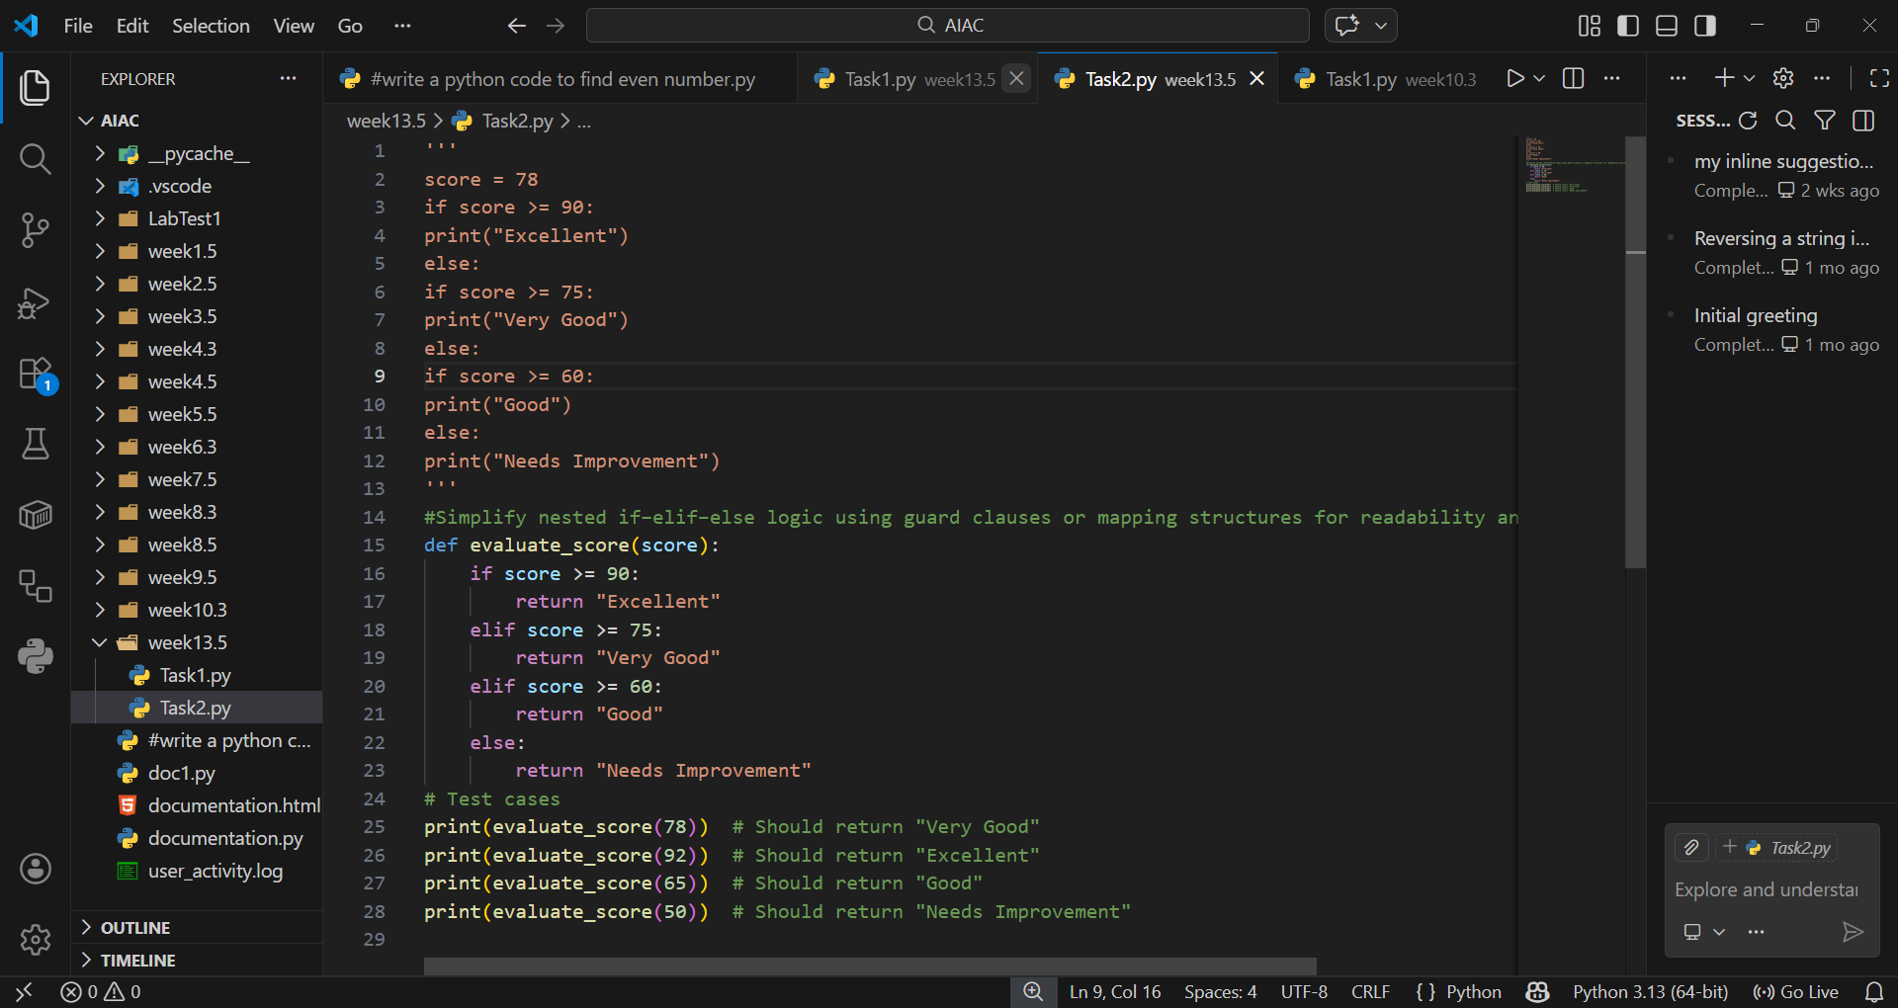

OUTPUT:
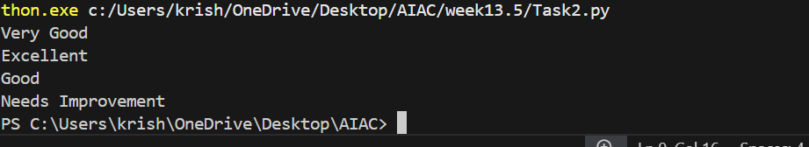

EXPLANATION:
Flattening conditionals reduces cognitive load and makes logic easier to follow. Guard clauses exit early, while mappings provide a clean lookup. This improves readability and future scalability.

Task 3 (Refactoring Repeated File Handling Code)
• Task: Use AI to refactor repeated file open/read/close logic.
• Focus Areas:
o DRY principle
o Context managers
o Function reuse
Legacy Code:
f = open("data1.txt")
print(f.read())
f.close()
f = open("data2.txt")
print(f.read())
f.close()
Expected Outcome:
o Reusable function using with open() and parameters.
PROMPT:
“Apply DRY principles by refactoring repeated file open/read/close code into a reusable function with context managers.”

CODE AND OUTPUT:
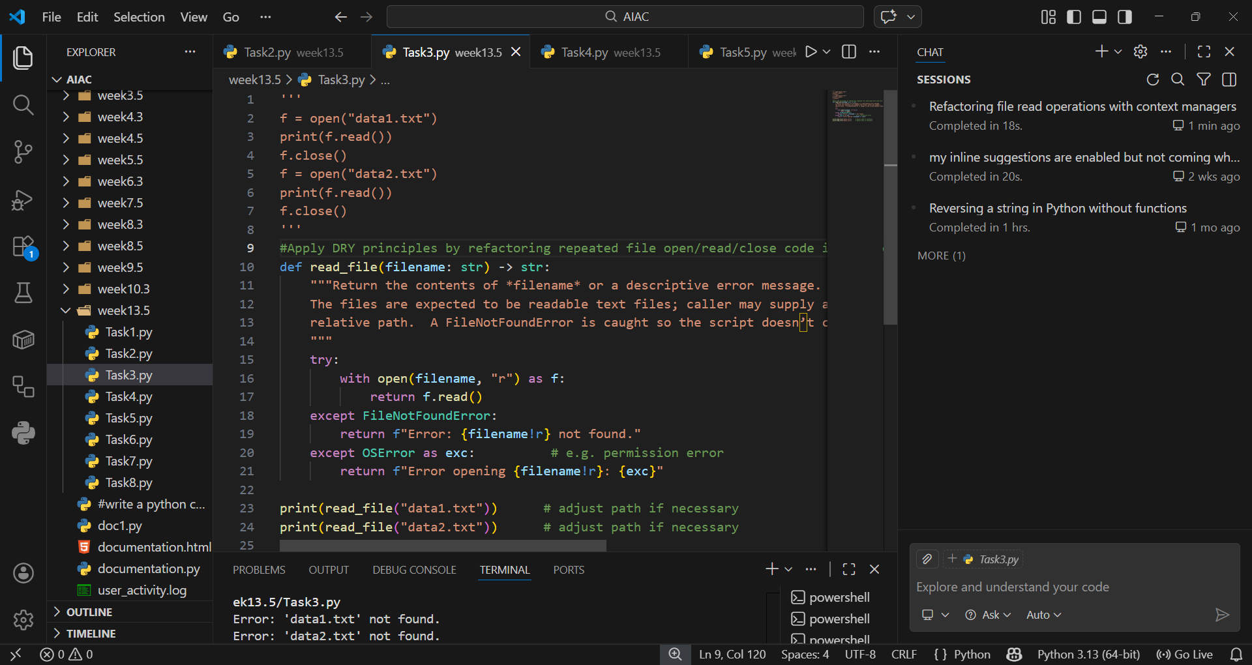
EXPLANATION:
Using with open() ensures safe resource handling and avoids manual closing. Encapsulating file logic in a function reduces duplication. This makes the code concise, reusable, and less error-prone.
Task 4 (Optimizing Search Logic)
• Task: Refactor inefficient linear searches using appropriate
data structures.
• Focus Areas:
o Time complexity
o Data structure choice
Legacy Code:
users = ["admin", "guest", "editor", "viewer"]
name = input("Enter username: ")
found = False
for u in users:
if u == name:
found = True
print("Access Granted" if found else "Access Denied")
Expected Outcome:
o Use of sets or dictionaries with complexity justification.
PROMPT:
“Replace inefficient linear searches with sets or dictionaries to achieve faster lookups."
CODE AND OUTPUT:
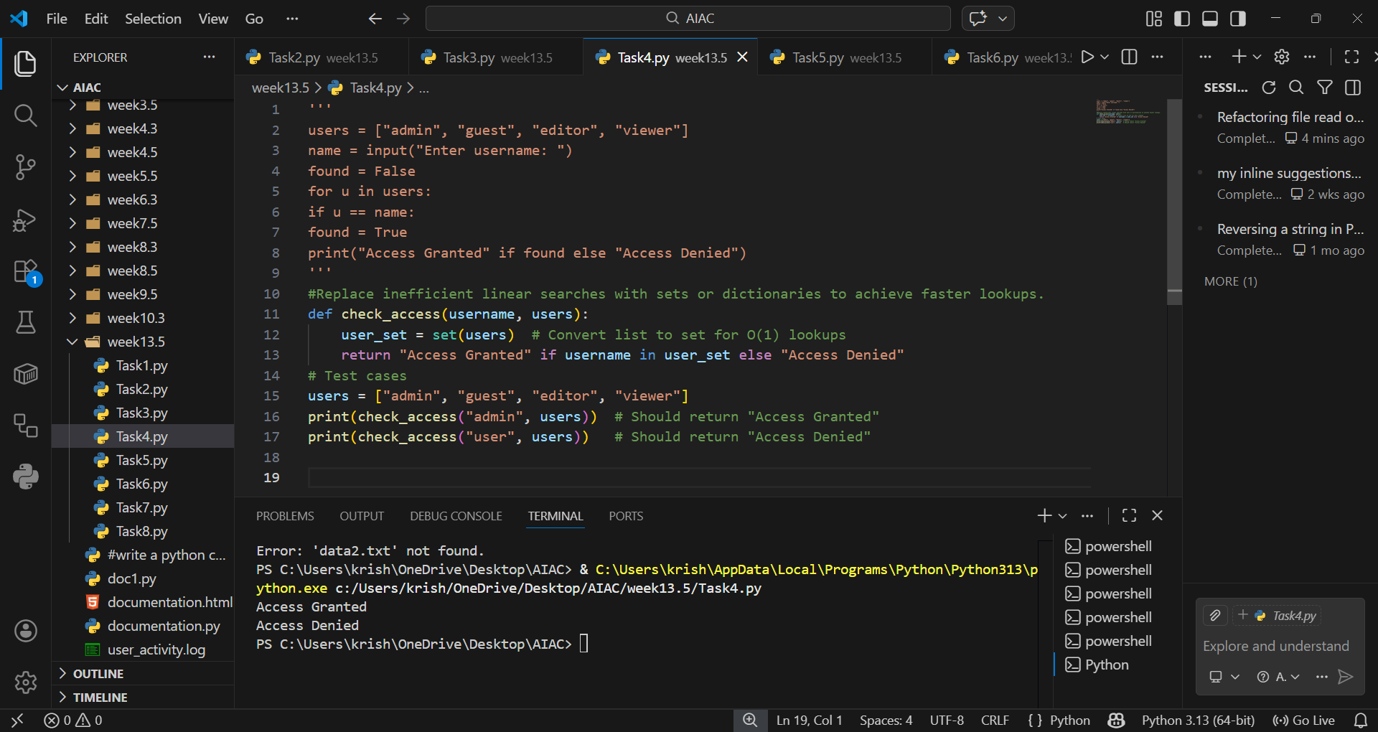
EXPLANATION:
Linear search has O(n) complexity, while sets/dictionaries provide average O(1) lookups. This drastically improves performance for large datasets. It also makes the code cleaner and more efficient.
Task 5 (Refactoring Procedural Code into OOP Design)
• Task: Use AI to refactor procedural code into a class-based
design.
• Focus Areas:
o Object-Oriented principles
o Encapsulation
Legacy Code:
salary = 50000
tax = salary * 0.2
net = salary - tax
print(net)
Expected Outcome:
o A class like EmployeeSalaryCalculator with methods and
attributes.
PROMPT:
“Refactor procedural salary calculation into a class-based design with encapsulated attributes and methods.”
CODE AND OUTPUT:
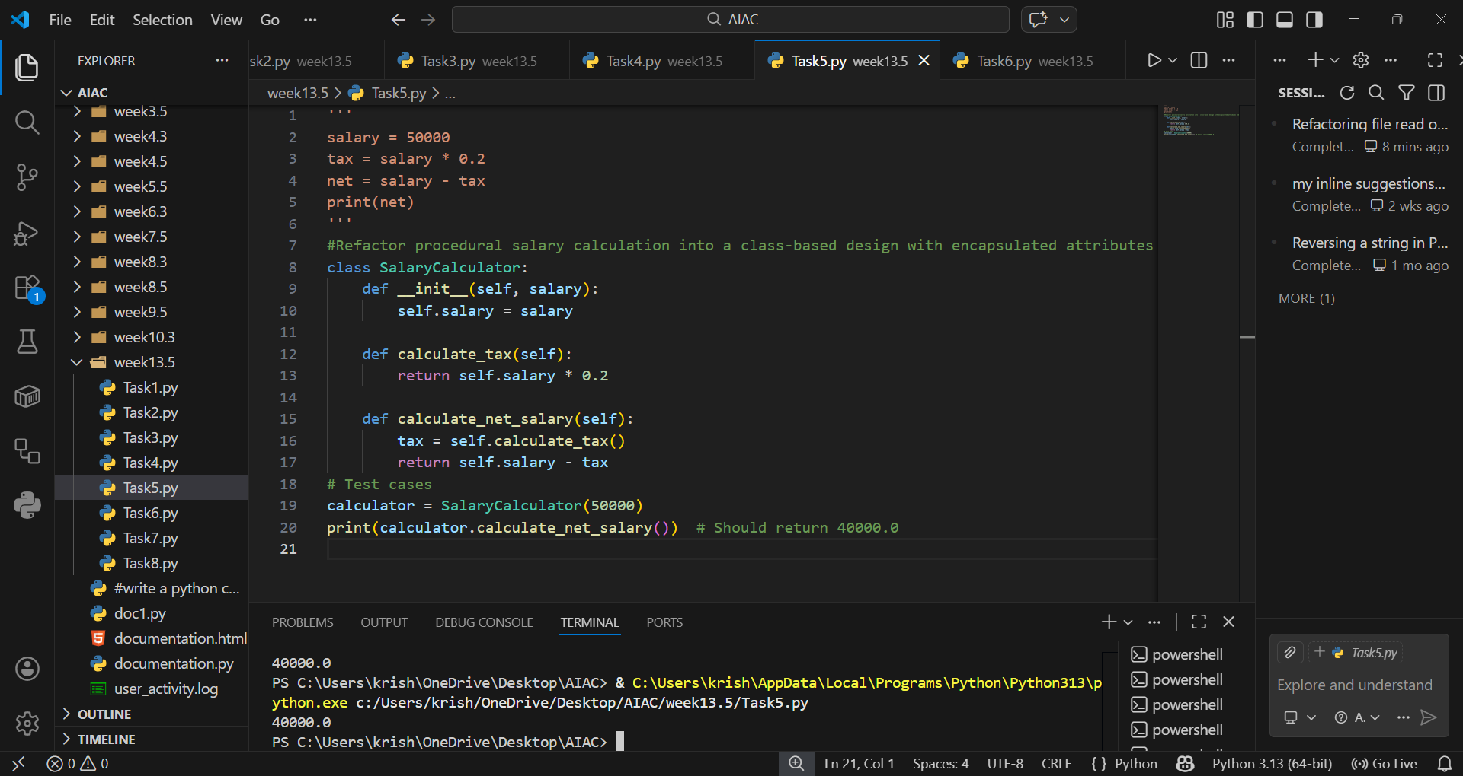
EXPLANATION:
Object-Oriented design improves structure and reusability. Encapsulation keeps salary, tax, and net logic within a class. This makes the code extensible, testable, and aligned with OOP principles.

Task 6 (Refactoring for Performance Optimization)
• Task: Use AI to refactor a performance-heavy loop handling
large data.
• Focus Areas:
o Algorithmic optimization
o Use of built-in functions
Legacy Code:
total = 0
for i in range(1, 1000000):
if i % 2 == 0:
total += i
print(total)
Expected Outcome:
o Optimized logic using mathematical formulas or
comprehensions, with time comparison.
PROMPT:
“Optimize heavy loops by using mathematical formulas or built-in functions instead of iterative summation."
CODE AND OUTPUT:
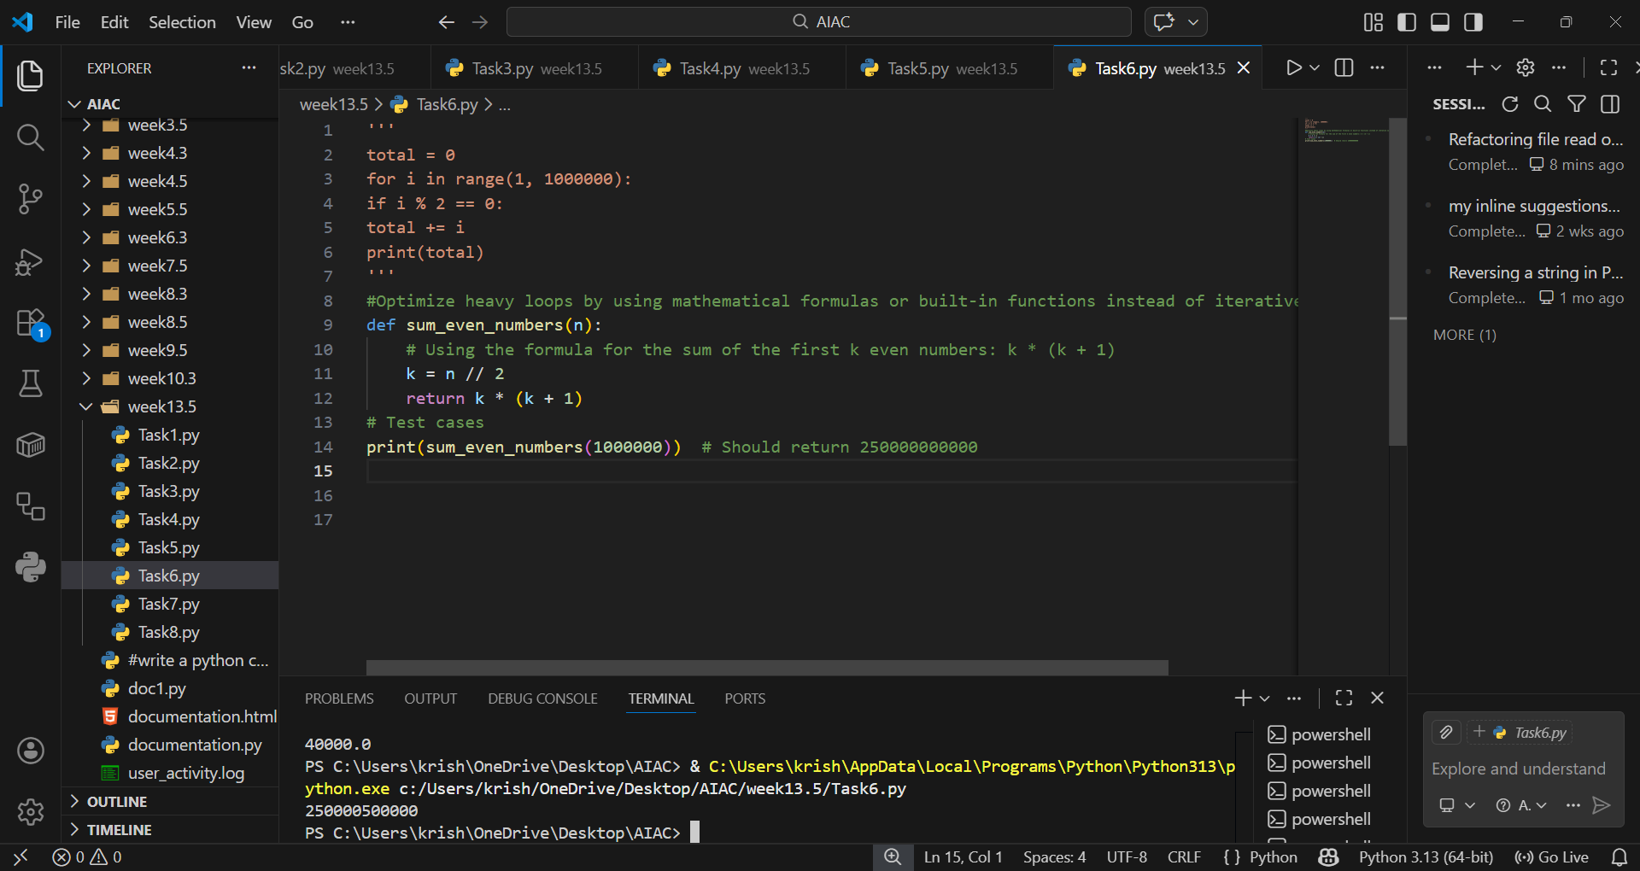

EXPLANATION:
Loops over large ranges are slow; formulas like arithmetic progression or built-ins like sum() with comprehensions are faster. This reduces runtime complexity and improves efficiency significantly.

Task 7 (Removing Hidden Side Effects)
• Task: Refactor code that modifies shared mutable state.
• Focus Areas:
o Functional-style refactoring
o Predictability
Legacy Code:
data = []
def add_item(x):
data.append(x)
add_item(10)
add_item(20)
print(data)
Expected Outcome:
o Refactored function returning values instead of mutating
globals.

PROMPT:
“Refactor functions that modify shared mutable state to return new values instead, following a functional style.”

CODE AND OUTPUT:
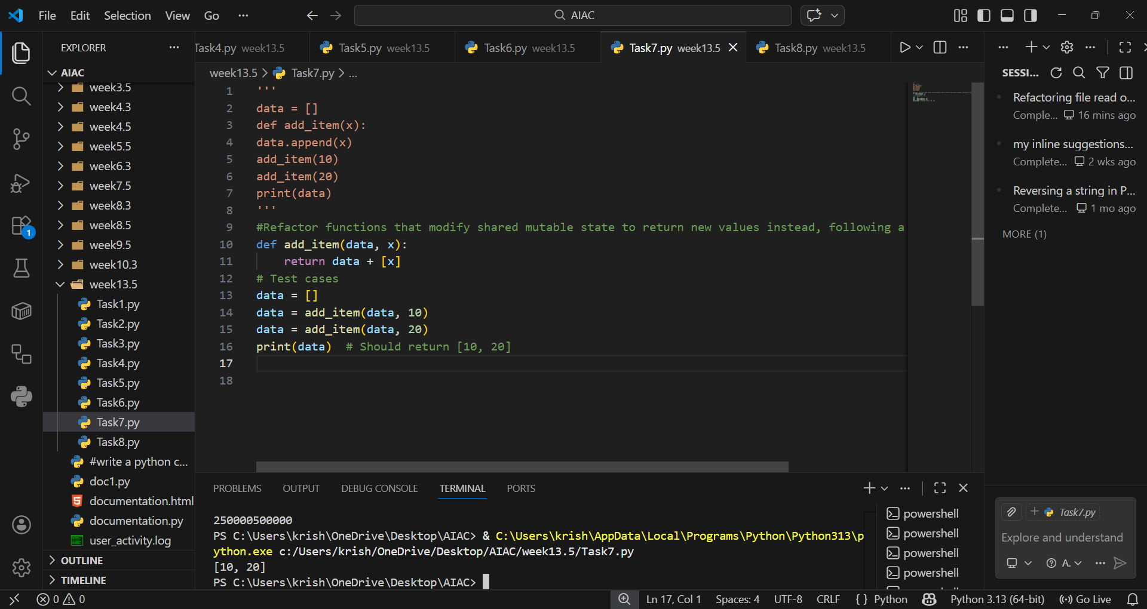
EXPLANATION:
This avoids hidden side effects by eliminating reliance on global or shared mutable data. Returning values makes behavior predictable and easier to test. It improves modularity and ensures functions remain pure, enhancing reliability.

Task 8 (Refactoring Complex Input Validation Logic)
• Task: Use AI to simplify and modularize complex validation
rules.
• Focus Areas:
o Readability
o Testability
Legacy Code:
password = input("Enter password: ")
if len(password) >= 8:
if any(c.isdigit() for c in password):
if any(c.isupper() for c in password):
print("Valid Password")
else:
print("Must contain uppercase")
else:
print("Must contain digit")
else:
print("Password too short")
Expected Outcome:
o Separate validation functions with clear responsibility

PROMPT:
“Simplify complex input validation by breaking rules into separate functions, each with clear responsibility."
CODE:
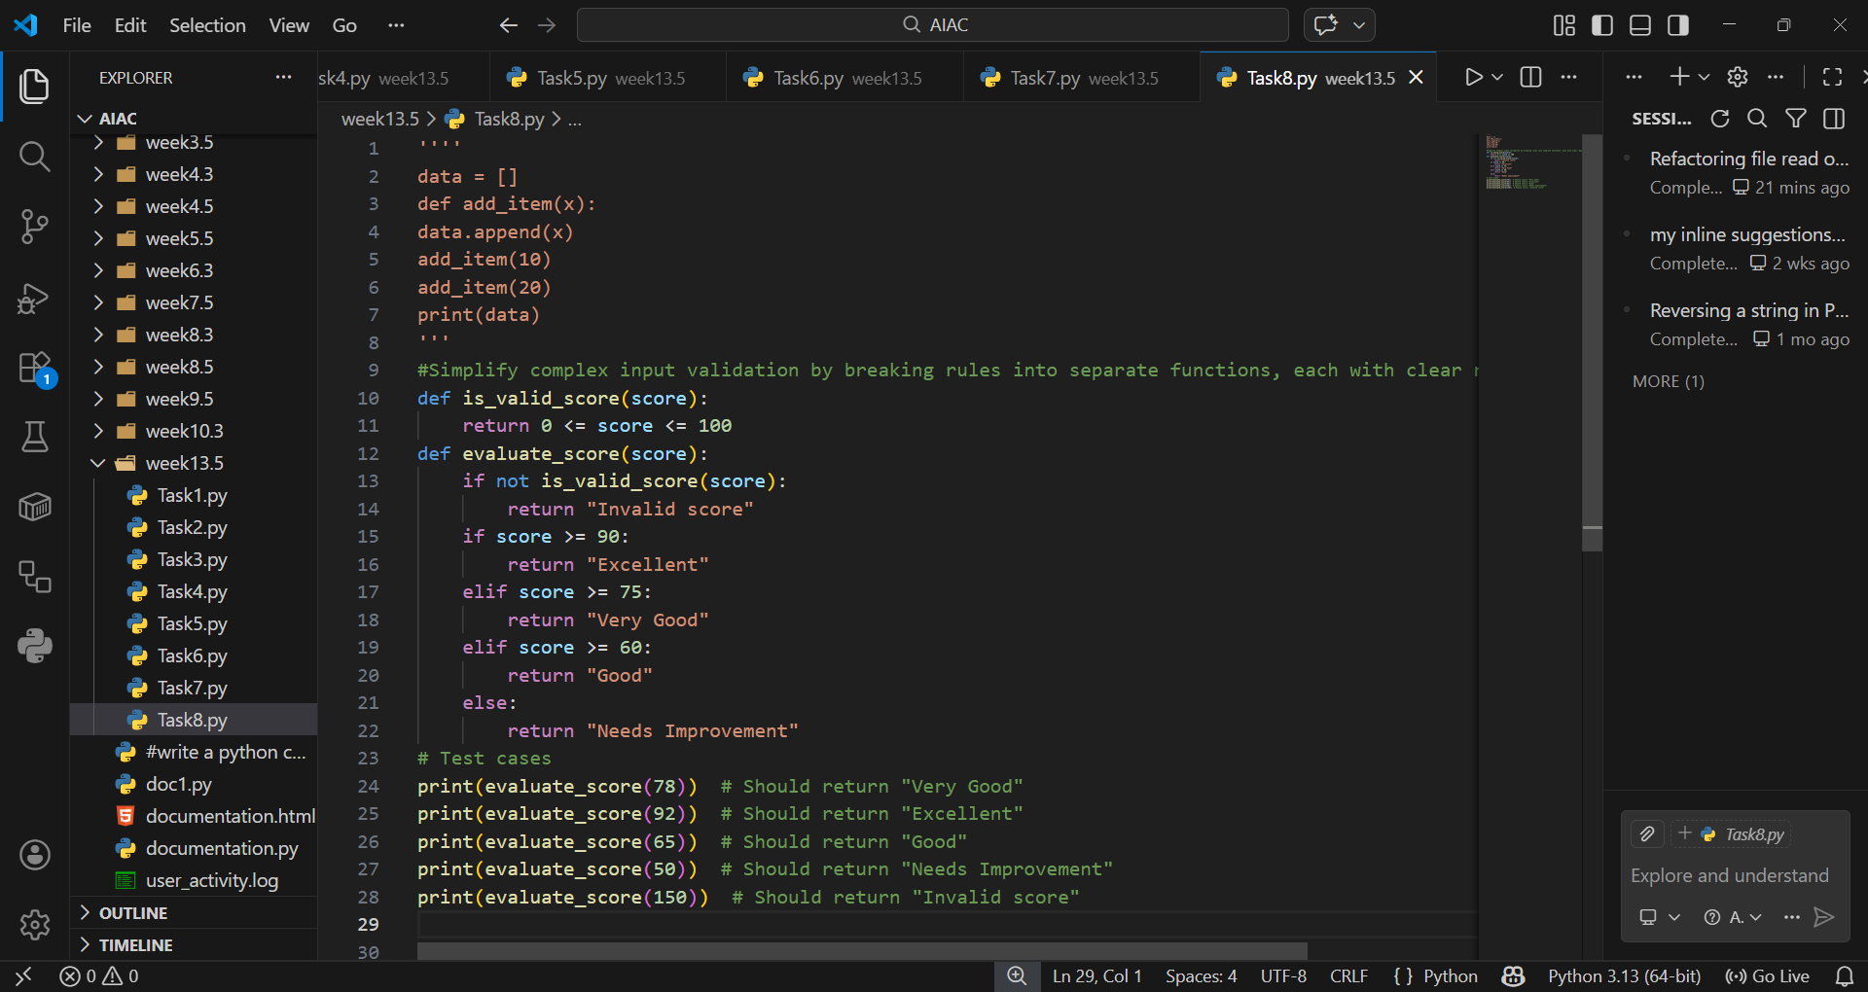
OUTPUT:
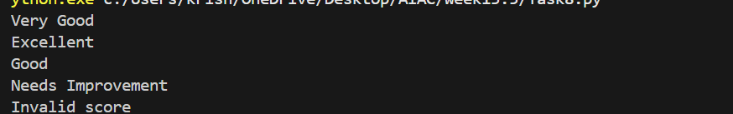
EXPLANATION:
Splitting validation into modular functions improves readability and testability. Each function handles one rule (length, digit, uppercase), making the logic easier to maintain. This approach supports unit testing and future extensions without nested conditionals.

