Lab Assignment 17.5
2403A52L05-B50
E. Sai Nithin
Task1:
Code and prompt:
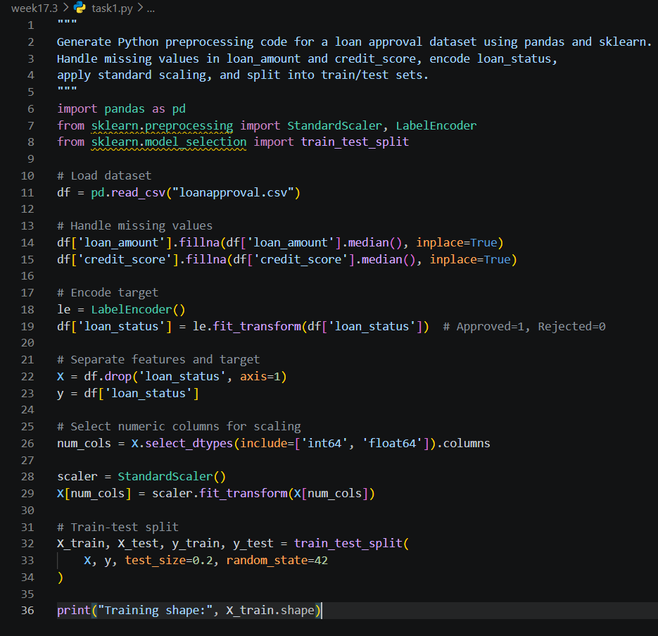

Task2:
Code and prompt:
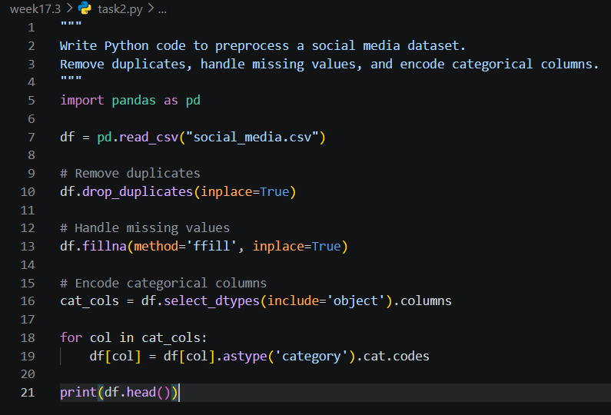
Task3:
Code and prompt:
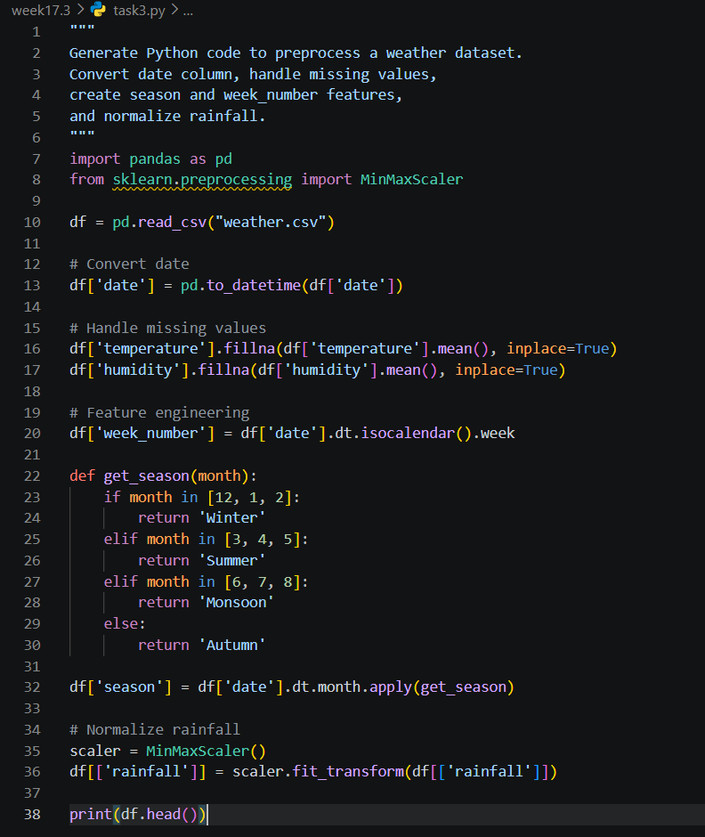
Task4:
Code and prompt:
