Lab Assignment 19.3
2403A52L05-B50
E. Sai Nithin
Task1:
Code and prompt:
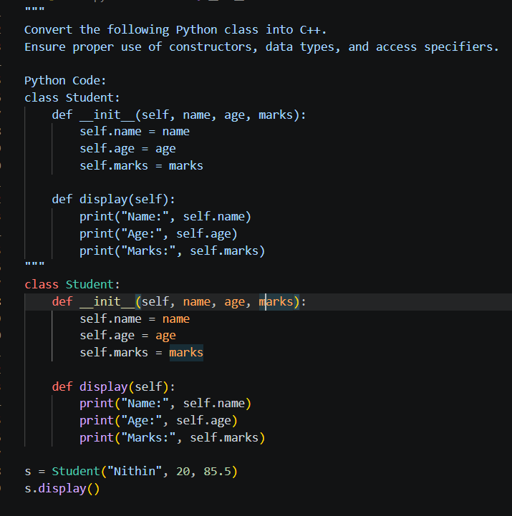
Output:
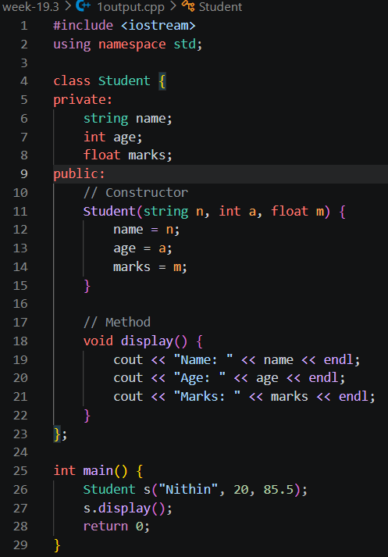
Task2:
Code and prompt:
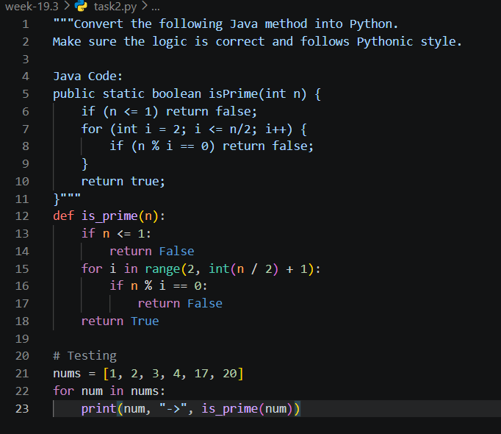
Task3:
Code and prompt:
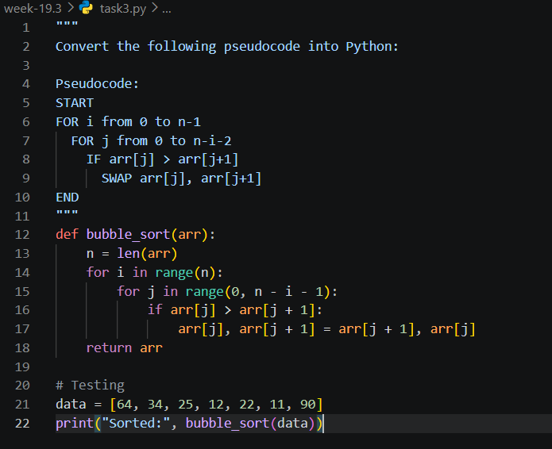
Task4:
Code and prompt:
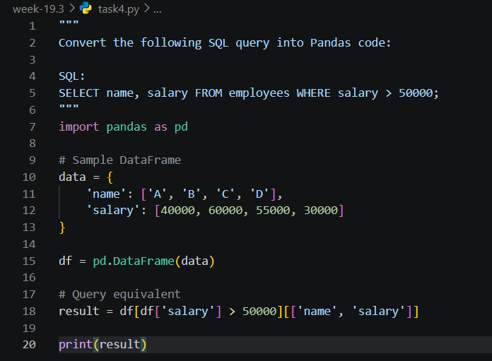
Task5:
Code and prompt:
