Lab04-Script.R

Nicholas Thiphakhinkeo A17686679

2024-10-14

# 1st R Script  
x <- 1:50  
plot(x)

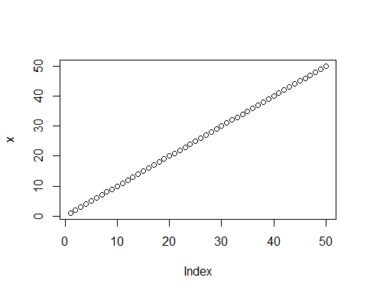

plot (x,sin(x))

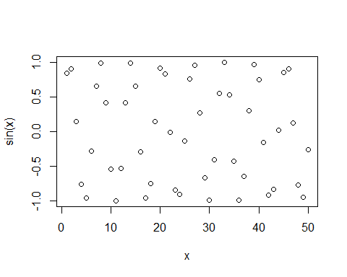

plot (x,sin(x),typ="l", col="green")

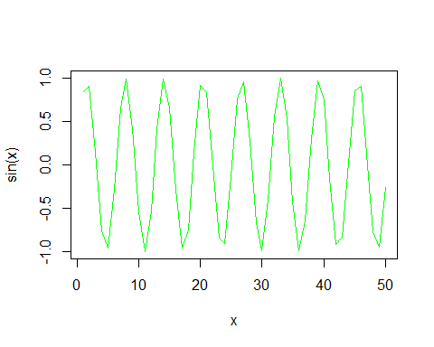

plot (x,sin(x),typ="l", col="purple", lwd=4)

