CIS336: Lab 1 Answer Sheet

Your name : Nathan Rivera

# Answer #1

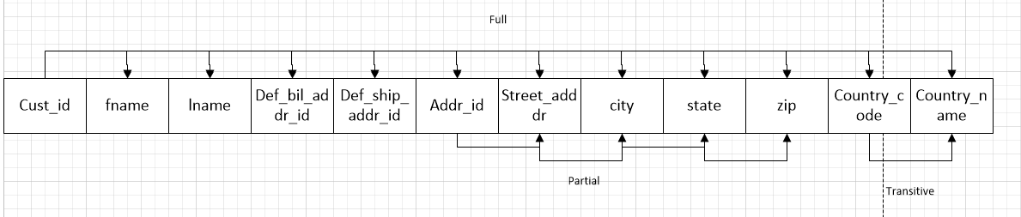

# Answer #2

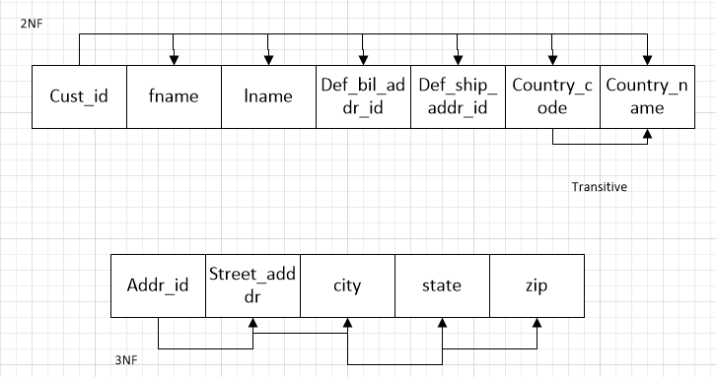

# Answer #3

# Answer #4

