Federal

It is important to note an overview of key Federal legislation related to alternative fuels and advanced transportation that has impacted the biobased economy. There are 8 policies that have contributed to the growth or decline of biofuel, renewable chemicals, and biobased products production.
- Energy Improvement and Extension Act of 2008 (October 3, 2008): This includes several provisions related to tax credits and exemptions for alternative fuels as well as fuel-efficient technologies.

- American Recovery and Reinvestment Act of 2009 (February 17, 2009): This adds nearly $800 billion to the creation of jobs, economic growth, tax relief, improvements in education and healthcare, infrastructure modernization, and investments in energy independence and renewable energy technologies. Supports grant programs, tax credits, research and development (R&D), fleet funding, and others to encourage alternative fuel.

- Tax Relief, Unemployment Insurance Reauthorization, and Job Creation Act of 2010 (December 17, 2011): This extends and reinstates several alternative fuel tax credits (the qualified alternative fuel vehicle fueling property tax credit, the volumetric ethanol excise tax credit, the ethanol and biodiesel producer tax credits, the alternative fuel, the alternative fuel mixture excise tax credits, and the biodiesel mixture excise tax credit).

- Business and Industry (B&I) Direct and Guaranteed Loans: This program finances business and industry acquisition, construction, conversion, expansion, and repair in rural areas. Loan funds can be used to finance the purchase and development of land, supplies and materials, and pay start-up costs of rural businesses, including operators of for-profit food hubs and food systems.

- American Taxpayer Relief Act of 2012 (January 2, 2013): This extends and reinstates several alternative fuel incentives (the alternative fuel infrastructure tax credit, biodiesel income tax credit, biodiesel mixture excise tax credit, alternative fuel mixture excise tax credits, and two- and three-wheeled plug-in electric vehicles tax credit). It also extends the second-generation biofuel producer tax credit, second-generation biofuel plant depreciation deduction allowance, the United States Department of Agriculture’s Advanced Biofuel Production Grants and Loan Guarantees, Advanced Biofuel Production Payments, Biodiesel Education Grants, Biomass Research and Development Initiative, and Ethanol Infrastructure Grant and Loan Guarantees.

- Tax Increase Prevention Act of 2014 (December 19, 2014): Reinstates many alternative fuel tax incentives (the alternative fuel infrastructure tax credit, the excise tax credit for alternative fuels, the tax credit for second-generation biofuel production, the income and excise tax credit for biodiesel and renewable diesel fuel mixtures, and the special depreciation allowance for second-generation biofuel plant property).

- Consolidated Appropriations Act of 2016 (December 18, 2015): Reinstates and extends many alternative fuel tax incentives (alternative fuel infrastructure tax credit, the excise tax credit for alternative fuels and alternative fuel mixtures, the tax credit for second-generation biofuel production, the income and excise tax credit for biodiesel and renewable diesel fuel mixtures, fuel cell motor vehicle tax credit, the special depreciation allowance for second-generation biofuel plant property, and the two- or three-wheeled plug-in electric drive motor vehicles tax credit).

- Biofuels Tax Extender Policy: The tax package retroactively extends the $1-per-gallon blenders tax credit for biodiesel and renewable diesel for 2 years, from Jan. 1, 2015 through Dec. 31, 2016. Extends the second-generation biofuel production credit which allows facilities producing cellulosic biofuels to claim a $1.01-per-gallon production tax credit. The tax extenders package also benefits biomass power with an extension of the Section 45 production tax credit (PTC).

Biofuel

Federal biofuel policies have been steadily increasing over the last few decades with the development of legislation and implementation of programs to assist the growth of the biofuel industry. The policy development began in 1970 with the Clean Air Act introducing initiatives to reduce pollutants. In direct relation to the energy field, the Energy Policy and Conservation Act of 1975 introduced the Corporate Average Fuel Economy (CAFE) standards. This began the demand for transparency of fuel economy information to the consumers. With the Alternative Motor Fuels Act, the CAFE credits were created. The CAFE standards tend to fluctuate with the price and availability of oil. The use of the CAFE standards was reduced with the cheap oil prices throughout the 1980s and the 1990s. In 2008, when there was an oil shock, a newfound interest in the CAFE standards and a change in fuel economy outlooks occurred.
Alternative fuel support began with the Energy Tax Act of 1978. This gave a tax exemption of $0.40 per gallon of ethanol. Acts ratified following the Energy Tax of 1978 fluctuated this amount for exemption over the last few decades. Following 2008, alternative fuel vehicle exemptions dropped significantly because of the economic downturn, and means to comply became more obtainable [9].
The overarching aim in the creation of biofuel policy is to reduce the dependence on imported oil and, to a lesser extent, to improve air quality. The Renewable Fuel Standards (RFS) were introduced by the Energy Policy Act of 2005. The goal of the RFS was to increase ethanol production from 4 billion gallons in 2006 to 7.5 billion gallons by 2012. The demand for energy independence is further exemplified with the introduction of the Energy Independence and Security Act of 2007. This expands biofuel mandates, specifically in blending requirements. In addition, the act stated the four types of biofuels to be renewable fuels, advanced biofuels, biomass-based diesel, and cellulosic biofuels.
There has been an increase in the United States biomass-based diesel demand since 2012, largely due to increasing Renewable Fuel Standards targets and the biodiesel tax credit. However, the amount of biodiesel and renewable diesel imports fluctuate due to uncertainty with both the RFS targets and the elimination and reinstatement of the biodiesel tax credit. In 2014, imports of biodiesel dropped significantly, over 80 million gallons, due to uncertainty with the RFS and the elimination of the tax credit. When the targets for both these legislations were finalized, the import amounts increased, which correlates to a 61 percent increase in 2015 with a total of 538 million gallons, compared to 61 million gallons in 2012. The majority of these imports were coming from Argentina, with over half the amount of renewable fuel imports in 2015. This was followed by Indonesia and then Canada [6].
The exports of biodiesel peaked in 2008 due to a biodiesel tax credit in the European Union. Once this credit was eliminated, the amount of exports dropped. In both 2013 and 2014, the United States imported more biodiesel than it exported. Since then, there has been a steady increase in the export amounts due to the expansion of regulations and the increase in the RFS targets. In 2016, the United States top export destination of biomass-based diesel was Canada with 1,642 thousand barrels out of a total export amount of 2,093 thousand barrels [10].
There has been a large effort to increase the research and development of biofuels within the United States’ economy. Many Federal programs, beyond the RFS, have been created to support these efforts. For instance, Biodiesel Education Grants are available through the Biodiesel Fuel Education Program. The grants aim to educate governmental and private entities on the benefits of biodiesel use. There has been an increase in grants, monetary incentives, and tax credits to encourage States, companies, organizations, and individuals to choose alternative fuels. Table 1 only includes the federally funded research and development centers; therefore, it is not an entire snapshot of the amounts dedicated to research and development within this sector.
Year | Expenditures
2006 | 13,218,947
2007 | 13,824,987
2008 | 15,616,390
2009 | 16,390,111
2010 | 18,880,609
2011 | 18,671,245
2012 | 18,280,943
2013 | 17,667,184
2014 | 17,718,556
2015 | 18,458,257
Table 1. Total R&D expenditures at federally funded research and development centers from 2006 to 2015 (in thousand dollars).

Biobased products

A focus on the bioproduct industry has been a relatively recent trend, and therefore not as many policies support the production of biobased products. A number of influential executive orders and programs have emphasized the development of biobased products within the United States economy.
Created by the 2002 Farm Bill and reauthorized by the Agricultural Act of 2014, the USDA BioPreferred Program aims to increase the purchasing of biobased products within the United States. This program is made up of two parts: a mandatory purchasing requirement for Federal agencies and a voluntary labeling initiative for the biobased products within the economy. The BioPreferred Program increases economic development and creates new jobs within new fields. Biobased products are products with materials “derived from plants and other renewable agricultural, marine, and forestry materials and provide an alternative to conventional petroleum derived products”.
Programs such as the BioPreferred Program have largely advanced the biobased products industry, as have recent executive orders. President Barack Obama signed Executive Order 13693 “Planning for Federal Sustainability in the Next Decade” in 2015. Based on 2008 levels, the Government’s greenhouse gas emissions should be reduced by 40 percent in the next decade. Part of this order is the increase in Government spending on biobased products. In 2015, the Renewable Chemical Act was introduced by Senator Stabenow of Michigan. The bill proposed to give a $0.15 tax credit per pound of biobased content for producers of renewable chemicals who meet certain criteria. Although the legislation was not enacted, work is being done on developing policies to grow the biobased product industry in the United States.
State
In the 2008, there were 106 biofuel tax incentive and rebate programs in 40 States. This has grown to 190 biofuel tax incentive and rebate programs in 45 different States. In addition, a total of 10 States had mandates or standards for the use of ethanol or biodiesel after the 2008 legislative season (Hawaii, Washington, Oregon, New Mexico, Louisiana, Florida, Montana, Minnesota, Iowa, and Missouri). Currently, there are 16 States with mandates or standards (addition of California, Maine, Massachusetts, New Jersey, Pennsylvania, and Wisconsin). While this is not a large increase, the biobased economy is expanding largely at the State level.

Biofuel

A large amount of policy comes from the State level for the biofuel industry. Many States have similar policies, such as an “Alternative Fuel School Bus Incentive” or an “Alternative Fuel Definition.” Although the Federal Government has created definitions to abide by within the biofuel sector, many States have created policies that define the terms by their own words. This would include an “biodiesel” definition. Depending on the State’s policy, this definition could include a certain type of blend or not. States also tend to provide alternative fuel incentives, tax credits, or exemptions. It appears many State policies revolve around vehicle use and alternative fuels, rather than focusing on agricultural incentives. Loan guarantee programs also seem to be common policies throughout the States.
As seen in figure 1, there is a large range of state biofuel policies. States, such as Alaska, have very few policies. However, other States, like California, are attempting to transition their economy and cut down on their emissions through the implementation of policy. A breakdown of each States amount of policies can be found in figure 1 as well.
The number of policies per State is growing each year; however, many credits or programs are running out of funding within the next few years. This leaves the responsibility to the State to keep expanding the biofuel industry. There is a worry that State legislatures will not put as much emphasis on the importance of the biofuel industry. However, California does exemplify a State that has placed emphasis on renewable chemicals with the passage of California's Low Carbon Fuel Standard (LCFS) Program which requires a reduction in the carbon intensity of transportation fuels that are sold, supplied, or offered for sale in the State by a minimum of 10 percent by 2020. The California Air Resources Board (ARB) regulations require transportation fuel producers and importers to meet specified average carbon intensity requirements for fuel. In the regulations, carbon intensity reductions are based on reformulated gasoline mixed with 10 percent corn-derived ethanol and low-sulfur diesel fuel.
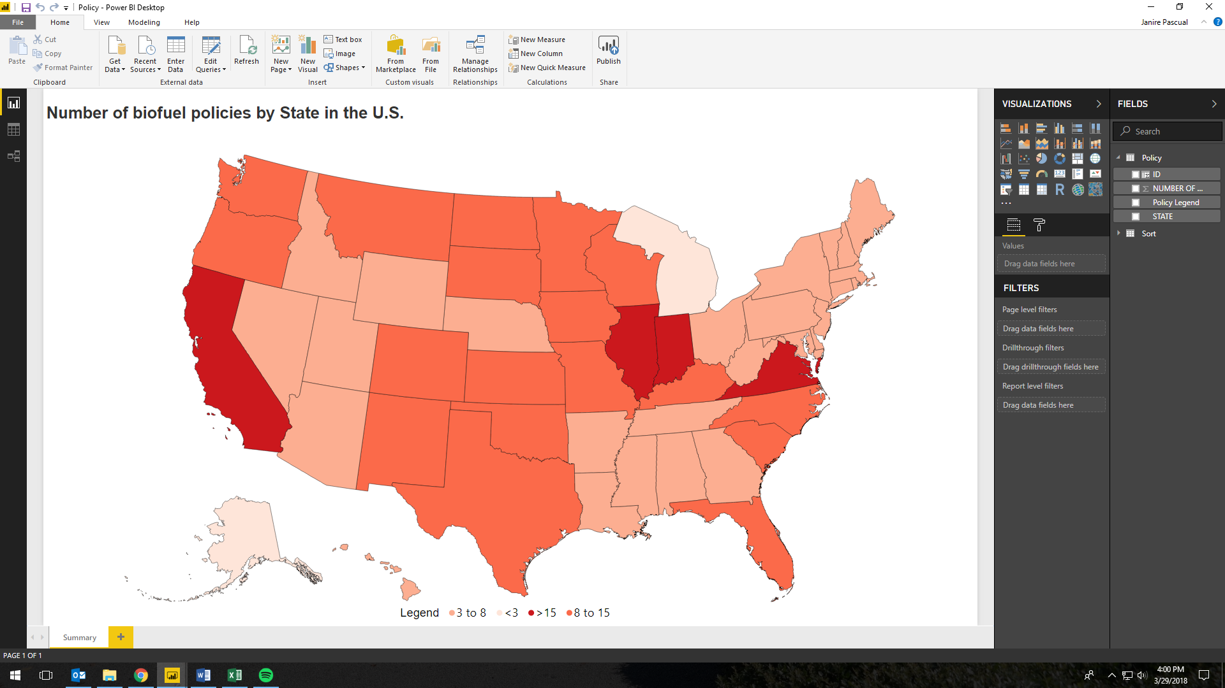

BioProduct

In the past decade, there has been an increase in States creating initiatives, programs, plans, and strategies to increase renewable chemicals and biobased products. Massachusetts created an Environmentally Preferable Products Procurement Program in 2009 that assists buyers in finding more environmentally friendly products, services, and vendors. Other States are creating goals such as to reduce reliance on landfills by increasing recycling and composting programs.
The State of Ohio through S.B. 131 of the 128th General Assembly requires the Department of Administrative Services (DAS) to establish a biobased product preference procurement program that is to apply to all purchases made by State agencies.
Recently, Maryland tried to pass HB 1330. This would require child care center and homes to use green product cleaning supplies. The bill had 50 percent progression, but then died in committee. Similar bioproduct-based legislation is being proposed in State legislatures across the country. Like the Federal policy, there is still a large lack in bioproduct policy at the State level. However, States are making more of an effort to introduce new policy than the Federal Government. For this reason, the biobased products industry will most likely be affected more by State regulations and programs in the future.
International
It is necessary to note that there are many agreements and actions taking place beyond the United States that are not included here. Examples as to how the United States biobased economy is likely influenced by other countries’ policies are included below. Moving forward, the United States will be pressured into increasing its own policies to compete with the global market.

There have been numerous international agreements that aim to create policy for the biobased economy. “Everything But Arms” provides lesser developed countries with duty-free and quota-free access to ethanol exports. The World Trade Organization has created agreements that focus on the imports and exports of biomaterials between countries.
The European Union began the Environmental Action Programs in 1973. Since then, there have been six programs that work towards creating a mutual interdependence between economic development, prosperity, and the protection of the environment. These six programs that have been introduced every 5 years develop aims and approaches on how to tackle sustainable development. Throughout this process, coinciding legislation has occurred as well. The Amsterdam Treaty of 1997 launched the initiative for environmental policy integration. Several directives, policies, and standards have been introduced (European Chemicals Policies, 2003 Emission Trading Directive, etc.) to further integrate. Many of the legislative actions of the EU and rest of the word, specifically tax incentives, influence the biofuel imports and exports of the United States. As previously mentioned, the spike in biofuel exports in 2008 was mainly due to a tax incentive created by the European Union.
In addition, other countries are trying to increase their biofuel and bioproduct economy. Nigeria is planning on spending $50 billion USD for local biofuel production to further secure its agricultural and energy sectors.
Business to Business
There has been an increase in business action within the biobased economy. Many businesses are creating coalitions in order to get ahead of the Federal and State legislation. Businesses are often attempting to identify the leading indicators to predict the future of the industry. Examples of industry coalitions and actions are included below. However, there is a need for more governmental-private sector partnership action for proper policies to be implemented.

Many corporations are creating their own internal and external policies that increase the demand for renewable chemicals and biobased products. Examples include B-2-B coalitions which have been created to drive sustainability in the supply chain as well as to communicate to institutional customers and individual consumers the sustainability of the product. The Sustainable Apparel Coalition was created as an alliance between large players within the apparel industry to account for one another’s practices through the creation of the Higg Index. The Higg Index is a set of self-assessment tools to measure a company’s environmental, social, and labor impacts and which incentivizes the utilization of renewable chemicals and biobased products. Other tools have been created to analyze a company’s impact. Life Cycle Assessment (LCA) evaluates a product’s environmental impact through all stages of its life.
Certification processes have become common for businesses to obtain for their entire business or for a specific product. For instance, the product of tea may become Fair Trade Certified after following social, environmental, and economic standards. A company may become a certified B Corporation if the entire company meets the standards of working conditions, environment, community empowerment and transparency. These and many other certifications translate to the consumer the transparency and positive impact that the business is attempting to promote.

