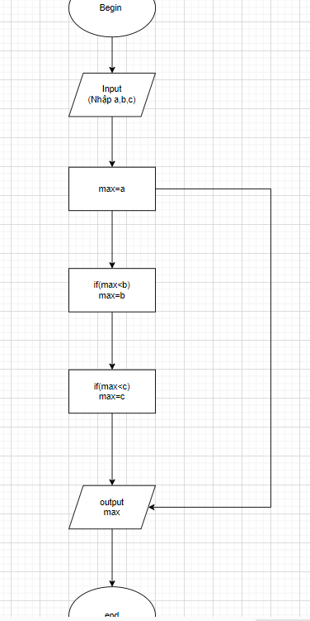

Begin

Input: a,b,c

Max=a

If(max<b) -> max=b

If(max<c) -> max=c

Output=max

end