HW8

108034058

鍾岷翰

1.

(a)

import sys

assert sys.version_info >= (3, 5)

# Scikit-Learn ≥0.20 is required

import sklearn

assert sklearn.__version__ >= "0.20"

# Common imports

import numpy as np

import os

# to make this notebook's output stable across runs

np.random.seed(42)

# To plot pretty figures

# %matplotlib inline

import matplotlib as mpl

import matplotlib.pyplot as plt

mpl.rc('axes', labelsize=14)

mpl.rc('xtick', labelsize=12)

mpl.rc('ytick', labelsize=12)

np.random.seed(4)

m = 1000

noise = 0.1

angles = np.random.rand(m) * random.uniform(0,2*np.pi)

X = np.empty((m, 3))

X[:, 0] = angles/6.28*np.cos(angles) + noise * np.random.randn(m)  * random.gauss(0,1)

X[:, 1] = angles/6.28*np.sin(angles) + noise * np.random.randn(m)  * random.gauss(0,1)

X[:, 2] =  noise * np.random.randn(m)* random.gauss(0,1)

from sklearn.decomposition import PCA

pca = PCA(n_components=2)

X2D = pca.fit_transform(X)

fig = plt.figure()

ax = fig.add_subplot(111, aspect='equal')

ax.plot(X2D[:, 0], X2D[:, 1], "k+")

ax.plot(X2D[:, 0], X2D[:, 1], "k.")

ax.plot([0], [0], "ko")

ax.arrow(0, 0, 0, 1, head_width=0.05, length_includes_head=True, head_length=0.1, fc='k', ec='k')

ax.arrow(0, 0, 1, 0, head_width=0.05, length_includes_head=True, head_length=0.1, fc='k', ec='k')

ax.set_xlabel("$z_1$", fontsize=18)

ax.set_ylabel("$z_2$", fontsize=18, rotation=0)

ax.axis([-2, 2, -2, 2])

ax.grid(True)

plt.show()

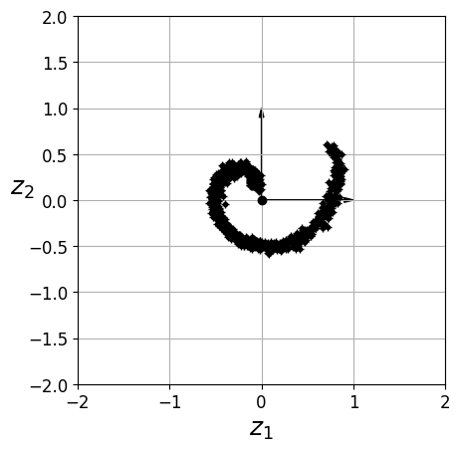

(b)

import sys

assert sys.version_info >= (3, 5)

# Scikit-Learn ≥0.20 is required

import sklearn

assert sklearn.__version__ >= "0.20"

# Common imports

import numpy as np

import os

# to make this notebook's output stable across runs

np.random.seed(42)

# To plot pretty figures

# %matplotlib inline

import matplotlib as mpl

import matplotlib.pyplot as plt

mpl.rc('axes', labelsize=14)

mpl.rc('xtick', labelsize=12)

mpl.rc('ytick', labelsize=12)

np.random.seed(4)

m = 1000

noise = 0.1

angles = np.random.rand(m) * random.uniform(0,2*np.pi)

X = np.empty((m, 3))

X[:, 0] = angles/6.28*np.cos(angles) + noise * np.random.randn(m)  * random.gauss(0,1)

X[:, 1] = angles/6.28*np.sin(angles) + noise * np.random.randn(m)  * random.gauss(0,1)

X[:, 2] =  angles*1 + noise * np.random.randn(m)* random.gauss(0,1)

from sklearn.decomposition import PCA

pca = PCA(n_components=2)

X2D = pca.fit_transform(X)

fig = plt.figure()

ax = fig.add_subplot(111, aspect='equal')

ax.plot(X2D[:, 0], X2D[:, 1], "k+")

ax.plot(X2D[:, 0], X2D[:, 1], "k.")

ax.plot([0], [0], "ko")

ax.arrow(0, 0, 0, 1, head_width=0.05, length_includes_head=True, head_length=0.1, fc='k', ec='k')

ax.arrow(0, 0, 1, 0, head_width=0.05, length_includes_head=True, head_length=0.1, fc='k', ec='k')

ax.set_xlabel("$z_1$", fontsize=18)

ax.set_ylabel("$z_2$", fontsize=18, rotation=0)

ax.axis([-2, 2, -2, 2])

ax.grid(True)

plt.show()

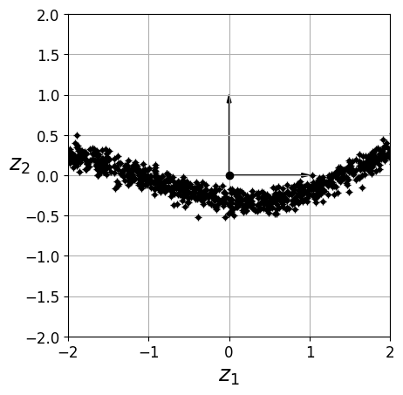

2.

#HW8_2

# This example is John Gutag's book

# the code is used to create clusters

# first we generate two cluster with mean and sigma

# second we apply k means cluster

# for simplicity we only use two clusters but the idea can be generalized

# the original code is written in class and object-oriented

# here we use more procedure type programming

import random

import pandas as pd

x1_record=[]

x2_record=[]

x1=0.0

x2=0.0

y1=0.0

y2=0.0

number_sample=30

#generate two clusters decorated with gaussian noise

for i in range(number_sample):

    x1=random.gauss(0,0.6) #create random number gauss (mean, sigma)

    x2=random.gauss(0,0.6)

    x1_record.append(float(x1))

    x2_record.append(float(x2))

for i in range(number_sample):

    y1= 1.0+random.gauss(0,0.6)

    y2= 1.0+random.gauss(0,0.6)

    x1_record.append(float(y1))

    x2_record.append(float(y2))

number = len(x1_record)

print(number)

#choose two cluster

cluster1= random.choice(range(0,number))

cluster2= random.choice(range(0,number))

centroid1x= x1_record[cluster1]

centroid1y= x2_record[cluster1]

centroid2x= x1_record[cluster2]

centroid2y= x2_record[cluster2]

print('initial choice',round(centroid1x,3), round(centroid1y,3), round(centroid2x,3), round(centroid2y,3))

index=[]

for j in range(number):

    index.append('0') # create a zero index tthis index record which cluster

                        #the data point is associated with

#run over all the sample and compute and compare the distance

for j in range(number):

    distance_to_cluster1= (centroid1x-x1_record[j])**2+(centroid1y-x2_record[j])**2

    distance_to_cluster2= (centroid2x-x1_record[j])**2+(centroid2y-x2_record[j])**2

    if distance_to_cluster1>distance_to_cluster2:

        index[j]=2

    else:

        index[j]=1

centroid_1_x=0.0  # index rule index for cluster

centroid_1_y=0.0

centroid_2_x=0.0

centroid_2_y=0.0

for iteration in range(10):

    sum_1_x=0.0

    sum_1_y=0.0

    sum_2_x=0.0

    sum_2_y=0.0

    count_1=0

    count_2=0

    for j in range(number):

        if index[j]==1:

            sum_1_x=sum_1_x+x1_record[j]

            sum_1_y=sum_1_y+x2_record[j]

            count_1=count_1+1

        elif index[j]==2:

            sum_2_x=sum_2_x+x1_record[j]

            sum_2_y=sum_2_y+x2_record[j]

            count_2=count_2+1

        else:

            print('error index') #for trouble shooting

    centroid_1_x=sum_1_x/count_1

    centroid_1_y=sum_1_y/count_1

    centroid_2_x=sum_2_x/count_2

    centroid_2_y=sum_2_y/count_2

    print('step', iteration, '1 x',round(centroid_1_x,3), '1 y',round(centroid_1_y,3),'2 x',round(centroid_2_x,3),'2 y',round(centroid_2_y,3))

    for j in range(number):

        distance_to_cluster1= (centroid_1_x-x1_record[j])**2+(centroid_1_y-x2_record[j])**2

        distance_to_cluster2= (centroid_2_x-x1_record[j])**2+(centroid_2_y-x2_record[j])**2

        if distance_to_cluster1>distance_to_cluster2:

            index[j]=2

        else:

            index[j]=1

df = pd.DataFrame(columns=['sample', 'x1', 'x2'])

for j in range(number):

    df = df.append({"sample": j+1 , "x1":round(x1_record[j],3), "x2":round(x2_record[j],3)},ignore_index=True)

    print( 'sample #', j, round(x1_record[j],3),round(x2_record[j],3))

df.to_csv('/content/drive/MyDrive/HW8_2.csv', index=False)

(a)

(b)

$$midpoint=\left(0.5765,0.4765\right)$$

$$m = -0.94011$$

$$y=-0.94011(x-0.5765)+0.4765$$

3.

