HW3

108034058

鍾岷翰

1.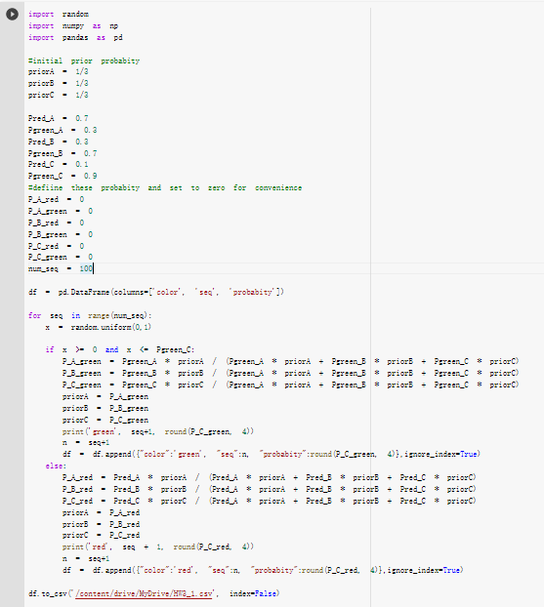

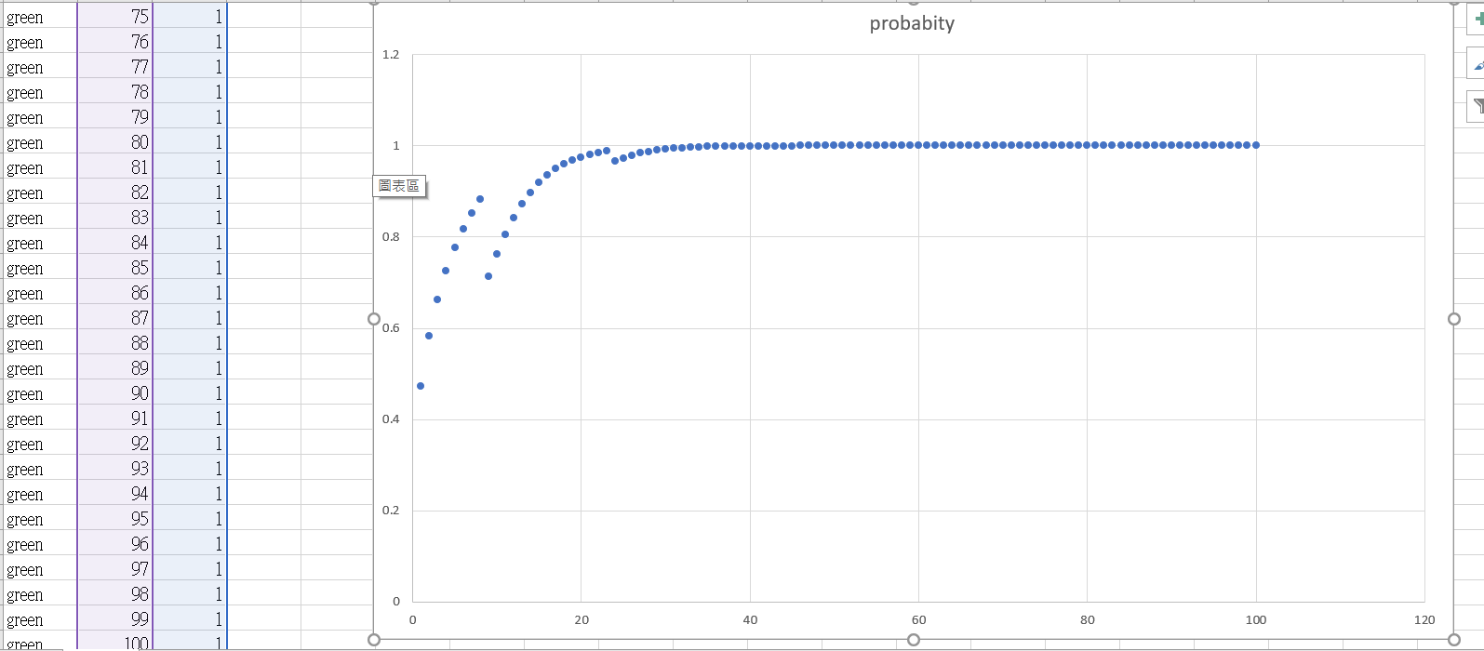

2.

(a)

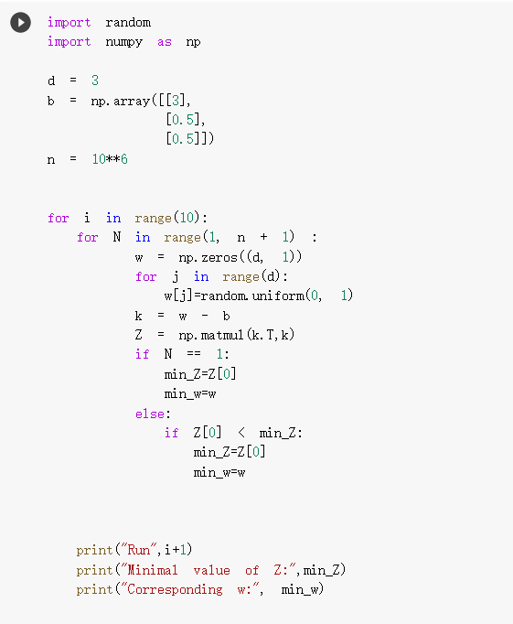

Run 1

Minimal value of Z: [4.00138847]

Corresponding w: [[0.99980643]

[0.47580479]

[0.49463876]]

Run 2

Minimal value of Z: [4.00052196]

Corresponding w: [[0.99987835]

[0.49444905]

[0.4978691 ]]

Run 3

Minimal value of Z: [4.00036959]

Corresponding w: [[0.99999511]

[0.48148326]

[0.50267734]]

Run 4

Minimal value of Z: [4.00241557]

Corresponding w: [[0.99946059]

[0.51042159]

[0.51220688]]

Run 5

Minimal value of Z: [4.00108955]

Corresponding w: [[0.99988299]

[0.52004773]

[0.48518112]]

Run 6

Minimal value of Z: [4.000575]

Corresponding w: [[0.99987269]

[0.49491573]

[0.50631735]]

Run 7

Minimal value of Z: [4.0011204]

Corresponding w: [[0.99972941]

[0.49584742]

[0.49544755]]

Run 8

Minimal value of Z: [4.00037229]

Corresponding w: [[0.99998685]

[0.49195584]

[0.51596794]]

Run 9

Minimal value of Z: [4.00176451]

Corresponding w: [[0.99984266]

[0.51343011]

[0.53089912]]

Run 10

Minimal value of Z: [4.00043057]

Corresponding w: [[0.99994454]

[0.48557321]

[0.49923499]]

(b)  
由3,0.5,0.5這個點以圓心出發，並不會接觸到此範圍的端點。並且由題(a)可得知最短距離並非在端點上。

(c)

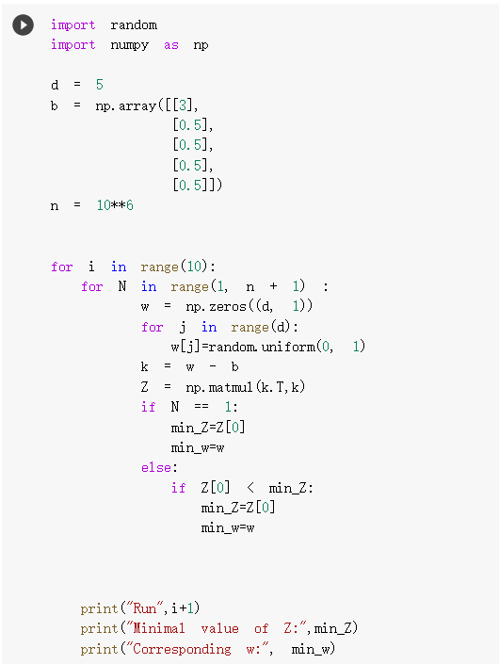

Run 1

Minimal value of Z: [4.01018901]

Corresponding w: [[0.99965185]

[0.56641203]

[0.49197593]

[0.44198602]

[0.46908503]]

Run 2

Minimal value of Z: [4.02361917]

Corresponding w: [[0.99936062]

[0.49557217]

[0.61628046]

[0.58519612]

[0.51618928]]

Run 3

Minimal value of Z: [4.00626693]

Corresponding w: [[0.99942141]

[0.46856787]

[0.54233232]

[0.48617531]

[0.5313226 ]]

Run 4

Minimal value of Z: [4.01746627]

Corresponding w: [[0.99899952]

[0.48234813]

[0.41742523]

[0.42584333]

[0.52887836]]

Run 5

Minimal value of Z: [4.01321197]

Corresponding w: [[0.99703192]

[0.51505635]

[0.51295715]

[0.52472619]

[0.51802467]]

Run 6

Minimal value of Z: [4.00782272]

Corresponding w: [[0.99909344]

[0.51206274]

[0.50566598]

[0.47862839]

[0.44032324]]

Run 7

Minimal value of Z: [4.00339092]

Corresponding w: [[0.99938546]

[0.48087851]

[0.50503177]

[0.50669911]

[0.52228324]]

Run 8

Minimal value of Z: [4.01641293]

Corresponding w: [[0.99705143]

[0.43756189]

[0.49328362]

[0.52315809]

[0.51140316]]

Run 9

Minimal value of Z: [4.01033131]

Corresponding w: [[0.99983572]

[0.57091717]

[0.51941806]

[0.54972146]

[0.45762514]]

Run 10

Minimal value of Z: [4.01642261]

Corresponding w: [[0.99802915]

[0.54564286]

[0.54452834]

[0.4457374 ]

[0.53904932]]