大學入學考試中心

102學年度學科能力測驗試題

英文考科

|  |
| --- |
| －作答注意事項－  考試時間：100 分鐘  題型題數：  第壹部分  ˙單選題共56題  第貳部分  ˙非選擇題共二大題  作答方式：  ˙選擇題用 2B 鉛筆在「答案卡」上作答；更正時，應以橡皮擦擦拭，切勿使用修正液（帶）。  ˙非選擇題用筆尖較粗之黑色墨水的筆在「答案卷」上作答；更正時，可以使用修正液（帶）。  ˙未依規定畫記答案卡，致機器掃描無法辨識答案；或未使用黑色墨水的筆書寫答案卷，致評閱人員無法辨認機器掃描後之答案者，其後果由考生自行承擔。  ˙答案卷每人一張，不得要求增補。 |

第壹部分：單選題（占72分）

一、詞彙題（占15分）

說明︰第1題至第15題，每題有4個選項，其中只有一個是正確或最適當的選項，請畫記在答案卡之「選擇題答案區」。各題答對者，得1分；答錯、未作答或畫記多於一個選項者，該題以零分計算。

1. It rained so hard yesterday that the baseball game had to be until next Saturday.

(A) surrendered (B) postponed (C) abandoned (D) opposed

2. As more people rely on the Internet for information, it has newspapers as the most important source of news.

(A) distributed (B) subtracted (C) replaced (D) transferred

3. Having saved enough money, Joy two trips for this summer vacation, one to France and the other to Australia.

(A) booked (B) observed (C) enclosed (D) deposited

4. Since I do not fully understand your proposal, I am not in the position to make any on it.

(A) difference (B) solution (C) demand (D) comment

5. Betty was to accept her friend’s suggestion because she thought she could come up with a better idea herself.

(A) tolerable (B) sensitive (C) reluctant (D) modest

6. The bank tries its best to attract more customers. Its staff members are always available to provide service.

(A) singular (B) prompt (C) expensive (D) probable

7. John’s part-time experience at the cafeteria is good for running his own restaurant.

(A) preparation (B) recognition (C) formation (D) calculation

8. Women’s fashions are changing: One season they may favor pantsuits, but the next season they may prefer miniskirts.

(A) lately (B) shortly (C) relatively (D) constantly

9. Standing on the seashore, we saw a of seagulls flying over the ocean before they glided down and settled on the water.

(A) pack (B) flock (C) herd (D) school

10. The book is not only informative but also , making me laugh and feel relaxed while reading it.

(A) understanding (B) infecting (C) entertaining (D) annoying

11. After working in front of my computer for the entire day, my neck and shoulders got so

that I couldn’t even turn my head.

(A) dense (B) harsh (C) stiff (D) concrete

12. Getting a flu shot before the start of flu season gives our body a chance to build up protection against the that could make us sick.

(A) poison (B) misery (C) leak (D) virus

13. The kingdom began to after the death of its ruler, and was soon taken over by a neighboring country.

(A) collapse (B) dismiss (C) rebel (D) withdraw

14. Though Kevin failed in last year’s singing contest, he did not feel . This year he practiced day and night and finally won first place in the competition.

(A) relieved (B) suspected (C) discounted (D) frustrated

15. Emma and Joe are looking for a live-in babysitter for their three-year-old twins, one who knows how to cook.

(A) initially (B) apparently (C) preferably (D) considerably

二、綜合測驗（占15分）

說明︰第16題至第30題，每題一個空格，請依文意選出最適當的一個選項，請畫記在答案卡之「選擇題答案區」。各題答對者，得1分；答錯、未作答或畫記多於一個選項者，該題以零分計算。

An area code is a section of a telephone number which generally represents the geographical area that the phone receiving the call is based in. It is the two or three digits just before the local number. If the number 16 is in the same area as the number making the call, an area code usually doesn’t need to be dialed. The local number, 17 , must always be dialed in its entirety.

The area code was introduced in the United States in 1947. It was created 18 the format of XYX, with X being any number between 2-9 and Y being either 1 or 0. Cities and areas with higher populations would have a smaller first and third digit, and 1 as the center digit. New York, being the largest city in the United States, was 19 the 212 area code, followed by Los Angeles at 213.

In countries other than the United States and Canada, the area code generally determines  
the 20 of a call. Calls within an area code and often a small group of neighboring area codes are normally charged at a lower rate than outside the area code.

16. (A) calling (B) being called (C) having called (D) has been calling

17. (A) in fact (B) to illustrate (C) at the same time (D) on the other hand

18. (A) for (B) as (C) by (D) in

19. (A) reserved (B) assigned (C) represented (D) assembled

20. (A) cost (B) format (C) quality (D) distance

For coin collectors who invest money in coins, the value of a coin is determined by various factors. First, scarcity is a major determinant. 21 a coin is, the more it is worth. Note, however, that rarity has little to do with the 22 of a coin. Many thousand-year-old coins often sell for no more than a few dollars because there are a lot of them around, 23 a 1913 Liberty Head Nickel may sell for over one million US dollars because there are only five in existence. Furthermore, the demand for a particular coin will also 24 influence coin values. Some coins may command higher prices because they are more popular with collectors. For example, a 1798 dime is much rarer than a 1916 dime, but the 25 sells for significantly more, simply because many more people collect early 20th century dimes than dimes from the 1700s.

21. (A) Rare as (B) The rare (C) Rarest (D) The rarer

22. (A) age (B) shape (C) size (D) weight

23. (A) since (B) while (C) whether (D) if

24. (A) merely (B) hardly (C) greatly (D) roughly

25. (A) older (B) better (C) latter (D) bigger

French psychologist Alfred Binet (1859-1911) took a different approach from most other psychologists of his day: He was interested in the workings of the 26 mind rather than the nature of mental illness. He wanted to find a way to measure the ability to think and reason, apart from education in any particular field. In 1905 he developed a test in which he 27 children do tasks such as follow commands, copy patterns, name objects, and put things in order or arrange them properly. He later created a standard of measuring children’s intelligence 28 the data he had collected from the French children he studied. If 70 percent of 8-year-olds could pass a particular test, then 29 on the test represented an 8-year-old’s level of intelligence. From Binet’s work, the phrase “intelligence quotient” (“IQ”) entered the Englishvocabulary. The IQ is the ratio of “mental age” to chronological age times 100, with 100 30 theaverage. So, an 8-year-old who passes the 10-year-old’s test would have an IQ of 10/8 times 100, or 125.

26. (A) contrary (B) normal (C) detective (D) mutual

27. (A) had (B) kept (C) wanted (D) asked

28. (A) composed of (B) based on (C) resulting in (D) fighting against

29. (A) success (B) objection (C) agreement (D) discovery

30. (A) is (B) are (C) been (D) being

三、文意選填（占10分）

說明：第31題至第40題，每題一個空格，請依文意在文章後所提供的 (A) 到 (J) 選項中分別選出最適當者，並將其英文字母代號畫記在答案卡之「選擇題答案區」。各題答對者，得1分；答錯、未作答或畫記多於一個選項者，該題以零分計算。

Often called “rainforests of the sea,” coral reefs provide a home for 25% of all species in the ocean. They are stony structures full of dark hideaways where fish and sea animals can lay their eggs and 31 from predators. Without these underwater “apartment houses,” there would be fewer fish in the ocean. Some species might even become 32 or disappear completely.

There are thousands of reefs in the world; 33 , however, they are now in serious danger. More than one-third are in such bad shape that they could die within ten years. Many might not even 34 that long! Scientists are working hard to find out what leads to this destruction. There are still a lot of questions unanswered, but three main causes have been 35 .

The first cause is pollution on land. The pollutants run with rainwater into rivers and streams, which 36 the poisons into the ocean. Chemicals from the poisons kill reefs or make them weak, so they have less 37 to diseases.

Global warming is another reason. Higher ocean temperatures kill the important food source for the coral—the algae, the tiny greenish-gold water plants that live on coral. When the algae die, the coral loses its color and it also dies 38 . This process, known as “coral bleaching,” has happened more and more frequently in recent years.

The last factor contributing to the 39 of coral reefs is people. People sometimes crash into reefs with their boats or drop anchors on them, breaking off large chunks of coral. Divers who walk on reefs can also do serious damage. Moreover, some people even break coral off to collect for 40 since it is so colorful and pretty.

How can we help the reefs? We need to learn more about them and work together to stop the activities that may threaten their existence.

(A) resistance (B) identified (C) last (D) escape (E) sadly

(F) eventually (G) disappearance (H) souvenirs (I) endangered (J) carry

四、閱讀測驗（占32分）

說明︰第41題至第56題，每題請分別根據各篇文章之文意選出最適當的一個選項，請畫記在答案卡之「選擇題答案區」。各題答對者，得2分；答錯、未作答或畫記多於一個選項者，該題以零分計算。

第41至44題為題組

The Swiss army knife is a popular device that is recognized all over the world. In Switzerland, there is a saying that every good Swiss citizen has one in his or her pocket. But the knife had humble beginnings.

In the late nineteenth century, the Swiss army issued its soldiers a gun that required a special screwdriver to dismantle and clean it. At the same time, canned food was becoming common in the army. Swiss generals decided to issue each soldier a standard knife to serve both as a screwdriver and a can opener.

**It** was a lifesaver for Swiss knife makers, who were struggling to compete with cheaper German imports. In 1884, Carl Elsener, head of the Swiss knife manufacturer Victorinox, seized that opportunity with both hands, and designed a soldier’s knife that the army loved. It was a simple knife with one big blade, a can opener, and a screwdriver.

A few years after the soldier’s knife was issued, the “Schweizer Offizier Messer,”or Swiss Officer’s Knife, came on the market. Interestingly, the Officer’s Knife was never given to those serving in the army. The Swiss military purchasers considered the new model with a corkscrew for opening wine not “essential for survival,” so officers had to buy this new model by themselves. But its special multi-functional design later launched the knife as a global brand. After the Second World War, a great number of American soldiers were stationed in Europe. And as they could buy the Swiss army knife at shops on military bases, they bought huge quantities of them. However, it seems that “Schweizer Offizier Messer” was too difficult for them to say, so they just called it the Swiss army knife, and that is the name it is now known by all over the world.

41. What is the main purpose of the passage?

(A) To explain the origin of the Swiss army knife.

(B) To introduce the functions of the Swiss army knife.

(C) To emphasize the importance of the Swiss army knife.

(D) To tell a story about the designer of the Swiss army knife.

42. What does “**It**” in the third paragraph refer to?

(A) The Swiss army needed a knife for every soldier.

(B) Every good Swiss citizen had a knife in his pocket.

(C) Swiss knives were competing with imported knives.

(D) Canned food was becoming popular in the Swiss army.

43. Why didn’t the Swiss army purchase the Swiss Officer’s Knife?

(A) The design of the knife was too simple.

(B) The knife was sold out to American soldiers.

(C) The army had no budget to make the purchase.

(D) The new design was not considered necessary for officers to own.

44. Who gave the name “the Swiss army knife” to the knife discussed in the passage?

(A) Carl Elsener. (B) Swiss generals.

(C) American soldiers. (D) German businessmen.

第45至48題為題組

Space is where our future is—trips to the Moon, Mars and beyond. Most people would think that aside from comets and stars there is little else out there. But, since our space journey started we have left so much trash there that scientists are now concerned that if we don’t clean it up, we may all be in mortal danger.

The first piece of space junk was created in 1964, when the American satellite Vanguard I stopped operating and lost its connection with the ground center. However, since it kept orbiting around the Earth without any consequences, scientists became increasingly comfortable abandoning things that no longer served any useful purpose in space.

It is estimated that there are currently over 500,000 pieces of man-made trash orbiting the Earth at speeds of up to 17,500 miles per hour. The junk varies from tiny pieces of paint chipped off rockets to cameras, huge fuel tanks, and even odd items like the million-dollar tool kit that astronaut Heidemarie Stefanyshyn-Piper lost during a spacewalk.

The major problem with the space trash is that it may hit working satellites and damage traveling spacecraft. Moreover, pieces of junk may collide with each other and break into fragments which fall back to the Earth. To avoid this, scientists have devised several ways for clearing the sky. Ground stations have been built to monitor larger pieces of space trash to prevent them from crashing into working satellites or space shuttles. Future plans include a cooperative effort among many nations to stop littering in space and to clean up the trash already there.

45. What was the first piece of man-made space trash?

(A) A camera. (B) A tool kit.

(C) A fuel tank. (D) A broken satellite.

46. Why were scientists **NOT** concerned about space trash in the beginning?

(A) It no longer served any useful purpose.

(B) It was millions of miles away from the Earth.

(C) It did not cause any problems.

(D) It was regarded as similar to comets and stars.

47. Which of the following statements is true about space junk?

(A) It is huge, heavy machines.

(B) It never changes position.

(C) It floats slowly around the Earth.

(D) It may cause problems for space shuttles.

48. What has been done about the space trash problem?

(A) Scientists have cleaned up most of the trash.

(B) Large pieces of space trash are being closely watched.

(C) Many nations have worked together to stop polluting space.

(D) Ground stations are built to help store the trash properly in space.

第49至52題為題組

An alcohol breath test (ABT) is often used by the police to find out whether a person is drunk while driving. In the United States, the legal blood alcohol limit is 0.08% for people aged 21 years or older, while people under 21 are not allowed to drive a car with any level of alcohol in their body. A “positive” test result, a result over the legal limit, allows the police to arrest the driver. However, many people who tested positive on the test have claimed that they only drank a “non-alcoholic” energy drink. Can one of these energy drinks really cause someone to test positive on an ABT? Researchers in Missouri set up an experiment to find out.

First, the amount of alcohol in 27 different popular energy drinks was measured. All but one had an alcohol level greater than 0.005%. In nine of the 27 drinks, the alcohol level was at least 0.096%. The scientists then investigated the possibility that these small levels of alcohol could be detected by an ABT. They asked test subjects to drink a full can or bottle of an energy drink and then gave each subject an ABT one minute and 15 minutes after the drink was finished.

For 11 of the 27 energy drinks, the ABT did detect the presence of alcohol if the test was given within one minute after the drink was taken. However, alcohol could not be detected for any of the drinks if the test was given 15 minutes after the drink was consumed. This shows that when the test is taken plays a crucial role in the test result. The sooner the test is conducted after the consumption of these drinks, the more likely a positive alcohol reading will be obtained.

49. For a person who just turned 20, what is the legal alcohol level allowed while driving in the US?

(A) 0.000%. (B) 0.005%. (C) 0.080%. (D) 0.096%.

50. What is the purpose of the Missouri experiment?

(A) To introduce a new method of calculating blood alcohol levels.

(B) To discover the relation between energy drinks and ABT test results.

(C) To warn about the dangers of drinking energy drinks mixed with alcohol.

(D) To challenge the current legal alcohol limit for drivers in the United States.

51. What were the participants of the experiment asked to do after they finished their energy drink?

(A) To line up in the laboratory. (B) To recall the drink brands.

(C) To take an alcohol breath test. (D) To check their breath for freshness.

52. What is the most important factor that affects the ABT test result for energy drink consumers?

(A) The age of the person who takes the test. (B) The place where the test is given.

(C) The equipment that the test uses. (D) The time when the test is taken.

第53至56題為題組

The majority of Indian women wear a red dot between their eyebrows. While it is generally taken as an indicator of their marital status, the practice is primarily related to the Hindu religion. The dot goes by different names in different Hindi dialects, and “bindi” is the one that is most commonly known. Traditionally, the dot carries no gender restriction: Men as well as women wear it. However, the tradition of men wearing it has faded in recent times, so nowadays we see a lot more women than men wearing one.

The position of the bindi is standard: center of the forehead, close to the eyebrows. It represents a third, or inner eye. Hindu tradition holds that all people have three eyes: The two outer ones are used for seeing the outside world, and the third one is there to focus inward toward God. As such, the dot signifies piety and serves as a constant reminder to keep God in the front of a believer’s thoughts.

Red is the traditional color of the dot. It is said that in ancient times a man would place a drop of blood between his wife’s eyes to seal their marriage. According to Hindu beliefs, the color red is believed to bring good fortune to the married couple. Today, people go with different colors depending upon their preferences. Women often wear dots that match the color of their clothes. Decorative or sticker bindis come in all sizes, colors and variations, and can be worn by young and old, married and unmarried people alike. Wearing a bindi has become more of a fashion statement than a religious custom.

53. Why did people in India start wearing a red dot on their forehead?

(A) To indicate their social rank. (B) To show their religious belief.

(C) To display their financial status. (D) To highlight their family background.

54. What is the significance of the third eye in Hindu tradition?

(A) To stay in harmony with nature.

(B) To observe the outside world more clearly.

(C) To pay respect to God.

(D) To see things with a subjective view.

55. Why was red chosen as the original color of the bindi?

(A) The red dot represented the blood of God.

(B) Red stood for a wife’s love for her husband.

(C) The word “bindi” means “red” in some Hindi dialects.

(D) Red was supposed to bring blessings to a married couple.

56. Which of the following statements is true about the practice of wearing a bindi today?

(A) Bindis are worn anywhere on the face now.

(B) Bindis are now used as a decorative item.

(C) Most Indian women do not like to wear bindis anymore.

(D) Wearing a bindi has become more popular among Indian men.

第貳部分：非選擇題（占28分）

一、中譯英（占8分）

說明：1.請將以下中文句子譯成正確、通順、達意的英文，並將答案寫在「答案卷」上。  
2.請依序作答，並標明子題號。每題4分，共8分。

1. 都會地區的高房價對社會產生了嚴重的影響。

2. 政府正推出新的政策，以滿足人們的住房需求。

二、英文作文（占20分）

說明︰1.依提示在「答案卷」上寫一篇英文作文。  
2.文長至少120個單詞（words）。

提示︰請仔細觀察以下三幅連環圖片的內容，並想像第四幅圖片可能的發展，寫出一個涵蓋連環圖片內容並有完整結局的故事。

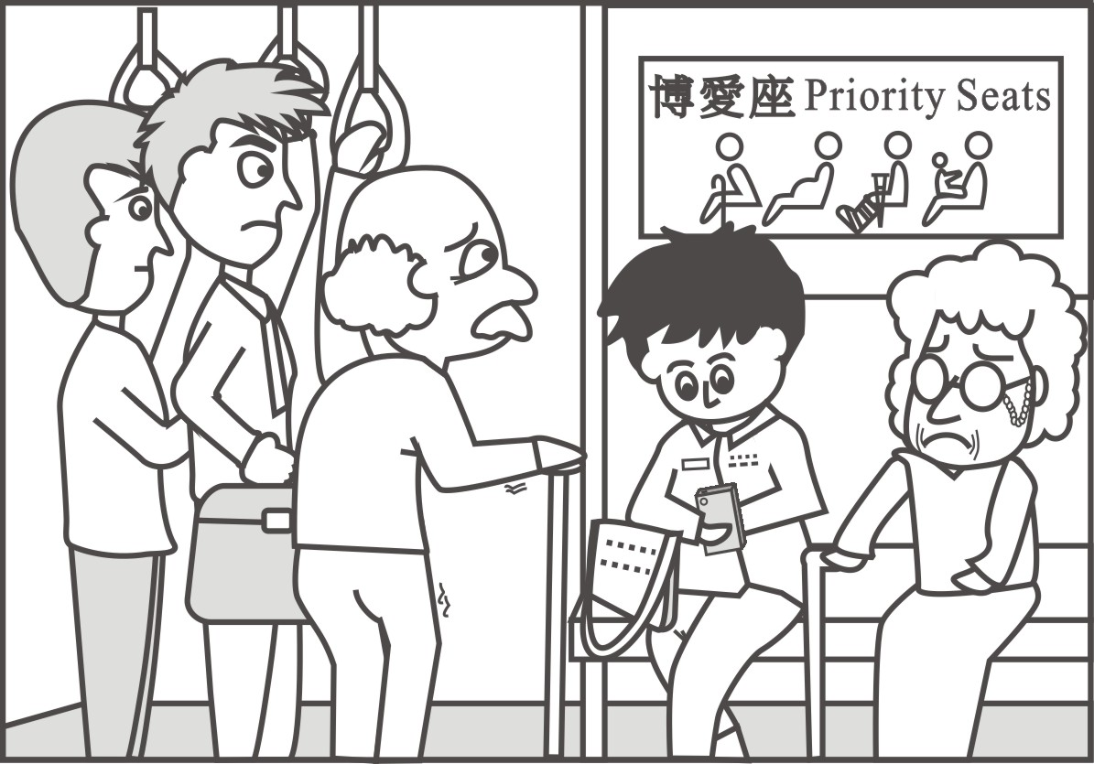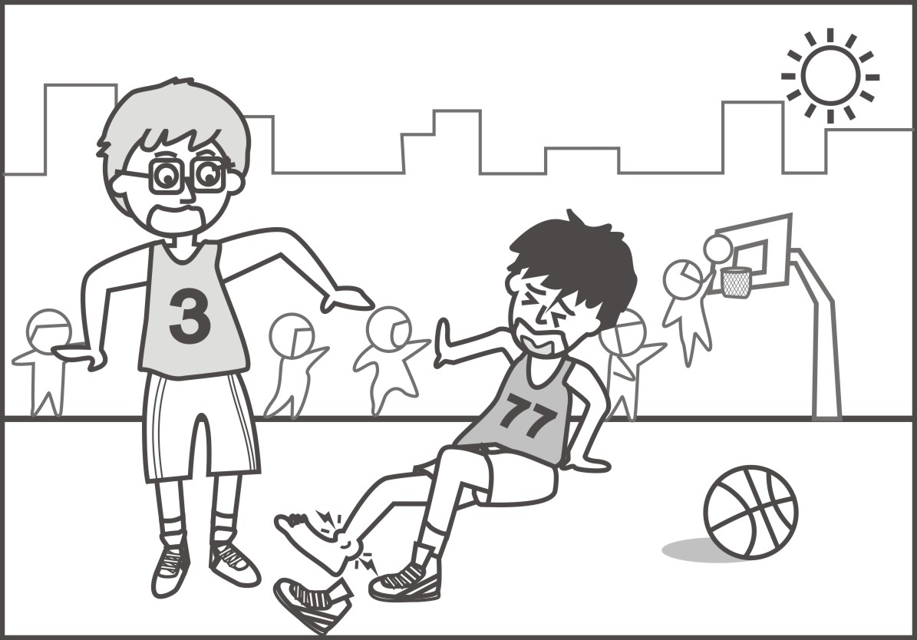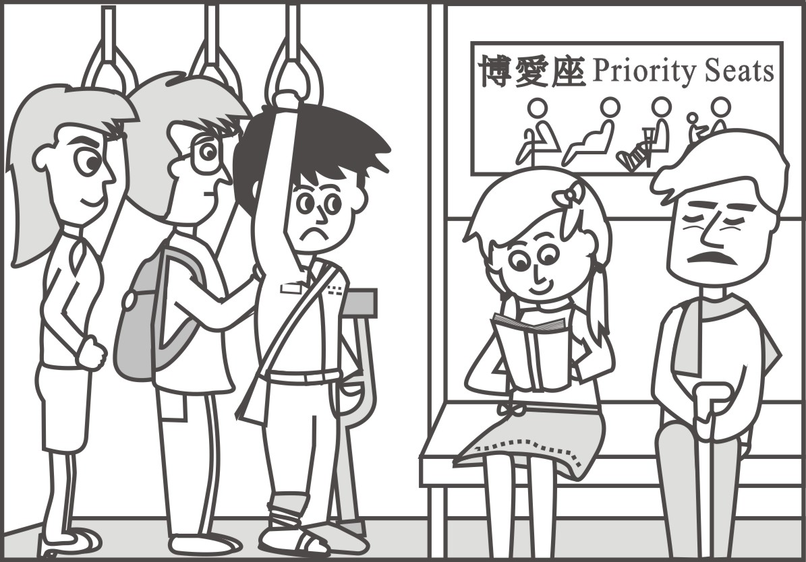

1

2

3

4