大學入學考試中心

九十四學年度學科能力測驗試題

英文考科

|  |
| --- |
| －作答注意事項－  考試時間：100 分鐘  題型題數：  第壹部分  ˙單選題共56題  第貳部分  ˙非選擇題共2大題  作答方式：  ˙選擇題用 2B 鉛筆在「答案卡」上作答，修正時應以橡皮擦拭，切勿使用修正液  ˙非選擇題用黑色或藍色筆在「答案卷」上作答  選擇題答錯不倒扣 |

祝考試順利

第壹部分：單選題

**一、詞彙(15%)**

說明︰第1至15題，每題選出最適當的一個選項，標示在答案卡之「選擇題答案區」。每題答對得1分，答錯不倒扣。

1. As computers are getting less expensive, they are _______ used in schools and offices today.

(A) widely (B) expectedly (C) consciously (D) influentially

2. Mr. Chang always tries to answer all questions from his students. He will not _____ any of them even if they may sound stupid.

(A) reform (B) depress (C) ignore (D) confirm

3. Irene does not throw away used envelopes. She ____ them by using them for taking telephone messages.

(A) designs (B) recycles (C) disguises (D) manufactures

4. Cheese, powdered milk, and yogurt are common milk ____.

(A) produces (B) products (C) productions (D) productivities

5. Although he is a chef, Roberto _____ cooks his own meals.

(A) rarely (B) bitterly (C) naturally (D) skillfully

6. Due to the yearly bonus system, the 100 ________ positions in this high-tech company have attracted many applicants from around the island.

(A) loyal (B) evident (C) typical (D) vacant

7. If you want to borrow magazines, tapes, or CDs, you can visit the library. They are all ______ there.

(A) sufficient (B) marvelous (C) impressive (D) available

8. The fire in the fireworks factory in Changhua set off a series of powerful _________ and killed four people.

(A) explosions (B) extensions (C) inspections (D) impressions

9. A good government official has to ________ the temptation of money and make the right decision.

(A) consist (B) insist (C) resist (D) persist

10. The drug dealer was ________ by the police while he was selling cocaine to a high school student.

(A) threatened (B) endangered (C) demonstrated (D) arrested

11. The rise of oil prices made scientists search for new energy resources to ______ oil.

(A) apply (B) replace (C) inform (D) persuade

12. Without much contact with the outside world for many years, John found many technological inventions _____ to him.

(A) natural (B) common (C) foreign (D) objective

13. The medicine you take for a cold may cause _____; try not to drive after you take it.

(A) incident (B) violence (C) bacteria (D) drowsiness

14. To gain more ______, some legislators would get into violent physical fights so that they may appear in TV news reports.

(A) publicity (B) reputation (C) significance (D) communication

15. To live an efficient life, we have to arrange the things to do in order of _____ and start with the most important ones.

(A) authority (B) priority (C) regularity (D) security

**二、綜合測驗(15%)**

說明︰第16至30題，每題一個空格，請依文意選出最適當的一個選項，標示在答案卡之「選擇題答案區」。每題答對得1分，答錯不倒扣。

Experts say that creativity by definition means going against the tradition and breaking the rules. To be creative, you must dare __(16)__, and courageously express your own outlook and __(17)__ what makes you unique.

But does our society encourage children to break the rules? I’m afraid the answer is no. The famous film director Ang Lee recalls his father’s disappointment with him when he was young. __(18)__ a small child, he would pick up a broom and pretend to be playing guitar for the entertainment of family guests. Then, when he was studying film in college, he would exhaust himself just for a performance tour. His father, __(19)__ always hoped that he would get a PhD and become a professor, __(20)__ with a scoff: “What is all this nonsense?!” But it later turned out that it was exactly his courage to “rebel” and to express his own ideas that marks his films with distinct creativity.

16.(A) rebel (B) to rebel (C) rebelling (D) be rebelled

17.(A) take pride in (B) fall short of (C) get out of (D) keep up with

18.(A) Since (B) For (C) To (D) As

19.(A) who (B) while (C) that (D) when

20.(A) relieved (B) relaxed (C) relied (D) reacted

European politicians are trying to get the UK Government to make cigarette companies print photos on the packets. These photos will show __(21)__ smoking damages your health. The shocking pictures include images of smoke-damaged lungs and teeth, with reminders in large print that smokers die younger.

The picture __(22)__ have been used in Canada for the last four years. It has been very successful and has led to a 44% __(23)__ in smokers wanting to kick the habit. At the moment EU tobacco manufacturers only have to put written health warnings on cigarette packets __(24)__ the dangers of smoking.

The aim of the campaign is to remind people of the damage the deadly weed does to their body. It is believed that this would be to the best interest of all people, __(25)__ teens who might be tempted to start smoking. These dreadful photos may change the impression among teenagers that smoking is cool and sexy.

21.(A) when (B) how (C) where (D) what

22.(A) symbols (B) warnings (C) commercials (D) decorations

23.(A) increase (B) change (C) portion (D) drop

24.(A) highlight (B) highlights (C) highlighting (D) highlighted

25.(A) in fact (B) rather than (C) regarding (D) especially

Do plants have feelings? There is currently no reason to believe that plants experience pain, because they are devoid of central nervous systems and brains. Animals are able to feel pain __(26)__ they can use it for self-protection. __(27)__, if you touch something hot and feel pain, you will learn from this__(28)__ that you should not touch that item in the future. On the other hand, plants cannot move __(29)__ and do not need to learn to avoid certain things, so this sensation would be unnecessary. From a physiological standpoint, plants are completely different from animals. They cannot feel pain. Therefore, __(30)__ animals’ body parts, many fruits and vegetables can be harvested over and over again without dying.

26.(A) although (B) because (C) when (D) so that

27.(A) In contrast (B) Before long (C) For example (D) To begin with

28.(A) discomfort (B) prescription (C) enjoyment (D) satisfaction

29.(A) from door to door (B) from place to place (C) from top to toe (D) from case to case

30.(A) as with (B) for (C) unlike (D) except for

**三、文意選填(10%)**

說明：第31至40題，每題一個空格，請依文意在文章後所提供的 (A) 到 (J) 選項中分別選出最適當者，並將其英文字母代號標示在答案卡之「選擇題答案區」。每題答對得1分，答錯不倒扣。

Falling in love is always magical. It feels eternal as if love will last __(31)__. We naively believe that somehow we are __(32)__ from the problems our parents had. We are assured that we are destined to live happily ever after.

But as the magic fades and daily life __(33)__, it happens that men, forgetting that men and women are supposed to be different, continue to expect women to think and react the way men do; women, __(34)__, expect men to feel and behave the way women do. __(35)__ taking time to understand and respect each other, we become demanding, resentful, judgmental, and intolerant.

__(36)__, our relationships are filled with unnecessary disagreements and conflicts. Somehow, problems creep in, resentments build, and communication __(37)__. Mistrust increases and rejection and repression surface. The magic of love is then lost.

Very __(38)__ people are able to grow in love. Yet, it does happen. __(39)__ men and women are able to respect and accept their differences, love has a chance to blossom. Love is, __(40)__, magical, and it certainly can last if we remember our differences and respect each other.

(A) breaks down (B) Consequently (C) similarly (D) indeed (E) few

(F) forever (G) Instead of (H) takes over (I) free (J) As long as

**四、閱讀測驗(32%)**

說明︰第41至56題，每題請分別根據各篇文章之文意選出最適當的一個選項，標示在答案卡之「選擇題答案區」。每題答對得2分，答錯不倒扣。

**41-44為題組**

For many years, I was convinced that my suffering was due to my size. I believed that when the weight disappeared, it would take old wounds, hurts, and rejections with it.

Many weight-conscious people also mistakenly believe that changing our bodies will fix ***everything****.* Perhaps our worst mistake is believing that being thin equals being loved, being special, and being cherished. We fantasize about what it will be like when we reach the long-awaited goal. We work very hard to realize this dream. Then, at last, we find ourselves there.

But we often gain back what we have lost. Even so, we continue to believe that next time it will be different. Next time, we will keep it off. Next time, being thin will finally fulfill its promise of everlasting happiness, self-worth, and, of course, love.

It took me a long while to realize that there was something more for me to learn about beauty. Beauty standards vary with culture. In Samoa a woman is not considered attractive unless she weighs more than 200 pounds. More importantly, if it's happiness that we want, why not put our energy there rather than on the size of our body? Why not look inside? Many of us strive hard to change our body, but in vain. We have to find a way to live comfortably inside our body and make friends with and cherish ourselves. When we change our attitudes toward ourselves, the whole world changes.

41. The passage tries to highlight the importance of ____________.

(A) body size (B) attitudes toward life

(C) culture difference (D) different beauty standards

42. What does the word “***everything***” in paragraph 2 mean?

(A) All the problems. (B) All the properties.

(C) The whole world. (D) The absolute truth.

43. What can be inferred about the author?

(A) The author is a Samoan.

(B) The author succeeded in losing weight.

(C) The author has been troubled by her/his weight.

(D) The author probably got wounded in wars or accidents.

44. According to the author, what is the common view of those who have lost some weight first and gained it back later?

(A) They feel angry about the regained weight.

(B) They are indifferent to the regained weight.

(C) They feel optimistic about future plans on weight control.

(D) They think they should give up their future plans on weight control.

**45-48為題組**

On December 26, 2003, the worst earthquake in more than a decade devastated Bam, a historic city in Iran. At least 25,000 people died in the quake—nearly a third of the city's population. And thousands more were left homeless, hungry, and grieving.

Bam was a city of mud-brick houses, old monuments and an ancient castle. But nearly everything crumbled in the disaster. One reason the earthquake caused such damage was that Bam's buildings were made mostly from baked mud. These buildings collapsed in heaps of dust and sand.

Bam was best known for its 2,000-year-old castle built out of mud, straw, and the trunks of palm trees. The castle was so big that it was once the city of Bam itself. Public dwellings lined its ground level; a marketplace and two mosques also fit comfortably inside.

Bam once blossomed as a trading post on the Silk Road. In the 16th and 17th centuries, treasures from the Far East were carried along the road into the capital cities of Europe. Fifty years ago, teams of architects began restoring the historic treasures of the city. Ever since, thousands of visitors have come to admire them.

In the face of this tragedy, food and other supplies from around the world landed in the provincial capital of Kerman on Sunday. With such support, spiritual leader Ayatollah Ali Khamenei vowed, “We will rebuild Bam stronger than before.”

45. This passage is most likely taken from a(n) __________.

(A) newspaper (B) history textbook

(C) book review (D) magazine on international trade

46. What was Bam most famous for?

(A) Beautiful palm trees. (B) Frequent earthquakes.

(C) An old mud and straw castle. (D) Treasures from the Far East.

47. The use of baked mud for buildings explains ____________.

(A) why the earthquake occurred

(B) why Bam collected so many treasures

(C) why Bam developed into a trading post

(D) why the earthquake caused such damage

48. Which of the following is CORRECT about the earthquake in Bam?

(A) About 50,000 people survived the earthquake.

(B) Not many countries sent food and supplies to Bam.

(C) The 2003 earthquake was the first one in its history.

(D) The city of Bam would be deserted after the earthquake.

**49-52為題組**

Jet lag, caused by traveling between time zones, is becoming a common problem for frequent travelers: for 49 per cent it is only a nuisance and for 45 percent it is a real problem. It is caused by disruption to the internal biological clock, and may lead to digestive problems, tiredness, and sleep disruption.

Generally speaking, our biological clock is slightly disturbed if we just move into the next time zone, but jet lag becomes a problem once we have passed through three or four time zones. The body takes about one day to get over each hour of time difference. But the seriousness of jet lag problems also depends on our direction of travel. If we go north or south, we won’t notice any difference, because there is usually no time zone change. However, if we travel west we will be in advance of ourselves as far as our internal clock is concerned, and problems may arise. A west-to-east journey, on the other hand, makes us late compared to the local time. It often demands even greater effort in adjustment since we are not quick enough to catch up with the new time schedule. Therefore, a trip from New York to Los Angeles often causes fewer problems than a Los Angeles-New York trip.

49. A traveler who suffers from jet lag has problems in ___________.

(A) adjusting his biological clock

(B) knowing the direction of a jet

(C) knowing the distance of his flight

(D) getting used to the weather of a new place

50. If one travels across three time zones, he needs about __________ hours to get over his jet lag problem.

(A) 24 (B) 36 (C) 48 (D) 72

51. A person may suffer the most serious case of jet lag when he takes a __________ journey.

(A) east-to-west (B) west-to-east (C) north-to-south (D) south-to-north

52. The main purpose of the passage is to ___________.

(A) explain the cause of jet lag problems

(B) teach us how to avoid jet lag problems

(C) explain the differences between time zones

(D) show the ways to lessen the degree of jet lag problems

**53-56為題組**

    Originally from tropical South America, the red fire ant gained entry to the United States through the port of Mobile, Alabama in the late 1930s on cargo ships, but the first colony of the red ants was not found until 1942 by a 13-year-old boy in his backyard.

It immediately began to thrive in the new land and colonies spread quickly throughout the southeastern states. By 1975 the red imported fire ant had colonized over 52 million hectares of the United States. Now, it has infested more than 275 million hectares in the country.

      Red imported fire ants build mounds in any type of soil. They also make mounds indoors. Each nest used to have but one queen, but now many mounds are often found with multiple queens. With multiple queens at work, its population increases rapidly. It’s common to find a nest with over 25,000 workers.

     Red imported fire ants can cause a number of problems. They construct their colonies on precious farmland, invading crops while searching for insects underground. They also like to make their mounds in sunny areas, heavily infesting lawns and pastures. They can quickly strip fruit trees of their fruit. Small birds such as baby quails are fair game to the expanding colony. They appear to be attracted to electromagnetic fields and attack electrical insulation or wire connections. They can cause electrical shorts, fires, and other damage to electrical equipment. Worst of all, their stings can be fatal to livestock and humans.

53. When was the first nest of the red ant found in the United States?

(A) In 1930s. (B) In 1942. (C) In 1975. (D) After 1975.

54. Which of the following is TRUE according to the article?

(A) Each nest of the red ant has one queen.

(B) The red ant was originally found in North America.

(C) The red ant can reproduce young ants very quickly.

(D) The red ant does not build mounds inside the house.

55. What kinds of problems can the red ant cause?

(A) Health, social, and agricultural. (B) Health, social, and environmental.

(C) Social, environmental, and agricultural. (D) Health, agricultural, and environmental.

56. What is the purpose of the article?

(A) To ask for help to kill the red ant.

(B) To urge people to protect the red ant.

(C) To provide information about the red ant.

(D) To seek help from the government to control the red ant.

第貳部分：非選擇題

1. **翻譯題(8%)**

說明：1.請將以下兩個中文句子譯成正確、通順、達意的英文，並將答案寫在「答案卷」上。

　　　2.請依序作答，並標明題號。每題4分，共8分。

1.人類對外太空所知非常有限，但長久以來我們對它卻很感興趣。

2.太空科技的快速發展，使我們得以探索它的奧秘。

**二、英文作文(20%)**

說明︰1.依提示在「答案卷」上寫一篇英文作文。

　　　2.文長120個單詞(words)左右。

提示：請根據以下三張連環圖畫的內容，以 “In the English class last week, …” 開頭，將圖中主角所經歷的事件作一合理的敘述。

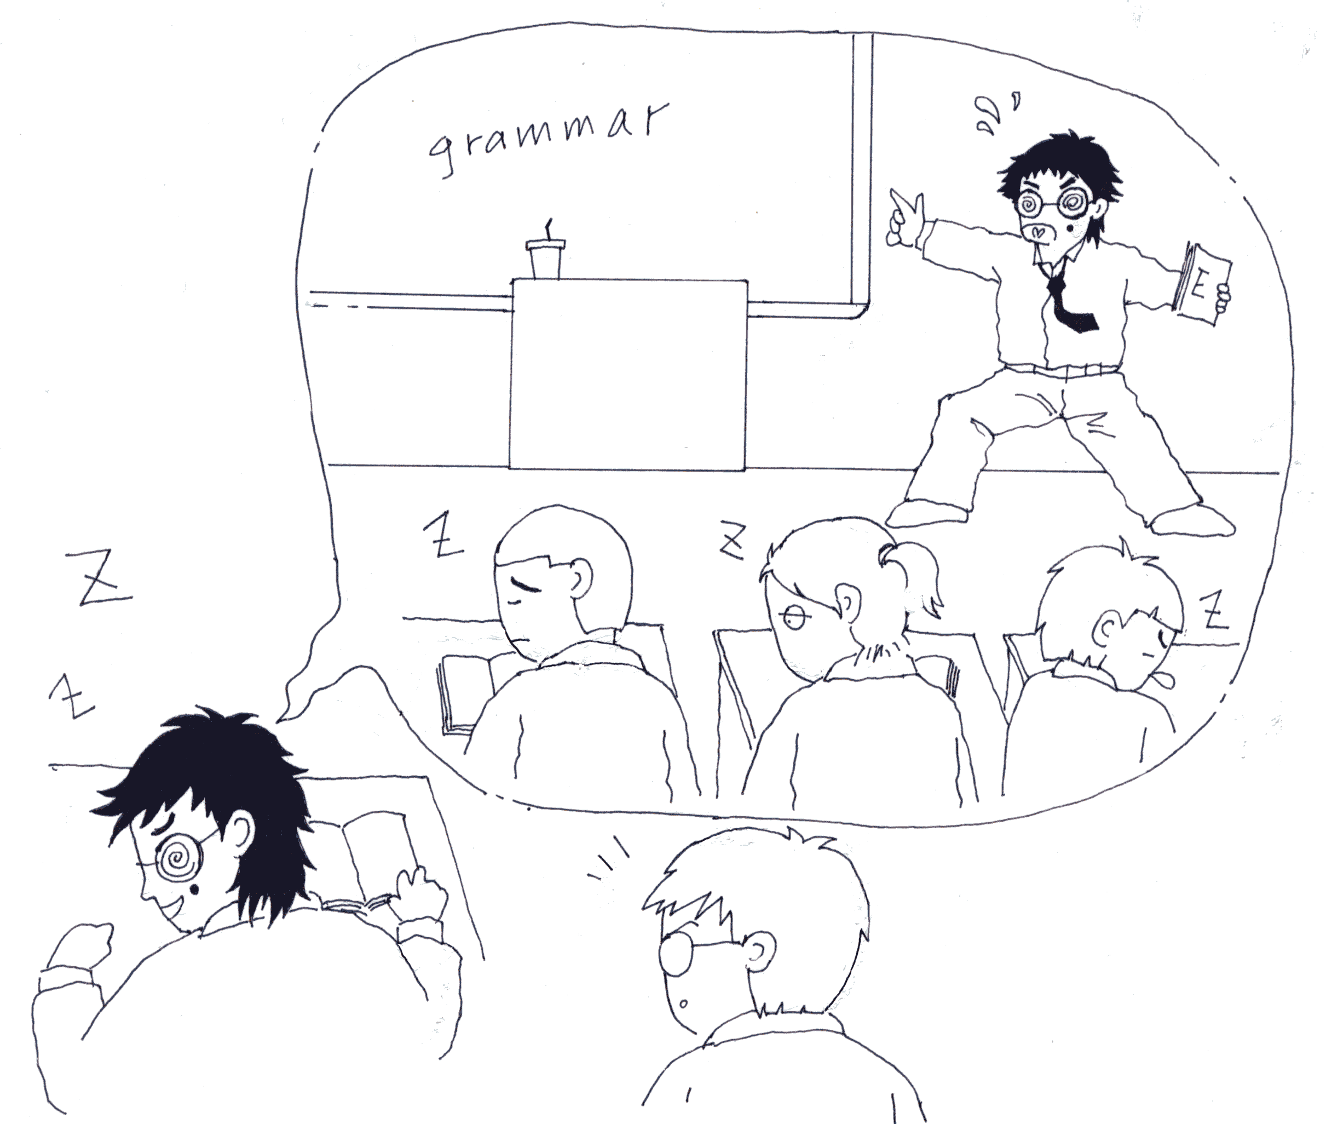

**2025**

年

1

月

15

日

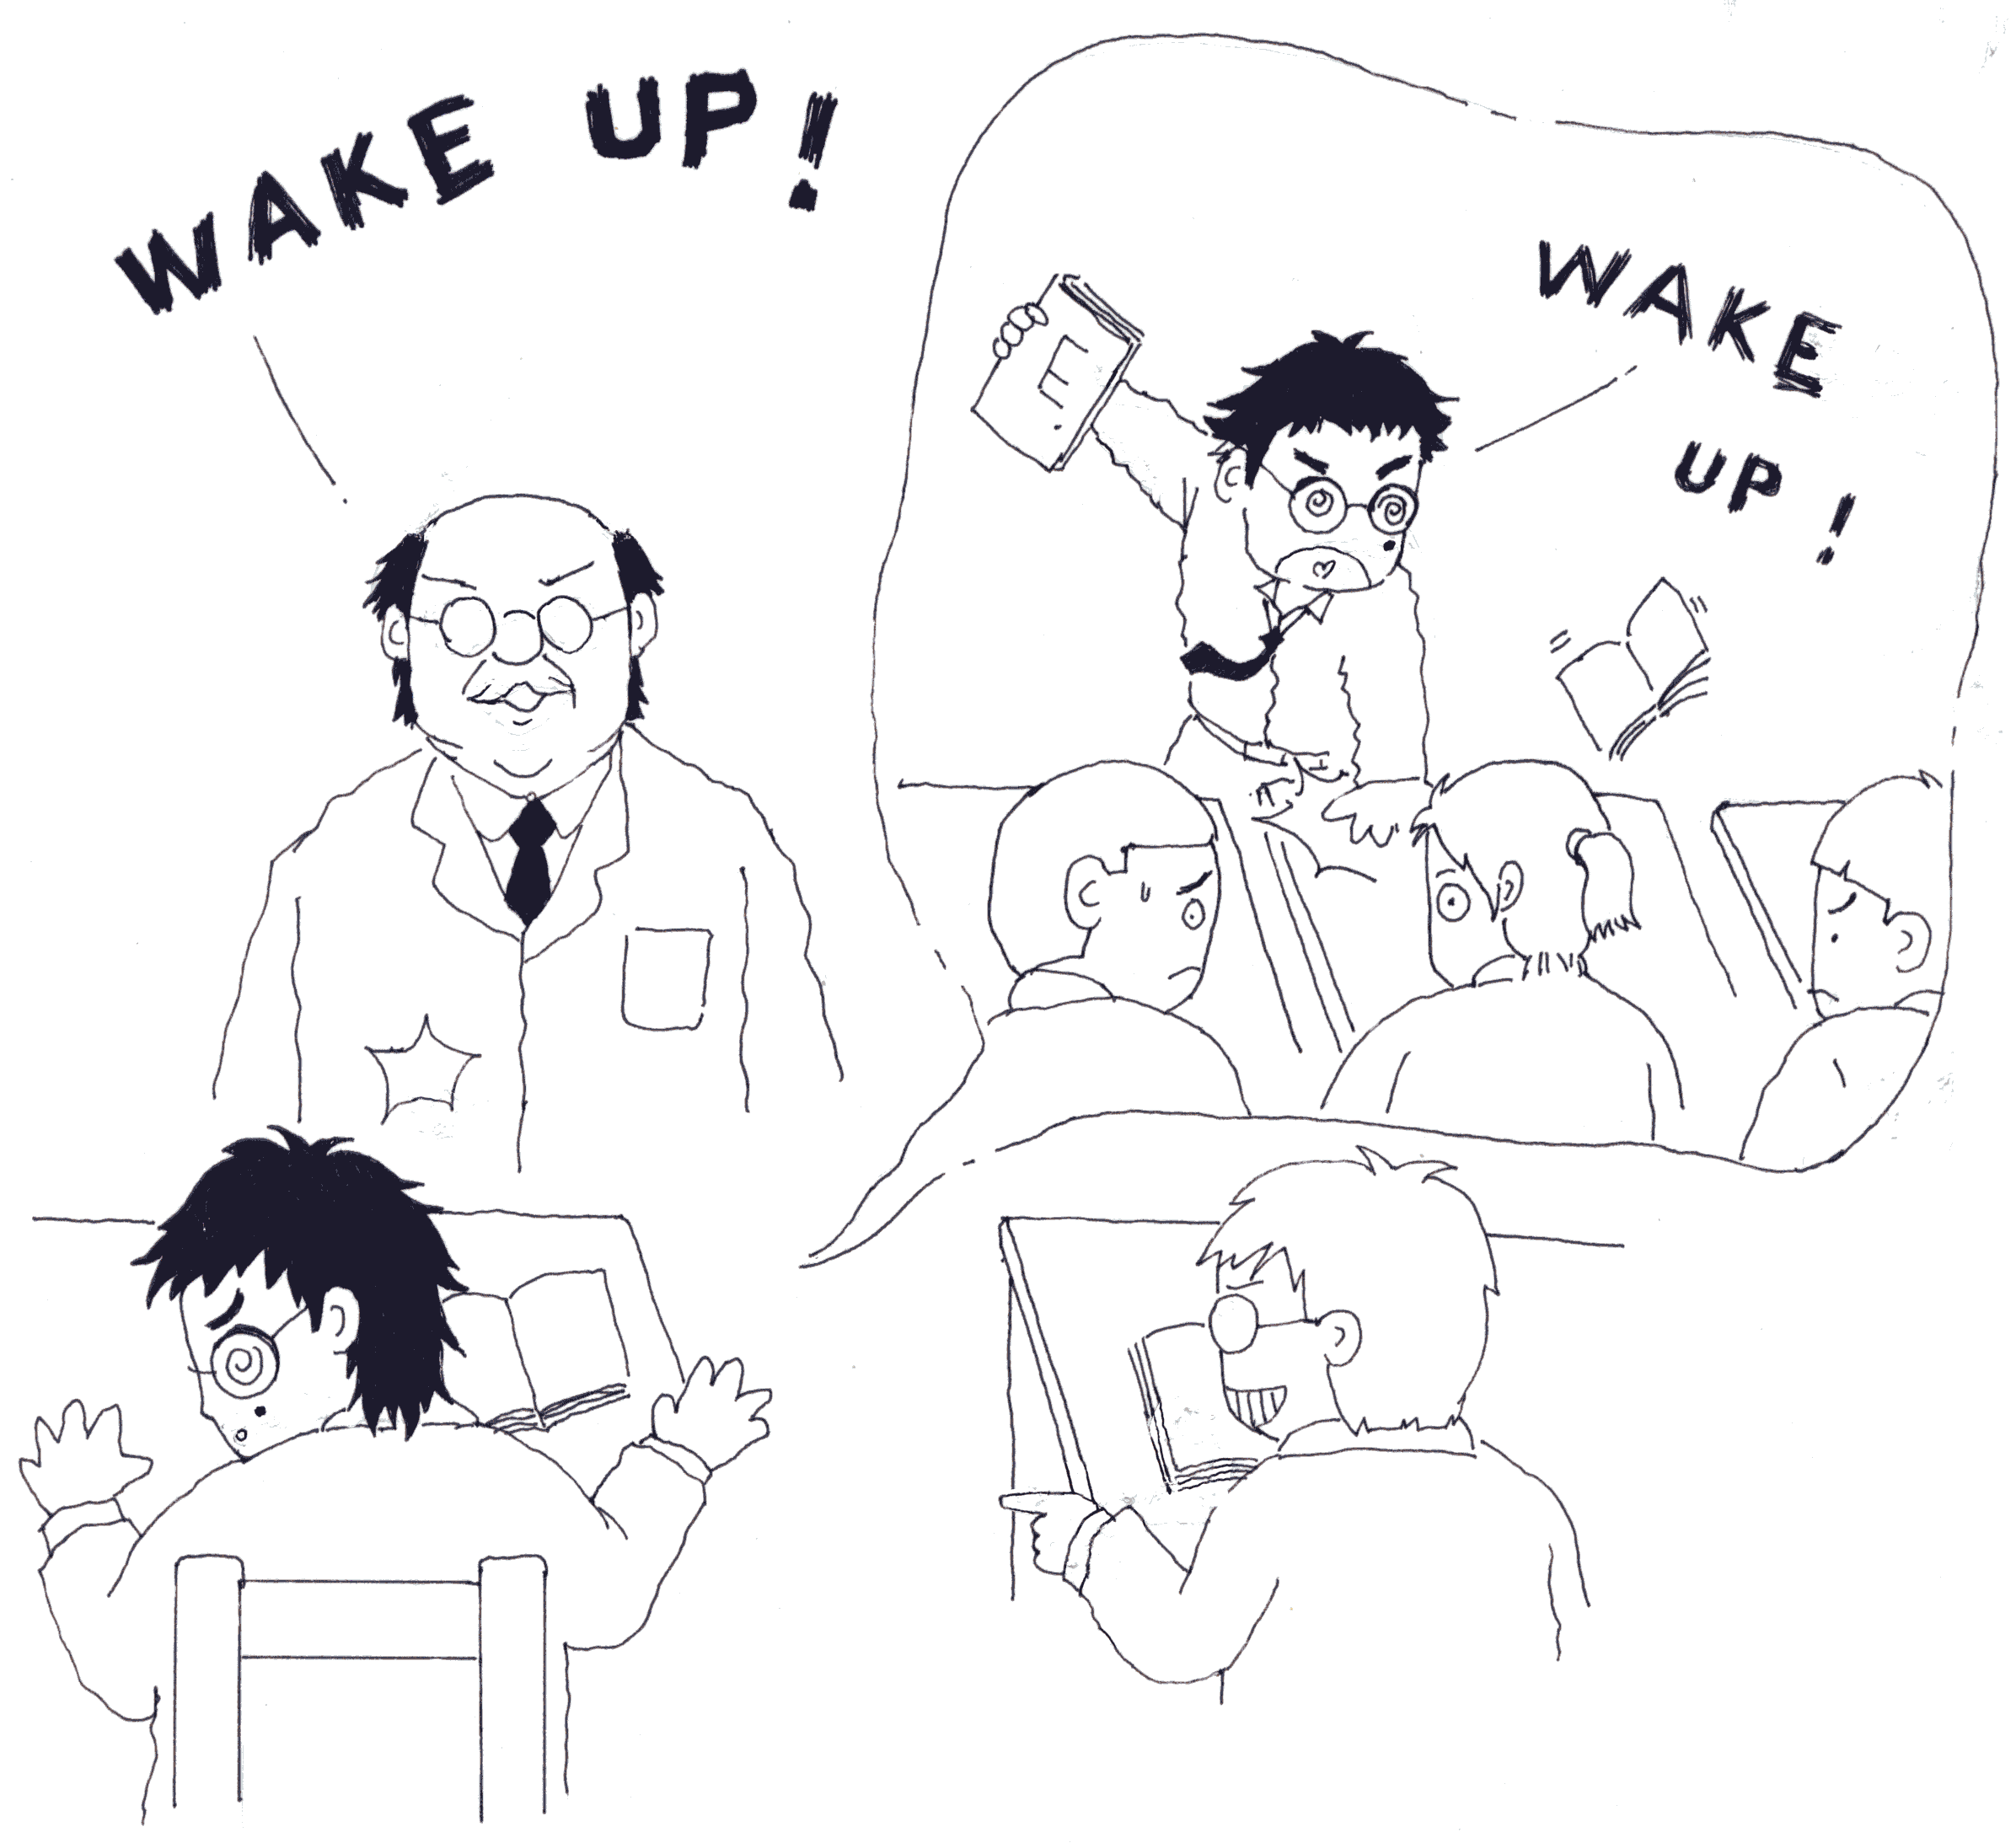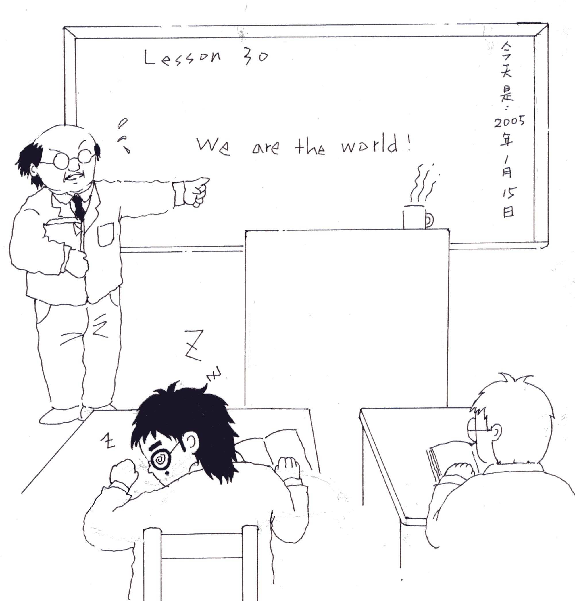

**2005**

年

1

月

15

日