大學入學考試中心

九十六學年度學科能力測驗試題

英文考科

|  |
| --- |
| －作答注意事項－  考試時間：100 分鐘  題型題數：  第壹部分  ˙單一選擇題共56 題  第貳部分  ˙非選擇題共2大題  作答方式：  ˙選擇題用 2B 鉛筆在「答案卡」上作答，修正時應以橡皮擦拭，切勿使用修正液  ˙非選擇題用黑色或藍色筆在「答案卷」上作答  選擇題答錯不倒扣 |

祝考試順利

第壹部分：單一選擇題

**一、詞彙(15%)**

說明︰第1至15題，每題選出最適當的一個選項，標示在答案卡之「選擇題答案區」。每題答對得1分，答錯不倒扣。

1. The movie director adapted this year’s bestseller into a hit and made a ______.

(A) fortune (B) request (C) companion (D) decision

2. Wang Chien-ming, the Yankees’ best pitcher last year, already showed his great _____ for baseball when he was still a teenager.

(A) response (B) reluctance (C) permission (D) potential

3. Although Jeffery had to keep two part-time jobs to support his family, he never ______ his studies. In fact, he graduated with honors.

(A) neglected (B) segmented (C) financed (D) diminished

4. If it is too cold in this room, you can ______ the air conditioner to make yourself feel comfortable.

(A) fasten (B) adjust (C) defeat (D) upload

5. This course will provide students with a solid ______ for research. It is highly recommended for those who plan to go to graduate school.

(A) admission (B) circulation (C) foundation (D) extension

6. Peter is now living on a ______ of NT$100 per day. He cannot afford any recreational activities.

(A) division (B) guidance (C) measure (D) budget

7. Amy succeeded in ______ for a raise though her boss didn’t agree to increase her salary at first.

(A) compensating (B) negotiating (C) substituting (D) advertising

8. Ms. Li’s business ______ very quickly. She opened her first store two years ago; now she has fifty stores all over the country.

(A) discouraged (B) transferred (C) stretched (D) expanded

9. Ruth is a very ____ person. She cannot take any criticism and always finds excuses to justify herself.

(A) shameful (B) innocent (C) defensive (D) outgoing

10. It’s a pity that you have to leave so soon. I ______ hope that you will come back very soon.

(A) sincerely (B) scarcely (C) reliably (D) obviously

11. We human beings may live without clothes, but food and air are ______ to our life.

(A) magnificent (B) essential (C) influential (D) profitable

12. The manager ______ without hesitation after he had been offered a better job in another company.

(A) retreated (B) revived (C) removed (D) resigned

13. Many important legal ______ concerning the tragic incident have now been preserved in the museum.

(A) distributions (B) formations (C) documents (D) constructions

14. I’m not sure exactly how much scholarship you’ll receive, but it will _____ cover your major expenses.

(A) recently (B) roughly (C) frankly (D) variously

15. Tom was very ill a week ago, but now he looks healthy. We are ______ by his quick recovery.

(A) amazed (B) convinced (C) advised (D) confirmed

**二、綜合測驗(15%)**

說明︰第16至30題，每題一個空格，請依文意選出最適當的一個選項，標示在答案卡之「選擇題答案區」。每題答對得1分，答錯不倒扣。

All dogs deserve to look and feel their best. After a spa treatment at Happy Puppy, dogs come home 16 pampered and relaxed. At Happy Puppy, your dog can enjoy a half day of care and then be taken to the salon at naptime. Here all the dogs are given a bath using professional shampoo and conditioners in a massaging tub. Their relaxing bath will be 17 a full fluff dry and brush-out. When you arrive for pick-up, your dog will be well-exercised and beautiful.

You can also bring your dog to Happy Puppy and wash it yourself. We supply everything, 18 waist-high tubs, shampoo, and towels. This service is available seven days a week during normal operating hours.

19 Happy Puppy is a relatively new service, we benefit from more than 20 years of experience in breeding and caring for dogs. We are completely 20 to helping dogs enjoy a full and active life. Our well-trained staff will provide the best possible service for you and your dog.

16. (A) will feel (B) to feel (C) have felt (D) feeling

17. (A) counted on (B) followed by (C) turned into (D) started with

18. (A) concerning (B) showing (C) including (D) relating

19. (A) Although (B) Because (C) Once (D) Until

20. (A) devoted (B) determined (C) delighted (D) directed

India is shrinking. A new analysis of satellite-based data has given precisely the rate 21 which the country is losing size as it pushes northward against the Himalayas. According to the analysis, the 22 between India’s southern and northern tips shrinks by 2 cm every year. As India’s size decreases, the thickness of the Himalayas increases. 23 the shrinking continues, India will disappear in 200 million years. There would only be a vast mountain range along the southern coast of China.

The Indian plate’s 24 movement is not new. However, this cannot be treated as a trivial finding in science. A movement of 25 a few millimeters (mm) of the earth’s crust is a sign of possible earthquakes. Such dangers are now obvious in India, where the movement of the plate continues.

21. (A) by (B) in (C) of (D) at

22. (A) height (B) distance (C) geography (D) landscape

23. (A) If (B) For (C) Unless (D) Though

24. (A) wayward (B) downward (C) northward (D) outward

25. (A) yet (B) even (C) rather (D) indeed

Whenever I set foot on the soil of Rwanda, a country in east-central Africa, I feel as if I have entered paradise: green hills, red earth, sparkling rivers and mountain lakes. Herds of goats and cows 26 enormous horns graze the lush green fields. Although located close to the equator, Rwanda’s “thousand hills,” 27 from 1,500 m to 2,500 m in height, ensure that the temperature is pleasant all year around. And being a tiny country, everything in Rwanda is 28 in a few hours and the interesting spots can be explored comfortably in a couple of weeks. But 29 , Rwanda is a symbol of the triumph of the human spirit over evil. Though it was once known to the world for the 1994 tribal conflict that resulted in about one million deaths, Rwanda has 30 the mass killing. Now it is healing and prospering and greets visitors with open arms.

26. (A) into (B) with (C) for (D) from

27. (A) differing (B) wandering (C) ranging (D) climbing

28. (A) off the record (B) beyond doubt (C) in touch (D) within reach

29. (A) worst of all (B) for that matter (C) above all (D) at most

30. (A) survived (B) transformed (C) recovered (D) endangered

**三、文意選填(10%)**

說明：第31至40題，每題一個空格，請依文意在文章後所提供的 (A) 到 (J) 選項中分別選出最適當者，並將其英文字母代號標示在答案卡之「選擇題答案區」。每題答對得1分，答錯不倒扣。

An old man who lived in a small side street of Mumbai had to put up with the nuisance of boys playing cricket and making a lot of noise outside his house, at night.

One evening when the boys were particularly 31 , he went out to talk to them. He explained that he had just retired and was happiest when he could see or hear boys playing his 32 game, cricket. He would therefore give them 25 rupees each week to play in the street at night. The boys were thrilled, for they could hardly believe that they were being paid to do something they 33 !

At the end of the first two weeks, the boys came to the old man’s house, and went away 34 with their 25 rupees. The third week when they came back, however, the old man said he had 35 money and sent them away with only 15 rupees. The fourth week, the man said he had not yet received his 36 from the government and gave them only 10 rupees. The boys were very 37 , but there was not much they could do about it.

At the end of the fifth week, the boys came back again and knocked at the old man’s house, waiting for their 38 . Slowly, the door opened and the old man appeared. He apologized that he could not afford to pay them 25 rupees as he had 39 , but said he would give them five rupees each week without fail.

This was really too much for the boys. “You expect us to play seven days a week for 40 five rupees!” they yelled. “No way!”

They stormed away and never played on the street again.

(A) disappointed (B) enjoyed (C) favorite (D) happily (E) merely

(F) noisy (G) paycheck (H) promised (I) reward (J) run out of

**四、閱讀測驗(32%)**

說明︰第41至56題，每題請分別根據各篇文章之文意選出最適當的一個選項，標示在答案卡之「選擇題答案區」。每題答對得2分，答錯不倒扣。

**41-44為題組**

Most American kids love Halloween treats, but a bucket of Halloween candy can be a dentist’s nightmare. Some parents try to get rid of half of the candy after their children go to bed, but dentists say parents also need to separate the good kinds of treats from the bad.

It is not exactly what a child eats that truly matters, but how much time it stays in his mouth. According to pediatric dentist Dr. Kaneta Lott, the most damaging stuff is something that is sticky or very hard and thus stays in the mouth for a long time. This is because we all have bacteria in our mouths. When we eat, the bacteria take our food as their food and produce an acid that destroys the surface of the teeth, causing cavities to form. The longer the food stays in the mouth, the more likely cavities will develop. Therefore, potato chips are worse than candy because they get stuck between teeth. For the same reason, raisins and crackers are not the best choice. Hard candies take a long time to consume and are also a bad choice for Halloween treats.

If children really love candy, dentists recommend that they eat chocolate instead. Unlike hard candies, chocolate dissolves quickly in the mouth. Besides, chocolate contains tannins, which help to kill some of the bacteria in the mouth. But no matter what a child eats, brushing after each meal is still the best way to fight cavities.

41. What is the main purpose of this passage?

(A) To discuss how cavities can be treated.

(B) To point out the problems with Halloween celebrations.

(C) To tell parents what sweets are less damaging to their children’s teeth.

(D) To teach parents the meaning of Halloween candies for their children.

42. Why are hard candies especially bad for teeth?

(A) They may break the child’s teeth. (B) They contain too much sugar.

(C) They help bacteria to produce tannins. (D) They stay in the mouth for a long time.

43. According to the passage, which of the following is a better choice for Halloween treats?

(A) Chocolate. (B) Crackers. (C) Raisins. (D) Potato chips.

44. According to the passage, which of the following is true of tannins?

(A) They are produced when the bacteria digest the food.

(B) They help to get rid of some bacteria in the mouth.

(C) They help chocolate to dissolve more quickly.

(D) They destroy the surface of the teeth.

**45-48為題組**

The largest television network in America is not ABC, CBS, or Fox. Nor is it one of the cable networks such as CNN, which carries only news and news stories. It is not ESPN, the all-sports cable network, or even MTV, which is famous for its music videos. Rather it is PBS, Public Broadcasting System, a non-profit public broadcasting TV service. PBS has 349 member television stations in the U.S. and some member stations by cable in Canada.

PBS only attracts a minority of all TV viewers, about 2 percent. The industry leader, NBC, however, attracts 11 percent of viewers. But the growth of public television in the past two decades has been dramatic. This is especially noteworthy when one considers that public television stations must often survive on very limited budgets, on viewers’ donations, and on private foundations and some governmental funding.

The level of quality of PBS programs, whether in national and international news, entertainment, or education, is excellent. Almost a whole generation of children throughout the world is familiar with Sesame Street and the characters of The Muppet Show. PBS is especially well known for the quality of its many educational TV programs. Over 95 percent of all public television stations have tele-courses. These courses are accepted and supported by more than 1,800 colleges and universities throughout the US. Each year, over a quarter of a million students take courses this way.

45. According to this article, PBS received part of its funding from _________.

(A) private organizations (B) public schools

(C) advertising agencies (D) other television stations

46. What is PBS most famous for?

(A) Cable services. (B) Generous donations.

(C) Educational programs. (D) Live news broadcasts.

47. Which of the following is true about public television stations?

(A) The majority of their viewers are minority people.

(B) Ninety-five percent of their programs are tele-courses.

(C) They are shrinking in number because they make no profits.

(D) Their courses are accepted by many universities in America.

48. Which of the following has the highest percentage of viewers?

(A) ABC (B) PBS (C) NBC (D) Fox

**49-52為題組**

Last week Jay McCarroll and The HSUS (The Humane Society of the United States) made a bold fur-free statement on the runway, marking **a new chapter** for the fashion industry and animal protection. The encouraging response to McCarroll’s show confirmed that change is happening in fashion.

McCarroll has good reasons for rejecting fur. Each year, tens of millions of animals, including dogs and cats, needlessly suffer and die to fuel the fur industry. But what did Jay McCarroll use in place of fur? “I have patchwork pieces that contain all sorts of combinations of fabrics. The rest is cotton, nylon, polyester...you name it. I even have some stuff made out of bamboo/cotton blend. Anything but fur and leather,” he told Fashion Wire Daily.

“So many people want to protect animals and live their lives without causing unnecessary cruelty. More than two thirds of Americans have pets, and we share a bond with animals every day. Saying no to fur can help millions of animals, and we want to show our respect to leading designers like Jay who embrace compassion as the fashion,” said Michael Markarian, executive vice president of The HSUS. “It is great to see leaders in the fashion industry recognizing that the animals need their fur more than we do.”

49. Which of the following is true about Jay McCarroll?

(A) He is a famous fashion designer.

(B) He is the executive vice president of the HSUS.

(C) He is an editor of *Fashion* Wire Daily.

(D) He is the head of an animal protection organization.

50. What does **“a new chapter”** in line 2, paragraph 1 mean?

(A) A new unit of a book. (B) The beginning of a new trend.

(C) The latest issue of a magazine. (D) A newly established organization.

51. Which of the following is NOT recommended for clothing by Jay McCarroll?

(A) Polyester. (B) Bamboo. (C) Leather. (D) Patchwork pieces.

52. What do we learn from this passage?

(A) Human beings depend emotionally on animals.

(B) Fashion can go hand in hand with compassion for life.

(C) Fur is more effective than bamboo/cotton blend for clothing.

(D) Fur is more expensive than other materials for fashion designers.

**53-56為題組**

Twenty years ago, most experts believed that differences in how boys and girls behaved were mainly due to differences in how they were treated by their parents, teachers, and friends. It’s hard to **cling to** that belief today. Recent research has shown that there are biological differences between boys and girls. Understanding these differences is important in raising and educating children.

For example, girls are born with more sensitive hearing than boys, and the difference increases as kids grow up. So when a grown man speaks to a girl in what he thinks is a normal voice, she may hear it as yelling. Conversely, boys who appear to be inattentive in class may just be sitting too far away to hear the teacher.

Likewise, girls are better in their expression of feelings. Studies reveal that negative emotions are seated in an area of the brain called the amygdala. Girls develop an early connection between this area and the cerebral cortex, enabling them to talk about their feelings. In boys these links develop later. So if you ask a troubled adolescent boy to tell you what his feelings are, he often cannot say much.

Dr. Sax, a proponent of single-sex education, points out that keeping boys and girls separate in the classroom has yielded striking educational, social, and interpersonal benefits. Therefore, parents and teachers should try to recognize, understand, and make use of the biological differences that make a girl a girl, and a boy a boy.

53. What is the main idea of the passage?

(A) Boys tend to pay less attention in class than girls.

(B) Girls are better than boys in their ability to detect sounds.

(C) Boys and girls behave differently because of biological differences.

(D) Single-sex schools are not good because they keep boys and girls separate.

54. Why do girls express negative feelings better than boys?

(A) Girls are more emotional than boys.

(B) Girls have more brain cells than boys.

(C) The amygdala is located in different areas of the brain for boys and girls.

(D) The links between certain parts of the brain develop earlier in girls than in boys.

55. Which of the following does the author believe?

(A) Girls need more training in communication.

(B) Boys and girls should be educated in different ways.

(C) Parents should pay more attention to boys.

(D) Sex differences should be ignored in education.

56. What does the phrase “**cling to**” in the first paragraph mean?

(A) maintain (B) abandon (C) evaluate (D) challenge

第貳部分：非選擇題

1. **翻譯題(8%)**

說明：1.請將以下兩個中文句子譯成正確、通順、達意的英文，並將答案寫在「答案卷」上。

　　　2.請依序作答，並標明題號。每題4分，共8分。

1. 如果我們只為自己而活，就不會真正地感到快樂。

2. 當我們開始為他人著想，快樂之門自然會開啟。

**二、英文作文(20%)**

說明︰1.依提示在「答案卷」上寫一篇英文作文。

2.文長120個單詞(words)左右。

提示︰請以下面編號1至4的四張圖畫內容為藍本，依序寫一篇文章，描述女孩與貓之間的故事。你也可以發揮想像力，自己選定一個順序，編寫故事。請注意，故事內容務必涵蓋四張圖意，力求情節完整、前後發展合理。

(3)

(1)

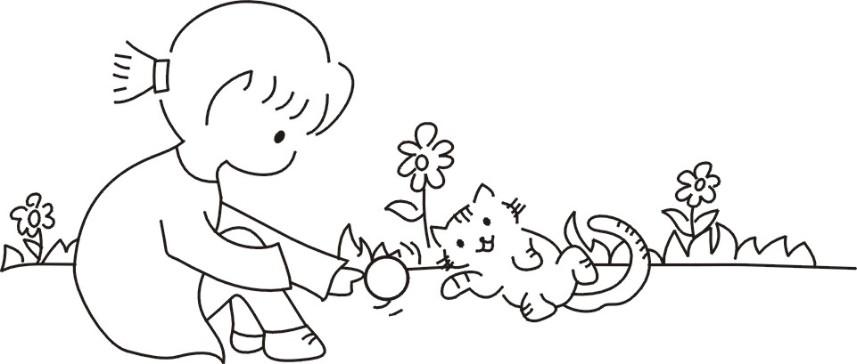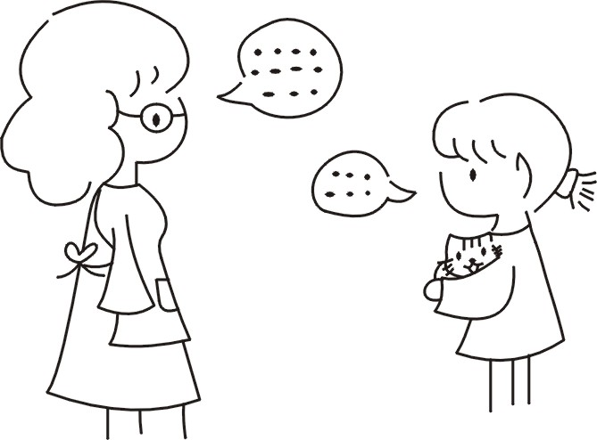

(4)

(2)

