Final Evaluation: 40%

|  |  |
| --- | --- |
| **Course Identification** | |
|  |  |
| Course title: | **APPLICATION DEVELOPMENT 1 (DESKTOP)** |
| Course number: | 420-942-VA |
| Group: | 07001 |
| Teacher’s name: | Alex Vilvert |
| Duration: | 4 periods (210 minutes) |
| Semester: | Winter 2022 |
| **Student Identification** | |
| Name: Tyler Nelson_______________________________ Student number: 2195426____  Date: August 11 2022_ Result: ______________  I declare that this is an original work, and that I credited all content sources of which I am not the author (online and printed, images, graphics, films, etc.), in the required quotation and citation style for this work. | |
| **Standard of the Evaluated Competencies** | |
|  | |
| **Evaluated elements of the competency.**   * Analyze the problem * Model the classes. * Produce the methods. * Program the classes. * Create Validation. * Test the Classes and methods. | |
| **Mark Breakdown** | |
|  | |
| * **This evaluation is worth for a total of 100 points.** | |

* **Insert your answers on this file, below of every question.**
* **Save the new midterm file with following the standard name below:**

**YOURNAME_YOURID_MIDTERM_OS**

**Scenario**

You are required to create a **C# Windows Forms Application** using **Visual Studio** .The application allows the teacher to enter student information, validate the input data, save the valid data to .dat file, delete students and search for students.

**Create a new project with student ID and name as final exam file.**

Create a form (design), similar to this image: Change the Form1 title with your name followed by **your student ID and the current date.**

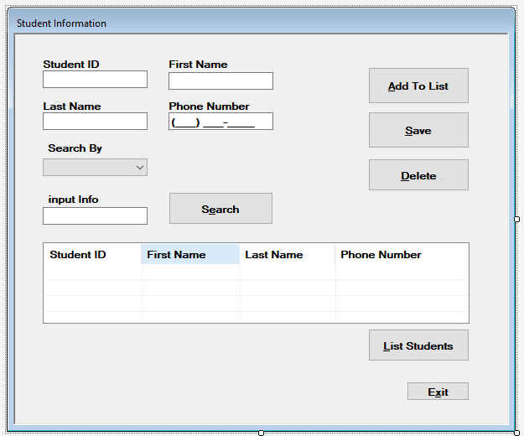

Validation:

Student ID must accept 7 number digits only.  
Last Name and First Name accept only text data type.

Save:

Save StudentID, Student FirstName and Student LastName at a .dat file.

Search by:

Search only for the Student ID. After found show all the Student info at their respective textboxes. If not found show an error message.

Delete:

Remove a student from the .dat file. Show a message to describe success or not.

List Students:

List all the students saved at the file or added to the list at list view.

Add Students to the list to be showed at listview:

List all the students saved at the file or added to the list at list view.

*Have fun and enjoy life!*